**Validated Ledger Bash script**

==================================================================================

This script is created as part of ripple technical coding round for my interview.

**Description**

The shell script periodically calls ripple server info command and record the sequence number of the latest validated ledger along with the current time. This data is then recorded in a file and then used to construct a plot time on X axis, and sequence number on y axis and age (time taken by server to validate ledger) of the each iteration on x2 axis that visualizes how frequently the ledger sequences incremented over time.

**Installation Steps:**

git clone <https://github.com/deepakkukreja1985/Validated-Ledger-Project.git>

**Requirements**

* Ubuntu 16.04
* BASH Shell
* CURL version 7.47.0
* JQ version 1.5.1
* Gnuplot 5.0
* Bats 0.4.0 (Bash Automated Test System)

**How to Execute:**

./scripts/validated_ledger.sh

**Documentation**

You can find detail documentation in **“/doc”** folder

<https://github.com/deepakkukreja1985/Validated-Ledger-Project/tree/master/doc>

**Directory Structure**

root

etc

Contains configuraiotn fule

scripts

output

log

test

doc

**Scripts Files**

They can be found under **“/scripts”** folder

|  |  |
| --- | --- |
| **Script Name** | **Description** |
| Validated_ledger.sh | This shell script periodically calls server info command and records the sequence number of the latest validated ledger along with the current time. This data is then recorded in a file and then used to construct a plot time on X axis and sequence number on y axis and age (time taken by server to validate ledger) of the each iteration on x2 axis. |
| Calculate_polling.sh | This shell script calculates polling interval during runtime by calculating the average time taken by the server to generate unique validated ledger sequences. The count of unique validated sequence that needs to be captured for polling interval calculation is stored in conf file parameter : CONFIG_SERVER_SAMPLE_COUNT |
| Install-bats-libs.sh | Steps to install bats environment with git.  **C:\Users\acer\Downloads\install-bats.png** |

**Configuration File**

Project uses 2 configuration file “validated_ledger.conf” and”plot.dat”, which can be found under **“/etc”** folder.

1) Configuration file name:”validated_ledger.conf”

Configurations file parameter:

|  |  |  |
| --- | --- | --- |
| Parameter Name | Default Value | Description |
| CONFIG_SERVER_URL | http://s1.ripple.com:51234/ | URL of the Server |
| CONFIG_SERVER_COMMAND | server_info | Server_info command |
| CONFIG_MAX_REDIRECT | 1 | Used by Curl to redirect in case of proxy. Count is number of time curl will try to redirect. |
| CONFIG_SERVER_DOWN_TIME_PERIOD | 10 | No of times the script will check if server available. |
| CONFIG_SERVER_POLLING_COUNT | 20 | No of times server info will be called to get validated  Timespan = CONFIG_SERVER_POLLING_COUNT * Polling interval |
| CONFIG_SERVER_SAMPLE_COUNT | 10 | Number of unique validated ledger sequences required to calculate polling interval |
| CONFIG_SERVER_POLLING_INTERVAL | 1 | Polling interval calculated by algorithm to fetch server data after given time |

2) Configuration file name:”plot.dat”

This file is input to gnuplot which contains graph settings.

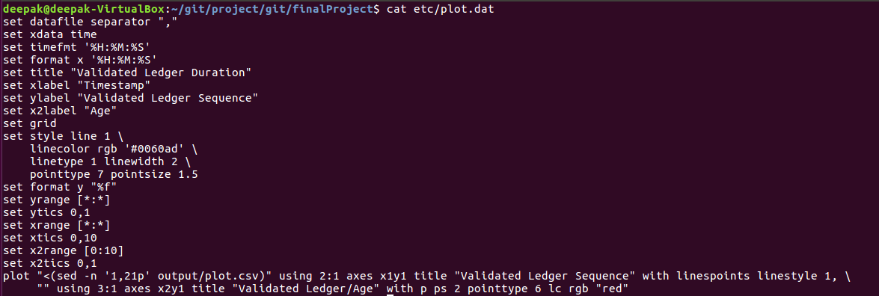

**Tests**

You can execute automated test suite using BATS.

There are 2 bats file one is pre execution test suite and second is post execution test suite, which can be found under **“/test”** folder.

Should output something like:

