AWS

**Cloud Computing :** Cloud computing is the on demand delivery of compute power, database, storage , applications and other IT resources through a cloud services platform via the internet with Pay as you go pricing model.

**Characteristics of Cloud :**

1. On demand Self Service
2. Broad network Access
3. Scalability
4. Resource Pooling
5. Measured service

**Certification** :

1. **AWS ­­­ Architect :** It has two level intermediate level is called Associate and expert level is called Professional
2. **AWS Devops :** It has two level intermediate level is called Associate and expert level is called Professional

* In Devops both development and operation are managed

1. **AWS Sysops :** It has two level intermediate level is called Associate and expert level is called Professional

* In Sysops both System admin and operation are managed

**Services in Cloud:**

Three types of services are provided by Cloud

1. **IAAS (Infrastructure as a Service)** 🡪 If we take from Network to Operating System on rent from cloud ie all the infrastructure.
2. **PAAS (Platform as a Service)** 🡪 If we take from Network to Runtime on rent from cloud ie all the infrastructure as well as platform(like mysql, jdk etc)

=> PAAS automatically includes IAAS

1. **SAAS (Software as a service)** 🡪 If we take from Network to Application on rent from cloud ie all the infrastructure as well as platform(like mysql, jdk etc) and software also.

|  |
| --- |
| Application |
| Data |
| Runtime |
| Middleware |
| Operating system |
| Virtualization |
| Server |
| Storage |
| Network |

**Deployment Model of Cloud :**

1. **Public cloud :** AWS, Azure, Google Cloud(GCP) means the services provided by this cloud is open to all.
2. **Private cloud :** also called Enterprise cloud it is mainly created by a company for its own purpose means if a company sets up their own cloud this will be accessible only from its own member office not from other office in entire world
3. **Hybrid cloud :** In Hybrid cloud we can merge it’s private cloud with public cloud .

* **In Azure cloud has more flexibility for hybrid configuration**

**Virtualization :** we can virtualize Network ,Storage, server with the help of **Hypervisor** it means **Hypervisor is a way to virtualize Network, Storage and server.**

**For AWS: Citrix is the hypervisor**

**For Microsoft : HyperV is the hypervisor**

**Note : Once these all three things (Network, Storage and server ) will become virtualize then only we can create a Cloud.**

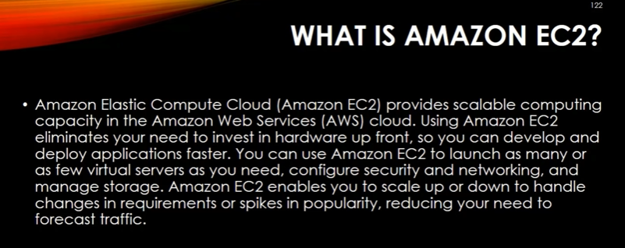 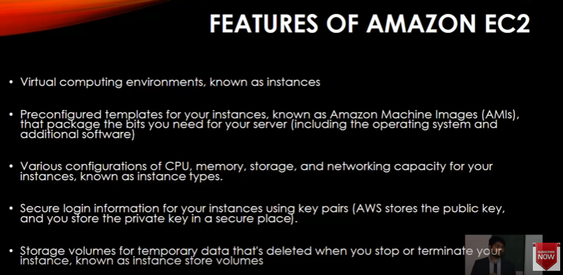 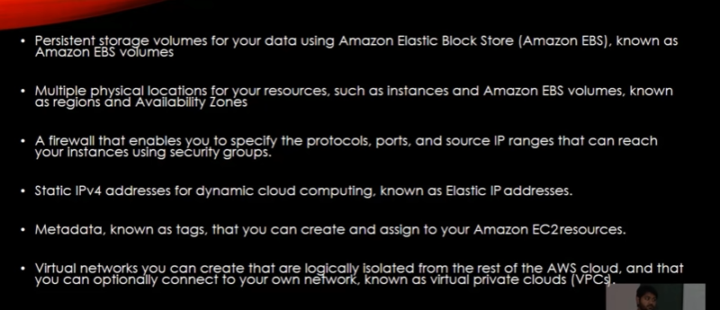 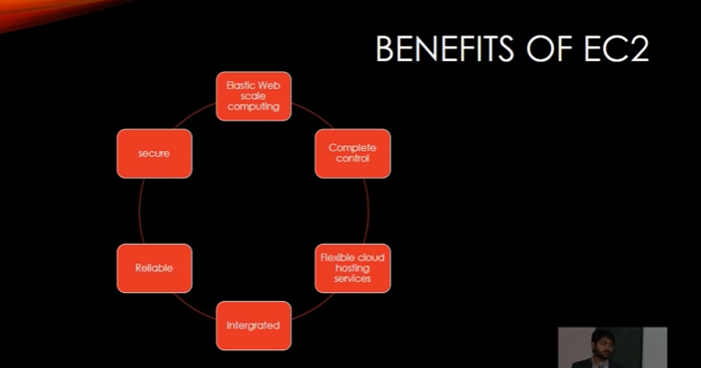 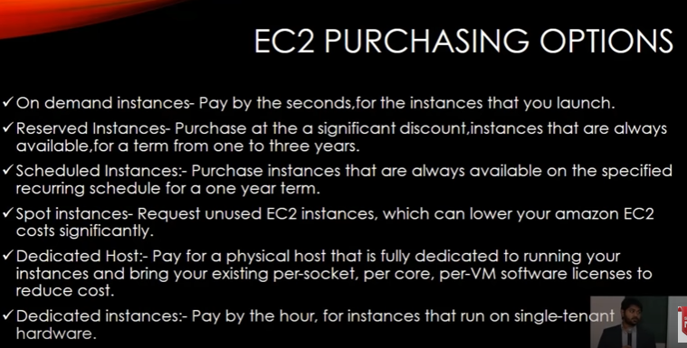 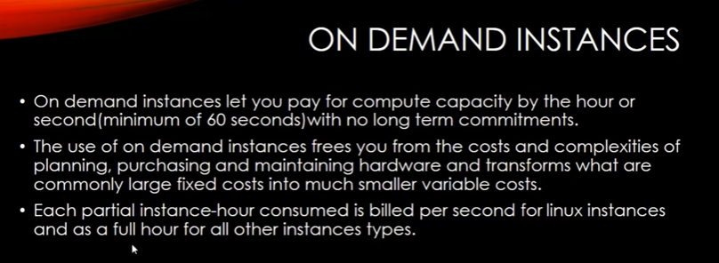 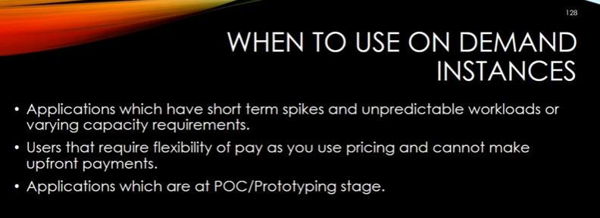 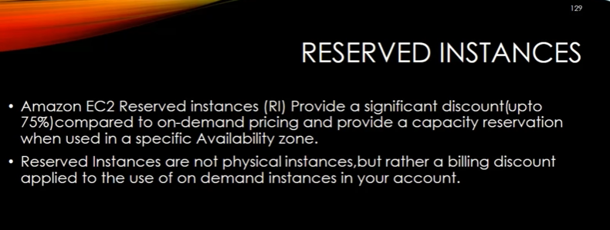 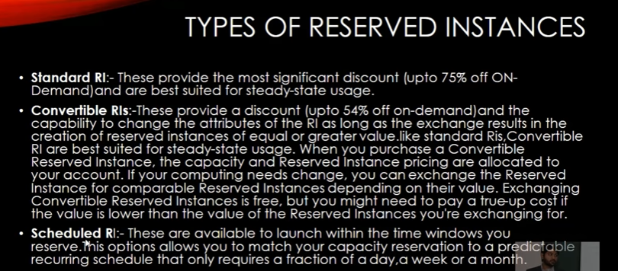 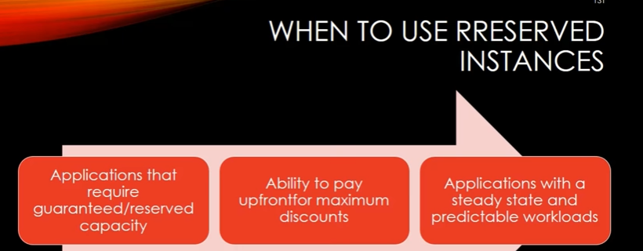 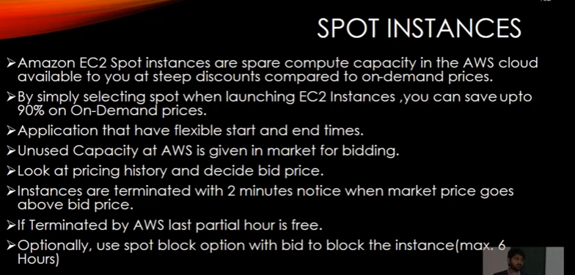 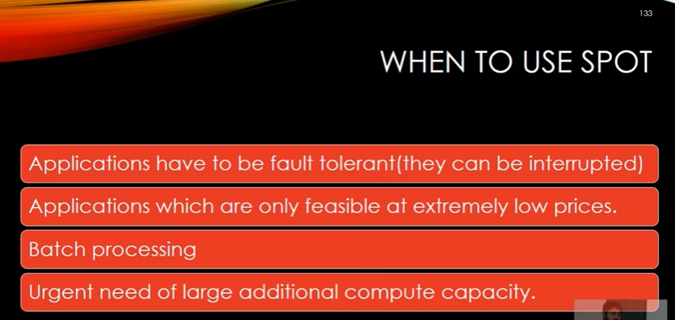 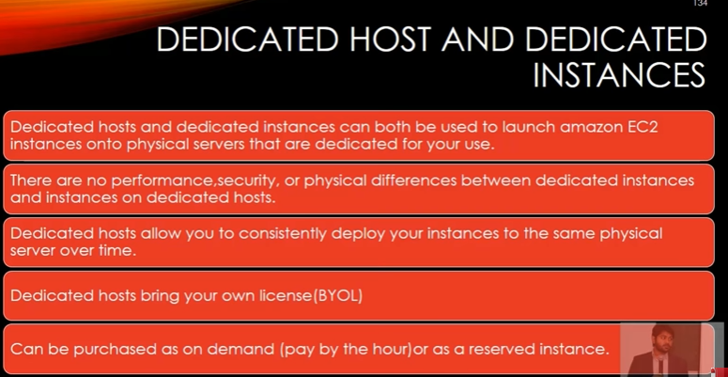 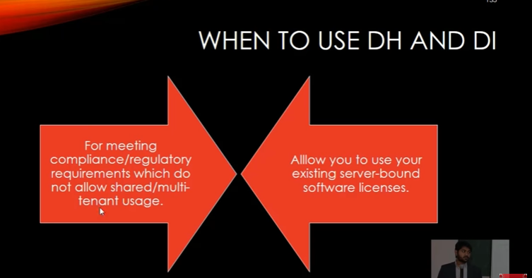 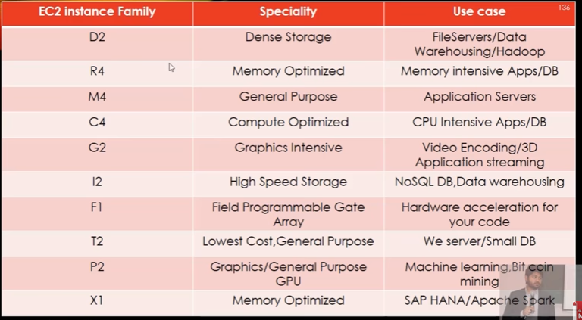

**How to launch Windows Instance in AWS:**

# How to attach extra volume in existing windows machine in AWS:

# Method 1 : On Instance creation time we create a separate volume (like 20gib)

# 

# Method 2 : After Instance creation we can create a separate volume by clicking Create Volume button

# 

# Once we click on Create Volume button a new window will be open:

# Fill all the required volume specification like Volume type, Size ,adding tag and then click on Create Volume button

# 

# Now we can see a new volume is created

# 

# Here we can see the 3rd volume that is available but not in use to make it in use we must have to attach this volume with the instance id

# Select Extended Volume 🡪Select Actions dropdown 🡪 select Attach volume 🡪 a new pop up will be come 🡪select our instance id 🡪click on attach button

# 

# Here all the volumes are in use now

# 

# Now let’s check from Server side :

# Go to server and after refreshing we can see now added volume is available there but that is offline it means that new added volume is not in use so to make it in use -> Select newly added volume 🡪 right click and Bring Online.

# 

# Once it is online we can just create a new volume for that newly added volume

# 

# After that we can see one new storage volume is added and we can create folder and start working on that …

# Amazon VPC | Creating VPC,Subnets,Route table,IGW:

# VPC : Virtual private Computer

# How to Create a VPC :

# First we create VPC

# Step 1 : Goto services🡪 Networking & Content Delivery 🡪 VPC

# Note : Here we can see for each region there is only one VPC but there could be multiple availability zone in a region . for each availability zone there will be one Subnet.

# Step 2 : Goto Your VPCs 🡪 in this tab you will see one default VPC available there.

# 

# To create your own VPC click on Create VPC button and a new pop up will open up :

# 

# Note 1 : In IPV4 CICDR block we create private ip like 10.0.0.0 and it must be ended with /16(slash 16) otherwise it will give error message . This /16 means 16 bit is reserved for this private ip network and remaining 16 is reserved for host.

# Note 2 : Tenancy we must have to select default otherwise if we select Dedicated it will be payable

# VPC is now created. Once VPC is created we have to create Subnet.

# Step 3: Click on Subnets : here it will show three already available subnets (because in London zone there are three availability zone are there) and top of that a Create subnet button is available.

# 

# Click on Create subnet button a new window will be open

# 

# Putting /24 means 24 bit is reserved for network and remaining 8 bit is for host.

# Create Internet Gateway:

# A default internet gateway is already available there but we create a new one

# By just clicking on button Create internet gateway

# Once this gateway is created it comes in detached state so we must have to attach this new gateway with MyVPC(own created VPC)

# Routing Table :

# There are by default two routing table are already available there. But we create one more route table by just clicking on button Create route Table

# Once rout table is created we must have to associate with subnet

# 2 VPC with in a Region | How to Setup AWS VPC Peering :

# We create two VPCs : VPC1 & VPC2 in both VPC creation we follow all previous task like Creating VPC 🡪 Sunbet 🡪 Internet gateway 🡪 route table and configuring routetable

# Then we need peering connection to communicate both VDC

# Goto Peering connection 🡪 Create peering Connection button

# A new window will be open in which one VPC will be treated as requester and other will be Accepter

# 

# Note : If Both VPCs are of same account i.e my account then select My account radio button but we can peer two VPCs of two another account also on that case we have to select Another account radio button .and the same thing is applied for two different regions VPC also.

# Now Peering is created between two VPCs but it still showing that request is pending so it will be accepted by clicking on Action dropdown -> select accept request button

# Now Peering is shown in active state.

# Now to Test the communication between two VPCs create two EC2 instances one is in VPC1 and second one is in VPC2.

# AWS-VPC Peering across Two Region | Cross-Region VPC Peering:

# Create 1 VPC in One region :

# Create VPC 🡪 create subnet with id 10.0.0.0/16🡪create internet gateway 🡪 create route tables :- in route table we add routes for internet connection(edit routes and add it with internet gateway on id 0.0.0.0/0) and associate newly created subnet .

# Similarly create other VPC in Mumbai region and follow the same task

# Note : After creating route table we do two things :

# First select route button

# 

# Here local subnet is added but internet gateway subnet is not displayed here so we have to add newly created internet gateway

# To do so we click on edit route button and a new pop up window will be open like below:

# 

# Finally we have to associate the subnet with this one.

# Click on Subnet Association button: Add the newly created subnet

# Create two EC2 instance one in Mumbai region and other is in London region.

# Note : On Creating Configure Security for both the EC2 instance we must add one more rule ICMP rule Ipv4 to connect between two different regions.

# 

# Our Two VPC are ready and started on two new instances ie two different machines

# Now our task is to peer them : We can create peering from any of two locations . goto Peering connection tab a new window will be created and fill the requester and accepter region and click on create peering submit button . now peering is created.

# Last thing : We have to make aware about subnet of peering connection so we have to add CIDR of both region in Routing table

# i.e under Route table of London we have to add CIDR of Mumbai and vice versa.

# 

# 

# 