**Git & Github**

**What is Git ?**

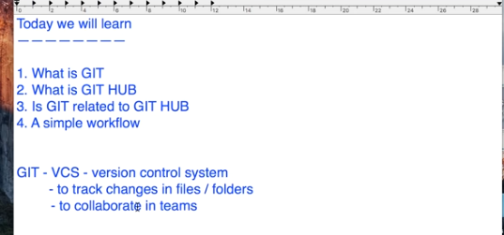

* Git is free and open Source

There are two types of VCS

Centralised VCS & Distributed VCS :

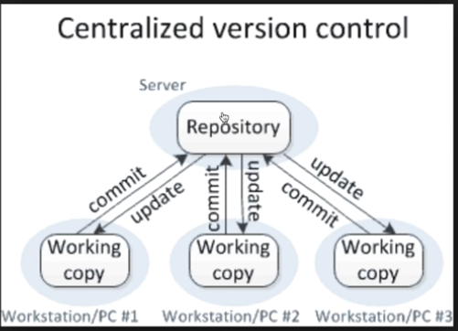

**Disadvantages of Centralized VCS :**

There is a single repository place in the server so if anything goes wrong with repository it will difficult to maintain us the backup and bring the repository to normal position. Also all the working team people have to online to collaborate with the server.

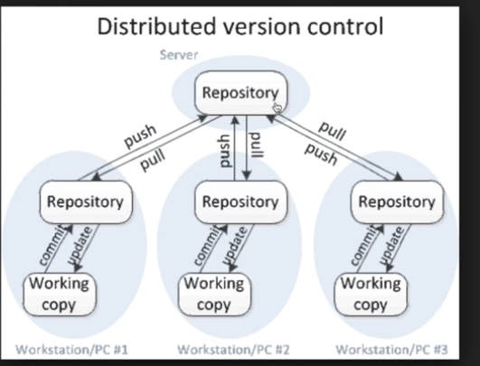

**Advantage of Distributed VCS :** If something wrong happened with Server then we can take backup from any local system because this is the complete copy of repository. Second advantage is you have no need to be online every time. You just take the copy and work offline in your local mode and you need internet connection only when you are needed to push/pull the changes.

Eg : Git is Distributed VCS.

-------------------------------------------------------------------------------------------------------------

**What is Git Hub?**

Git hub is website to upload your repository online

Advantages :

* It provides backup of your repository on the cloud
* It provides visual interface to your repository
* It makes collaboration with all the team mates as well as other people easier.

**Is Git related to GitHub?**

**Ans🡪**  **Git != Github**

* Git is a VCS where as Github is a website to upload repository online
* Github can be used with any VCS like Git or SVN and similarly Git can also be used with any version control management system like Github or Bitbucket or anything else .

**Workflow :**

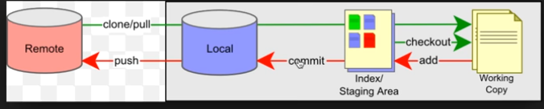

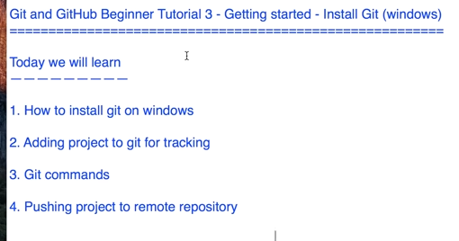

1. **how to install git on windows :** <https://git-scm.com/>
2. **Adding Projects to git for tracking :**

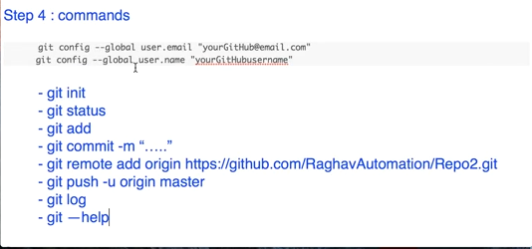

**Step 4 : Pushing project to remote repository :**

**git remote add origin https://github.com/deepakkumar-100/Study-material.git**

**git push -u origin master**

**Branching and Merging :**

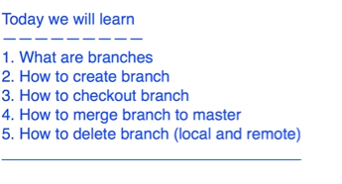

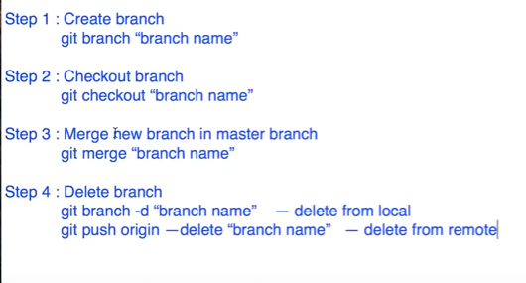

**Imp Note :**

1. If we want to merge any branch with master first we checkout master branch (**git checkout master** ) then only we run the merge command (**git merge MyNewBranch**) .after merging to master we must push into master branch **(git push –u origin master).**

* Now both our **master** as well as **MyNewbranch** is equivalent and in sysnc**.**

**How to delete branch :**

**git branch –d MyBranchName** : it will delete our branch from local only

**git push origin** –delete MyNewBranch : it will delete our branch from remote

# How to send email from GitHub:

# 

# Git Tags - what, why, when and how:

# 

# 

# How to create tags in Git ?

# 

# Note : we can create an annotated tag also by using command

# git tag –a v1.1 –m “tag for release version”

# The previous tag was a light weight tag and this is an annotated tag. The difference between both the tags is in an annotated tag we can give some message and will also contain some message having all the information about tagger and it will be stored as a complete git object in git repository.

# 

# The above delete tag will delete the tags from our local only

# 

# 

# How do you Checkout tags in Git ?

# 

# 

# How to Commit, Push, Pull from Eclipse to GitHub?

# 

# 