PROCESS CREATION AND TERMINATION SYSTEM CALLS

Name: Deepak Kumar roll no. 2019418

* ABOUT THE CODE

LINES 1 - 48

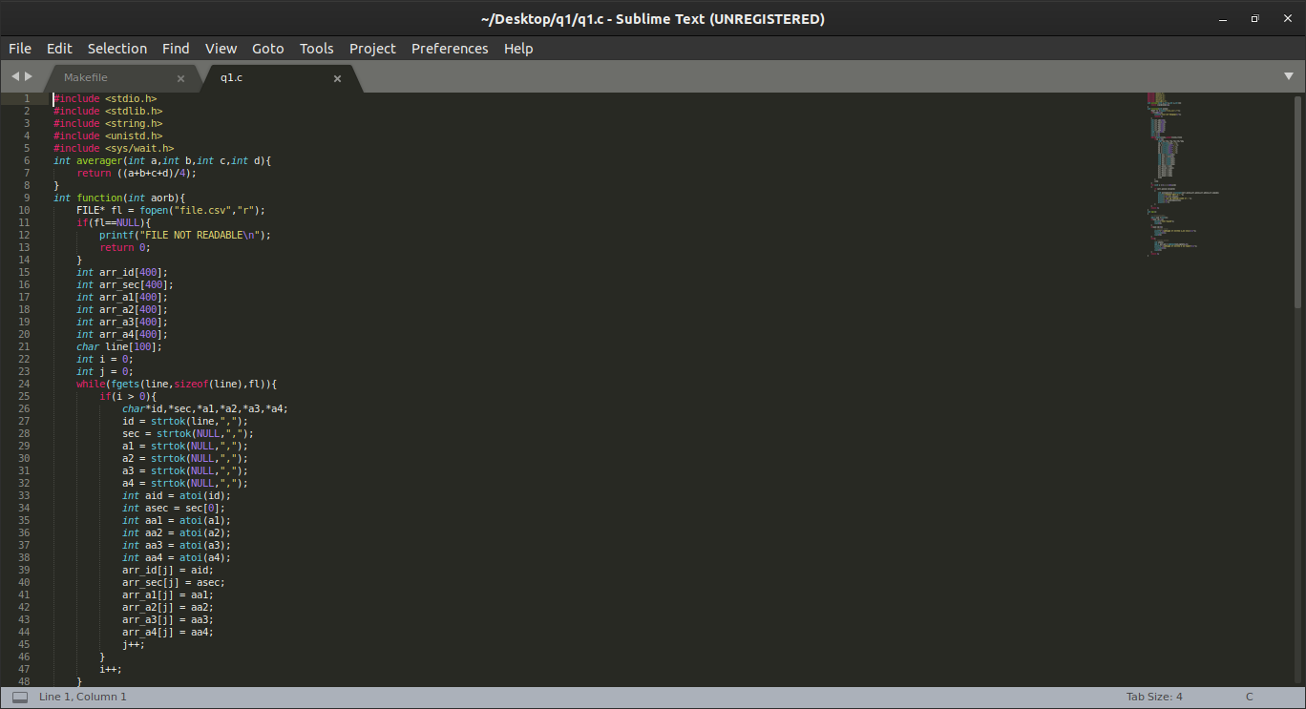

In the lines 6-8 a function has been created that returns an average score of students.

In the lines 9-62 it is our main code where we read the csv file and save those as integers in integer array.

The sections are also converted to their ascii codes and entered into an integer type array.

65 - A

66 – B

After all data has been saved as required.

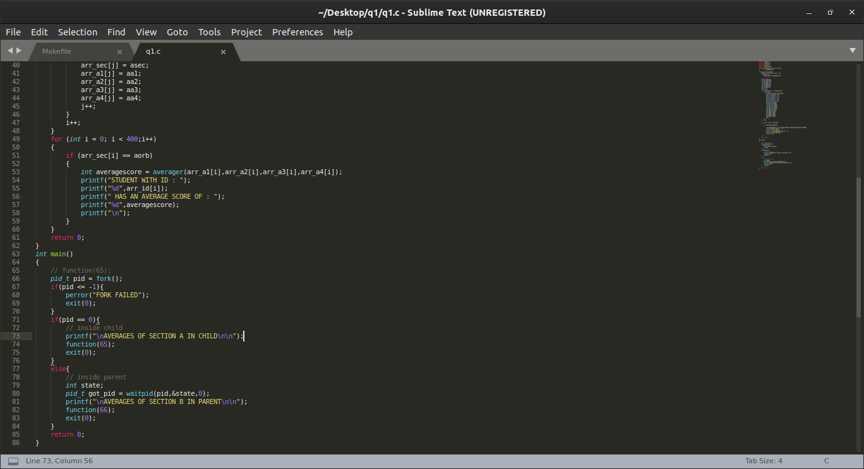

we run a loop and according to the input which can be 65 or 66 we find the required positions and their average scores and print the student ids and averages.

In the main function we make our fork in line 64 and if the fork returns -1, we give an error that fork is failed.

If 0 is returned it means we have entered the child and print the averages for section A.

In else statement

When the child work is done the we run the function for 66 that means for B.

This is done by waitpid which helps the child process to first complete and then parent process to work.

* IN MAKE FILE

In make file we run gcc for the code and execute the output.

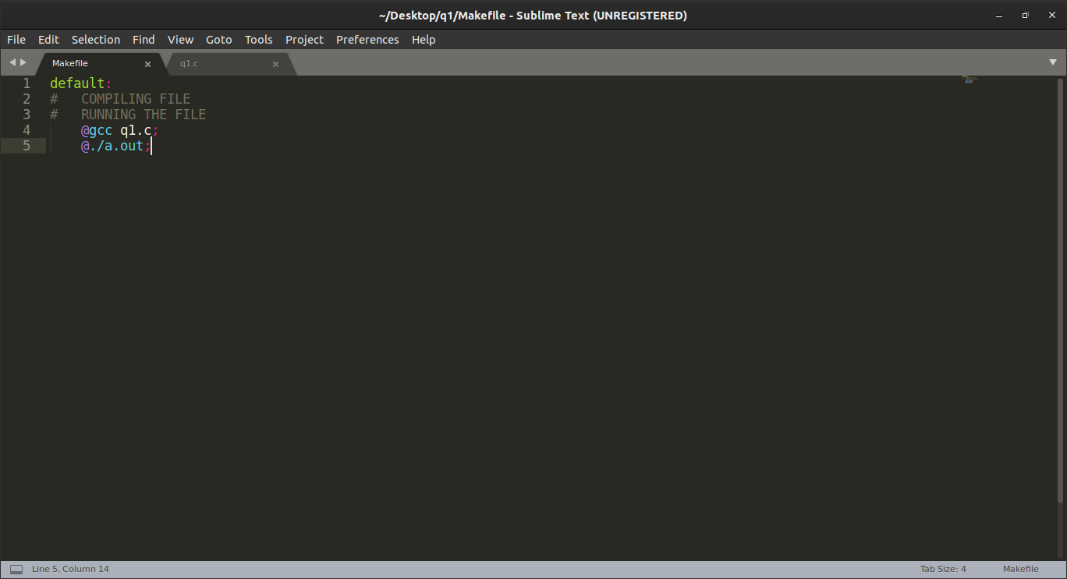

* OUTPUT

In the output file we get first the outputs for section A and then for section B as the child process will first complete and then the parent will work.

