Basic Linux/Unix shell

Name: Deepak Kumar roll no. 2019418

* ABOUT THE CODE

I have written external function in different c files.

2019418_cat.c

2019418_date.c

2019418_ls.c

2019418_mkdir.c

2019418_rm.c

My internal functions are inside 2019418_shell.c , those functions are cd , echo , history , pwd , exit.

This is my make file

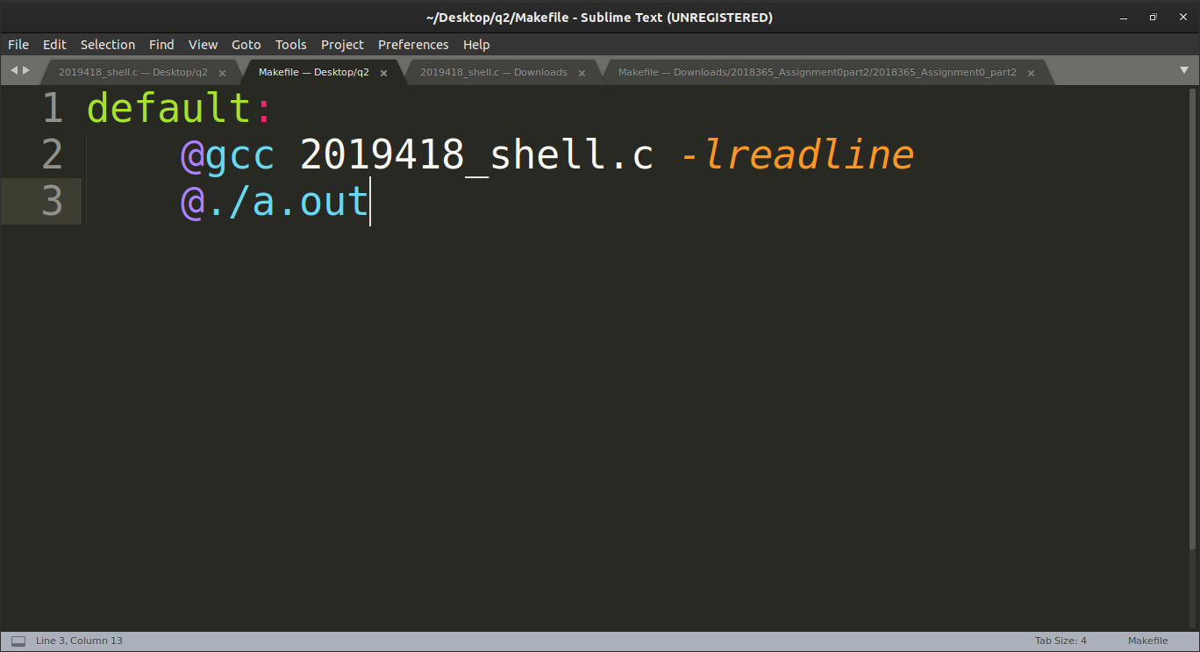

* Explaining all functions:

Cat – cat is used to display all files.

Eg – cat a.txt

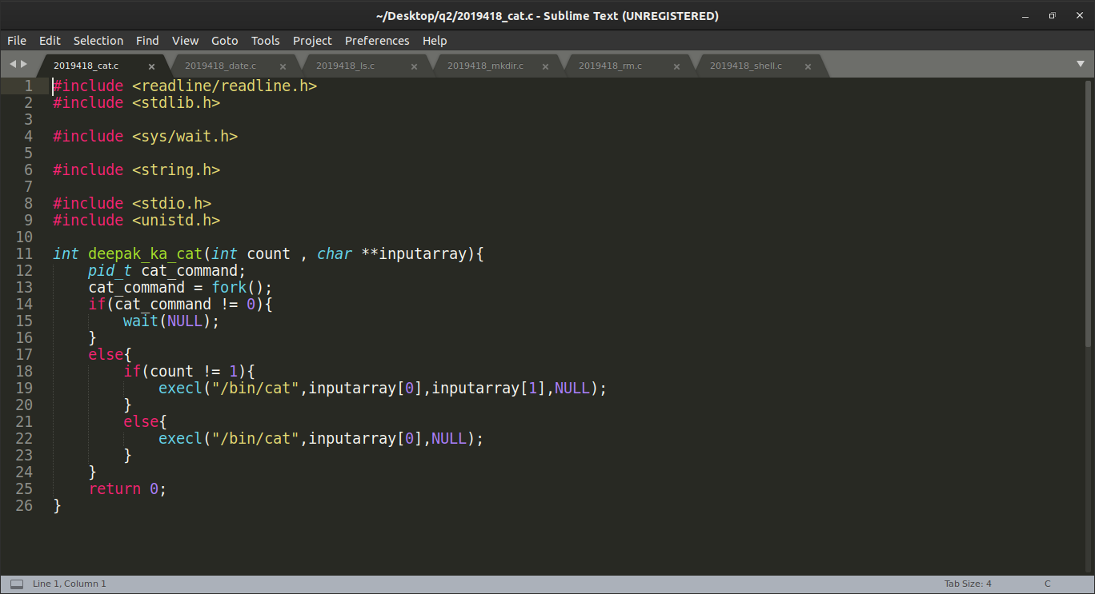

Date – date is used to display the current date and time.

Eg – type date in shell

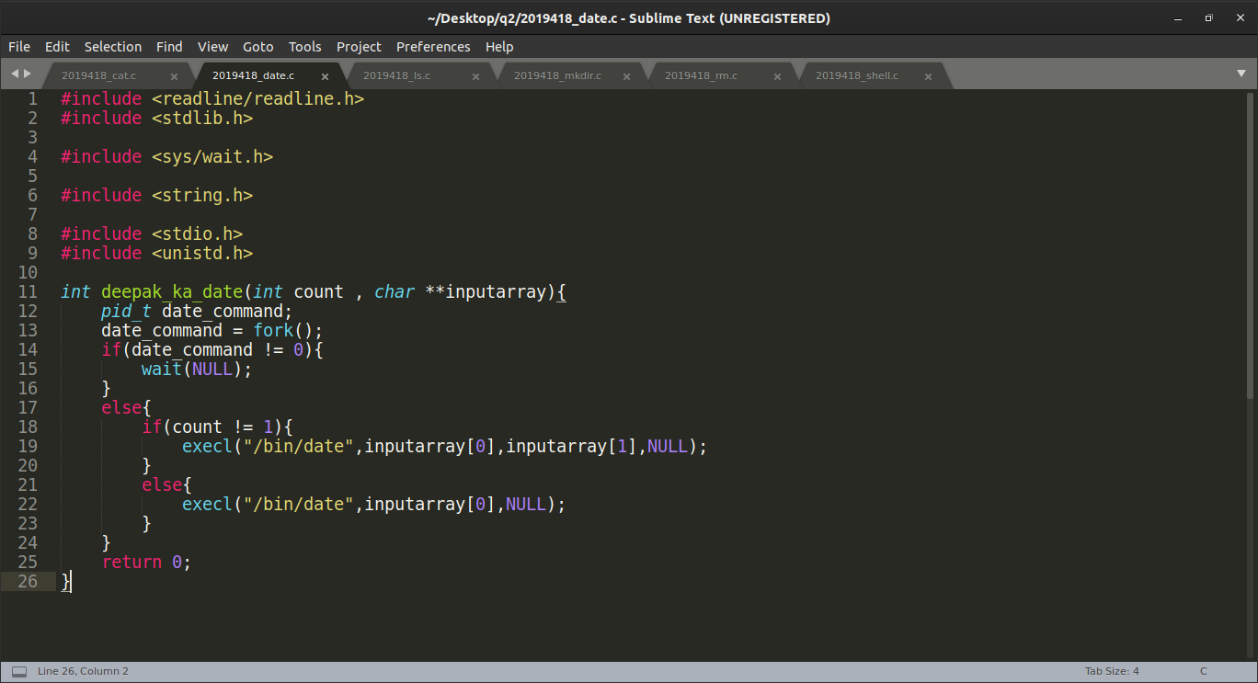

Ls – ls is used to get list of all the files in current directory.

Eg – if two files a.txt and b.txt is present in current directory then type ls in shell and it will display a.txt and b.txt. 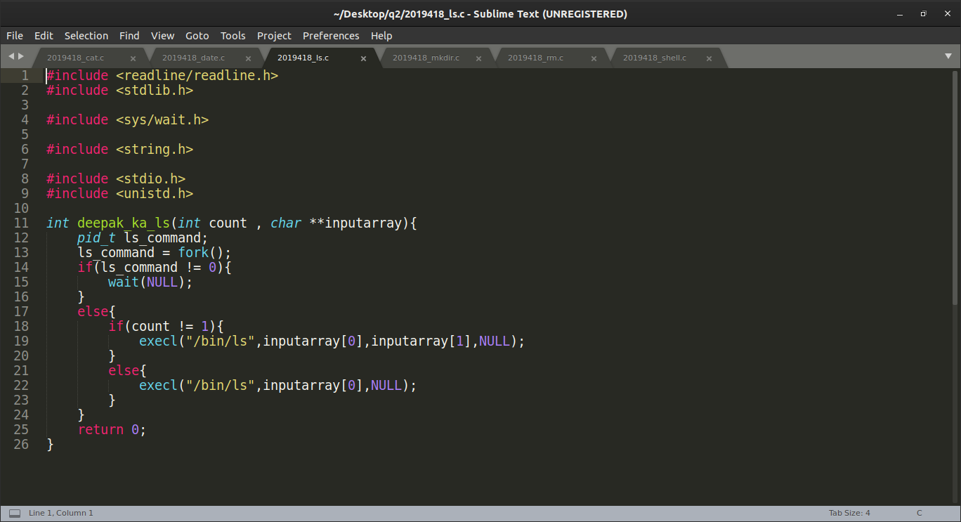

Mkdir – mkdir is used to make a new directory.

Eg. mkdir newdict

This makes a new directory newdict in current directory. 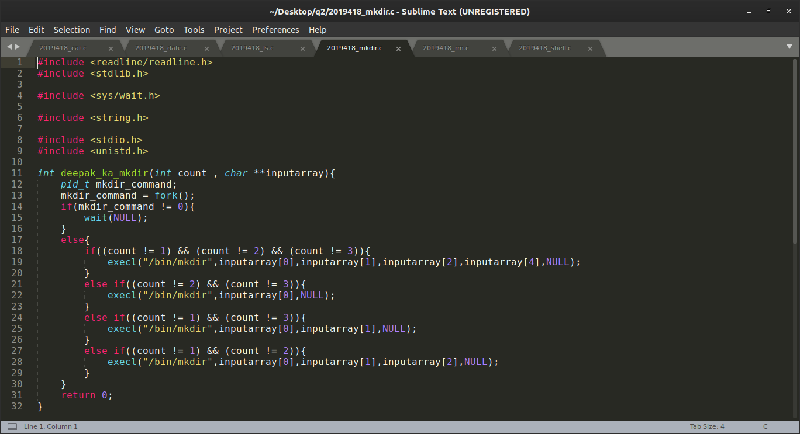

Rm – rm delets a file. 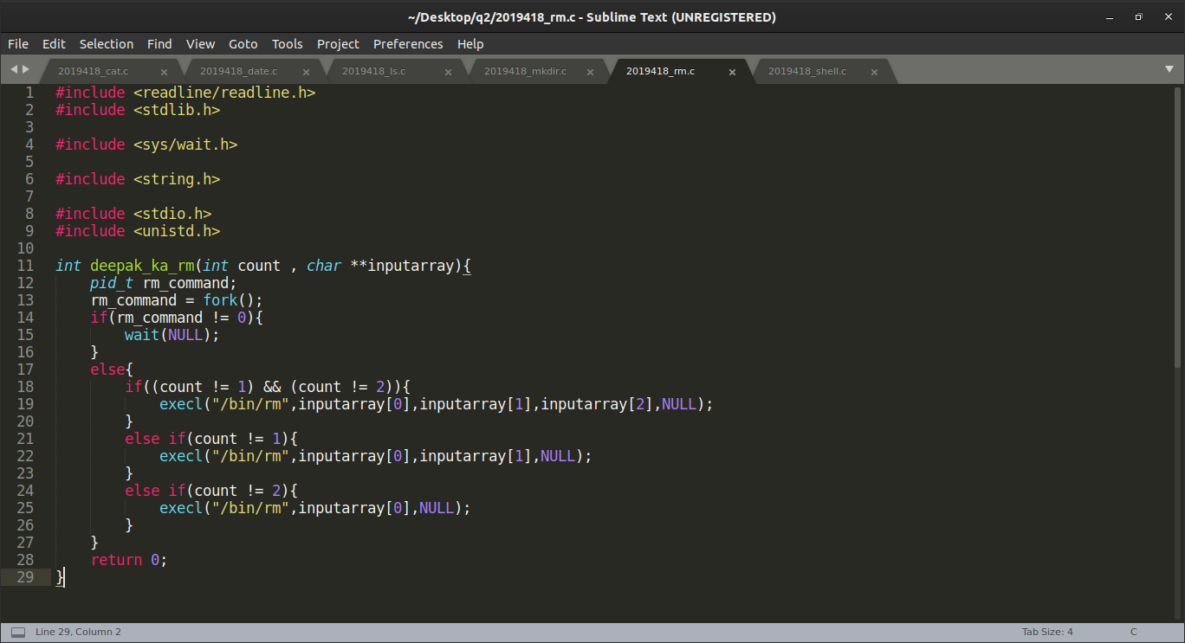

Eg – rm a.txt

This will delet a.txt from current directory.

Cd – cd is used to change directory.

Echo – echo is used to print something on shell.

Eg – echo doremon

Will print doremon on shell.

History – history tells which all commands are used till now.

Eg – if we used ls till now then history command will tell us ls is used

Pwd – pwd tells the full path of current working directory.

Exit – exit is used to exit the shell and end all tasks going on.

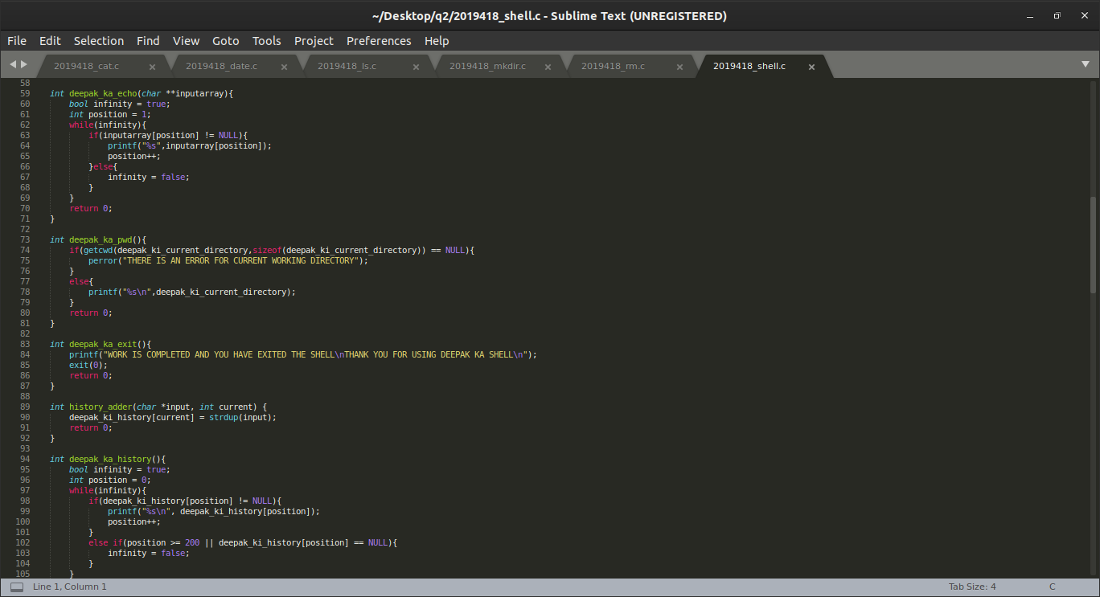

* OUTPUT FOR VARIOUS INPUT

