Day 2 JS tasks:

1. The modern mode, “use strict”:

Task 11:

        a=10;

        console.log(a);

o/p:

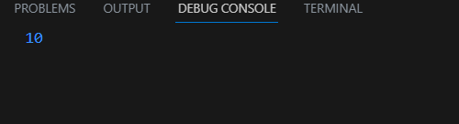

Task 12:

       "use strict"

        a=10;

        console.log(a);

o/p:

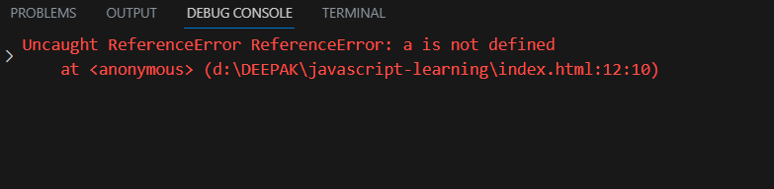

Task 13:

        "use strict"

        let a=10;

        delete a;

        console.log(a);

o/p:

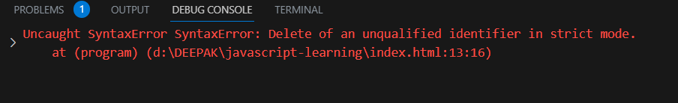

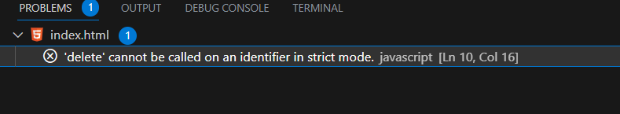

Task 14:

        a=10;

        "use strict"

        console.log(a);

o/p:



Task 15:

        "use strict"

        let var=10;

        console.log(var);

o/p:

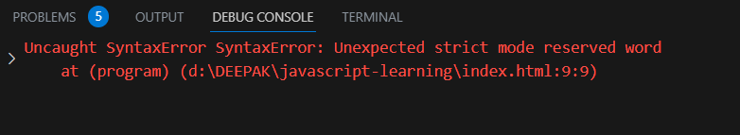

2. Variables:

Task 16:

           // console.log(a);//Cannot access 'a' before initialization at <anonymous>

            let a=10;

            const PI=3.144444;//used for constant value for examples color code ,mathematical constants etc..

            console.log(b);//undefined

            var b=20;

            var b=90;//we can reassign and redeclare a variable using var but it is not preferrable because a variable can be used before declaring it while using var

            console.log(a);

            console.log(b);

            console.log(PI);

o/p:

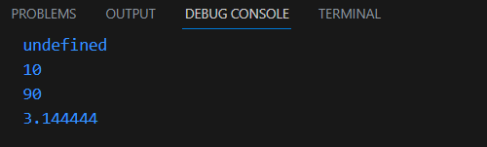

Task 17:

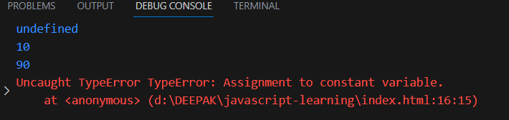

Task 18:

            let a;

            const PI=3.144444;

            var b=90;

            console.log(a);

            console.log(b);

            console.log(PI);

o/p:

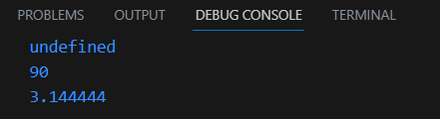

Task 19:

            let name="deepak";

            let id=123;

            let status=true;

            console.log(typeof(name));

            console.log(typeof(id));

            console.log(typeof(status));

o/p:

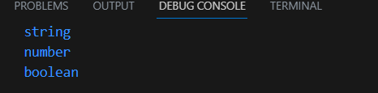

Task 20:

        let name1="deepak", status1=true;

            console.log(typeof(name));

           console.log(typeof(status));

o/p:

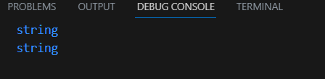

Day 3:

Task 21&22:

<script>

        let strng="deepak kumaravelu";

        let num=123;

        let boo=true;

        let obj=null;

        let undef;

        console.log(typeof(strng),typeof(num),typeof(boo),typeof(obj),typeof(undef));

    </script>

o/p:

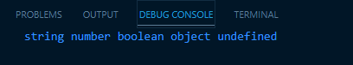

Task 23:

let $;

        console.log(typeof($));

o/p:

undefined

Task 24:

let stat=null;

        console.log(typeof(stat));

o/p:

object

Task 25:

if(true){

            let a=10;

            console.log(a);

        }

        console.log(a);

o/p:

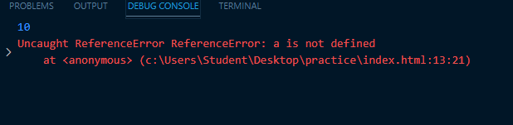

if(true){

            var a=10;

            console.log(a);

        }

        console.log(a);

o/p:

10

10

Task 26:

 let a="123";

        console.log(typeof(Number(a)));

o/p:

number

let a="123"\*1;

        console.log(typeof(a));

o/p:

number

Task 27:

   let a=true;

        console.log(typeof(String(a)));

o/p:

string

console.log(typeof(Boolean(String(a))));

o/p:

Boolean

Task 28:

let a=10,b=20;

        console.log(a+b,a\*b,a-b,a/b,a%b);

o/p:

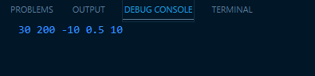

Task 29:

 let a=10;

        console.log(a++);

        console.log(++a);

        console.log(--a);

        console.log(a--);

o/p:

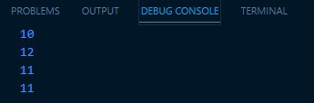

Task 30:

 let a=10,b=20;

        console.log((a+b)/a+40\*2);

o/p:

83