JavaScript Tasks

1. An Introduction to JavaScript

Task 1:

Index.html

<!DOCTYPE html>

<html lang="en">

<head>

    <meta charset="UTF-8">

    <meta http-equiv="X-UA-Compatible" content="IE=edge">

    <meta name="viewport" content="width=device-width, initial-scale=1.0">

    <title>Document</title>

    <script src="script.js"></script>

</head>

<body>

    <form>

        <button type="button" onclick=func()>Click me</button>

    </form>

</body>

</html>

Script.js

function func(){

    alert("Hello world");

}

o/p:

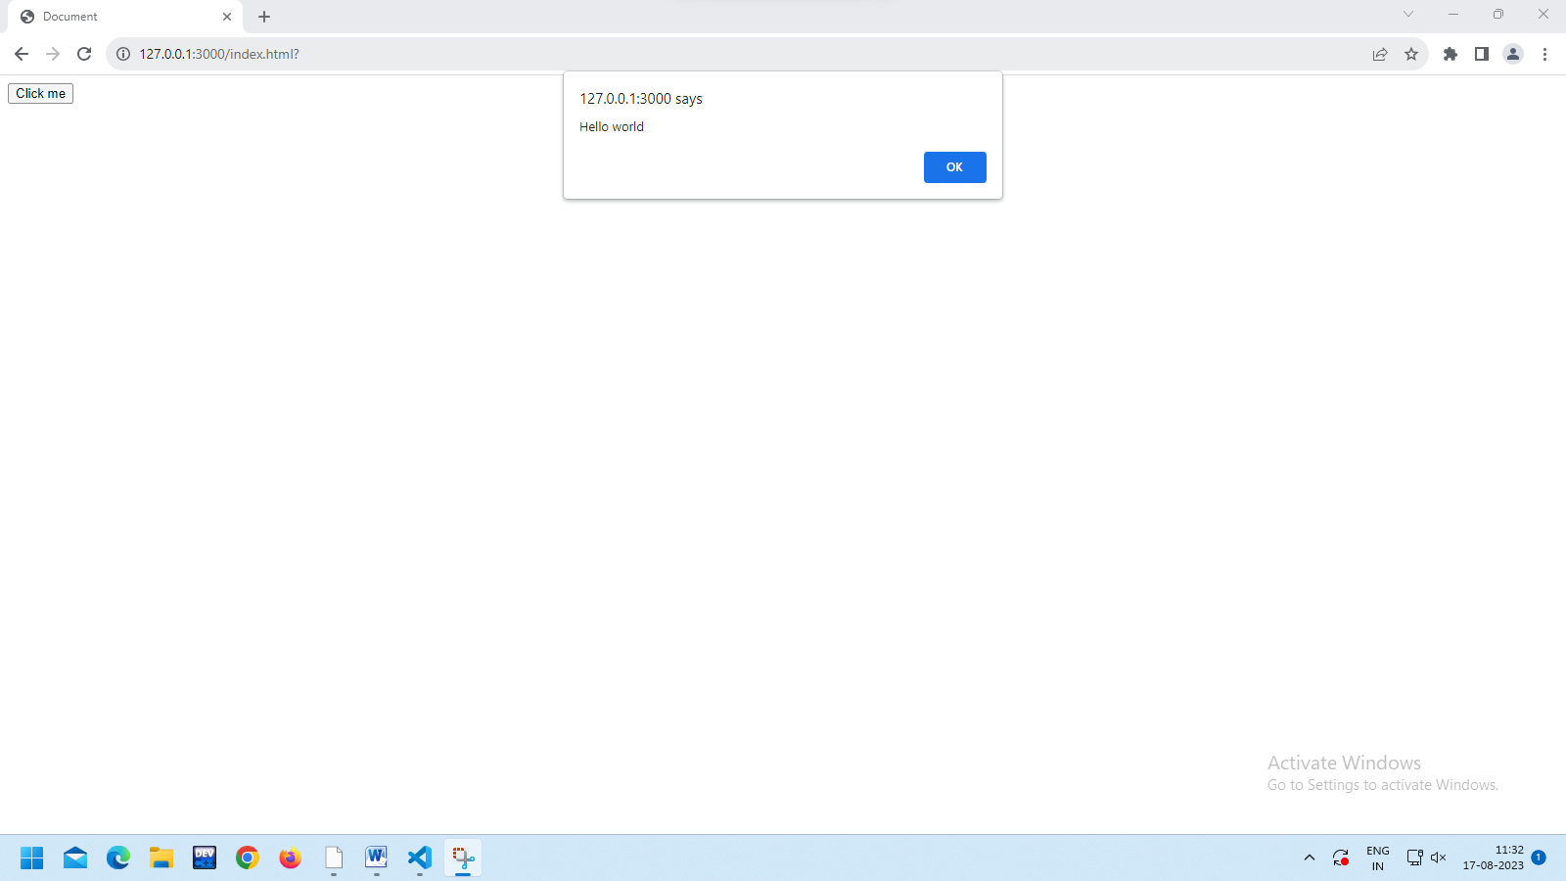

Task 2:

let nam="deepak";

let id=004;

console.log(nam);

console.log(id);

o/p:

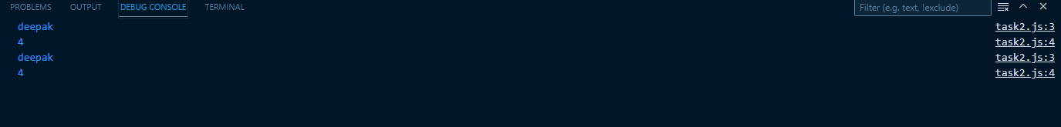

Task 3:

let a=2;

let b=4;

console.log(`multiply ${a*b}`);

console.log(`division ${a/b}`);

console.log(`power ${a**b}`);

console.log(`addition ${a+b}`);

console.log(`subtraction ${a-b}`);

o/p:

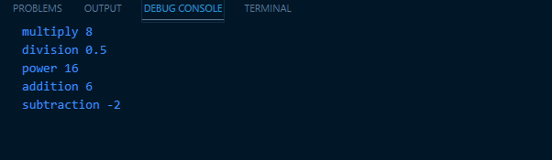

Task 4:

let greet="hi Mr.";

let name="Deepak";

console.log(`${greet}${name}`);

console.log(greet+name);

o/p:

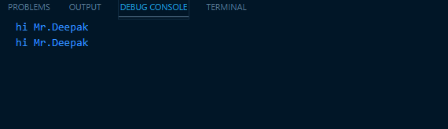

Task 5:

let nam="danush";

let id=123;

let accno=123214342n;

let status_=true;

console.log(typeof(nam));

console.log(typeof(id));

console.log(typeof(accno));

console.log(typeof(status_));

o/p:

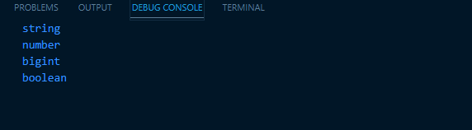

2. Code structure:

Task 6:

//this code is to add two numbers

let a=123;

let b=123;

console.log(a+b);

/* author:Deepak K

   date:17/08/2023

*/

Task 7:

let a=25

(a).toString()

console.log(a);

o/p:

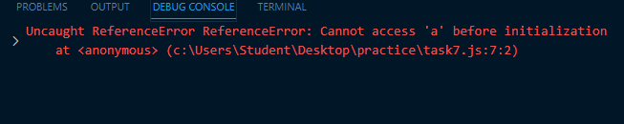

let a=25;

(a).toString();

console.log(a);

o/p:

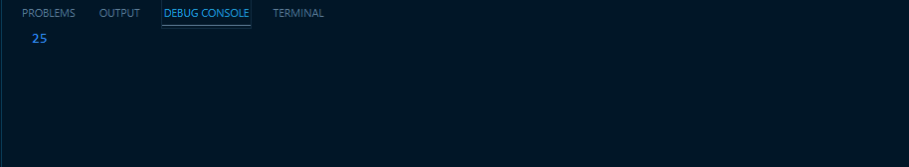

Task 8:

let a=1;

for(i=0;i<5;i++){

    for(j=i;j<5;j++){

        if(i==j){

        console.log(a++);

        }

    }

}

o/p:

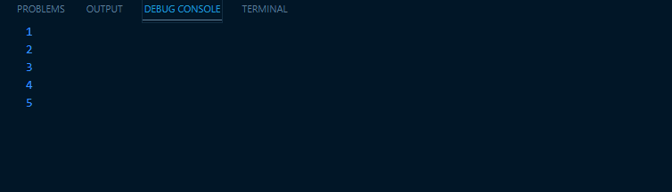

Task 9:

let a,b,c;

a=122;

b="abcdefg";

c=true;

console.log(a,b,c);

o/p:

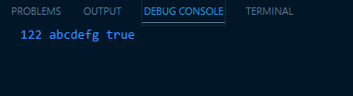

Task 10:

<body>

     <script>

        const button = document.getElementById("btn");

        button.addEventListener("click", function (e) {

            alert("The button is Pressed");

        });

    </script>

        <button id="btn">Click Here</button>

</body>

o/p:

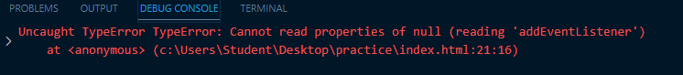

 <button id="btn">Click Here</button>

        <script>

            const button = document.getElementById("btn");

            button.addEventListener("click", function (e) {

                alert("The button is Pressed");

            });

        </script>

o/p:

