PROJECT SYNOPSIS

GGL E- Procurement

SYNOPSIS SUBMITTED FOR THE PARTIAL FULFILMENT OF THE
REQUIREMENT FOR THE BACHLOR IN COMPUTER APPLICATION

SUBMITTED TO
“BBD University”
LUCKNOW

SUBMITTED BY:
STUDENT NAME

(College Enrolment Number- XXXXXXX )
2021-2024



Under the Guidance of

Er. Brijesh Mishra

Senior Consultant
SOFTPRO INDIA COMPUTER TECHNOLOGIES (P) LTD

INTRODUCTION

Green Gas Limited (GGL) is a Joint Venture of GAIL (India) Limited [GAIL] and Indian Oil Corporation Limited [IOCL]. It has been incorporated for the implementation of City Gas Projects for supply of Piped Natural Gas (PNG) to domestic, commercial and industrial Consumers and Compressed Natural Gas (CNG) to automobile consumers in the cities of Luck now and Agra.

The Company i.e. Green Gas Limited is desirous for seeking for Design, Development, Hosting & Maintenance of the web portal for e-procurement of Green Gas Limited, Lucknow. GGL intends to outsource the services to help GGL substantially augment its image building endeavor amongst all stake holders viz. customers, investors, business partners, employees, business communities and the public at large and to bring it to a level commensurate with size and strategic importance of GGL and its role in CNG & PNG sector of Nation.

Objective:

- The foremost objective of this project is to provide single global platform to all consumer, their Vendors, agents and users to buy GGL Products respective properties.
- One of the objectives of this project is to give a different visualization to the portal which has more features, attractive animations and all together a new look in contrast to the already existing portals.
- The next objective of this project “to generate the jobs for the people” is to enable the job Seekers to search for jobs online.
- Registration of the Vendor and User.
- Web portal interface is required in order to provide the users to interact with the services in an efficient way. The display format must contain all the details about the CNG and PNG cost and their access points.

- The tenders Details should be uploaded without any difficulty by admin.
Business Needs:

Currently the organization is working in One Country: India. They are collecting the information provided by their different agents and after that we are storing the information related to the properties in the database. The client wanted to improve the productivity by providing the services of Online Registration of Vendors and related franchise. The primary goal of the client is to introduce a global concept of accessing the services that are CNG and PNG. It is responsible for storing all the details about the Bidder and Vendor The client wants to get the services of GGL on the single click event of the user.

Existing System Description:

GGL is currently discharging their services like registration, balance enquiry, card recharge, complains etc. annually which in turn is taking lots of time of the consumer as well as the officers present in the offices. This system also requires a lot of manpower to satisfy the consumers. This system also requires a separate management of records of the consumers which is a very cumbersome task.

The existing system has following drawbacks:
- Currently client does not have such portal that provides a single platform for all the users and centralizes all the information about available services.
- They don’t have centralized database to maintain information related to the consumer account, all the information needed about consumers are available in manual form.
- Actual owner registration for CNG card was not possible online. Only registrations can be done manually by visiting the GGL offices, increases the time and manpower.

Proposed System:

We proposed complete web application solution to create an “Online CNG Prepaid Card System Portal”. The iterative, time bound approach adopted by us to address the client requirements that are as follows:

Define To- Be processes:

- Come up with the solution of the existing problem
- Go through the regressive reviews by different business process
- Prepared user interface requirements

Develop High Level Design and Low-Level Design before Execution:

- Built and design all the processes required by Client
- Conducted survey of all consumers availing the facility.
- Developed the architecture of the Software Solution
- Developed the project design in detail for the software developer in company.

SOFTWARE REQUIREMENT FOR DEVELOPMENT:

User Interface Designing | HTML5, CSS3, Java Script, Bootstrap
Programming Language | Python with Django Framework
Database | SQLite3
IDE | PyCharm

Modules:

- Vendor Management Module
- Recruitment Module
- Tender Management Module
- Administrator module

Module Description:

Vendor Management Module:

This module helps the vendor to do the following activities such as he can register, view the available Tender, apply for the tender, the Vendor can update this/her profile which he has entered at the time of registration, the vendor can send his feedback regarding the portal or working, or related to tender etc., the vendor can also post his/her query regarding the Tender. The activities can be summarized as:
- Vendor can register
- View the tender
- Apply for tender
- Edit their profile
- Send feedback
- Send query

Recruitment Module:

This module provides the vendor to apply online for the job which are advertise on the GGL website and the vendor can also check the job details.
The activities can be summarized as:
- Apply online for the job
- View the job details

Tender Management Module:

This module provides the administrator to add the new tender which will carry the detail such as tender no, apply date, bidding date, eligibility criteria, document cost, work item etc. The administrator can delete the existing Tender or can update the detail of existing tender. The overall functioning of this module can be summarized as:
- Admin can add the Tender
- Delete the old Tender
- Update the Tender Detail

Administrator Module:

This module provides the administrator with the privileges to the following works such as he can approve the registered vendor, block the old vendor, Add the job detail or the detail regarding the new recruitment. The administrator can give the reply to the feedback send by the vendor and he can also post reply to the query of the vendor through mail. The overall functioning of this module is as follow:

- Approve the Vendor
- Block the Vendor
- Add the Job detail
- Reply for feedback
- Reply to query

HIGH LEVEL DESIGN:

Data Flow Diagram

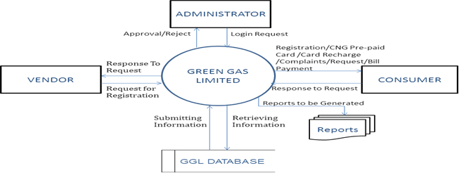

Entity Relationship Diagram:

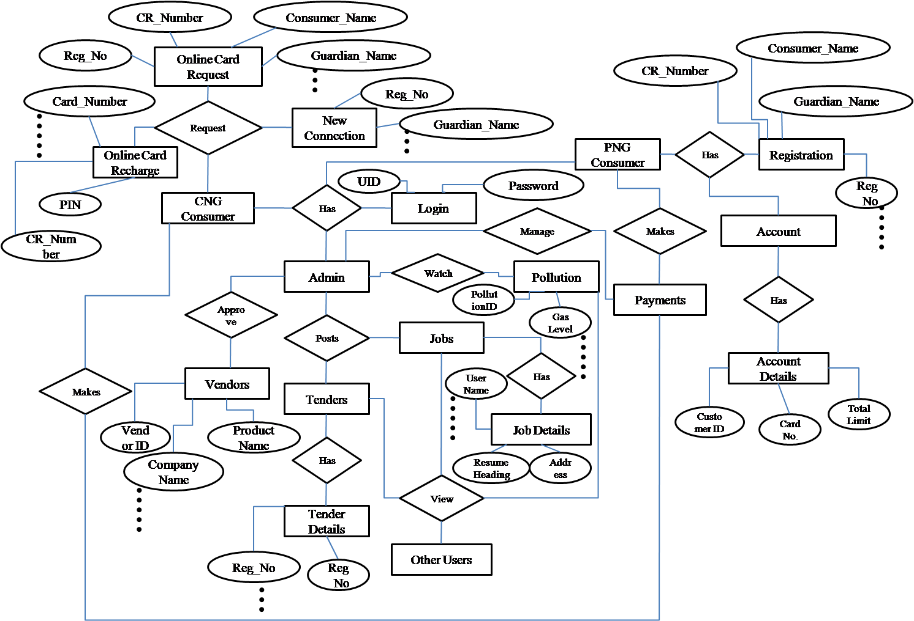

FUTURE SCOPE OF PROJECT:

The future scope of the Green Gas Limited (GGL) project is envisioned to encompass continuous enhancement and adaptation to emerging technologies, ensuring a cutting-edge digital platform for the dynamic needs of consumers, vendors, agents, and job seekers. The portal will evolve to integrate advanced features and functionalities, fostering a seamless and user-friendly experience. Continuous improvements in user interface design, incorporating innovative and attractive animations, will be a priority to maintain a modern and engaging online presence. The platform will extend beyond its current capabilities, providing an expanded range of services and information to stakeholders.
Future developments may include the integration of smart technologies for real-time tracking of CNG and PNG availability, optimizing user convenience. The job portal will be further refined, offering advanced search and application functionalities for job seekers. The portal will adapt to evolving industry standards and user expectations, ensuring that GGL remains at the forefront of the CNG and PNG sector. Additionally, the scope may encompass the incorporation of advanced security measures to safeguard sensitive information, as well as the exploration of mobile applications for enhanced accessibility. Regular updates, scalability, and flexibility will be key aspects of the project's future scope, ensuring its continued relevance and effectiveness in meeting the diverse needs of stakeholders in the rapidly evolving digital landscape.

