**Hospital Management System 🏥**

This is a **Java Swing-based Hospital Management System** that allows basic patient data management and room allocation. The system connects to a **MySQL** backend and provides a graphical user interface for hospital staff to use efficiently.

**🔧 Features**

* **Patient Management**
  + Add, update, and view patient details
  + Store check-in time and room allocation
* **Room Allocation System**
  + Automatically updates room status from Available to Occupied and vice versa when a patient is moved
  + View and assign room numbers
* **Billing Management**
  + Track amount deposited and calculate pending dues based on room price
* **User Interface**
  + Clean GUI built using Java Swing
  + Buttons: CHECK, UPDATE, BACK
* **Database Integration**
  + MySQL used to store patient and room data
  + JDBC used to connect Java application to the MySQL database

**📊 Technologies Used**

* **Java** (JDK 8+)
* **Swing** (GUI Framework)
* **MySQL** (Database)
* **JDBC** (Database Connectivity)

**📁 Project Structure**

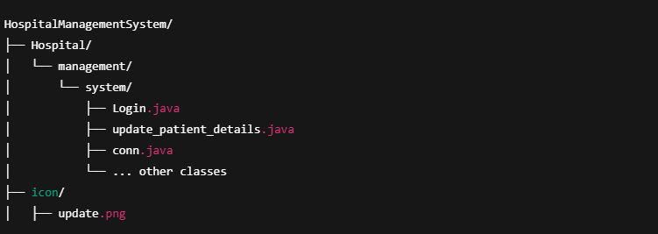

**🧪 Step-by-Step (in Java CMD style)**

**🟡 1. Open Command Prompt**

Navigate to the folder containing the Hospital directory:

Bash

* **cd C:\Users\YourUsername\Desktop\project**

**🟡 2. Compile All Java Files**

* **javac Hospital/management/system/*.java**

This compiles all Java source files inside the package.

**🟡 3. Run the Main Class**

Make sure the main class has a public static void main(String[] args) method.

To run Login.java:

* **java Hospital.management.system.Login**

Or to run update_patient_details.java:

* **java Hospital.management.system.update_patient_details**

**🟡 3. Set Up the MySQL Database**

* + Create a database (e.g., hospital_db)
  + Create tables like patient_info and room
  + Update database credentials in conn.java

**🟡 4. Run in Your IDE**

* + Open the project in IntelliJ / Eclipse / NetBeans
  + Run the update_patient_details main method.

**📸 Screenshots**

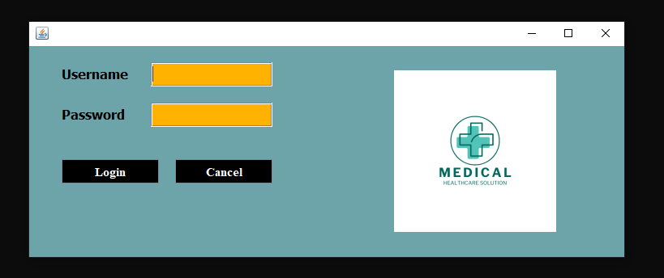**Login frame :**

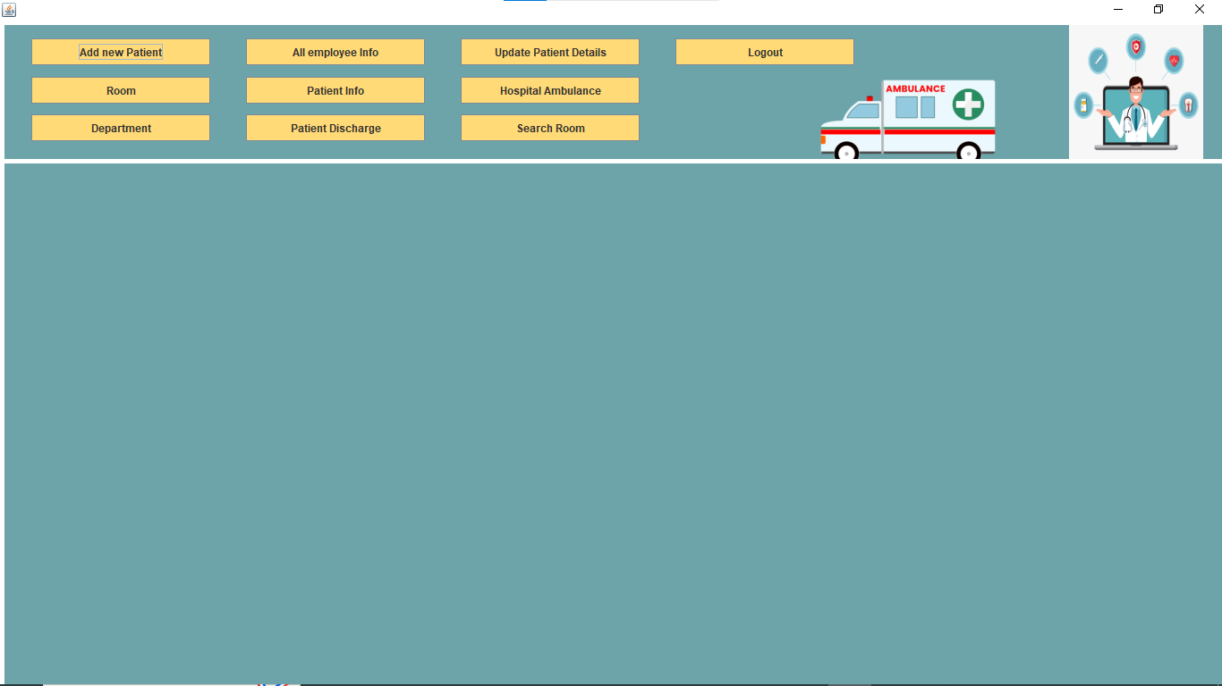**Dashboard frame :**

**Add New Patient Frame:**

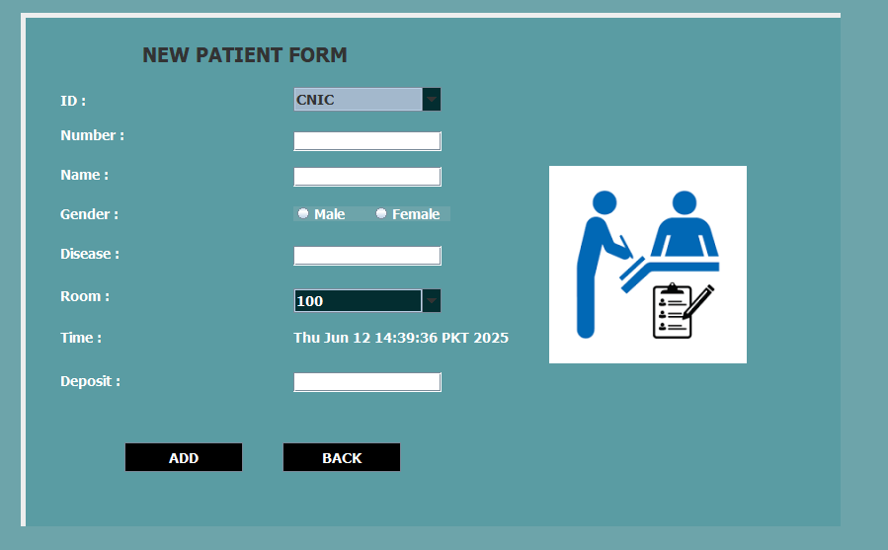

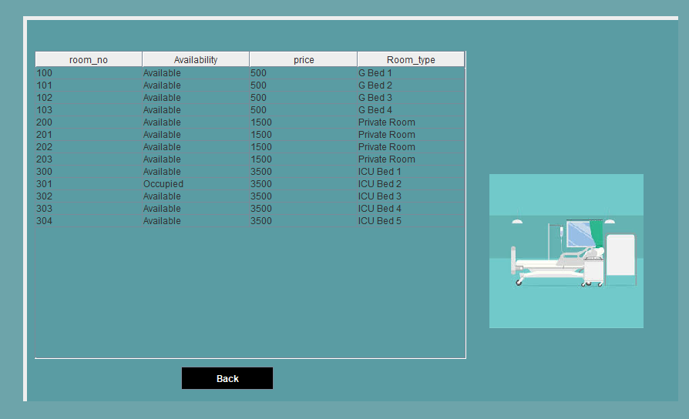**Room frame :**

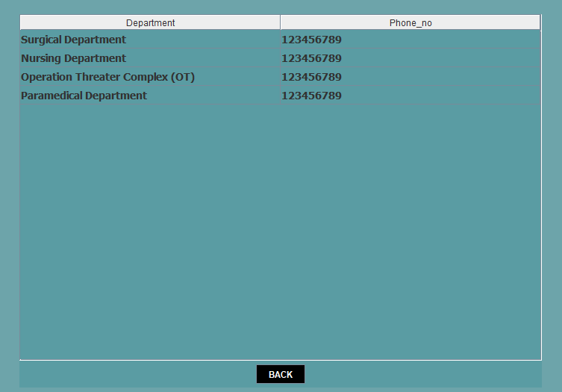**Department Frame :**

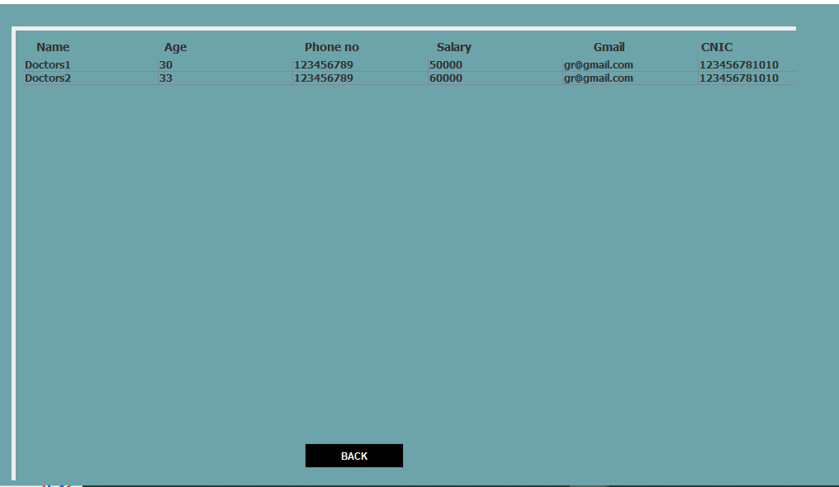**All Employee Info Frame :**

**Patient Info Frame :**

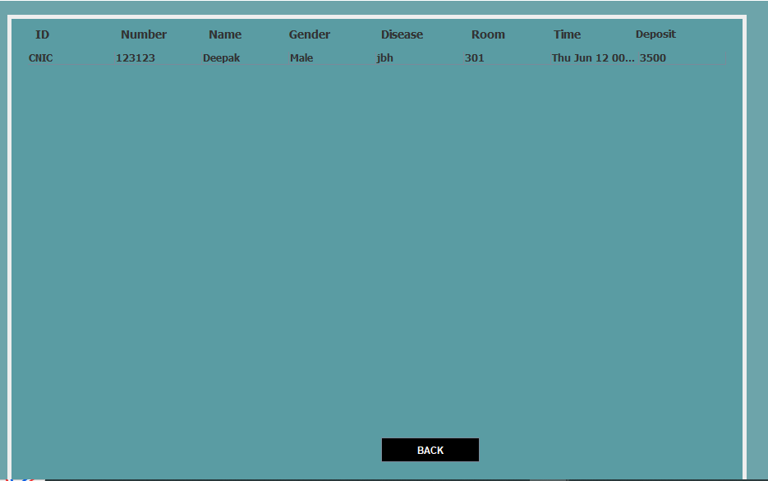

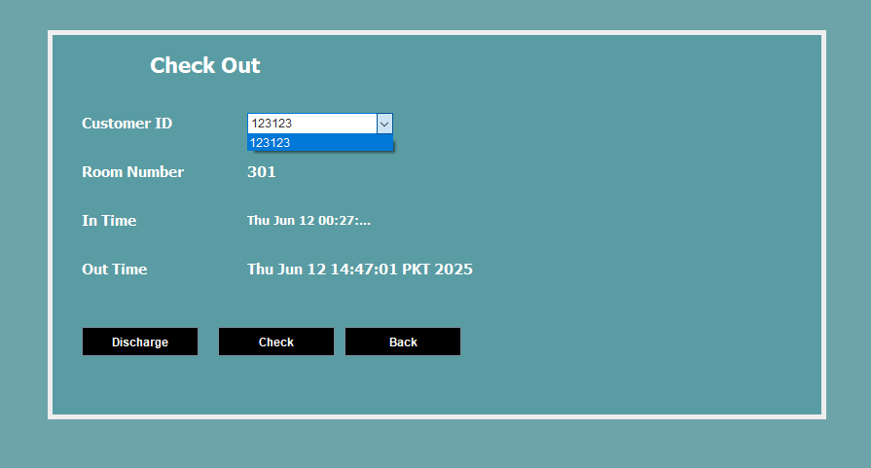**Patient Discharge Frame :**

**Patient Info Frame :**

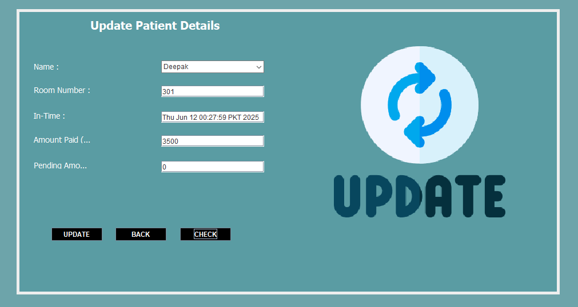

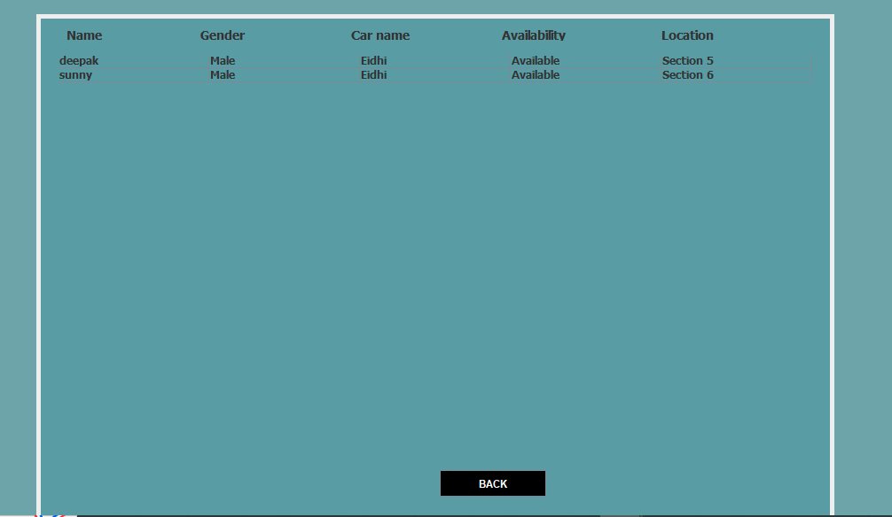**Ambulance Frame :**

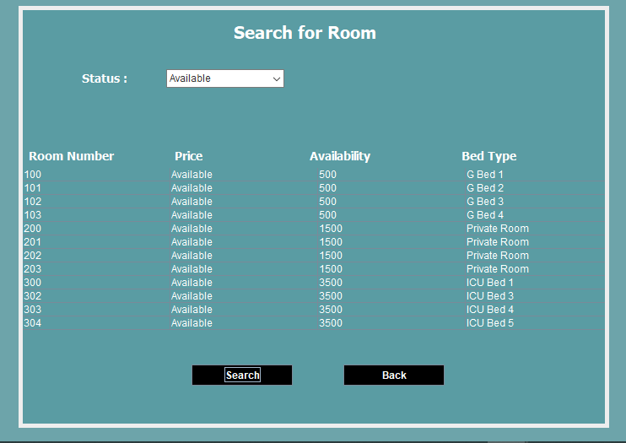

**Search Room Frame :**