Hospital Management System 🏥
This is a Java Swing-based Hospital Management System that allows basic patient data management and room allocation. The system connects to a MySQL backend and provides a graphical user interface for hospital staff to use efficiently.

🔧 Features
- Patient Management
  - Add, update, and view patient details
  - Store check-in time and room allocation
- Room Allocation System
  - Automatically updates room status from Available to Occupied and vice versa when a patient is moved
  - View and assign room numbers
- Billing Management
  - Track amount deposited and calculate pending dues based on room price
- User Interface
  - Clean GUI built using Java Swing
  - Buttons: CHECK, UPDATE, BACK
- Database Integration
  - MySQL used to store patient and room data
  - JDBC used to connect Java application to the MySQL database

📊 Technologies Used
- Java (JDK 8+)
- Swing (GUI Framework)
- MySQL (Database)
- JDBC (Database Connectivity)

📁 Project Structure
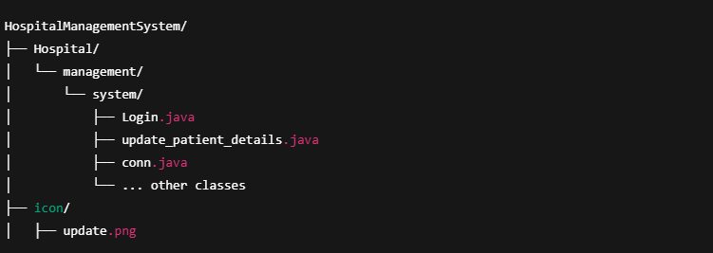
🧪 Step-by-Step (in Java CMD style)
🟡 1. Open Command Prompt
Navigate to the folder containing the Hospital directory:
Bash
- cd C:\Users\YourUsername\Desktop\project
🟡 2. Compile All Java Files
- javac Hospital/management/system/*.java
This compiles all Java source files inside the package.
🟡 3. Run the Main Class
Make sure the main class has a public static void main(String[] args) method.
To run Login.java:
- java Hospital.management.system.Login
Or to run update_patient_details.java:
- java Hospital.management.system.update_patient_details

🟡 3. Set Up the MySQL Database
  - Create a database (e.g., hospital_db)
  - Create tables like patient_info and room
  - Update database credentials in conn.java
🟡 4. Run in Your IDE
  - Open the project in IntelliJ / Eclipse / NetBeans
  - Run the update_patient_details main method.

📸 Screenshots

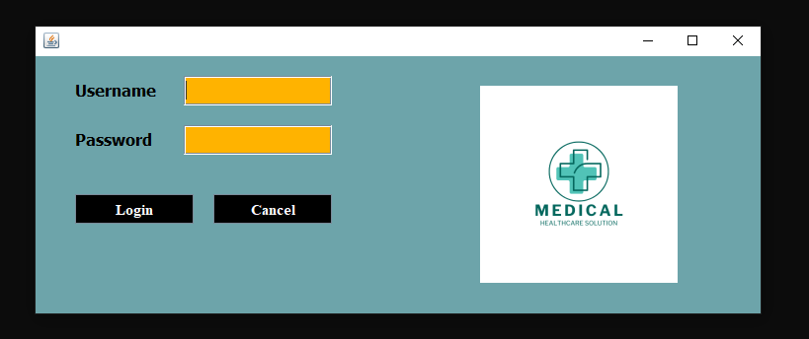
Login frame :

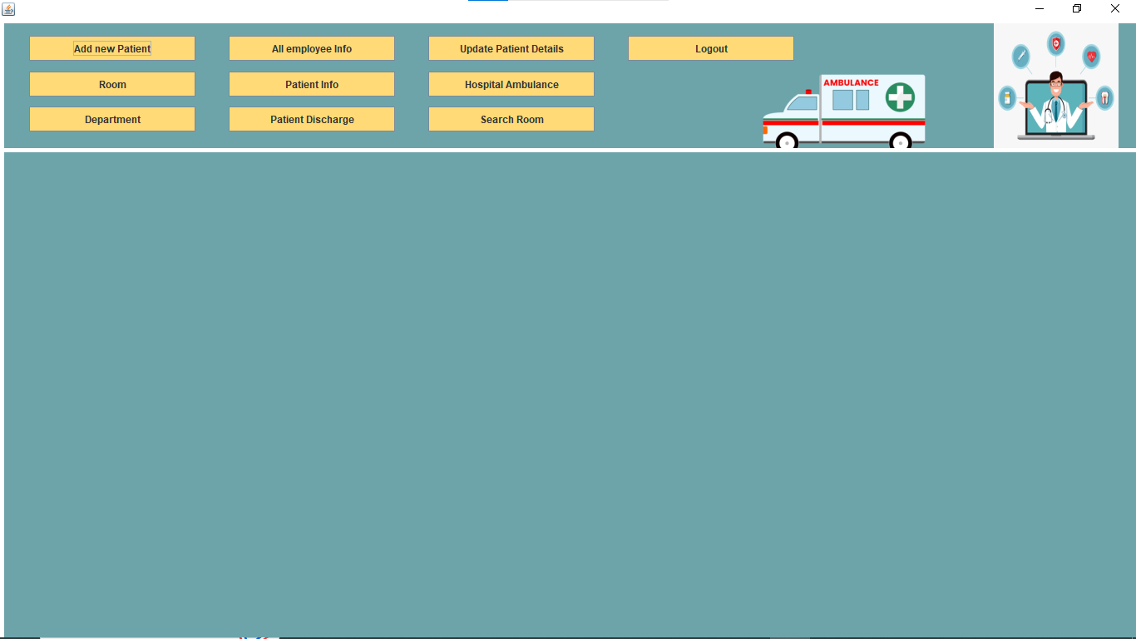
Dashboard frame :

Add New Patient Frame:
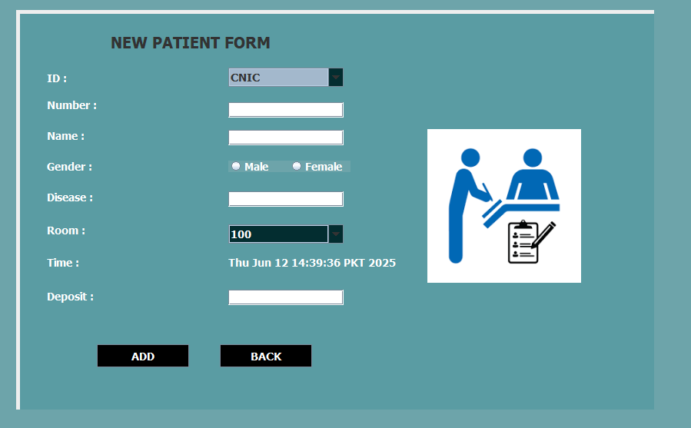

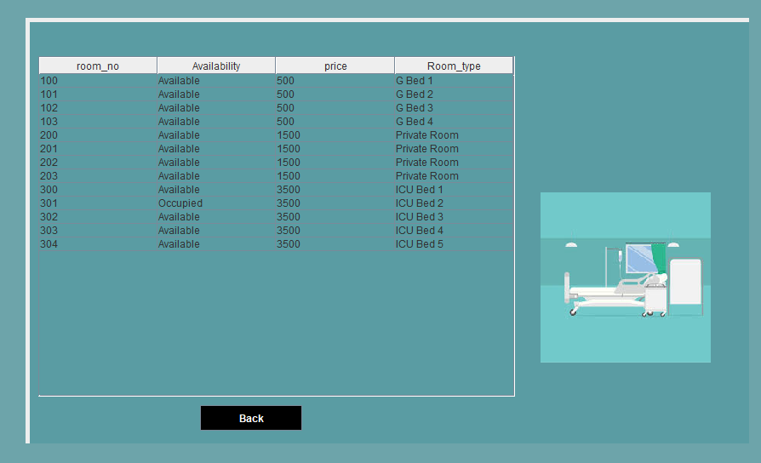
Room frame :

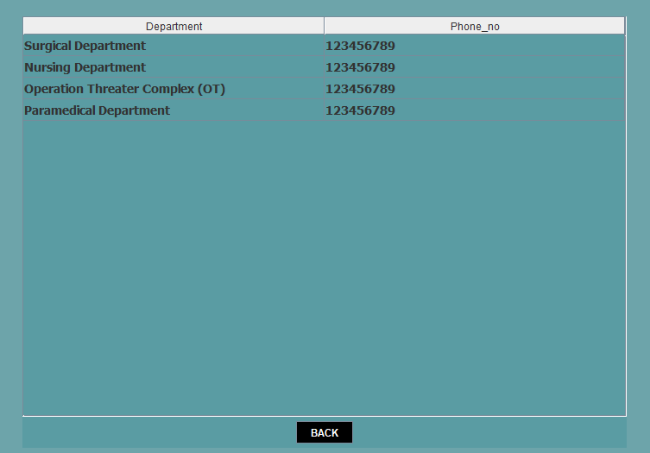
Department Frame :

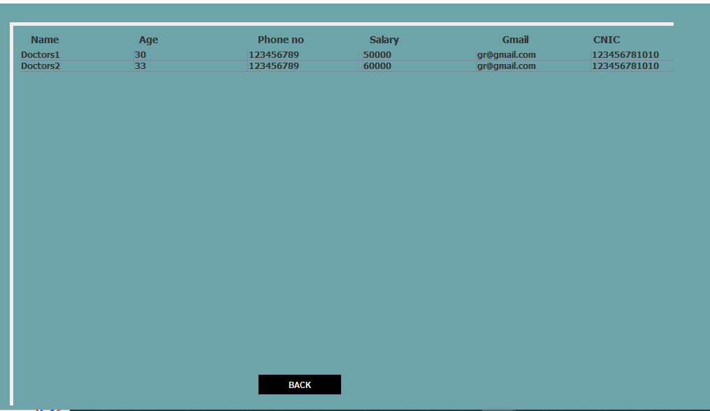
All Employee Info Frame :

Patient Info Frame :
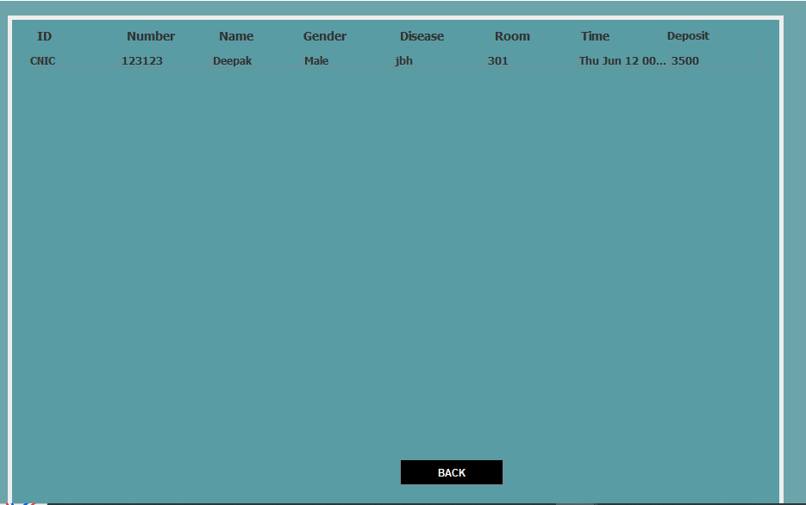

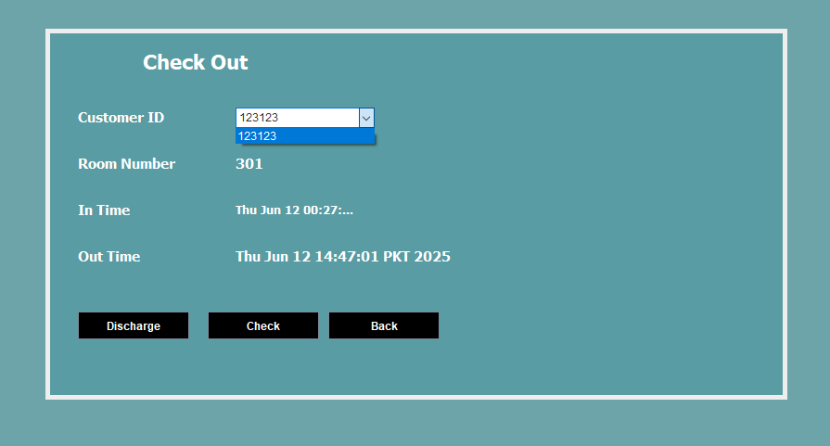
Patient Discharge Frame :

Patient Info Frame :
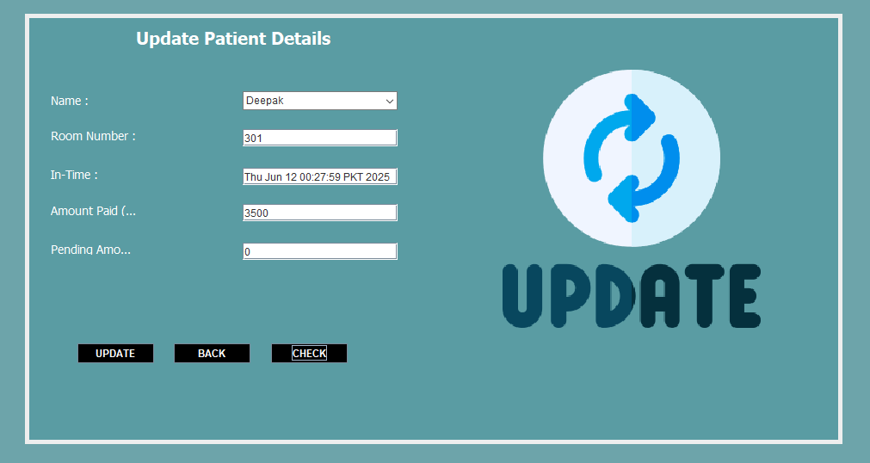
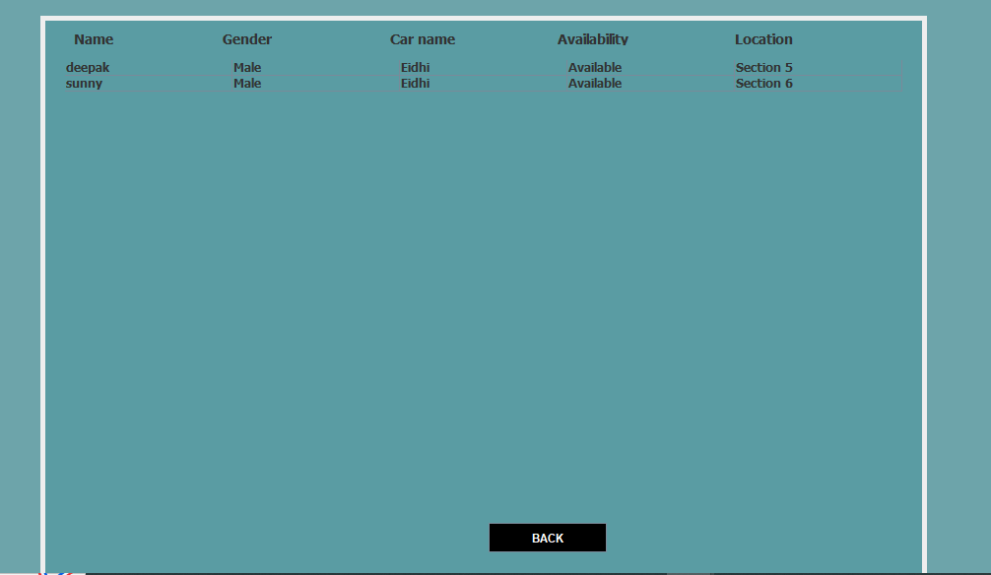
Ambulance Frame :

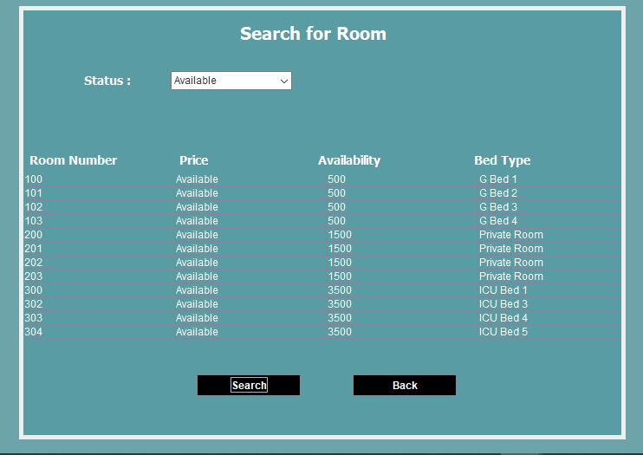

Search Room Frame :

