ASSIGNMENT5

deepak

2023-11-30

knitr::opts_chunk$set(echo = TRUE)

##R MARKDOWN

#loading all the required libraries  
library(factoextra)

## Loading required package: ggplot2

## Welcome! Want to learn more? See two factoextra-related books at https://goo.gl/ve3WBa

library(dendextend)

##   
## ---------------------  
## Welcome to dendextend version 1.17.1  
## Type citation('dendextend') for how to cite the package.  
##   
## Type browseVignettes(package = 'dendextend') for the package vignette.  
## The github page is: https://github.com/talgalili/dendextend/  
##   
## Suggestions and bug-reports can be submitted at: https://github.com/talgalili/dendextend/issues  
## You may ask questions at stackoverflow, use the r and dendextend tags:   
## https://stackoverflow.com/questions/tagged/dendextend  
##   
## To suppress this message use: suppressPackageStartupMessages(library(dendextend))  
## ---------------------

##   
## Attaching package: 'dendextend'

## The following object is masked from 'package:stats':  
##   
## cutree

library(cluster)  
library(tidyverse)

## ── Attaching core tidyverse packages ──────────────────────── tidyverse 2.0.0 ──  
## ✔ dplyr 1.1.3 ✔ readr 2.1.4  
## ✔ forcats 1.0.0 ✔ stringr 1.5.0  
## ✔ lubridate 1.9.3 ✔ tibble 3.2.1  
## ✔ purrr 1.0.2 ✔ tidyr 1.3.0

## ── Conflicts ────────────────────────────────────────── tidyverse_conflicts() ──  
## ✖ dplyr::filter() masks stats::filter()  
## ✖ dplyr::lag() masks stats::lag()  
## ℹ Use the conflicted package (<http://conflicted.r-lib.org/>) to force all conflicts to become errors

library(knitr)

#importing the data  
cereals = read.csv("C:/Users/durga/Downloads/Cereals.csv")  
numericaldata = data.frame(cereals[,4:16])

#omitting all the missing values present in the data  
OmitMissing = na.omit(numericaldata)

#normalizing and scaling the data  
Normalise = scale(OmitMissing)

#measuring the distance using the euclidian distance and computing the dissimilarity matrix  
distance = dist(Normalise, method = "euclidian")

#performing hierarchial clustering using complete linkage and representing in plot  
hierarchial_clustering = hclust(distance,method = "complete")  
plot(hierarchial_clustering)

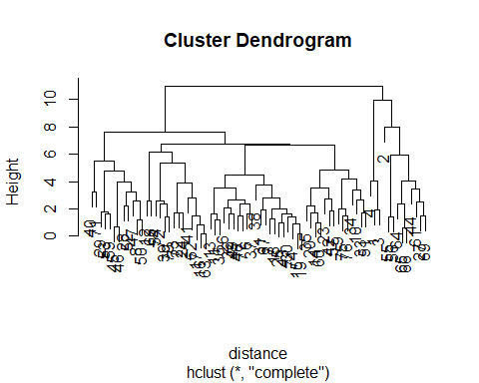

#rounding off the decimals  
round(hierarchial_clustering$height, 3)

## [1] 0.143 0.196 0.575 0.698 0.828 0.904 1.003 1.004 1.201 1.203  
## [11] 1.254 1.378 1.408 1.421 1.454 1.463 1.474 1.517 1.608 1.611  
## [21] 1.616 1.625 1.650 1.687 1.692 1.720 1.730 1.795 1.839 1.897  
## [31] 1.919 1.982 2.015 2.046 2.203 2.224 2.339 2.381 2.394 2.522  
## [41] 2.563 2.574 2.579 2.668 2.682 2.734 2.776 2.787 3.229 3.236  
## [51] 3.385 3.451 3.510 3.535 3.717 3.866 3.957 4.005 4.031 4.168  
## [61] 4.456 4.779 4.839 5.342 5.488 5.920 6.169 6.669 6.731 7.650  
## [71] 7.964 9.979 10.984

#performing clustering using AGNES  
HCsingle = agnes(Normalise, method = "single")  
HCcomplete = agnes(Normalise, method = "complete")  
HCaverage = agnes(Normalise, method = "average")  
HCward = agnes(Normalise, method = "ward")

#comparing the agglomerative cosfficients of single , complete, average, ward  
print(HCsingle$ac)

## [1] 0.6067859

print(HCcomplete$ac)

## [1] 0.8353712

print(HCaverage$ac)

## [1] 0.7766075

print(HCward$ac)

## [1] 0.9046042

#according to the above values, ward method is the best with the value of 0.904.plotting ward using agnes and the dendogram

#determining optimal clusters  
#using the ward method for hierarchial clustering  
HC1 <- hclust(distance, method = "ward.D2" )  
plot(HC1,cex=0.6)  
rect.hclust(HCward,k=5, border=2:10)

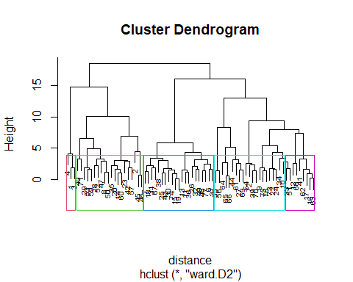

#from the above results i.e ward method graphs, th4e k value is considered as 5  
#plotting agnes using the ward method  
subgrp = cutree(HC1,k=5)  
table(subgrp)

## subgrp  
## 1 2 3 4 5   
## 3 20 21 21 9

cereals <- as.data.frame(cbind(Normalise,subgrp))

#visualising the results on scatterplot  
fviz_cluster(list(data = Normalise, cluster = subgrp))

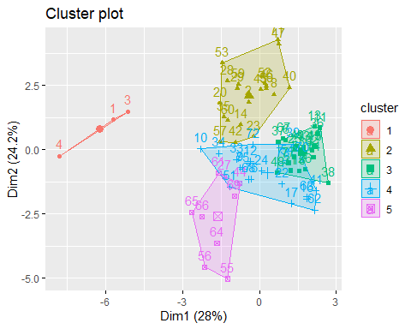

#selecting the best breakfast cereal cluster with high protein, fibre and low in sugar and sodium.  
#choosing the healthy cereal cluster  
Newdatacereals = numericaldata  
Newdatacereals_omit = na.omit(Newdatacereals)  
Clust = cbind(Newdatacereals_omit, subgrp)  
Clust[Clust$subgrp==1,]

## calories protein fat sodium fiber carbo sugars potass vitamins shelf weight  
## 1 70 4 1 130 10 5 6 280 25 3 1  
## 3 70 4 1 260 9 7 5 320 25 3 1  
## 4 50 4 0 140 14 8 0 330 25 3 1  
## cups rating subgrp  
## 1 0.33 68.40297 1  
## 3 0.33 59.42551 1  
## 4 0.50 93.70491 1

Clust[Clust$subgrp==2,]

## calories protein fat sodium fiber carbo sugars potass vitamins shelf weight  
## 2 120 3 5 15 2.0 8.0 8 135 0 3 1.00  
## 8 130 3 2 210 2.0 18.0 8 100 25 3 1.33  
## 14 110 3 2 140 2.0 13.0 7 105 25 3 1.00  
## 20 110 3 3 140 4.0 10.0 7 160 25 3 1.00  
## 23 100 2 1 140 2.0 11.0 10 120 25 3 1.00  
## 28 120 3 2 160 5.0 12.0 10 200 25 3 1.25  
## 29 120 3 0 240 5.0 14.0 12 190 25 3 1.33  
## 35 120 3 3 75 3.0 13.0 4 100 25 3 1.00  
## 40 140 3 1 170 2.0 20.0 9 95 100 3 1.30  
## 42 100 4 2 150 2.0 12.0 6 95 25 2 1.00  
## 45 150 4 3 95 3.0 16.0 11 170 25 3 1.00  
## 46 150 4 3 150 3.0 16.0 11 170 25 3 1.00  
## 47 160 3 2 150 3.0 17.0 13 160 25 3 1.50  
## 50 140 3 2 220 3.0 21.0 7 130 25 3 1.33  
## 52 130 3 2 170 1.5 13.5 10 120 25 3 1.25  
## 53 120 3 1 200 6.0 11.0 14 260 25 3 1.33  
## 57 100 4 1 135 2.0 14.0 6 110 25 3 1.00  
## 59 120 3 1 210 5.0 14.0 12 240 25 2 1.33  
## 60 100 3 2 140 2.5 10.5 8 140 25 3 1.00  
## 71 140 3 1 190 4.0 15.0 14 230 100 3 1.50  
## cups rating subgrp  
## 2 1.00 33.98368 2  
## 8 0.75 37.03856 2  
## 14 0.50 40.40021 2  
## 20 0.50 40.44877 2  
## 23 0.75 36.17620 2  
## 28 0.67 40.91705 2  
## 29 0.67 41.01549 2  
## 35 0.33 45.81172 2  
## 40 0.75 36.47151 2  
## 42 0.67 45.32807 2  
## 45 1.00 37.13686 2  
## 46 1.00 34.13976 2  
## 47 0.67 30.31335 2  
## 50 0.67 40.69232 2  
## 52 0.50 30.45084 2  
## 53 0.67 37.84059 2  
## 57 0.50 49.51187 2  
## 59 0.75 39.25920 2  
## 60 0.50 39.70340 2  
## 71 1.00 28.59278 2

Clust[Clust$subgrp==3,]

## calories protein fat sodium fiber carbo sugars potass vitamins shelf weight  
## 6 110 2 2 180 1.5 10.5 10 70 25 1 1  
## 7 110 2 0 125 1.0 11.0 14 30 25 2 1  
## 11 120 1 2 220 0.0 12.0 12 35 25 2 1  
## 13 120 1 3 210 0.0 13.0 9 45 25 2 1  
## 15 110 1 1 180 0.0 12.0 13 55 25 2 1  
## 18 110 1 0 90 1.0 13.0 12 20 25 2 1  
## 19 110 1 1 180 0.0 12.0 13 65 25 2 1  
## 25 110 2 1 125 1.0 11.0 13 30 25 2 1  
## 26 110 1 0 200 1.0 14.0 11 25 25 1 1  
## 30 110 1 1 135 0.0 13.0 12 25 25 2 1  
## 31 100 2 0 45 0.0 11.0 15 40 25 1 1  
## 32 110 1 1 280 0.0 15.0 9 45 25 2 1  
## 36 120 1 2 220 1.0 12.0 11 45 25 2 1  
## 37 110 3 1 250 1.5 11.5 10 90 25 1 1  
## 38 110 1 0 180 0.0 14.0 11 35 25 1 1  
## 43 110 2 1 180 0.0 12.0 12 55 25 2 1  
## 48 100 2 1 220 2.0 15.0 6 90 25 1 1  
## 49 120 2 1 190 0.0 15.0 9 40 25 2 1  
## 67 110 2 1 70 1.0 9.0 15 40 25 2 1  
## 74 110 1 1 140 0.0 13.0 12 25 25 2 1  
## 77 110 2 1 200 1.0 16.0 8 60 25 1 1  
## cups rating subgrp  
## 6 0.75 29.50954 3  
## 7 1.00 33.17409 3  
## 11 0.75 18.04285 3  
## 13 0.75 19.82357 3  
## 15 1.00 22.73645 3  
## 18 1.00 35.78279 3  
## 19 1.00 22.39651 3  
## 25 1.00 32.20758 3  
## 26 0.75 31.43597 3  
## 30 0.75 28.02576 3  
## 31 0.88 35.25244 3  
## 32 0.75 23.80404 3  
## 36 1.00 21.87129 3  
## 37 0.75 31.07222 3  
## 38 1.33 28.74241 3  
## 43 1.00 26.73451 3  
## 48 1.00 40.10596 3  
## 49 0.67 29.92429 3  
## 67 0.75 31.23005 3  
## 74 1.00 27.75330 3  
## 77 0.75 36.18756 3

Clust[Clust$subgrp==4,]

## calories protein fat sodium fiber carbo sugars potass vitamins shelf weight  
## 9 90 2 1 200 4 15 6 125 25 1 1  
## 10 90 3 0 210 5 13 5 190 25 3 1  
## 12 110 6 2 290 2 17 1 105 25 1 1  
## 16 110 2 0 280 0 22 3 25 25 1 1  
## 17 100 2 0 290 1 21 2 35 25 1 1  
## 22 110 2 0 220 1 21 3 30 25 3 1  
## 24 100 2 0 190 1 18 5 80 25 3 1  
## 33 100 3 1 140 3 15 5 85 25 3 1  
## 34 110 3 0 170 3 17 3 90 25 3 1  
## 39 110 2 1 170 1 17 6 60 100 3 1  
## 41 110 2 1 260 0 21 3 40 25 2 1  
## 51 90 3 0 170 3 18 2 90 25 3 1  
## 54 100 3 0 320 1 20 3 45 100 3 1  
## 62 110 1 0 240 0 23 2 30 25 1 1  
## 63 110 2 0 290 0 22 3 35 25 1 1  
## 68 110 6 0 230 1 16 3 55 25 1 1  
## 70 110 2 1 200 0 21 3 35 100 3 1  
## 72 100 3 1 200 3 16 3 110 100 3 1  
## 73 110 2 1 250 0 21 3 60 25 3 1  
## 75 100 3 1 230 3 17 3 115 25 1 1  
## 76 100 3 1 200 3 17 3 110 25 1 1  
## cups rating subgrp  
## 9 0.67 49.12025 4  
## 10 0.67 53.31381 4  
## 12 1.25 50.76500 4  
## 16 1.00 41.44502 4  
## 17 1.00 45.86332 4  
## 22 1.00 46.89564 4  
## 24 0.75 44.33086 4  
## 33 0.88 52.07690 4  
## 34 0.25 53.37101 4  
## 39 1.00 36.52368 4  
## 41 1.50 39.24111 4  
## 51 1.00 59.64284 4  
## 54 1.00 41.50354 4  
## 62 1.13 41.99893 4  
## 63 1.00 40.56016 4  
## 68 1.00 53.13132 4  
## 70 1.00 38.83975 4  
## 72 1.00 46.65884 4  
## 73 0.75 39.10617 4  
## 75 0.67 49.78744 4  
## 76 1.00 51.59219 4

Clust[Clust$subgrp==5,]

## calories protein fat sodium fiber carbo sugars potass vitamins shelf weight  
## 27 100 3 0 0 3 14 7 100 25 2 1.00  
## 44 100 4 1 0 0 16 3 95 25 2 1.00  
## 55 50 1 0 0 0 13 0 15 0 3 0.50  
## 56 50 2 0 0 1 10 0 50 0 3 0.50  
## 61 90 2 0 0 2 15 6 110 25 3 1.00  
## 64 80 2 0 0 3 16 0 95 0 1 0.83  
## 65 90 3 0 0 4 19 0 140 0 1 1.00  
## 66 90 3 0 0 3 20 0 120 0 1 1.00  
## 69 90 2 0 15 3 15 5 90 25 2 1.00  
## cups rating subgrp  
## 27 0.80 58.34514 5  
## 44 1.00 54.85092 5  
## 55 1.00 60.75611 5  
## 56 1.00 63.00565 5  
## 61 0.50 55.33314 5  
## 64 1.00 68.23588 5  
## 65 0.67 74.47295 5  
## 66 0.67 72.80179 5  
## 69 1.00 59.36399 5

#here we calculate the mean rating in order determine the healthy cluster cereals  
mean(Clust[Clust$subgrp==1,"rating"])

## [1] 73.84446

mean(Clust[Clust$subgrp==2,"rating"])

## [1] 38.26161

mean(Clust[Clust$subgrp==3,"rating"])

## [1] 28.84825

mean(Clust[Clust$subgrp==4,"rating"])

## [1] 46.46513

mean(Clust[Clust$subgrp==5,"rating"])

## [1] 63.0184

#From the above results it is clearly evident that mean rating is highest for subgroup 1.  
#so, it is recommended to choose subgrp 1 as the healthy diet cluster.