**Question: Create the following file tree**

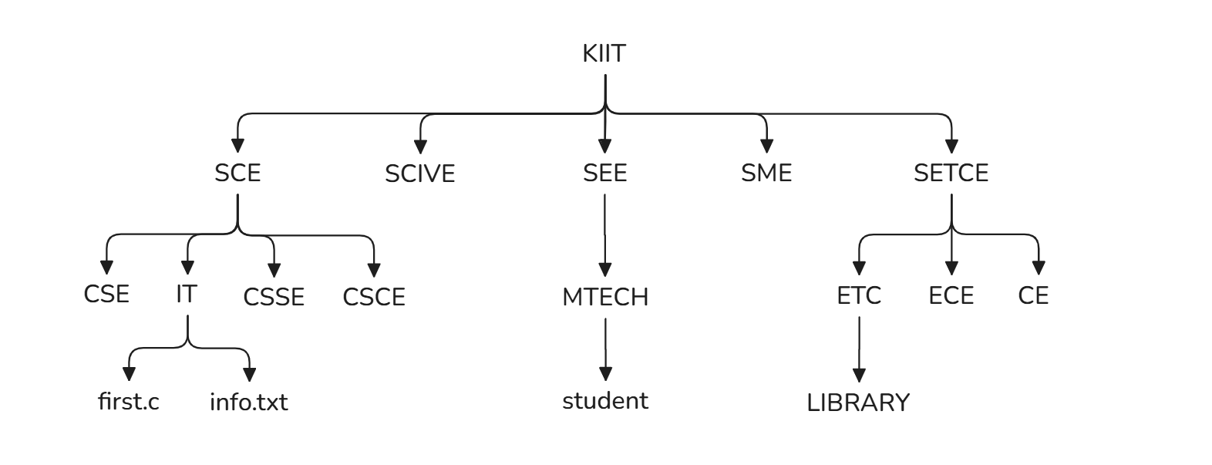

mkdir KIIT

cd KIIT/

mkdir SCE SCIVE SEE SME SETCE

cd SCE/

mkdir CSE IT CSSE CSCE

cd IT/

touch first.c info.txt

cd ../../SEE/

mkdir MTECH

cd MTECH/

touch student

cd ../../SETCE/

mkdir ETC ECE CE

cd ETC/

mkdir LIBRARY

cd ../../

tree

**File tree:**

KIIT/

├── SCE

│   ├── CSCE

│   ├── CSE

│   ├── CSSE

│   └── IT

│      ├── first.c

│      └── info.txt

├── SCIVE

├── SEE

│   └── MTECH

│   └── student

├── SETCE

│   ├── CE

│   ├── ECE

│   └── ETC

│   └── LIBRARY

└── SME

14 directories, 3 files

**Question: Perform the following operations**

1. Rename info.txt to studentdata.txt
2. Copy the file first.c into CE with same name
3. Copy the file first.c into SME with new name

mv SCE/IT/info.txt SCE/IT/studentinfo.txt

cp SCE/IT/first.c SETCE/CE/

cp SCE/IT/first.c SME/newname.c

**File tree after operations:**

KIIT/

├── SCE

│   ├── CSCE

│   ├── CSE

│   ├── CSSE

│   └── IT

│   ├── first.c

│   └── studentinfo.txt

├── SCIVE

├── SEE

│   └── MTECH

│   └── student

├── SETCE

│   ├── CE

│   │   └── first.c

│   ├── ECE

│   └── ETC

│   └── LIBRARY

└── SME

└── newname.c

14 directories, 5 files