Big of 1               O(1)                contant

Jab hame pata ho jese apne pass ek array hai 10 number bali value chaiye to hame index bhi pata hai bass value get karna hai / one step me get output

**Examples :>**

let arr = [10, 20, 30, 40, 50];

console.log(arr[2]); // prints 30

function getPi() {

return 3.14;

}

function isFirstZero(arr) {

return arr[0] === 0;

}

let user = {

name: "Deepak",

age: 19

};

console.log(user.name); // Deepak

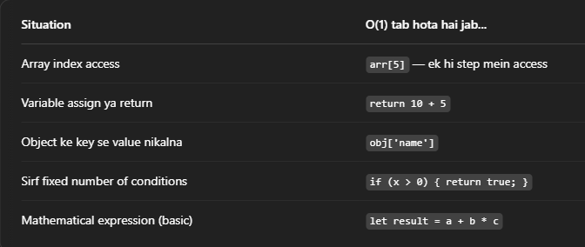----------------------------------------------------------------------------------------------------------------

O(log n)      Logarithmic / Binary

Isme binary search me har bar adha karke dekha jata hai value badi hai y chhoti

----------------------------------------------------------------------------------------------------------------

Big of n                O(n)                Linear

Jitna jada bada array y string utna time / function jitni bar call karoge

**Examples :>**

let arr = [1, 2, 3, 4, 5];

for (let i = 0; i < arr.length; i++) {

console.log(arr[i]);}

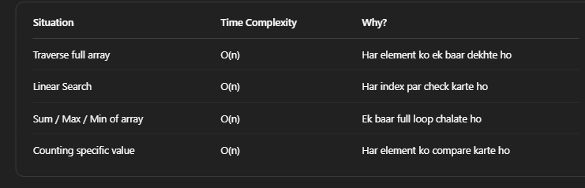

----------------------------------------------------------------------------------------------------------------

O(n log n) Linearithmic / Merge Sort, Quick Sort

* Array is **divided** into halves again and again → This takes **log n** steps
* At each level of division, we do **n comparisons** to merge arrays.

----------------------------------------------------------------------------------------------------------------

O(n²)            Quadratic / **Bubble Sort, Selection Sort, Insertion Sort**

* Outer loop runs **n** times In
* Inner loop also runs **n** times for each outer lo
* **n × n = n²**

----------------------------------------------------------------------------------------------------------------

O(2ⁿ) Exponential / Recursive Fibonacci

**Example:>**

n = 5; steps = 2⁵ = 32

2 x 2 x 2 x 2 x 2 = 32,

function fibonacci(n) {

if (n <= 1) return n;

return fibonacci(n - 1) + fibonacci(n - 2);

}

----------------------------------------------------------------------------------------------------------------

O(n!) Factorial / Solving permutations

n = 5; 5! = 120 steps

5 x 4 x 3 x 2 x 1 = 120

factorial ke Barabar Badhta hai to Time complexity O(n!) hoti Hai

----------------------------------------------------------------------------------------------------------------

