React

* Props : Mean Key Value Paire

#Create Folder :=>

React Commoud =>{

* Npm create vite / npx create-react-app Package-Name
* Open Folder
* Npm i
* npm run dev

}

# Props

Props are Like parameters to a Function

# What is Usestate Hooks

The **useState** hook in React is used to add and manage data (state) in functional components. It creates one state variable at a time

** Fisrt approach App Component and we can make only one parent component App.jsx

** angular js is 2 way binding

* React primarily uses one-way data binding, where data flows from parent to child components, and child components don't directly modify parent component data. However, you can simulate two-way binding using state and props, with child components updating parent state via callback functions
* Angular uses the concept of two-way binding

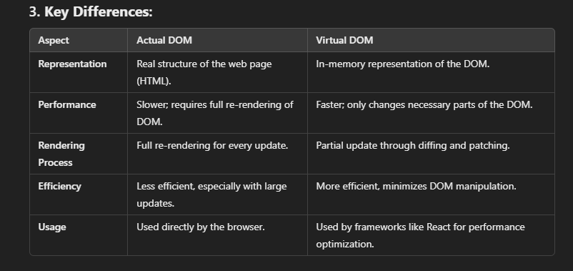

**1. Actual DOM:**

* The **Actual DOM** is the real structure of the web page that the browser uses to render HTML elements.

**2. Virtual DOM:**

* The **Virtual DOM** is a lightweight copy of the Actual DOM that helps to update only parts of the page that have changed, improving performance.

### 3. what is ****Components****:

* **Components** are small, reusable pieces of code that define parts of a user interface (UI) in web applications. Each component manages its own structure, logic, and behavior.

* **Hooks** can only be used in **functional components** in React

4.What is state

**State** is used to store data in a component that can change, and when the state changes, it causes the component to re-render with the updated data. This helps keep the UI in sync with the application's data. || State is a Object

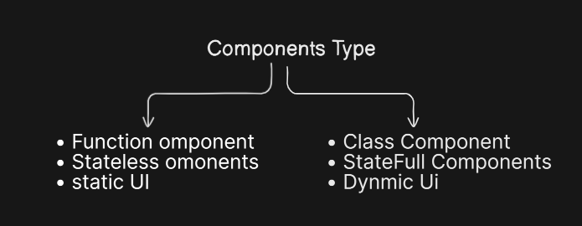

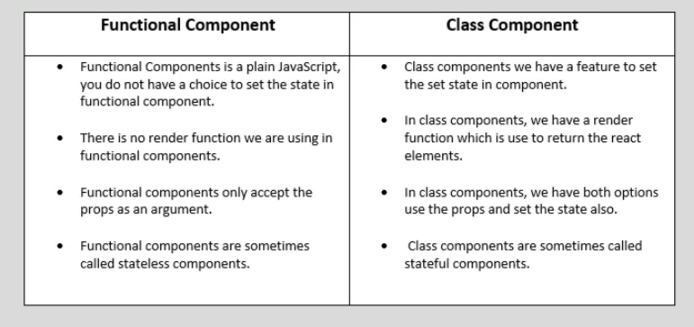

**Stateless Components** are simpler and only receive data through **props**.

**Stateful Components** manage their own **state**, allowing them to update dynamically based on changes in the data.

5 index.css is a global CSS file that is applied to the entire application.

**Usage**: It is typically imported in the main entry file (like index.js or App.js) to style the whole application.

**Effect**: Once imported, the styles in index.css are available globally, so you don’t need to import it into individual components.

6 . What is Fragment

A **React Fragment** is a lightweight wrapper that lets you group multiple elements or components together without introducing an additional parent element

Syt: <> </>

7. What is Components Life circle

• **Mounting**: When the component is created and added to the DOM.

* **Example**: constructor(), render(), componentDidMount()

• **Updating**: When the component's state or props change, causing it to re-render.

* **Example**: shouldComponentUpdate(), render(), componentDidUpdate()

• **Unmounting**: When the component is removed from the DOM.

* **Example**: componentWillUnmount()