React

- Props : Mean Key Value Paire

#Create Folder :=>
React Commoud =>{
- Npm create vite / npx create-react-app Package-Name
- Open Folder
- Npm i
- npm run dev
}

# Props
Props are Like parameters to a Function

# What is Usestate Hooks
The useState hook in React is used to add and manage data (state) in functional components. It creates one state variable at a time

** Fisrt approach App Component and we can make only one parent component App.jsx

** angular js is 2 way binding
- React primarily uses one-way data binding, where data flows from parent to child components, and child components don't directly modify parent component data. However, you can simulate two-way binding using state and props, with child components updating parent state via callback functions
- Angular uses the concept of two-way binding

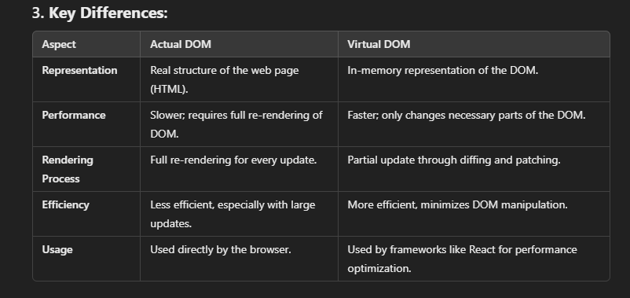

1. Actual DOM:
- The Actual DOM is the real structure of the web page that the browser uses to render HTML elements.

2. Virtual DOM:
- The Virtual DOM is a lightweight copy of the Actual DOM that helps to update only parts of the page that have changed, improving performance.

3. what is Components:
- Components are small, reusable pieces of code that define parts of a user interface (UI) in web applications. Each component manages its own structure, logic, and behavior.

- Hooks can only be used in functional components in React

4.What is state
State is used to store data in a component that can change, and when the state changes, it causes the component to re-render with the updated data. This helps keep the UI in sync with the application's data. || State is a Object

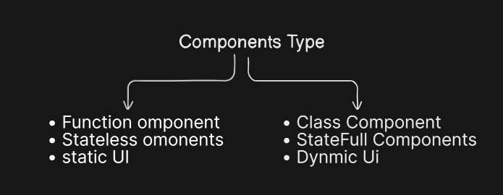
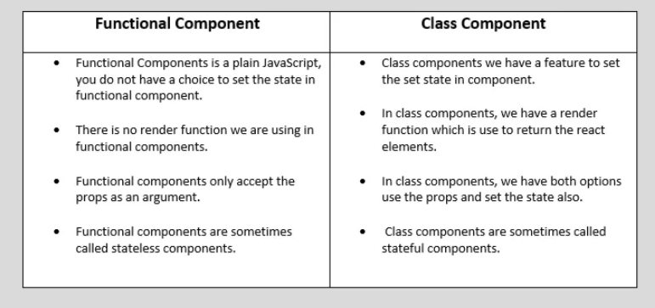

Stateless Components are simpler and only receive data through props.
Stateful Components manage their own state, allowing them to update dynamically based on changes in the data.

5 index.css is a global CSS file that is applied to the entire application.
Usage: It is typically imported in the main entry file (like index.js or App.js) to style the whole application.
Effect: Once imported, the styles in index.css are available globally, so you don’t need to import it into individual components.

6 . What is Fragment
A React Fragment is a lightweight wrapper that lets you group multiple elements or components together without introducing an additional parent element
Syt: <> </>

7. What is Components Life circle
• Mounting: When the component is created and added to the DOM.
- Example: constructor(), render(), componentDidMount()
• Updating: When the component's state or props change, causing it to re-render.
- Example: shouldComponentUpdate(), render(), componentDidUpdate()
• Unmounting: When the component is removed from the DOM.
- Example: componentWillUnmount()

