**# encrypt-c-Code**

Hey every one i am here to describe you how to encrypt/obfuscate your c# code in easy way. Secure your c# code from reverse engineering.

* first of all you have to convert your class file into dll file with the help of visual studio.
* Go to create new project



Then find a class library project



create a class library project according to your project /.net framework version.

**OR**

* you can also create dll file with the help of vs(Visual Studio 2019 Developer Command Prompt)
* 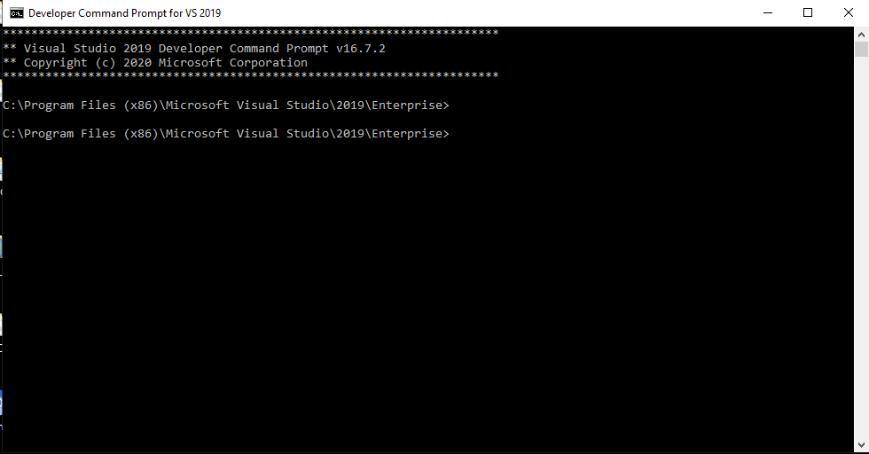
* you have to go that location where your class file is exists and just type

**csc /t:library /out:DllName.dll yourclassfile.cs**

AND BOOM your dll file is created!!!!!! ☺