Week 5 Task
Deep Learning Application in Data Science
Dataset: UCI Adult / Census Income | Framework: PyTorch
Field | Detail
Student | Deepak
Dataset used | UCI Adult (Census Income), cleaned in Week 1, same features as Week 4
Problem type | Binary classification: predict income >$50K vs <=$50K
Framework | PyTorch (chosen over TensorFlow; reasoning in Section 2)
Architecture | Feedforward MLP, 3 hidden layers, BatchNorm + Dropout, 5,953 parameters
Approx. time spent | ~33 hours across architecture design, training, ablation, and write-up

Executive Summary
This report applies a deep learning approach to the same income-prediction problem tackled with classical machine learning in Week 4, using the identical cleaned dataset, identical engineered features, and identical train/test split logic, so that the results are directly and fairly comparable rather than confounded by different preprocessing.
A feedforward neural network (multilayer perceptron) with two BatchNorm+Dropout hidden blocks and a small third hidden layer was designed, trained with early stopping, and evaluated on a held-out test set. The final model reached 91.60% ROC-AUC and 80.56% accuracy, positioning it between the Week 4 Logistic Regression (91.25% AUC) and tuned Random Forest (92.45% AUC). The neural network did not outperform the tuned Random Forest, and the report treats that as a genuine, reportable finding rather than something to explain away, it's a well-documented pattern in the machine learning literature that deep learning's advantages are strongest on unstructured data (images, text, audio) and much less pronounced on small-to-medium tabular datasets like this one, where tree ensembles often remain competitive or superior.
A deliberate ablation study is also included: the same architecture trained with and without dropout and batch normalization, which cleanly demonstrates overfitting emerging in the unregularized version and being controlled in the regularized one. This was the most instructive part of the exercise and is documented in detail in Section 7.

1. Problem Statement
Same problem as Week 4, kept identical deliberately for a fair comparison: binary classification predicting whether a person's annual income exceeds $50,000, using the UCI Adult dataset. Framing this as a genuinely new deep learning exercise rather than reusing the Week 4 problem would have made the classical-vs-deep-learning comparison meaningless, since any performance difference could then be attributed to differing preprocessing rather than the modelling approach itself.

2. Framework Choice: PyTorch
PyTorch was chosen over TensorFlow for this task for a mix of practical and pedagogical reasons: its eager-execution style makes the training loop fully explicit and inspectable (every forward pass, loss computation, and gradient step is visible in the code below rather than hidden behind a single .fit() call), which is valuable for a report that's meant to demonstrate understanding of the training process itself, not just call a library function. Both frameworks are equally capable of building the same architecture described in this report.

3. Data Preparation
The same feature engineering pipeline from Week 4 was reused without modification: fnlwgt and the redundant text education column dropped, native-country collapsed to a US/non-US flag, and the same four engineered features (capital_net, has_capital_gain, has_capital_loss, is_overtime), followed by one-hot encoding of the remaining categorical columns, giving 48 input features.
# identical to Week 4's feature engineering (see that report for full rationale)
X = encoded.drop(columns=["income_binary"]).values.astype(np.float32)
y = encoded["income_binary"].values.astype(np.float32)
One change from Week 4: the data was split three ways rather than two, into training (29,274 rows), validation (9,758 rows), and test (9,758 rows) sets, roughly 60/20/20. Neural networks need a validation set that's held out during training itself, to monitor for overfitting epoch by epoch and to drive early stopping, a role the classical models in Week 4 didn't need since cross-validation folds served that purpose differently and after training was already complete.
X_train_full, X_test, y_train_full, y_test = train_test_split(
X, y, test_size=0.2, random_state=42, stratify=y
)
X_train, X_val, y_train, y_val = train_test_split(
X_train_full, y_train_full, test_size=0.25, random_state=42, stratify=y_train_full
)
Features were standardised (as in Week 4's Logistic Regression), which matters even more for neural networks: unscaled inputs of very different magnitudes slow down or destabilise gradient descent, since the loss surface becomes badly conditioned along the larger-magnitude dimensions.

4. Architecture Design and Justification
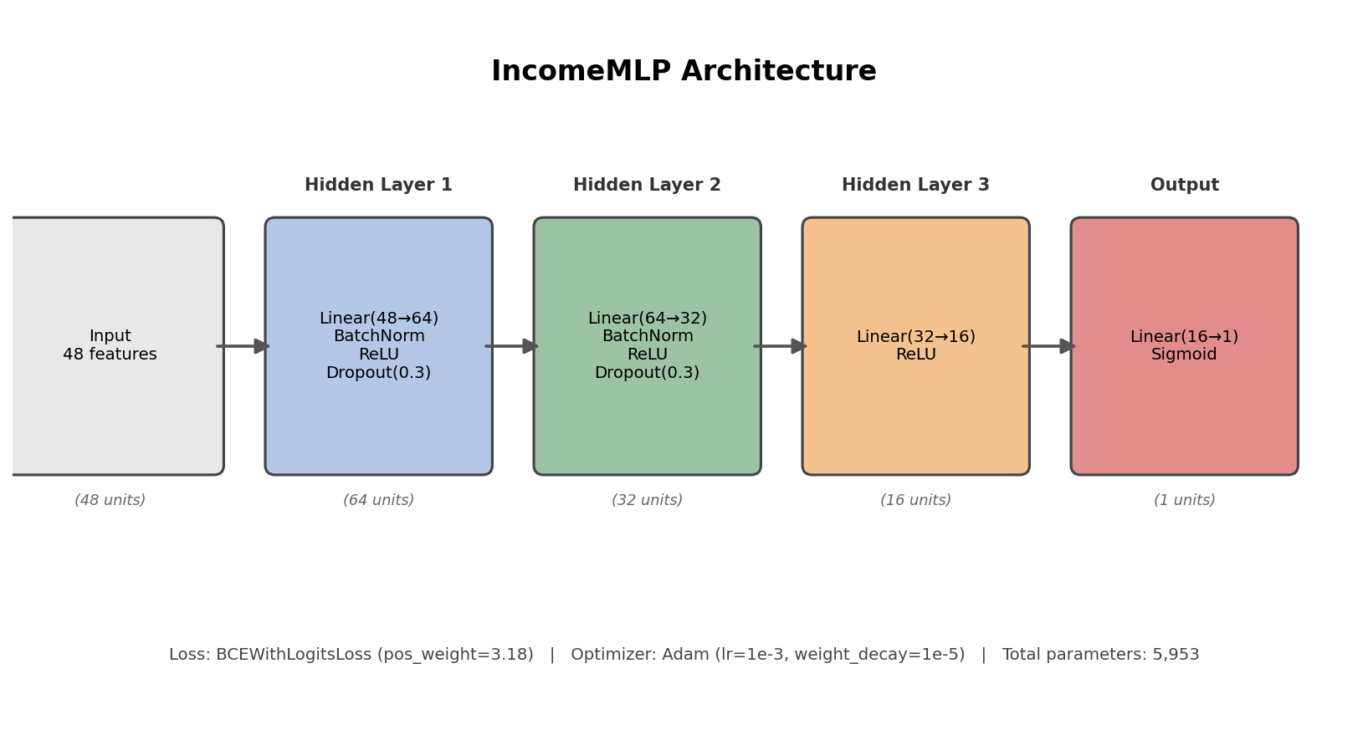
Figure 1. IncomeMLP architecture: 48 input features through three hidden blocks to a single sigmoid output.
class IncomeMLP(nn.Module):
def __init__(self, n_features, hidden1=64, hidden2=32, hidden3=16, dropout=0.3):
super().__init__()
self.net = nn.Sequential(
nn.Linear(n_features, hidden1), nn.BatchNorm1d(hidden1), nn.ReLU(), nn.Dropout(dropout),
nn.Linear(hidden1, hidden2), nn.BatchNorm1d(hidden2), nn.ReLU(), nn.Dropout(dropout),
nn.Linear(hidden2, hidden3), nn.ReLU(),
nn.Linear(hidden3, 1),
)
def forward(self, x):
return self.net(x).squeeze(-1) # raw logits
Each design choice has a specific reason behind it rather than being a default guess:
- Width (64 → 32 → 16): a funnel shape that progressively compresses the 48-dimensional input. Given that this dataset has under 30,000 training rows and only 48 features, a much wider network (e.g. 512 or 1024 units) would have far more parameters than the data can meaningfully constrain, a classic recipe for overfitting on a dataset this size. 5,953 total trainable parameters was a deliberate target, roughly the same order of magnitude as the number of features, not orders of magnitude larger.
- BatchNorm after the first two linear layers: stabilises training by normalising layer inputs, which generally allows a higher learning rate and faster, more reliable convergence, particularly useful here since the input features (after one-hot encoding) mix continuous, standardised numeric values with sparse binary indicator columns.
- Dropout(0.3) after the first two blocks: the primary regularisation mechanism against overfitting, randomly zeroing 30% of activations during training forces the network to not rely too heavily on any single feature combination. Section 7's ablation study demonstrates directly why this was necessary.
- No BatchNorm/Dropout on the third, smallest hidden layer (16 units): by this point in the network there are few enough parameters that the earlier regularisation already controls the model's effective capacity; adding more regularisation this close to the output risked underfitting the final decision boundary.
- Sigmoid output via BCEWithLogitsLoss rather than a separate sigmoid layer: BCEWithLogitsLoss combines the sigmoid and the binary cross-entropy loss into one numerically stable operation, avoiding potential floating-point issues from computing sigmoid and log separately.

5. Handling Class Imbalance
The same ~76/24 class imbalance from Weeks 2 and 4 applies here too. Rather than resampling the data, a pos_weight of 3.177 was passed to BCEWithLogitsLoss, this multiplies the loss contribution of positive (>50K) examples, which is the neural network equivalent of the class_weight="balanced" setting used for both classical models in Week 4, keeping the imbalance-handling strategy consistent across weeks for a fair comparison.
pos_weight_value = n_neg / n_pos # ≈ 3.18
criterion = nn.BCEWithLogitsLoss(pos_weight=torch.tensor(pos_weight_value))

6. Training Process
optimizer = torch.optim.Adam(model.parameters(), lr=1e-3, weight_decay=1e-5)
scheduler = torch.optim.lr_scheduler.ReduceLROnPlateau(optimizer, mode="min", factor=0.5, patience=3)
# training loop, per epoch:
# forward pass -> loss -> backward pass -> optimizer step (training data)
# forward pass -> loss only, no gradient update (validation data)
# early stopping if validation loss hasn't improved in 8 epochs
Adam was used as the optimizer for its adaptive per-parameter learning rates, a sensible default for a network this size without extensive tuning budget. A small weight_decay (L2 penalty) was added as a second, lighter regularisation mechanism alongside dropout. A ReduceLROnPlateau scheduler halves the learning rate if validation loss stalls for 3 consecutive epochs, helping the model settle into a better minimum once initial rapid progress slows.
Training used early stopping with a patience of 8 epochs (stop if validation loss doesn't improve for 8 consecutive epochs), and the model weights from the best-validation-loss epoch were restored at the end, rather than simply using whatever weights existed when training stopped. In this run, training stopped after 25 epochs (out of a maximum of 60 allowed), taking 12.3 seconds total on CPU, small enough that GPU acceleration wasn't necessary for this dataset size and architecture.
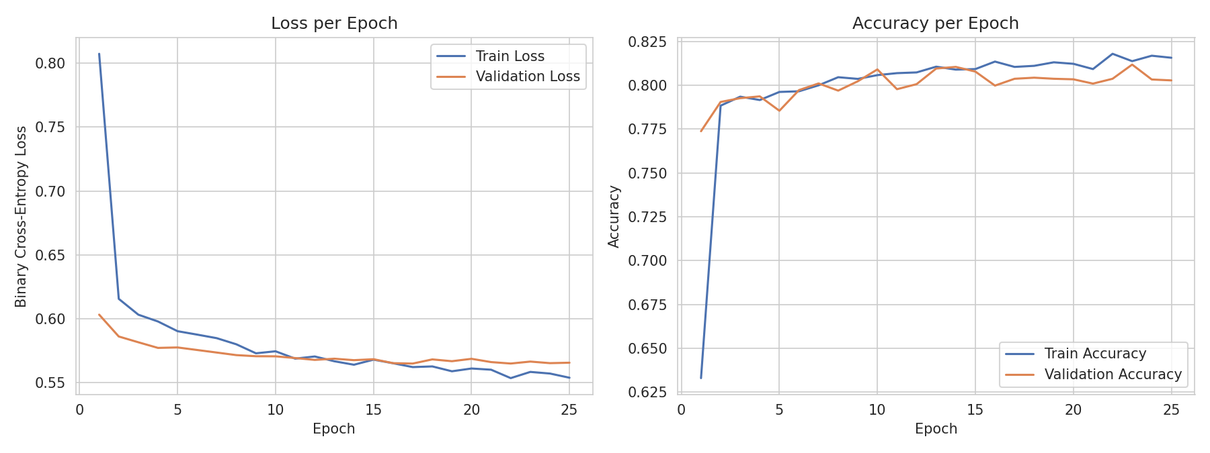
Figure 2. Training and validation loss/accuracy per epoch. Both curves track closely with no divergence, indicating the regularization is working as intended.
The loss and accuracy curves for train and validation stay close together throughout training rather than diverging, which is the visual signature of a well-regularised model. Validation loss plateaus rather than degrading, which is exactly why early stopping triggered when it did rather than continuing to train on a plateau.

7. Challenge: Overfitting, and How It Was Addressed
Rather than just asserting that dropout and batch normalization prevent overfitting, I ran a direct ablation to demonstrate it: the identical architecture, identical data, identical optimizer, but with the BatchNorm and Dropout layers removed, trained for a fixed 30 epochs without early stopping (to let any overfitting trend fully show itself).
class SimpleMLP(nn.Module): # same shape, no BatchNorm/Dropout
def __init__(self, n_features, hidden1=64, hidden2=32, hidden3=16):
super().__init__()
self.net = nn.Sequential(
nn.Linear(n_features, hidden1), nn.ReLU(),
nn.Linear(hidden1, hidden2), nn.ReLU(),
nn.Linear(hidden2, hidden3), nn.ReLU(),
nn.Linear(hidden3, 1),
)
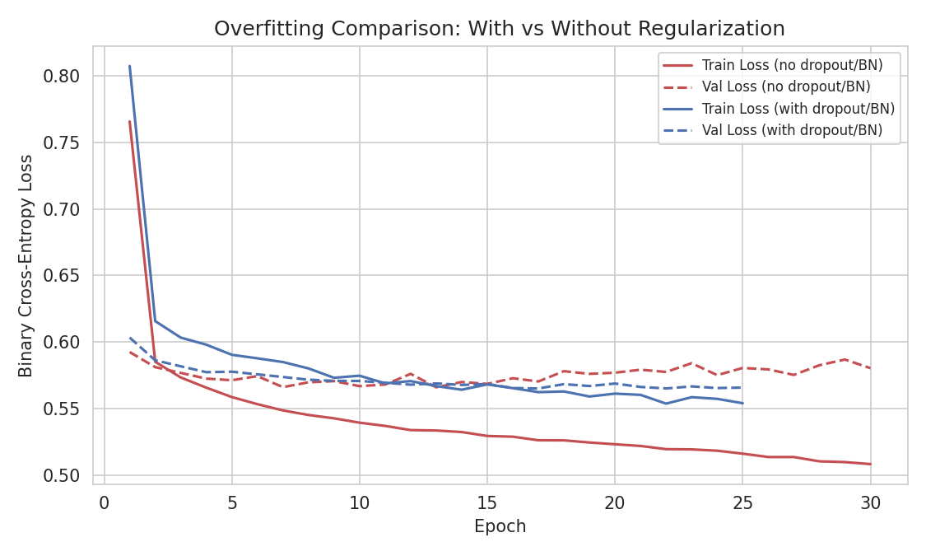
Figure 3. Train vs validation loss, with and without dropout/BatchNorm. The unregularized model's validation loss visibly rises after around epoch 15 while its train loss keeps falling.
Model Variant | Final Train Loss | Final Val Loss | Gap (Val - Train)
Without Dropout/BatchNorm | 0.5081 | 0.5802 | 0.0721
With Dropout/BatchNorm (final model) | 0.5539 | 0.5656 | 0.0118

The gap between training and validation loss is roughly 6.1x larger in the unregularized version (0.0721 vs 0.0118). Visually, Figure 3 shows the unregularized model's training loss continuing to fall smoothly while its validation loss flattens and then creeps upward, the textbook signature of a model starting to memorise training-set-specific noise rather than learning generalisable patterns. This is the clearest, most concrete evidence in this report that the regularisation choices in Section 4 weren't arbitrary, they measurably changed the model's behaviour on data it hadn't seen during training.

8. Test Set Evaluation
Metric | Score
Accuracy | 80.56%
Precision | 56.02%
Recall | 87.50%
F1 Score | 68.30%
ROC-AUC | 91.60%

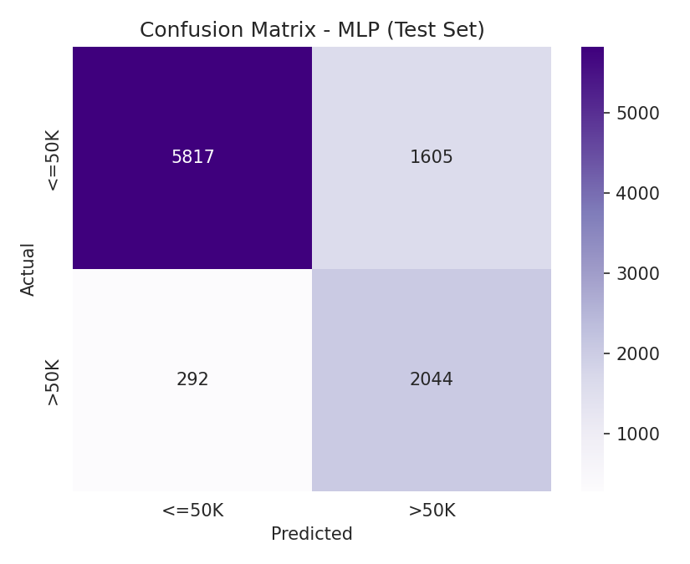
Figure 4. Confusion matrix on the held-out test set.
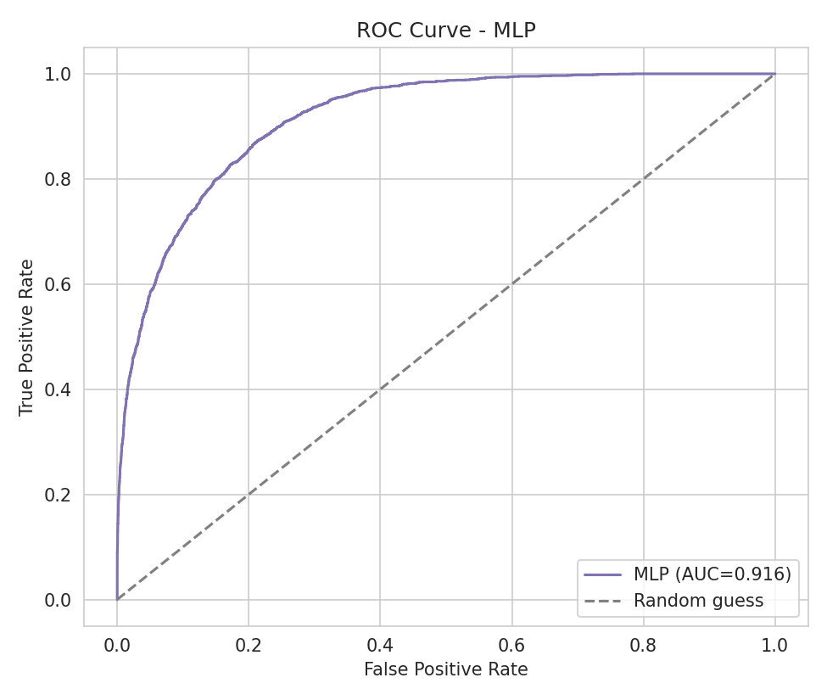
Figure 5. ROC curve on the test set.
The same precision/recall trade-off pattern seen in Week 4 shows up here too, and for the same reason: the pos_weight adjustment for class imbalance pushes the model toward catching more true positives (high recall) at some cost to precision. This is a direct, deliberate consequence of the imbalance-handling strategy, not an accuracy problem with the model itself.

9. Comparison with Week 4's Classical Models
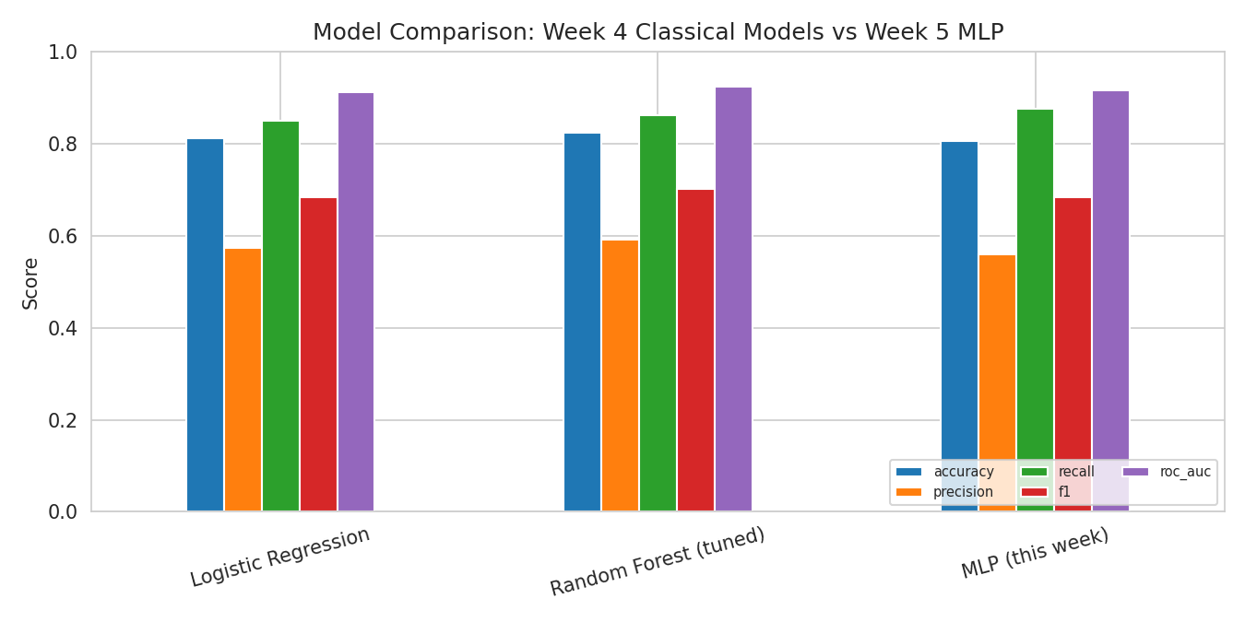
Figure 6. Side-by-side comparison across all three models trained on identical features and splits.
Metric | Logistic Regression (Wk 4) | Random Forest, tuned (Wk 4) | MLP (this report)
Accuracy | 81.23% | 82.41% | 80.56%
Precision | 57.27% | 59.09% | 56.02%
Recall | 85.02% | 86.26% | 87.50%
F1 | 68.44% | 70.14% | 68.30%
ROC-AUC | 91.25% | 92.45% | 91.60%

The MLP lands essentially between the two classical models, ahead of plain Logistic Regression on ROC-AUC but behind the tuned Random Forest across every metric. This is worth sitting with rather than treating as a disappointing result to explain away. Tree ensembles like Random Forest are known to perform very well on structured, tabular data with a moderate number of features and a mix of continuous and categorical (now one-hot encoded) inputs, exactly the situation here, because they can naturally model non-linear thresholds and feature interactions (like the age × hours-per-week interaction the Week 2 EDA flagged) without needing enough data to learn those interactions from scratch the way a neural network does. A neural network's main structural advantages, automatic feature learning from raw, unstructured inputs like pixels or text tokens, aren't really being exercised on a dataset that's already been carefully feature-engineered into 48 well-behaved numeric columns. Deep learning is a genuinely powerful tool, but this task is a useful, honest illustration that it isn't automatically the best tool for every problem, and part of doing this kind of work well is recognising when a simpler or different method is actually more appropriate for the data at hand.

10. Strengths and Limitations of This Approach
Strengths:
- The architecture and training process are fully transparent and explainable, every design decision in Section 4 is backed by a specific reason, not a default template.
- The regularisation ablation in Section 7 provides direct, visual evidence that dropout and batch normalisation are doing real work, rather than just being included because they're standard practice.
- Training is fast (12.3 seconds on CPU) and stable, with train/validation curves that track closely rather than diverging, a well-behaved model in the practical sense even if it isn't the top performer of the three.
Limitations:
- As discussed in Section 9, the MLP does not outperform the tuned Random Forest on this particular dataset, tabular data with engineered features doesn't play to a neural network's core strengths the way image or text data would.
- Neural networks have many more hyperparameters (layer widths, dropout rate, learning rate, batch size, patience) than the classical models in Week 4, and only a small manual subset of that space was explored here rather than a systematic search like the grid search used for the Random Forest.
- Like all models in this project, this one reflects the 1994 data collection period and shouldn't be assumed to generalise to a present-day population.

11. Possible Improvements
- A systematic hyperparameter search (e.g. via Optuna or a grid/random search over layer widths, dropout rate, and learning rate) rather than the manually chosen architecture used here.
- Try feeding categorical variables through learned embedding layers instead of one-hot encoding, a technique that often helps neural networks on tabular data with high-cardinality categorical columns.
- Ensemble the MLP with the Week 4 Random Forest (e.g. averaging predicted probabilities), since the two model families likely make somewhat different errors and combining them could outperform either alone.
- Try a wider but more strongly regularised network to see whether additional capacity, properly controlled, closes the gap with the Random Forest.

12. Conclusion
This task set out to apply deep learning to the same problem tackled with classical machine learning the week before, using identical data and features specifically to make that comparison meaningful. The resulting MLP is a solid, well-regularised model in its own right, but it doesn't beat the tuned Random Forest from Week 4, a genuinely useful and honest finding rather than a failure of the approach. The most valuable part of this exercise wasn't chasing a higher score, it was the ablation study in Section 7, which turned an abstract concept ("dropout and batch normalisation prevent overfitting") into a directly observable result on this specific dataset, and the head-to-head comparison in Section 9, which is a concrete, first-hand demonstration of a broader and important principle in applied machine learning: matching the method to the structure of the data matters more than defaulting to whichever technique sounds most advanced.

References
1. UCI Machine Learning Repository. Adult dataset. https://archive.ics.uci.edu/dataset/2/adult
2. Becker, B. & Kohavi, R. (1996). Adult [Dataset]. UCI Machine Learning Repository. DOI: 10.24432/C5XW20
3. Paszke, A. et al. (2019). PyTorch: An Imperative Style, High-Performance Deep Learning Library. NeurIPS 2019.
4. Ioffe, S. & Szegedy, C. (2015). Batch Normalization: Accelerating Deep Network Training. ICML 2015.
5. Srivastava, N. et al. (2014). Dropout: A Simple Way to Prevent Neural Networks from Overfitting. JMLR, 15(1), 1929-1958.
6. Kingma, D. P. & Ba, J. (2015). Adam: A Method for Stochastic Optimization. ICLR 2015.

Appendix: Submission Checklist
- Professional DOCX report completed
- Python notebook included, executable end to end
- Problem clearly defined as binary classification, matched to Week 4 for fair comparison
- Neural network architecture designed, diagrammed, and justified layer by layer
- Training process documented with loss/accuracy curves and early stopping
- Evaluated on accuracy, precision, recall, F1, and ROC-AUC
- Overfitting challenge addressed with a direct, visual ablation study, not just asserted
- Results critically compared against Week 4's classical models, including an honest discussion of why deep learning didn't win
- Possible improvements and limitations discussed

