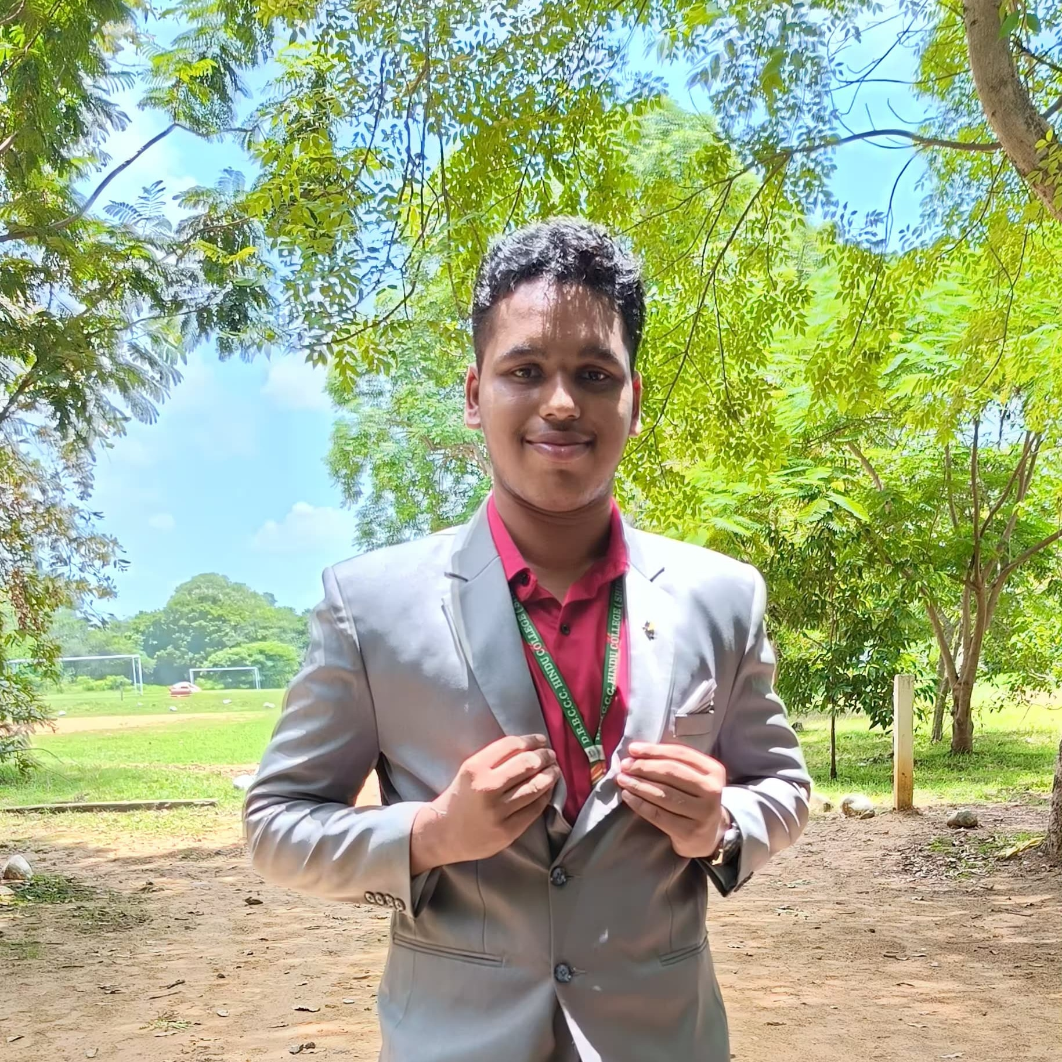

Hello

I’m Deepak. N

**2nd Year BCA Student| java Developer and front end developer**

**6383745169 | [**[**ndeepakndeepak293@gmail.com**](mailto:ndeepakndeepak293@gmail.com)**]**

# Skills

**Java and Html css javascript (front end and backend developer)**

**Problem solving and website creator**

# Education

**DRBCCC Hindu College, Chennai**

**Affiliated with Madras University**

**2023 - 2026 (Expected Graduation)**

**Academic**

**● Developed an IoT-based solution for optimizing agricultural processes**

**● Integrated sensors for real-time monitoring & automation**

**Strengths**

**● Problem-solving mindset**

**● Passion for learning new technologies**

**● Strong analytical & logicalthinking**

**Contacts**

**Contact:**

**📞6383745169|📧[ndeepakndeepak293@gmail.com].**