**KARNATAK** **UNIVERSITY**

**DHARWAD**

**Janata Shikshana Samiti’s**

**Shri Manjunatheshwara Institute of UG & PG Studies Vidyagiri, Dharwad 580004.**



**A INTERNSHIP/PROJECT REPORT ON**

**“ADVERTISEMENT MANAGEMENT WEBSITE”**

**BACHELOR OF COMPUTER APPLICATION (BCA)**

**OF**

**KARNATAK UNIVERSITY, DHARWAD**

PROJECT GUIDED BY

**Mrs. Manjula Kalmath**

Submitted by

**Mr. Chetan Lingaraj Singannavar**

**BCA VI SEMESTER**

**REG NO: U02BF21S0111**

**Department of Computer Science**

**Janata Shikshana Samiti’s**

**Shri Manjunatheshwara Institute of UG & PG Studies Vidyagiri, Dharwad 580004.**



**CERTIFICATE**

**This is to certify that Mr.Chetan Lingaraj Singannavar has satisfactorily completed the Internship/project work entitled as “Advertisement Management Website” for the partial fulfillment of BCA prescribed by the Karnatak University, Dharwad for the academic year 2023-2024.**

**Mrs. Manjula Kalmath Shri.Vivek M.Laxmeshwar Dr.Ajith Prasad**

**[ Project Guide ] [ HOD ] Principal**

**Computer Department**

**Examiners:**

**1)**

**2)**

***MEMORANDUM OF UNDERSTANDING FOR STUDENT'S INTERNSHIPS***

This Memorandum of Understanding (MoU) is made & entered into on **28-04-2024** (Date) whereas **JSS SMI UG & PG** college as first party and **Amba Softwares and Solutions**(Internship offering Institution) as second party where as Offers fully integrated hands-on training in Web Designing.

**PURPOSE:**

The MoU is being signed with **Amba Softwares and Solutions** (Internship offering Institution) as a partner to facilitate internships for students enrolled for BCA in **JSS SMI UG & PG** College. This MoU between **JSS SMI UG & PG** College and **Amba Softwares and Solutions** (Internship offering Institution) will outline the collaboration to facilitate internships for Students enrolled in **JSS SMI UG & PG** college, Dept of **Computer Science** for the purpose of **Internship.**

**CONTEXT:**

**JSS SMI UG & PG** College, offers an Internship (Under NEP 2020 Scheme) course in which students are given the opportunity for hands-on experiential learning through external organizations.

**JSS SMI UG & PG** College, is exploring partnership with different stakeholders and has identified **Amba Softwares and Solutions** (Internship offering Institution) as a potential partner.

**AS PART OF THIS MOU, BOTH THE PARTIES HERE TO AGREE TO THE FOLLOWING RESPECTIVELY:**

* **Amba Softwares and Solutions** (Internship offering Institution) will make all the necessary resources and guidance available to students registered through this partnership.
* **Amba Softwares and Solutions** (Internship offering Institution) will not charge any amount to **JSS SMI UG & PG** College, for offering internships.
* Under this MoU **Amba Softwares and Solutions** (Internship offering Institution) accepted to offer internships to **BCA** students during the 3/4 years course of study (in any semester of the student).
* Both the parties may terminate this MoU with the notice period of one Month. In this context, both parties have discharge their obligation.

**VALIDITY:**

This Agreement will be valid for 6months or until it is expressly terminated by either Party on mutually agreed terms.

**RELATIONSHIP BETWEEN THE PARTIES:**

It is expressly agreed that First Party and Second Party are acting under this MoU as independent contractors, and the relationship established under this MoU shall not be construed as a partnership.

**Accepted and Agreed**

Signature Signature

First Party Second Party

[JSS SMI UG & PG College] [Amba Softwares and Solution ]

Seal: Seal:

**Witness**  **Witness**

1. 1.

2. 2.

Date : Date :

***\*INTERNSHIP COMPLETION CERTIFICATE***

***Date:***

**TO WHOMSOEVER IT MAY CONCERN**

This is to certify that **Mr. Deepak Laxmikanth Naik** student of **JSS SMI UG & PG Studies Dharwad** studying in **BCA** 6th semester in **Full Stack Developer** (course)has successfully completed his Internship with **Amba Softwares and Solutions**. During the period of Internship he worked under in the following areas.

1. **HTML, CSS, Bootstrap**
2. **MySQL and Django**

He has shown special flair for **Full Stack Developer** and his performance in preparation of the report has been rated as **10** (in 1 to 10 Points/Grade).

During the period his internship program he was punctual and hardworking. I wish **Mr. Deepak Laxmikanth Naik** every success in his career and life.

**Signature**

Mentor of the Organization

***FORMAT FOR NOC TO BE OBTAINED FROM***

***COLLEGE / INSTITUTION***

**Date:**

Sub : No Objection Certificate for Internship Programme at **Amba Softwares and Solutions**

This is to certify that **Mr. Deepak Laxmikanth Naik** is a bonafide student of this college studying in **BCA** (UG) 6 semester. His ID No. is **U02BF21S0120.** The college has no objection for doing the Internship programme at **Amba Softwares and Solutions** for the period from 15-04-2024 to 14-06 2024. The conduct of the student as recorded by the College/Institution has been found good/ satisfactory.

***HOD Principal***

**Internship Acceptance Cum Undertaking Letter By The Students**

To,

The Principal JSS SMI UG & PG Studies

I hereby declare and undertake as following:

* I will maintain at least 75% attendance during the present semester.
* I am agreed to work on projects as directed by JSS SMI UG and PG College and staff of the Internship Organization.
* I agree to report to the Internship Organization Zephyr Technologies and Solutions Pvt Ltd at times directed by the Internship organization.
* I agree to follow the administrative policies of the Internship Organization, including confidentiality policies, personnel practices, and business protocols.
* I agree to abide by the JSS SMI UG and PG College Code of Student Conduct and any other College/departmental or program policies relating to professional behaviour.
* I hereby agree and confirm to abide by the terms and conditions set out by the college for Internship/Project work. I further declare that the college shall not be held responsible in the event of any misfortune or loss resulting in permanent or temporary.
* I am responsible for my transportation, stay and other personal arrangements during the Internship/Project work period.
* I am responsible for any cost, any kind of loss, damages, liability, or expense, which may arise out of my performance of services at
* Internship Organization. I will not ask the authority to re-conduct any Examination if missed by me or request for anyother relaxation in this regard.
* I will maintain regular communication with my Program Coordinator/ Mentor and keep him/her informed of my activities during the internship period.

I will submit a copy of internship certificate as well as internship report within working days of the completion of the internship to

Signature

Name : Deepak Laxmikanth Naik

Class and Section : BCA VI ‘A’

Register No : U02BF21S0120

Phone Number : 8088623634

# 

# **TITLE PAGE**

**Report Title:** Harnessing data-driven insights through advanced analytics.

**Name Of The Company:** SVARKS Information Technology LLP

**Student Name**: Deepak Laxmikanth Naik

**Registration Number:** U02BF21S0120

**Class:** BCA VI A division

**College:** JSS Shri Manjunatheshwara Institute of UG and PG Studies Dharwad.

**Internship Dates:**

28/04/2024 to 28/06/2024

# 

# **TABLE OF CONTENTS**

**Acknowledge Section** 11

**Information About The Company** 12

Services 13

**Introduction to Advertisement Management Website Project:** 14

Project Overview 14

Project Objectives 14

Key Features 15

Technologies Used 15

Project Significance 15

**Information about internship position** 16

Introduction 16

Key Responsibilities 16

Skills and Tools 25

**Description of internship experience** 27

Benefits 27

**Work Responsibilities During The Internship** 29

Overview of project 34

Key Features 34

**Skills you learned and the Experiences you had** 36

Skills learnt 36

Experiences Gained 47

Professional Development 49

Career Goals and Future Contributions 53

**Conclusion And Ongoing Considerations** 57

Conclusion 57

# **Acknowledge Section**

The successful presentation of this Internship is acknowledgements of the immense support extended by **JSS SMI UG & PG STUDIES, DHARWAD**, which has provided us opportunity to fulfil the most cherished & desired way to reach our goal.

I would like to express our heartfelt thanks to our President **Shri Shri Vishwaprasanna** **Theertha Swamiji** of Sri Pejavarmath, Udupi, **Parama Pujya Dr. D. Veerendra Heggadeji**, the Chairman of Janata Shikshana Samiti **&** Dharmadhikari of Shree Kshetra Dharmasthala and the Former Secretary of Janata Shikshana Samiti **Late.Dr. N. Vajrakumar.**

I would like to express our sincere and hearty thanks of gratitude to our beloved Principal and secretary of Janata Shikshana Samiti **Dr. Ajith Prasad** and our Head of the Computer Science Department **Prof. Vivek M. Laxmeshwar** for their support and advices to get and complete internship.

I would also take this opportunity to offer our sincere gratitude to our Internship Guide **Prof. Manjula Kalmath** for her excellent support throughout the Internship Process and providing the necessary information on our demand at all the times.

I would like to express my sincere gratitude to the **SVARKS INFORMATION TECHNOLOGY and AMBA SOFTWARES**, for providing me with the opportunity to work as Intern. I am thankful for the guidance and support I received from my mentors and colleagues throughout my internship.

I would like to express my sincere gratitude to **My Parents** for supporting me throughout My internship as well as Graduation Journey.

**Deepak Laxmikanth Naik**

# 

# **Information About The Company**

SVARKS INFORMATION TECHNOLOGY LLP

**SVARKS Information Technology LLP** was established in **2015**, (and In India It was in the Market since 2013). to provide information technology solutions for small to medium sized businesses and companies. It is a technology intensive corporation geared to deliver state-of-the-art solutions in areas of integrated business solutions, system applications, product development, Internet/Intranet applications.

SVARKS provides clients with a comprehensive range of solutions including Infrastructure consultancy, onsite/offsite services, custom software development, web development, software and web application testing and enterprise consulting. We strive to deliver rapid, reliable and robust information technology solution that work.

Since inception this mission has been to develop partnerships with clients to provide effective and reliable information technology solutions that provide operational efficiency, productivity gains and cost savings to their clients.

SVARKS Technologies is proud to offer a predictable web application development experience. It works without sacrificing inspiration or creativity, delivering the job exactly as clients want, through teamwork of skilled and experienced programmers, building sites with special functionality as required by clients.

**Location**: #228/4, 5th main road, K.G. Nagar,

Near Ramakrishna Ashrama Mahantara Layout,

Kempegowda Nagar,

Bangalore - 560019

Karnataka, India.

**Contact Information:**

* Email**:** [info_hr@svarks.com](mailto:info_hr@svarks.com)
* Website: http://svarks.com

**Opening hours:** 10:00 AM – 18:00 PM

## SERVCIES

1. **Software Development**: Software development is also known as application development, software design, designing software, software application development, or platform development and is a development of a software product. The term "software development" is used to refer to the activity of computer programming, which is the process of writing and maintaining the source code, but in a broader sense of the term it includes all that is involved between the conception of the desired software through to the final manifestation of the software. We have a team who are experts in N-tier application development, which ensures that all of our applications are both flexible and scalable, and is able to respond to the shifting needs of today's dynamic business. At SVARKS LLP we provide software applications and designing, for your business.
2. **Web Development:** SVARKS Technologies is proud to offer a predictable web application development experience. We work without sacrificing inspiration or creativity, delivering the job exactly as you want, through teamwork of skilled and experienced programmers, building sites with special functionality as required by you.
3. **Website Development:** A Website resembles the standard and image of a company. Developing a Web site is creating that virtual space where your customers make a contact with you and then you reach out to them. Visual appeal is important in a website, but the main key is the functionality and looks. A Web site-must be seamless in navigation to facilitate information into communication, contact and collaboration. Websites can be of different types, be it static, dynamic, e-commerce etc, but the main aspect of all is the site must be user friendly. Keeping in mind the market and the needs of customers we design them respectively. Hence SVARKS Technologies offers complete Web solutions for every business need/s.
4. **Mobile Application**: As a leading mobile application development company, we have developed mobile applications for 2 clients. Our Company conceives, develops and manages high quality applications for mobiles.

We convert all ideas to the real world with world class UI & UX for businesses to whose mobile is equally important as web.

* IOS App Development
* Android App Development
* Mobile App UI Design.

1. **Content Management:** A content management system (CMS) is a system that allows publishing, editing, and modifying content as well as site maintenance. These procedures can be manual or computer-based In CMS websites, any updates can be done like uploading images/ pictures, editing text. Deleting images and contents etc. the advantage of CMS is that people who don't have much knowledge on computer language can also do the editing an updations.

SVARKS Technologies LLP promote the use of CMS software for all our customers, as it doesn't just give customers the freedom of controlling their own website, but at the same time it educates the customer on the web and it' s advantages.

# 

# **Introduction to Advertisement management Project*:***

## Project Overview

## The advertisement industry plays a crucial role in connecting businesses with their target audiences, significantly impacting sales and brand awareness. In today's digital age, managing advertisements efficiently and effectively is more important than ever. This project aims to develop a comprehensive advertisement management platform using HTML, CSS, Bootstrap for the frontend, and MySQL with Django for the backend. The objective is to create a user-friendly, scalable, and robust system that simplifies the process of managing and tracking advertisements, benefiting both advertisers and publishers.

## Project Objectives

* **Enhanced User Experience**: The primary goal is to craft an intuitive and visually appealing user interface with React.js. This interface will prioritize ease of navigation and engagement, ensuring that users can seamlessly explore products and complete transactions.
* **Effective Database Integration**: Leveraging MongoDB's capabilities to manage product data, user profiles, and transaction records efficiently ensures data integrity and scalability. This integration is fundamental to maintaining a responsive and reliable e-commerce platform.
* **Responsive Design Across Devices**: Ensuring the website delivers a consistent user experience across various devices—desktops,is critical..

## Key Features

## • User-Friendly Interface: Leveraging HTML, CSS, and Bootstrap to create a clean, intuitive, and responsive user interface that enhances the user experience.

## • Backend Efficiency: Utilizing Django and MySQL to ensure a robust, secure, and scalable backend infrastructure capable of handling large volumes of data and user interactions.

## • Ad Management: Providing tools for creating, editing, and deleting advertisements, along with options for targeting specific demographics and regions.

## • Analytics and Reporting: Implementing comprehensive analytics to track advertisement performance, including impressions, clicks, conversions, and ROI.

## • Scheduling: Allowing users to schedule advertisements for specific times and dates, ensuring maximum impact and efficiency.

## • ****Security****: Ensuring data privacy and security through robust authentication and authorization mechanisms.

## Technologies Used

* **Frontend**: HTML5, CSS3, and Bootstrap for creating responsive and interactive user interfaces.
* **Backend**: Django for server-side logic and API development.
* **Database**: MySQL for efficient data storage and retrieval, ensuring scalability and performance.

## *Project Significance*

The main goal of this project is to deliver a powerful advertisement management platform that meets the needs of modern digital marketing. By focusing on usability, scalability, and efficiency, this system aims to provide advertisers with the tools they need to optimize their campaigns, track performance, and achieve their marketing objectives. Through this project, we aim to bridge the gap between technology and marketing, driving success for businesses in the digital landscape.

# **Information about internship position**

## *Introduction*

## A fullstack developer plays a crucial role in the development and maintenance of an advertisement management platform. Their responsibilities span both the frontend and backend, ensuring a seamless, efficient, and user-friendly experience

## 

## *Key Responsibilities During the Internship*

#### **1. Requirement Analysis**

**Client Meetings:**

**Purpose:**

* **Understand Client Needs:** The primary goal was to align the project outcomes with the client's business goals by thoroughly understanding their needs and expectations.

**Activities:**

* **Engagement:** Attended multiple meetings with clients, actively participating to understand their requirements. This involved asking open-ended questions and engaging in discussions to clarify their business processes and needs.
* **Clarification:** Practiced active listening and asked specific questions to clarify any ambiguities. This ensured a comprehensive understanding of the client's expectations.

**Outcome:**

* **Information Gathering:** Gathered detailed information necessary for documenting system requirements, ensuring the project was tailored to meet client expectations.

**Documentation:**

**Functional Requirements:**

* **Creation:** Developed comprehensive documents detailing what the system should do, including writing user stories and acceptance criteria to specify desired functionalities. This involved defining user roles, system interactions, and expected outcomes.
* **Non-functional Requirements:**
  + **Specification:** Defined criteria such as performance, usability, reliability, and security to ensure the system met quality standards. This included setting benchmarks for system performance and defining security protocols to protect data integrity.

**Outcome:**

* **Requirement Specifications:** Developed detailed requirement specifications and use case diagrams to visualize interactions between users and the system, providing a clear roadmap for development.

**Technical Specifications:**

**System Architecture:**

* **Outline:** Defined the overall structure of the system, including modules and their interactions to ensure a scalable and maintainable design. This included identifying key components, data flow, and integration points.

**Data Models:**

* **Definition:** Defined entities, attributes, and relationships to create a robust data structure. This involved creating entity-relationship diagrams and data dictionaries to ensure clarity and consistency in data handling.

**Functionalities:**

* **Specification:** Mapped features and capabilities to technical details, ensuring all functionalities were clearly defined and feasible. This included specifying API endpoints, data validation rules, and business logic.

**Outcome:**

* **Blueprint for Development:** Created a blueprint for system design and development, facilitating a structured approach to implementation.

#### **2. Database Design**

**Schema Design:**

**Activities:**

* **Design:** Designed the schema to efficiently store, retrieve, and manage data by defining tables, columns, data types, and relationships. This involved considering data integrity, normalization, and indexing strategies.

**Outcome:**

* **Robust Schema:** Created a robust schema to support the application's data needs, ensuring efficient data handling and integrity.

**Normalization:**

**Process:**

* **Application:** Applied normalization techniques to eliminate data redundancy and improve integrity. This included identifying functional dependencies and decomposing tables to achieve higher normal forms.
* **Levels:** Achieved appropriate normal forms, primarily up to the third normal form (3NF), to ensure data consistency and eliminate redundancy.

**Outcome:**

* **Efficient Database:** Ensured a well-structured and efficient database that enhances data consistency and reduces storage requirements.

**ER Diagrams:**

**Creation:**

* **Development:** Developed Entity-Relationship diagrams to represent data structures and relationships visually. This involved defining entities, relationships, and cardinalities.

**Usage:**

* **Communication:** Used these diagrams as blueprints during database implementation and for communication with stakeholders to ensure a common understanding of the database structure.

**Outcome:**

* **Clear Representation:** Provided a clear and accurate representation of the database schema, facilitating better understanding and implementation.

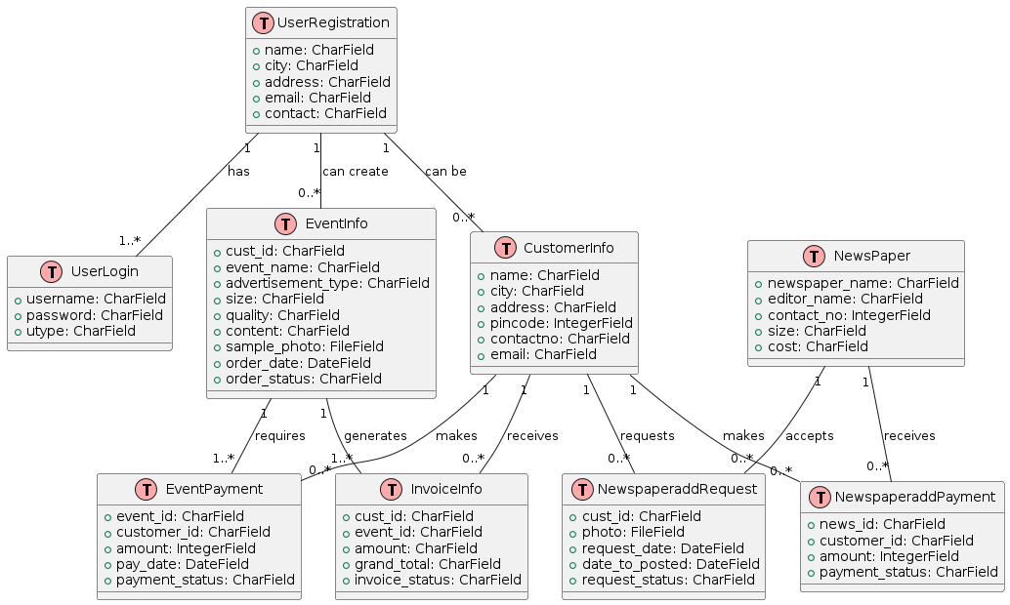

#### **3. Backend Development**

**Model Creation:**

**Process:**

* **Utilization:** Utilized Django's ORM to create models reflecting the database tables, simplifying database interactions and ensuring data integrity. This involved defining model classes, fields, and relationships.

**Outcome:**

* **Seamless Interaction:** Facilitated seamless interaction between the application and the database, streamlining data handling and operations.

**View Functions:**

**Activities:**

* **Development:** Developed view functions to handle various user actions such as create, read, update, and delete (CRUD) operations. This included writing logic to process user requests and interact with the database.

**Outcome:**

* **Core Logic Implementation:** Implemented core logic for the application's functionality, ensuring responsive and dynamic user interactions.

**Templates:**

**Integration:**

* **Usage:** Used Django templates to dynamically render HTML content based on the data from the database. This involved creating template files, passing context data, and using template tags.

**Outcome:**

* **Dynamic Interfaces:** Provided user-friendly interfaces displaying data dynamically, enhancing the user experience.

**APIs:**

**Development:**

* **Creation:** Created RESTful APIs to enable communication between the frontend and backend. This involved defining API endpoints, handling HTTP requests, and formatting responses in JSON.
* **Format:** Ensured data exchange using JSON format for asynchronous operations, facilitating smooth communication and data transfer.

**Outcome:**

* **Efficient Communication:** Enhanced user experience through efficient data handling and seamless frontend-backend communication.

#### **4. Frontend Development**

**Template Integration:**

**Activities:**

* **Integration:** Integrated Django templates with backend logic to dynamically generate content based on database data. This included creating and rendering templates, passing context data, and using template inheritance.

**Outcome:**

* **Real-Time Updates:** Ensured that the application's content was updated in real-time, providing an engaging user experience.

**User Interface (UI) Design:**

**Contribution:**

* **Design:** Assisted in designing intuitive and responsive UI using HTML, CSS, and JavaScript. This involved creating layouts, styling components, and adding interactive elements.

**Outcome:**

* **Improved Usability:** Improved the application's usability and user experience, ensuring it was easy to navigate and interact with.

**Form Handling:**

**Implementation:**

* **Development:** Developed forms for capturing user input with validation mechanisms to ensure data accuracy and completeness. This included creating form classes, handling form submissions, and implementing client-side and server-side validations.

**Outcome:**

* **Accurate Data Entry:** Ensured accurate and complete data entry before processing, enhancing data quality and reliability.

#### **5. Testing and Debugging**

**Unit Testing:**

**Activities:**

* **Writing Tests:** Wrote unit tests to verify the functionality of individual components, ensuring they work as intended. This involved using Django’s testing framework to create test cases and assertions.

**Outcome:**

* **Early Bug Identification:** Identified and resolved bugs early in the development process, improving the quality and stability of the application.

**Integration Testing:**

**Process:**

* **Testing:** Conducted tests to ensure seamless interaction between system components, validating their integration. This involved testing interactions between different modules and verifying data flow.

**Outcome:**

* **Module Cohesion:** Verified that different modules worked together correctly, ensuring the system's cohesiveness and functionality.

**System Testing:**

**Scope:**

* **End-to-End Testing:** Performed end-to-end testing of the entire system to validate its overall functionality and reliability under various conditions. This involved simulating real-world scenarios and user interactions.

**Outcome:**

* **System Reliability:** Ensured the system met all specified requirements and performed reliably in different scenarios.

**Bug Tracking:**

**Tools:**

* **Documentation:** Used bug tracking software to document, prioritize, and fix issues systematically. This involved logging bugs, assigning priorities, and tracking resolution progress.

**Outcome:**

* **Efficient Bug Management:** Managed and resolved bugs efficiently, maintaining system quality and performance.

#### **6. Documentation**

**User Manuals:**

**Creation:**

* **Development:** Developed step-by-step instructions for using the system, designed for end-users to navigate and perform tasks within the application. This included writing clear and concise instructions, adding screenshots, and providing troubleshooting tips.

**Outcome:**

* **User Self-Sufficiency:** Facilitated ease of use and user self-sufficiency, enabling users to operate the system without constant support.

**Technical Documentation:**

**Content:**

* **Documentation:** Documented system architecture, data models, and code structure, aimed at developers for insights into system design and implementation. This included creating architecture diagrams, API documentation, and code comments.

**Outcome:**

* **Development Reference:** Provided a reference for development and maintenance, ensuring continuity and ease of future enhancements.

**Deployment Guides:**

**Documentation:**

* **Outline:** Outlined the deployment process, including server setup, database configuration, and application integration. This included step-by-step instructions for setting up the environment, installing dependencies, and configuring the application.

**Outcome:**

* **Smooth Deployment:** Ensured smooth deployment and ease of future maintenance, providing a clear roadmap for setup and configuration.

#### **7. Deployment**

**Server Configuration:**

**Activities:**

* **Setup:** Configured the Apache server and MySQL database using XAMPP, ensuring proper integration with the Django application. This involved setting up the server environment, configuring settings, and ensuring security protocols were in place.

**Outcome:**

* **Stable Server Environment:** Established a stable server environment to host the application, ensuring it ran smoothly and efficiently.

**Database Setup:**

**Process:**

* **Import:** Imported the database schema and initial data into MySQL, running SQL scripts to create tables and populate them with initial data. This included setting up database users, defining permissions, and ensuring data integrity.

**Outcome:**

* **Foundation for Application:** Established the foundational data structure for the application, ensuring data was correctly set up and ready for use.

**Application Deployment:**

**Activities:**

* **Deployment:** Deployed the Django application, ensuring all dependencies were correctly installed and configured. This involved transferring code to the server, setting up the virtual environment, and configuring application settings.

**Outcome:**

* **Operational Application:** Made the application accessible from the local network, ensuring it was fully operational and ready for user access.

**Testing Post-Deployment:**

**Process:**

* **Comprehensive Testing:** Conducted thorough testing to verify the application's functionality, performance, and security post-deployment. This included performing system tests, load tests, and security assessments.

**Outcome:**

* **Reliable System:** Ensured the system met all requirements and operated reliably in the production environment, providing a stable and secure application for users.

Throughout the internship, I collaborated closely with supervisors and team members, actively participating in team meetings, code reviews, and brainstorming sessions. This collaborative environment significantly enhanced my learning experience and allowed me to contribute effectively to the project.

## 

## *Skills and Tools*

**1. Front-End Basics**

**HTML (Hypertext Markup Language):**

* **Structure Creation:** Learned to create the basic structure of web pages using HTML, including elements like headings, paragraphs, lists, links, images, and tables.
* **Semantic HTML:** Utilized semantic HTML tags to enhance the accessibility and SEO of web pages, ensuring that the content is meaningful and properly structured.

**CSS (Cascading Style Sheets):**

* **Styling Web Pages:** Applied CSS to style and layout web pages, focusing on properties such as color, typography, spacing, and alignment.
* **Responsive Design:** Implemented responsive design techniques using media queries to ensure that web pages look and function well on different devices and screen sizes.

**Bootstrap**

* **Pre-Designed Components**: Leveraged Bootstrap's pre-designed components, such as modals, tooltips, carousels, and navigation bars, to add interactivity and enhance user engagement.
* **Grid System**: Utilized Bootstrap's grid system to create responsive layouts that adapt seamlessly to different screen sizes and devices.
* **Responsive Utilities**: Employed Bootstrap's responsive utilities to hide, show, or adjust elements based on the screen size, ensuring a consistent user experience across all devices.
* **Custom Styles and Extensions**: Extended Bootstrap with custom CSS to tailor the appearance to specific project needs, and used Bootstrap's built-in classes to implement simple animations and transitions for a smoother user experience.

**2. Soft Skills**

**Creativity and Innovation:**

* **Unique Design Concepts:** Demonstrated the ability to generate creative and unique design concepts that engage users and enhance the visual appeal of the website.
* **Problem Solving:** Applied innovative thinking to solve design challenges and improve the overall user experience.

**Attention to Detail:**

* **Pixel-Perfect Designs:** Ensured that all design elements are precise and pixel-perfect, maintaining high standards of quality and consistency.
* **Quality Assurance:** Conducted thorough reviews and quality checks to identify and correct any design inconsistencies or errors.

**Communication:**

* **Design Presentation:** Effectively presented design ideas and concepts to team members and stakeholders, using clear and compelling visual aids.
* **Collaboration:** Collaborated closely with developers, project managers, and other team members to ensure that design specifications are understood and implemented correctly.

**Time Management:**

* **Project Prioritization:** Managed multiple design projects simultaneously, prioritizing tasks based on deadlines and project requirements.
* **Meeting Deadlines:** Demonstrated strong organizational skills by consistently meeting project deadlines and delivering high-quality work on time.

As a Web Designer Intern at Alpha Groups, you have played a crucial role in shaping the company’s online presence. Your designs directly impact how users perceive and interact with the website, making it an essential position for driving user engagement and satisfaction. Through this internship, you have gained hands-on experience in web design, user experience, and collaboration with a professional team. These experiences have set a strong foundation for your future career in web design, equipping you with the skills and knowledge necessary to excel in the field. Your contributions have not only enhanced your professional development but have also added significant value to Alpha Groups, demonstrating the importance of effective web design in achieving business goals and user satisfaction.

# ***Description of internship experience***

An internship is a period of practical training, typically offered by organizations or companies, to provide individuals with hands-on experience and exposure to a specific field or industry. It serves as a critical bridge between academic learning and professional employment, allowing students or recent graduates to apply their theoretical knowledge, develop essential skills, and gain valuable insights into their chosen profession. Internships often involve working on real projects, collaborating with professionals, and learning from experienced mentors, thereby offering a comprehensive learning experience.

During an internship, interns engage in various activities that mirror the tasks and responsibilities they would encounter in a full-time role within the industry. These experiences are invaluable as they help interns to understand the dynamics of the workplace, the expectations of employers, and the practical applications of their academic studies. Moreover, internships can be a stepping stone toward future career opportunities, enabling individuals to build a strong foundation in their desired field, develop a professional network, and enhance their resumes with relevant experience.

## *Benefits*

* **Practical Experience**: Interning in a software company allows you to gain real-world experience and apply the theoretical knowledge you've learned in your education. This hands-on experience can significantly enhance your skillset and make you more attractive to potential employers in the future.
* **Learning Environment**: Software companies often have a strong learning culture, providing you with opportunities to learn from experienced professionals. This exposure to new technologies, coding best practices, and industry standards can accelerate your growth as a programmer.
* **Exposure to Different Roles**: Working in a software company gives you exposure to various roles and responsibilities. This helps you understand different aspects of the software development lifecycle, and might help you discover your preferred area of specialization.
* **Professional Development**: Internships allow you to develop crucial professional skills such as time management, teamwork, problem-solving, and communication. These skills are highly transferable and valuable in any career path.
* **Networking Opportunities**: Internships provide an excellent chance to build professional connections with industry experts, mentors, and colleagues. Networking within a software company can open doors to future job opportunities, collaborations, and valuable references.
* **Resume Building**: Having an internship experience in a software company can significantly boost your resume. Employers often value practical experience, and it can make you stand out from other candidates during job searches.
* **Career Opportunities**: In today's digital world, there is a high demand for skilled programmers and developers. Learning to code can open up a wide range of career opportunities in tech-related fields.
* **Problem-solving skills**: Learning to code helps you develop logical thinking and problem-solving skills, which are useful in many areas of life, not just in programming.
* **Understanding technology**: In a world that is reliant on technology, understanding how to code gives you a deeper understanding of how software and systems work, making you more tech-savvy and adaptable.
* **Industry Insight**: Interning in a software company provides you with a first-hand understanding of how the industry operates. You can gain insights into the latest trends, methodologies, and technologies, which can help you align your career goals accordingly.

# ***Work Responsibilities During The Internship***

**Internship Role:** Intern as a Django Programmer.

Throughout my Internship, I on going various work responsibilities and task which were assigned by the staff and company. As an intern in a company, your work responsibilities will primarily revolve around learning and gaining practical experience in your chosen field. Here are some common work responsibilities you can expect during an internship with an introductory aspect.

A Django developer plays a crucial role in a project, responsible for building the server-side logic, database integration, and backend architecture using the Django framework. Their primary focus is to create a scalable, secure, and maintainable backend that supports the project's requirements. Here are some key roles and responsibilities of a Django developer in a project:

1. Backend Architecture: Design and implement the backend architecture using Django's Model-View-Controller (MVC) pattern.

2. Database Integration: Define database models, perform database schema migrations, and ensure data consistency using Django's ORM (Object-Relational Mapping) system.

3. Server-side Logic: Write Python code to implement business logic, authentication, authorization, and data processing.

4. View and Template Development: Create Django views and templates to handle HTTP requests and render dynamic web pages.

5. URL Routing: Define URL patterns to map URLs to appropriate views and templates.

6. Database Query Optimization: Optimize database queries for performance and efficiency.

7. Testing and Debugging: Write unit tests, integration tests, and debug code to ensure the backend functions correctly.

8. Deployment: Configure and deploy the Django application on cloud platforms, servers, or containers.

9. Security: Implement security measures to protect against common web vulnerabilities and ensure data privacy.

10. Collaboration: Work with frontend developers, designers, and project managers to ensure a cohesive and functional product.

By fulfilling these responsibilities, a Django developer creates a robust, scalable, and maintainable backend that supports the project's goals and provides a solid foundation for the application.

Internships provide an opportunity to apply theoretical knowledge into practical situations. By actively participating in work responsibilities, interns can learn new skills and improve existing ones. This can include technical skills related to programming languages, software development, data analysis, or any other field relevant to their internship.

# Designed Web Pages

* + 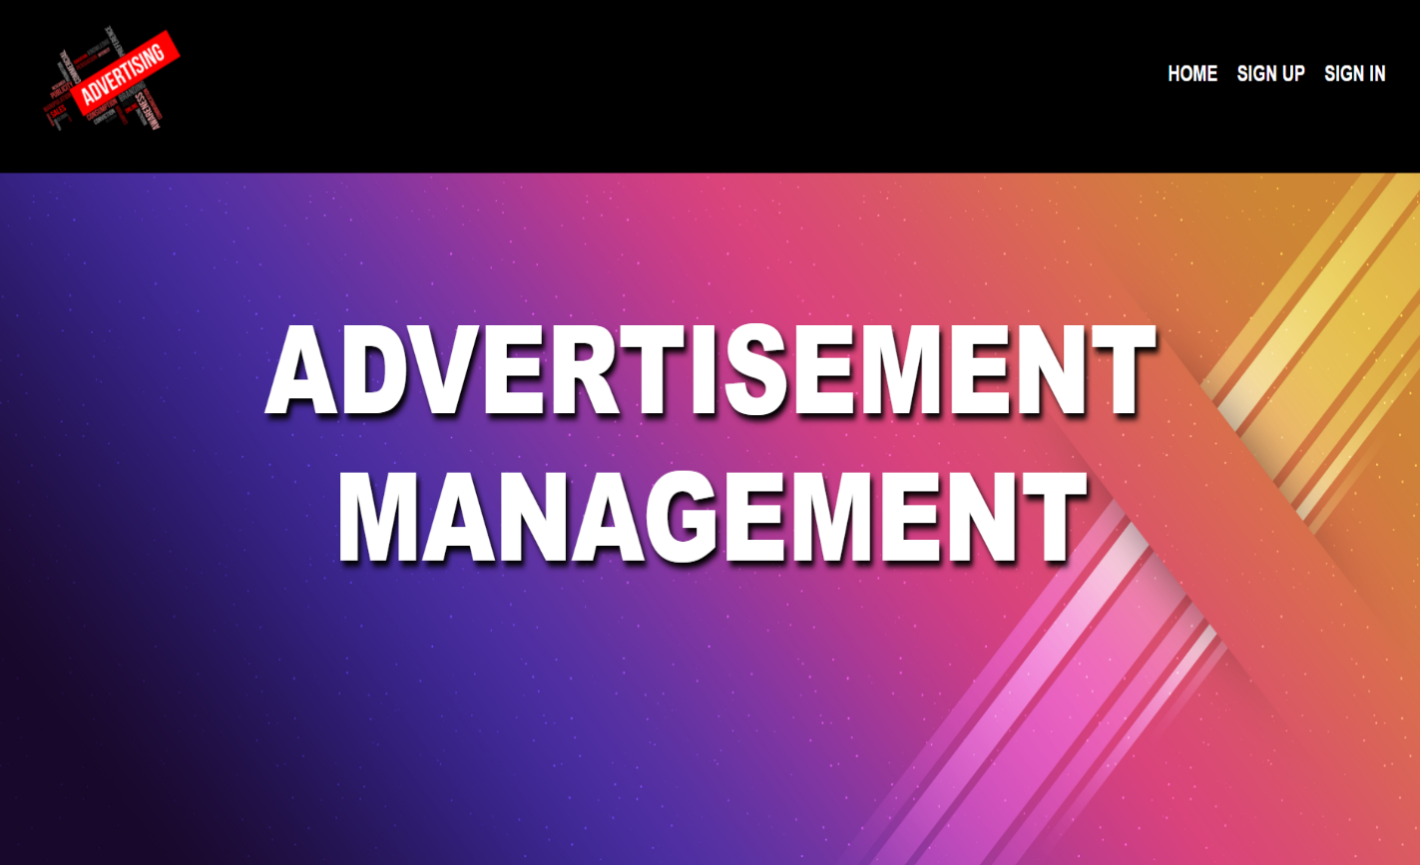Home Page
  + Admin Page



* Customer Home Page
* Login Page

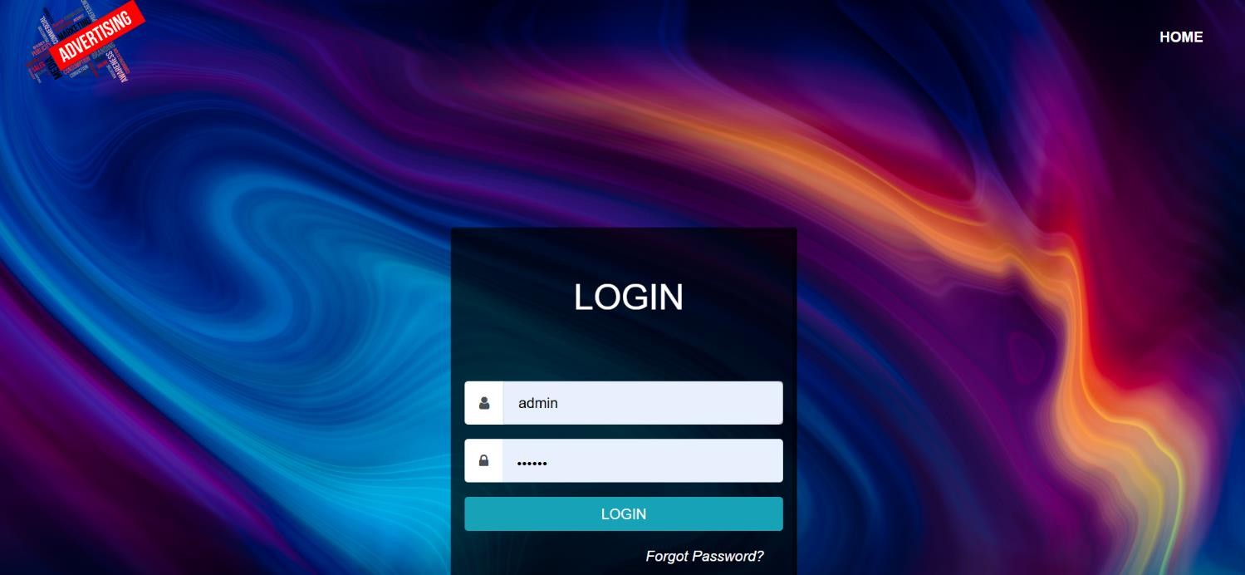

* + 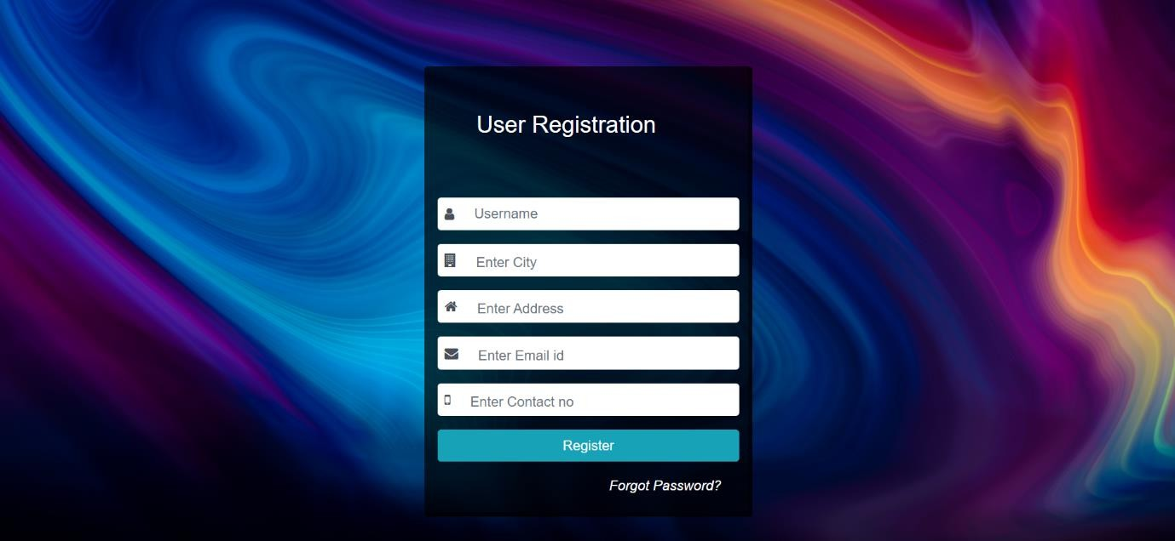User Registration Page

# **Designed Modules**

* + **User Management Module** : This module includes the User authentication(Login ,Logout) ,User Roles and Permissions (Admin, owner ,User) and User Profile Management.
  + **Customer Management Module :** This module includes the Customer Event Requests and newspaper ads requests.
  + **Dashboard and User Interface Module :** This Module includes the customizable user interfaces and User-friendly controls and visualizations.

# **Database Support**

* + Set up a MySQL database to store user information.
  + Designed a Database Schema with tables for User Registration , User login , Event Requests and newspaper ads requests.
  + Established connection between the webpages and the MySQL database using PHP

# **Testing and Validation Methods**

* + **System Testing :** Validates the complete and Integrated system to ensure it meets the specified requirements.
  + **Unit Testing :** Verifies individual components of the automation system work as intended.
  + **Integration System :** Ensures different modules and subsystems work together correctly

# **Challenges and Solutions**

* + - **Browser Compatibility:** Ensuring the web pages rendered correctly across different browsers (Chrome, Firefox, Edge) required thorough testing and adjustments to CSS properties.

**Responsive Design:** Implementing media queries and flexible layouts to accommodate smartphones, tablets, and desktops without compromising user experience.

## *Overview of project*

The primary goal was to align the project outcomes with the client's business goals by thoroughly understanding their needs and expectations. The front-end development was crucial in ensuring that the interface was intuitive, responsive, and accessible across different devices.

## 

## *Key Features*

**1. User Management**

**User Registration and Login:**

* **Allow Users to Create Accounts or Login Using Existing Credentials:** A straightforward registration process enables users to create accounts quickly using their email addresses. Additionally, users can log in using existing credentials from social media platforms like Google, Facebook, or LinkedIn, facilitating easier access.
* **Password Recovery and Management:** Secure options for users to recover forgotten passwords and manage account settings, ensuring a smooth user experience.

**User Profiles:**

* **Provide Personalized User Profiles:** Each user has a personalized profile where they can manage their personal information, order history, and account settings. Profiles also include options to save multiple shipping addresses and payment methods for convenience.
* **Manage Orders, Wishlists, and Payment Methods:** Users can view their order history, track current orders, manage their wishlist, and save preferred payment methods. This personalization improves user satisfaction and loyalty.

.

**Request Confirmation:**

* **Provide Users with Order Confirmation Details:** After completing a purchase, users receive an order confirmation via email and on the website. The confirmation includes order details, estimated delivery times, and tracking information, ensuring transparency and trust.

**2. Navigation**

**Navigation Menu:**

* **Include a Clear and Intuitive Navigation Menu:** A well-organized navigation menu provides easy access to different sections of the website, such as product categories, special offers, user account settings, and customer support. This intuitive layout enhances the overall user experience.

**3. Security and Performance**

**Implement Security Best Practices:**

* **Protect User Data and Payment Information:** Security is a top priority, with measures in place to protect user data and payment information. This includes SSL encryption, secure payment gateways, and adherence to industry standards for data protection.
* **Regular Security Audits:** Regular security audits and updates ensure that the platform remains secure against evolving threats.

# ***Skills you learned and the Experiences you had***

The internship provided me with a wealth of knowledge and practical experience in both technical and professional aspects. These skills and experiences were instrumental in my development and significantly enhanced my capabilities as a future professional in the field of web development and database management.

### Technical Skills

#### **1. Django Framework**

**Architecture and Components:**

**Understanding MVT Architecture:**

* **In-Depth Knowledge:** Developed a comprehensive understanding of Django's Model-View-Template (MVT) architecture, crucial for structuring web applications. This pattern effectively separates the data (Model), the user interface (Template), and the business logic (View), promoting clean and maintainable code.
* **Component Utilization:** Utilized Django's built-in components such as the admin panel, URL routing, forms, and the authentication system to manage application data, direct web traffic, handle user input, and manage user accounts and permissions. These components streamline the development process by providing pre-built solutions for common tasks.

**Creating Models:**

* **Mastery in Models:** Gained expertise in creating Django models to represent database tables, defining fields, setting up relationships (one-to-one, one-to-many, and many-to-many), and leveraging model methods for additional functionality.
* **Database Interactions:** Efficiently performed CRUD operations using Django's ORM, simplifying the process of writing and managing complex SQL queries. This abstraction layer allows for intuitive and Pythonic interactions with the database.
* **Migrations Management:** Managed database schema changes using Django’s migration system, creating and applying migrations to update the database schema in a controlled manner. This ensures smooth transitions between different versions of the database schema without data loss.

**Best Practices:**

**Code Organization:**

* **Adopted Best Practices:** Followed industry best practices for organizing Django projects, maintaining a clear and scalable project structure. This includes adhering to conventions for file and directory organization, separating settings for different environments, and using reusable apps to modularize the codebase.
* **Reusability:** Created reusable components and modules to streamline development and promote consistency across the application. This reduces redundancy and makes the codebase more maintainable and scalable.
* **Security Measures:** Implemented robust security practices using Django's built-in protections against SQL injection, cross-site scripting (XSS) attacks, cross-site request forgery (CSRF), and other common vulnerabilities. This ensures the application remains secure against potential threats.

# **Configuration of Django**

1. check your python version it should be 3.1.7 or less above 3.1.0
2. open pychram create new project in comfortable folder
3. open terminal type first command **pip install django==2.2.13** Django will be installed you will be able to see
4. in terminal now type command **django-admin startproject NameProject and enter**
5. you will able to see a new folder on you Nameproject which is your main django project folder
6. now in terminal type **cd Nameproject** and enter terminal will start pointing at that folder
7. type **dir and enter** you must able able to see manage.py file else their in is some mistakes'
8. now in terminal type **python manage.py startapp AppName** to create a app
9. you will able to see a new folder with AppName which inculdes 6 files. we are going to use only 2 files views.py and modules.py.
10. now in terminal type **python manage.py runserver**

# **file structure of Django**

create 4 new folders in project main folder thoes are templetes,static,media,assets

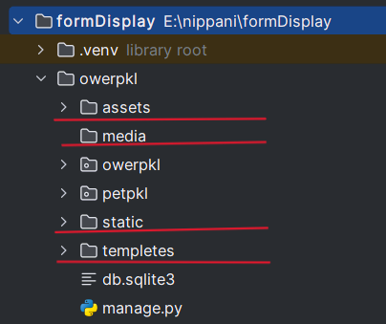

# **Project Settings chnages**

Add your App in INSTALLED_APPS

example : 'AppName'

INSTALLED_APPS = [

'django.contrib.admin',

'django.contrib.auth',

'django.contrib.contenttypes',

'django.contrib.sessions',

'django.contrib.messages',

'django.contrib.staticfiles',

'AppName'

]

# **Project Settings changes**

change Templates settings add this in line

os.path.join(BASE_DIR, 'templates')

TEMPLATES = [

{

'BACKEND': 'django.template.backends.django.DjangoTemplates',

'DIRS': ["templates"],

'APP_DIRS': True,

'OPTIONS': {

'context_processors': [

'django.template.context_processors.debug',

'django.template.context_processors.request',

'django.contrib.auth.context_processors.auth',

'django.contrib.messages.context_processors.messages',

],

},

},

]

# **Project Settings changes for static**

Go to settings.py file and paste the below code at the end of the file

STATICFILES_DIRS=[

os.path.join(BASE_DIR,'static')

]

STATIC_ROOT=os.path.join(BASE_DIR,'assets')

MEDIA_URL = '/media/'

MEDIA_ROOT = os.path.join(BASE_DIR,'media')

# **Configuration of Static files**

1. once the all above settings are done now open new terminal run this command
2. **python manage.py collectstatic**
3. you will see the that static all files will be configured to assests file

# **loading static files in Html**

1. To apply CSS and Bootstrap will need to load the static files which we just configured
2. open your html file form templates folder
3. in html file 2 line copy this line

**{%load static %}**

4. in html file where u find css/js/images add this statments

**before ----> href="css/fontawesome.min.css">**

**to change ---> href="{% static 'css/fontawesome.min.cs' %} ">**

**Important to note that only do this for static files not for internet links which starts with https example**

href="https://fonts.googleapis.com">

**don’t apply the notation for this kind of links**

# **Showindex views definition**

Go to the views.py file which will be inside your app folder and write the code example is below

def showindex(request):

return render(request, "index.html")

# **Showindex URLs perpartion**

Go to the urls.py file which will be inside your Project folder and write the code example is below

from django.conf.urls import url

from django.contrib import admin

from django.urls import path

from petpkl import views

urlpatterns = [

path('admin/', admin.site.urls),

url('showindex', views.showindex, name='showindex'),

]

Important NOTE : first write the url in urlpatterns then click on help option and import url and views to the page make sure views import only app name is mentioned if it as mentioned project name then remove it

# **run the application it should run successfully**

cd ProjectName

dir

once you type dir you must see manage.py file . if found then continue

python manage.py runserver

#### **2. Database Management**

**Designing Relational Databases:**

**Schema Design:**

* **Enhanced Schema Design:** Improved ability to design efficient and normalized database schemas, ensuring optimal performance and data integrity. This involves defining tables, columns, data types, constraints, and relationships to accurately reflect business requirements.
* **Data Modeling:** Developed comprehensive data models representing business requirements and relationships between entities, facilitating effective data management and retrieval.

**SQL Proficiency:**

**Complex Queries:**

* **Advanced SQL Proficiency:** Gained proficiency in writing advanced SQL queries involving joins, subqueries, and nested queries to retrieve and manipulate data efficiently. This skill is essential for performing complex data analysis and ensuring accurate data retrieval.
* **Transaction Management:** Learned to manage database transactions effectively, ensuring data consistency and integrity. This includes using SQL statements for transaction control such as BEGIN, COMMIT, and ROLLBACK to handle multi-step operations reliably.

**Normalization and Optimization:**

**Normalization Techniques:**

* **Applied Normalization:** Applied normalization techniques to reduce data redundancy and improve database efficiency, achieving up to the third normal form (3NF). This ensures that the database design minimizes redundancy and dependency, leading to a more efficient and maintainable structure.
* **Performance Optimization:** Implemented indexing and query optimization techniques to enhance database performance. This includes creating indexes on frequently queried columns and optimizing query execution plans to ensure quick data retrieval and efficient database operations.

# **Login and Database connection**

Go create login page and home pages according to the synopses modules or if have ready created in templates the paste the in templates

make sure in **login.html** you have label for and input name given as **t1,t2,t3 etc.** and **method POST**

and login button should to use href link like this

**href="{% url 'logcheck' %}"**

write in **login.html** page form must contain

**{% csrf_token %}**

And

**method="POST"**

# **Project Settings changes for database**

GO to settings.py file in project folder change Database settings to given below and **make sure you put your database name in NAME and you must have empty database in xampp on that name if not then create one with same name**

DATABASES = {

'default': {

'ENGINE': 'django.db.backends.mysql',

'NAME': 'intern', #give your database name

'USER': 'root',

'PASSWORD': '',

'HOST': '127.0.0.1',

'PORT': '3306',

}

}

# **Database connection**

* open Xampp and start apche and sql
* go to xampp dashbord and check you have empty database which you mentioned in settings.py if not create 1 and update settings.py
* once above all steps are clear then run this commands
* python manage.py makemigrations
* python manage.py migrate
* now run go in Xampp dashboard and check for database are loaded or not if loaded

# **Initial user and admin creation**

1. Go to xampp and start sql and apache
2. click on mysql admin you will get admin dashboard in browser
3. go to your database inside which you will see all tables
4. open login table which will be with name your app name and the login ex: **APPNAME_login**
5. now click on insert on top options and insert the id 1 as admin with userid and password and id 2 as user once done you can run the project and login now.

#### **3. Web Development**

**Full-Stack Development:**

**Backend Development:**

* **Comprehensive Backend Experience:** Acquired extensive experience in backend development using Django, handling data processing, business logic, and server-side operations. This includes developing view functions, managing URLs, and implementing application logic to meet business requirements.

**Frontend Development:**

**Frontend Technologies:**

* **HTML, CSS, and JavaScript:** Developed skills in frontend technologies to create responsive and interactive web interfaces. This involved designing user interfaces, styling web pages, and adding interactivity to enhance user experience.

**Frontend Frameworks:**

**Bootstrap:**

* **Responsive Design:** Used Bootstrap to create responsive designs, ensuring the application looks good on various devices. Bootstrap's grid system and pre-built components facilitate the development of mobile-friendly web applications.

**jQuery:**

* **Dynamic Content Handling:** Leveraged jQuery for dynamic content handling and enhancing user interactions on the frontend. This includes using jQuery for DOM manipulation, event handling, and

# **write views**

to create model first import

from django.http import HttpResponse

from .models import Student # Correctly import the Student model

from django.shortcuts import render

from django.http import HttpResponse**:**

* This line imports the HttpResponse class from Django's http module.
* HttpResponse is a class used to generate HTTP responses in Django views. It allows you to send a response back to the client with content like HTML, JSON, or plain text.

from .models import Student**:**

* This line imports the Student model from the current directory's models.py file.
* In Django, models are typically defined in a models.py file within each app. By importing Student, you can access the Student model class in your views to interact with the database.

from django.shortcuts import render**:**

* This line imports the render function from Django's shortcuts module.
* The render function is commonly used in Django views to render a template with context data and return an HttpResponse object. It simplifies the process of rendering templates and passing data to them

### 

## 

## Experiences Gained

#### **1. Client Interaction**

**Understanding Requirements:**

**Active Listening:**

* **Client Engagement:** Engaged with clients to understand their needs and expectations, practicing active listening and asking pertinent questions. This involves empathetic communication, attentiveness, and clarity in understanding client objectives.
* **Requirement Gathering:** Documented detailed client requirements to ensure the project aligned with their business goals and objectives. This includes creating requirement specifications, user stories, and acceptance criteria.

**Communicating Technical Information:**

**Simplification:**

* **Technical Communication:** Learned to communicate complex technical information to non-technical stakeholders, using clear and simple language. This involves translating technical jargon into understandable terms and providing relevant examples.
* **Demonstrations:** Conducted demonstrations and presentations to explain project updates and functionalities, ensuring client understanding and satisfaction. This includes preparing visual aids, live demos, and interactive sessions.

**Building Relationships:**

**Trust and Rapport:**

* **Client Relationships:** Built strong relationships with clients, ensuring open communication and fostering trust. This involves consistent communication, reliability, and responsiveness to client needs.
* **Client Satisfaction:** Prioritized client satisfaction by delivering high-quality results and addressing their concerns promptly. This includes proactive problem-solving, feedback incorporation, and exceeding client expectations.

#### **2. Agile Methodology**

**Iterative Development:**

**Feedback Integration:**

* **Iterative Improvement:** Embraced iterative development, incorporating regular client and team feedback to improve the project incrementally. This involves continuous refinement, testing, and adaptation based on feedback.
* **Adaptive Planning:** Adapted project plans based on changing requirements, ensuring the delivery of valuable and relevant features. This includes flexibility, responsiveness, and iterative planning.

**Scrum Practices:**

**Daily Stand-Ups:**

* **Team Alignment:** Participated in daily stand-up meetings to discuss progress, challenges, and plans, promoting transparency and team alignment. This involves concise updates, issue tracking, and collaborative problem-solving.
* **Sprint Planning:** Involved in sprint planning sessions to define and prioritize tasks for each iteration, ensuring focused and manageable workloads. This includes goal setting, task breakdown, and resource allocation.
* **Retrospectives:** Engaged in retrospectives to reflect on completed sprints, identifying areas for improvement and celebrating successes. This involves honest feedback, actionable insights, and continuous learning.

**Flexibility and Adaptability:**

**Prioritization:**

* **Effective Prioritization:** Learned to prioritize tasks effectively based on client feedback and evolving project requirements. This includes dynamic prioritization, resource management, and stakeholder collaboration.

**Continuous Improvement:** Embraced a mindset of continuous improvement, constantly seeking ways to enhance processes, workflows, and outcomes. This includes iterative refinement, proactive problem-solving, and a commitment to excellence.

## Overall, the skills and experiences gained during my internship were invaluable. They not only enhanced my technical and professional abilities but also prepared me for future challenges in the field of software development. The practical application of my academic knowledge in a real-world setting provided me with a solid foundation for my career.

## *Professional Development*

#### **1. Project Management**

**Planning and Scheduling:**

**Task Management:**

* **Efficient Task Planning:** Learned to plan and schedule project tasks efficiently, using tools like Gantt charts and project management software (e.g., Trello, Jira) to track progress and meet deadlines. This includes breaking down tasks into manageable units and assigning them based on priority and resource availability.
* **Time Management:** Developed strong time management skills, prioritizing tasks to ensure timely completion of project milestones. This involves setting realistic deadlines, avoiding procrastination, and managing interruptions effectively.

**Resource Allocation:**

**Team Coordination:**

* **Effective Resource Allocation:** Allocated resources effectively, ensuring tasks were assigned based on team members' skills and availability, maximizing productivity and efficiency. This includes assessing team strengths and workloads to optimize task assignments.
* **Risk Management:** Identified potential risks and developed mitigation strategies to minimize project disruptions. This involves proactive planning, regular risk assessments, and contingency planning.

**Communication:**

**Stakeholder Interaction:**

* **Clear Communication:** Communicated project goals, updates, and challenges clearly to stakeholders, ensuring everyone was aligned and informed. This includes regular meetings, status reports, and transparent communication channels.
* **Documentation:** Maintained comprehensive project documentation, including requirement specifications, technical designs, and user manuals, ensuring clarity and continuity. This documentation serves as a reference for current and future project stakeholders.

#### **2. Problem-Solving**

**Systematic Approach:**

**Problem Decomposition:**

* **Systematic Problem-Solving:** Developed the ability to break down complex problems into manageable parts, systematically addressing each component to find effective solutions. This involves analytical thinking, detailed planning, and iterative testing.

**Solution Development:**

**Innovative Solutions:**

* **Innovative Solutions:** Generated innovative solutions to technical challenges, applying critical thinking and technical expertise. This includes brainstorming, prototyping, and evaluating different approaches to identify the best solution.

**Debugging and Troubleshooting:**

**Tool Utilization:**

* **Efficient Debugging:** Used debugging tools like Django’s debugging toolbar and MySQL logs to identify and resolve issues efficiently. This includes setting breakpoints, inspecting variables, and analyzing logs to pinpoint and fix bugs.

**Root Cause Analysis:**

* **Root Cause Analysis:** Performed root cause analysis to understand and address underlying issues, ensuring long-term stability and reliability. This involves thorough investigation, identifying patterns, and implementing preventive measures.

**Critical Thinking:**

**Evaluation:**

* **Evaluative Thinking:** Evaluated different approaches and solutions, considering factors like feasibility, efficiency, and scalability. This involves comparing alternatives, assessing trade-offs, and selecting the most effective option.
* **Decision Making:** Made informed decisions based on a thorough analysis of available options, balancing short-term needs and long-term goals. This includes strategic planning, risk assessment, and stakeholder input.

#### **3. Collaboration**

**Teamwork:**

**Knowledge Sharing:**

* **Collaborative Environment:** Actively shared knowledge and insights with team members, fostering a collaborative and learning-focused environment. This includes mentoring, pair programming, and collaborative problem-solving.
* **Task Division:** Coordinated with team members to divide tasks effectively, ensuring balanced workloads and timely completion. This involves clear communication, role assignments, and mutual support.

**Code Reviews:**

**Constructive Feedback:**

* **Code Quality Improvement:** Participated in code reviews, providing and receiving constructive feedback to improve code quality and foster continuous improvement. This involves adherence to coding standards, identifying potential issues, and suggesting enhancements.
* **Best Practices:** Learned and implemented coding best practices from peer reviews, enhancing the overall quality of the project. This includes code readability, maintainability, and performance optimization.

**Conflict Resolution:**

**Mediation:**

* **Conflict Management:** Managed and resolved conflicts within the team, ensuring productive discussions and maintaining a positive working environment. This involves active listening, empathy, and negotiation skills.

## Consensus Building: Facilitated consensus-building processes, ensuring team alignment and collective decision-making. This includes fostering open communication, encouraging diverse perspectives, and finding common ground.

## *Career Goals and Future Contributions*

**1. Career in Web Development**

**Relation to Internship:**

* **Strong Foundation in Front-End and Back-End Web Technologies:** During my internship, I developed a comprehensive understanding of both front-end and back-end web technologies. This experience provided me with essential skills such as HTML, CSS, Bootstrap, and working with APIs, which are fundamental for building dynamic and responsive web applications. I also gained exposure to back-end development, enhancing my ability to create robust server-side functionalities.

**Future Contribution:**

* **Develop High-Quality, User-Centric Web Applications:** With the skills and knowledge acquired, I am well-equipped to create high-quality web applications that prioritize user experience. I understand the importance of designing interfaces that are not only aesthetically pleasing but also intuitive and user-friendly. My ability to focus on user-centric design will ensure that the web applications I develop meet users' needs and expectations.
* **Contribute to Growth and Innovation of Future Employers:** My solid foundation in web development positions me to contribute effectively to the growth and innovation of any future employer. I can leverage my skills to develop innovative solutions that drive business progress. By staying updated with the latest trends and technologies in web development, I can help my future employers stay competitive and deliver cutting-edge web applications.

**2. Role in Web Designing**

**Relation to Internship:**

* **Practical Experience with Web Concepts and Tools:** During my internship, I applied web concepts and tools in practical projects, gaining valuable hands-on experience. This practical application of theoretical knowledge allowed me to understand the nuances of web design and development. I learned how to use various design tools and frameworks to create visually appealing and functional web interfaces.

**Future Contribution:**

* **Analyse Data and Build Predictive Models:** My experience with web design also involved working with data. I developed the ability to analyze data and build predictive models that can inform design decisions. This skill is crucial for creating data-driven designs that enhance user engagement and satisfaction. By leveraging data analytics, I can contribute to designing web applications that are not only visually appealing but also highly effective in meeting user needs.
* **Contribute to Data-Driven Decision-Making Processes:** In future roles, I can play a key role in data-driven decision-making processes. By providing insights based on data analysis, I can help organizations make informed decisions that improve their web applications. My ability to interpret and utilize data effectively will be instrumental in driving successful web design strategies.

**3. Aspiration for Full-Stack Development**

**Relation to Internship:**

* **Combined Skills in Front-End and Back-End Development:** My internship allowed me to develop skills in both front-end and back-end development. I learned to work on the client side using technologies like HTML, CSS, and Bootstrap. This combination of skills has prepared me to handle full-stack development tasks, giving me a holistic understanding of web application development.

**Future Contribution:**

* **Capable of Handling End-to-End Development Processes:** With my full-stack development skills, I am capable of managing the entire development process, from initial design to final deployment. This end-to-end capability ensures that I can deliver comprehensive solutions that meet project requirements. My ability to oversee the entire development lifecycle will be valuable in delivering cohesive and well-integrated web applications.
* **Adaptable to Various Roles Within a Development Team:** My diverse skill set allows me to adapt to various roles within a development team. Whether it's working on front-end design, back-end logic, or integrating both, I can contribute effectively in multiple capacities. This flexibility makes me a versatile team member who can support different aspects of a project, ensuring its success.

**4. Long-Term Goal of Technical Leadership**

**Relation to Internship:**

* **Insights into Project Management and Team Collaboration:** Through my internship, I gained valuable insights into project management and team collaboration. I learned about the importance of effective communication, task delegation, and teamwork in achieving project goals. This experience provided me with a strong foundation in managing projects and leading teams towards successful outcomes.
* **Developed Leadership Potential Through Hands-On Project Experience:** By taking on responsibilities and actively participating in projects, I developed my leadership potential. I learned how to motivate and guide team members, resolve conflicts, and ensure that projects stay on track. These hands-on experiences have prepared me to take on leadership roles in my future career.

**Future Contribution:**

* **Prepared for Roles That Require Leading and Mentoring Development Teams:** With my leadership experience, I am ready to take on roles that involve leading and mentoring development teams. I can provide guidance, support, and direction to team members, helping them achieve their best performance. My ability to inspire and lead a team will be crucial in driving project success and fostering a positive work environment.
* **Drive Innovation and Technical Excellence in Future Organizations:** I am equipped to lead initiatives that promote innovation and technical excellence in future organizations. By staying abreast of the latest technological advancements and encouraging a culture of continuous improvement, I can help organizations achieve their strategic goals. My commitment to high standards and innovative solutions will contribute to the overall success and growth of the organizations I work with.

My internship experience has been instrumental in shaping my career goals and preparing me for future contributions in the field of web development, web designing, full-stack development, and technical leadership. The skills and knowledge I have acquired, combined with my practical experience, have equipped me to take on complex challenges and drive progress in any organization I join. I am excited to continue building on this foundation and look forward to contributing to the success of my future employers with dedication, innovation, and a commitment to excellence

# 

# ***Conclusion***

## *Conclusion*

The Advertisement Agency project was a significant learning experience that allowed me to apply my academic knowledge to a real-world scenario. Throughout the internship, I developed essential technical and professional skills that will be invaluable in my future career.

Looking forward, there are several ongoing considerations for the project:

1. **Scalability:** As the agency grows, the system needs to handle increased data volumes and user interactions. Continuous performance monitoring and optimization will be necessary to ensure scalability.
2. **Security:** Ensuring the security of the system is paramount, especially with sensitive client data being stored and processed. Regular security audits and updates are essential to protect against potential threats.
3. **User Feedback:** Gathering and incorporating user feedback will be crucial in improving the system's functionality and usability. This will involve regular updates and enhancements based on user needs and technological advancements.
4. **Maintenance:** Regular maintenance is required to keep the system running smoothly. This includes bug fixes, performance improvements, and adapting the system to new technologies and industry standards