**My Excel experience:**

**Sheet1:** Raw data (illustrated only sample data from the excel due to copyright issues)

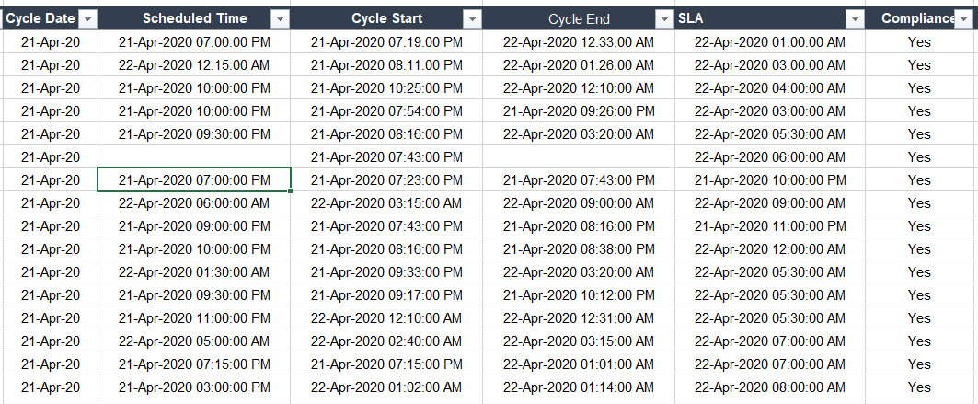

Sheet 2: Generating monthly data for trend and analysis

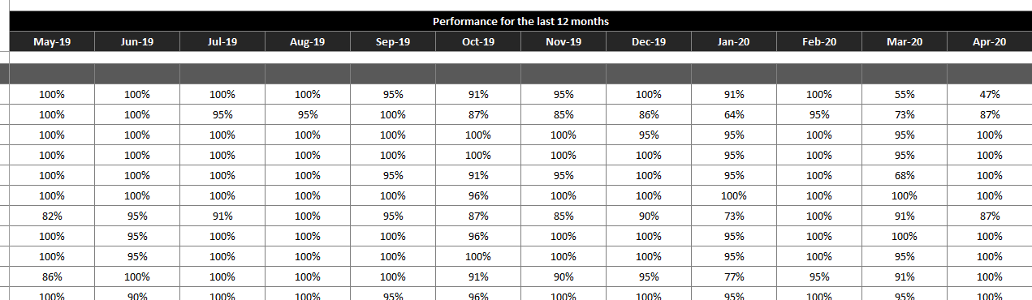

Sheet3: Generation of graphs

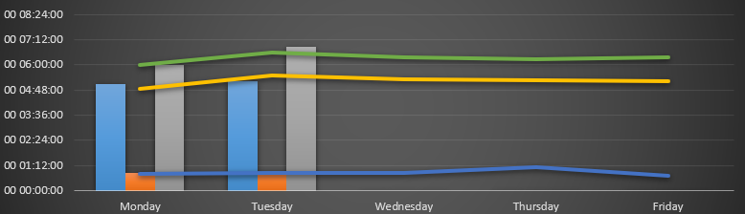

Sheet 4: Pivoting the data

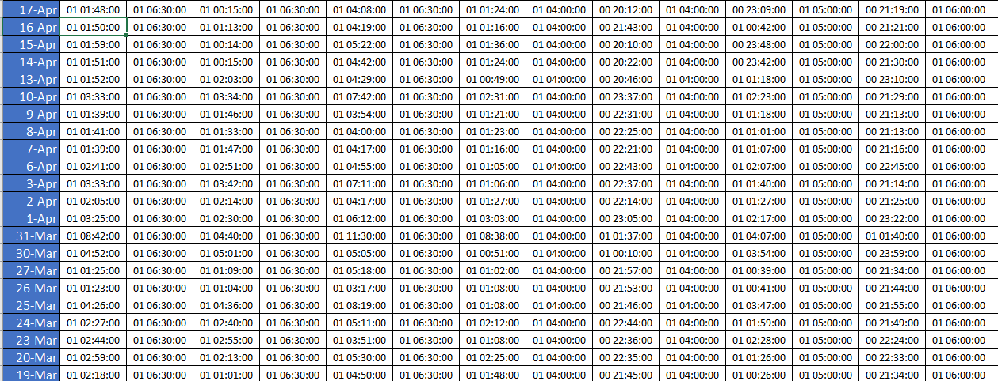

Sheet 5: Dashboard

