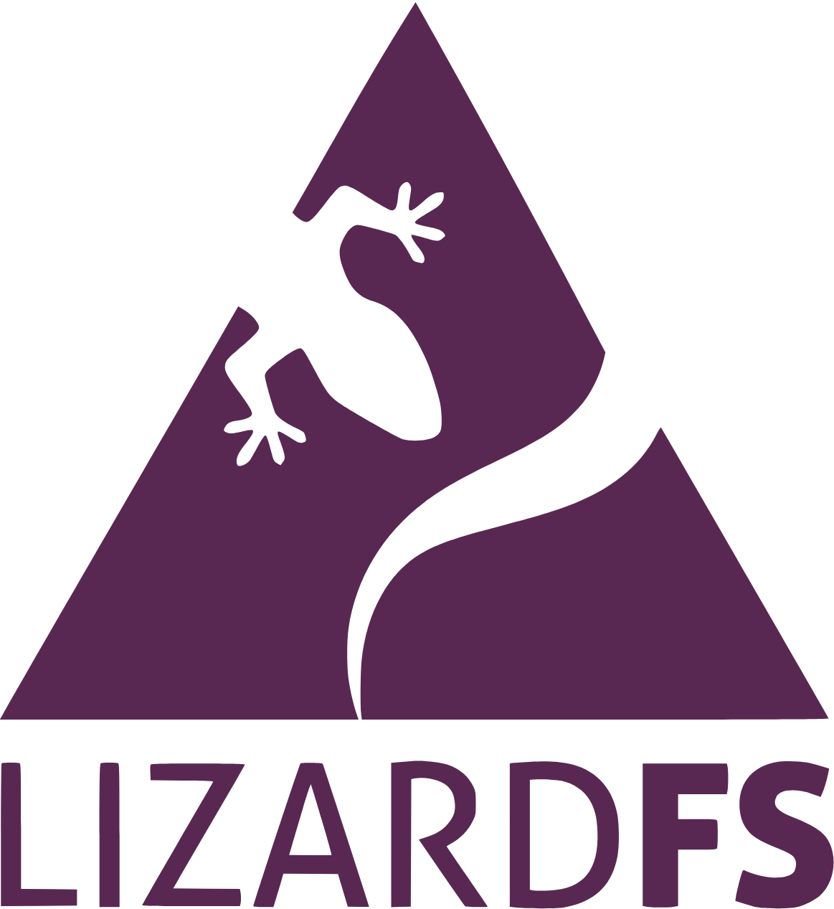

**LizardFS – LizardFS is an open source distributed file system that is POSIX-compliant and licensed under GPLv3. It was released in 2013 as fork of MooseFS. LizardFS is also offering a paid Technical Support (Standard, Enterprise and Enterprise Plus) with possibility of configurating and setting up the cluster and active cluster monitoring.**

**It is Software Defined Storage is a distributed, scalable, fault-tolerant, and highly available file system. It allows combining disk space located on several servers into a single namespace visible on Unix-like and Windows systems in the same way as other file systems. LizardFS was inspired by the GoogleFS distributed file system that was introduced in 2010.**

**PROJECT SUMMARY**

| **Website** | **https://lizardfs.com/** |
| --- | --- |
| **Organization** | **LizardFS** |
| **License** | **GPLv3** |
| **Open/Proprietary** | **Open** |
| **Source Path**  **Brief Description** | [**https://github.com/lizardfs/lizardfs**](https://github.com/lizardfs/lizardfs)  LizardFS – Software Defined Storage is a distributed, scalable, fault-tolerant, and highly available file system. It allows combining disk space located on several servers into a single namespace visible on Unix-like and Windows systems in the same way as other file systems. LizardFS was inspired by the GoogleFS distributed file system that was introduced in 2010. |

***PROJECT DETAILS :***

**Key Features:**

* **ERASURE CODING REPLICA**

Keeping several copies of each file is not space-efficient. Instead of doing that the Erasure Coding, divides each chunk of data into parts. It also creates additional parts called parity stripes which can easily recover missing parts of the original data, allowing the cluster to work efficiently in every condition. Depending on the configuration, this feature allows you to save even 70% of your storage capacity.

* **FAST SNAPSHOTS**

Copying large files can be done extremely efficiently by using the snapshot feature. When creating a snapshot, only the metadata of a target file is copied, speeding up the operation. Chunks of the original and the duplicated file are now shared until one of them is modified.

* **GEOREPLICATION**

Georeplication allows you to have data replicated between two data centers located in different geographical locations. With Georeplication you can decide where the data is stored. The topology feature allows for suggesting which copy should be read by a client in the case when more than one copy is available.

* **QOS REPLICATION**

LizardFS offers mechanisms that allow administrators to set read/write bandwidth limits for all the traffic generated by a given mount point, as well as for a specific group of processes spread over multiple client machines and mount points.

**Architecture :**

LizardFS keeps metadata and the data separately. Metadata is kept on metadata servers, while data is kept on chunk servers. Check up a typical installation on the scheme.

LizardFS makes files secure by keeping all the data in many replicas spread over all available servers. It can also be used to build affordable storage as it runs perfectly on commodity hardware. Disk and server failures are handled transparently without any downtime or data loss.

When storage requirements grow, you can scale up LizardFS installation just by adding new servers – at any time, without any downtime. Data chunks will be automatically moved to the new servers, as it is continuously balancing disk usage across all connected nodes.

Removing a server is just as simple and easy as adding a new one.

A set of chunk servers which store the data. Each file is divided into blocks called chunks (each up to 64 MB) which are stored on the chunk servers. A suggested configuration of a chunkserver is a machine with large disk space available either in a JBOD or RAID configuration. CPU and RAM are not very important. You can have as little as 2 chunk servers or as many as hundreds of them.

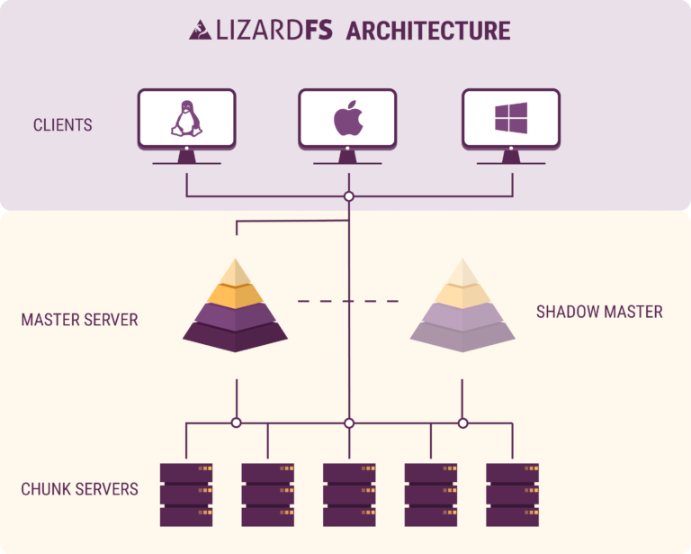



Products

**Technical Support and Maintenance :**

In LizardFS we have one goal: offer the best possible service quality. We operate globally providing 24/7 technical support from the best engineers who created LizardFS. We can help you improve the performance, configure and set up the system, train your team and most importantly remove critical and non-critical issues of the LizardFS data storage.

Have peace of mind with our helpful, passionate support team on standby.

* **We offer 3 types of LizardFS Technical Support**
* **Standard Technical Support:**

Monday-Friday 9-17 CET support

plus Standard maintenance package

* **Enterprise Technical Support:**

Monday-Friday 9-17 CET support

plus Premium maintenance package

* **Enterprise + Technical Support:**

24/7 support plus

Premium maintenance package

**REFERENCE :**

[**LizardFS official website**](https://lizardfs.com/)

[**LizardFS on GitHub**](https://github.com/lizardfs/lizardfs)

[**LizardFS official documentation**](http://docs.lizardfs.com/)