AWS HEALTHCARE DATASET
PREPROCESSING WORKFLOW
Amazon S3 → VPC / IAM → Amazon SageMaker → Processed Dataset
Practical Implementation Documentation
Prepared by: Deepak P
Register Number | 722824148013
Roll Number | 24AM013
Register No.: 722824148013 | Roll No.: 24AM013
Secure storage and preprocessing of a healthcare dataset for Machine Learning.
Note: AWS-console-style visuals are illustrative reconstructions, not screenshots from a live AWS account.

Objective
To design an AWS-based workflow that securely stores a healthcare dataset in Amazon S3 and prepares it for Machine Learning using an Amazon SageMaker notebook. The workflow handles missing values, encodes categorical attributes, scales numerical features, and stores the processed dataset back in S3.

Cloud Infrastructure Design
Healthcare CSV → Amazon S3 → SageMaker in VPC / Private Subnet → Data Preprocessing → Amazon S3
Supporting security: IAM execution role, restricted S3 permissions, encryption, and controlled network connectivity.
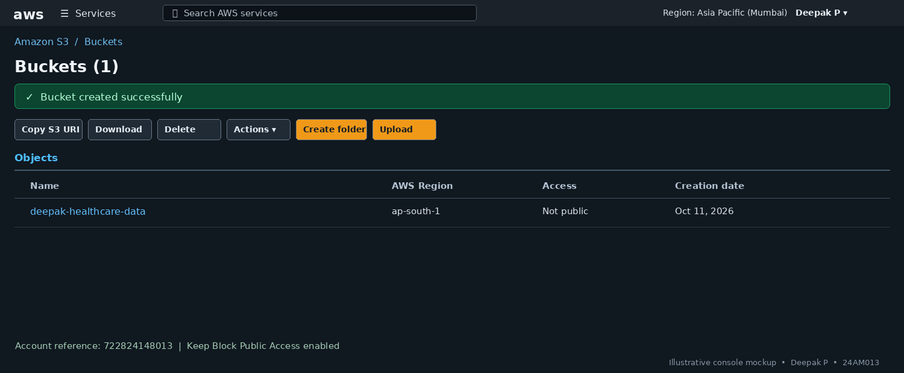
Documentation note: The console-style visuals in this report are illustrative. Replace them with actual screenshots from your AWS account if implementation proof is required.

Step 1: Create an Amazon S3 Bucket
What was done: Create a private S3 bucket to store the original healthcare CSV file. Upload the dataset, keep Block Public Access enabled, and enable encryption.
Outcome: The original dataset is stored in S3 and is ready for authorized access.
Implementation note: Choose a globally unique bucket name and the required AWS Region.

Step 2: Configure IAM Permissions
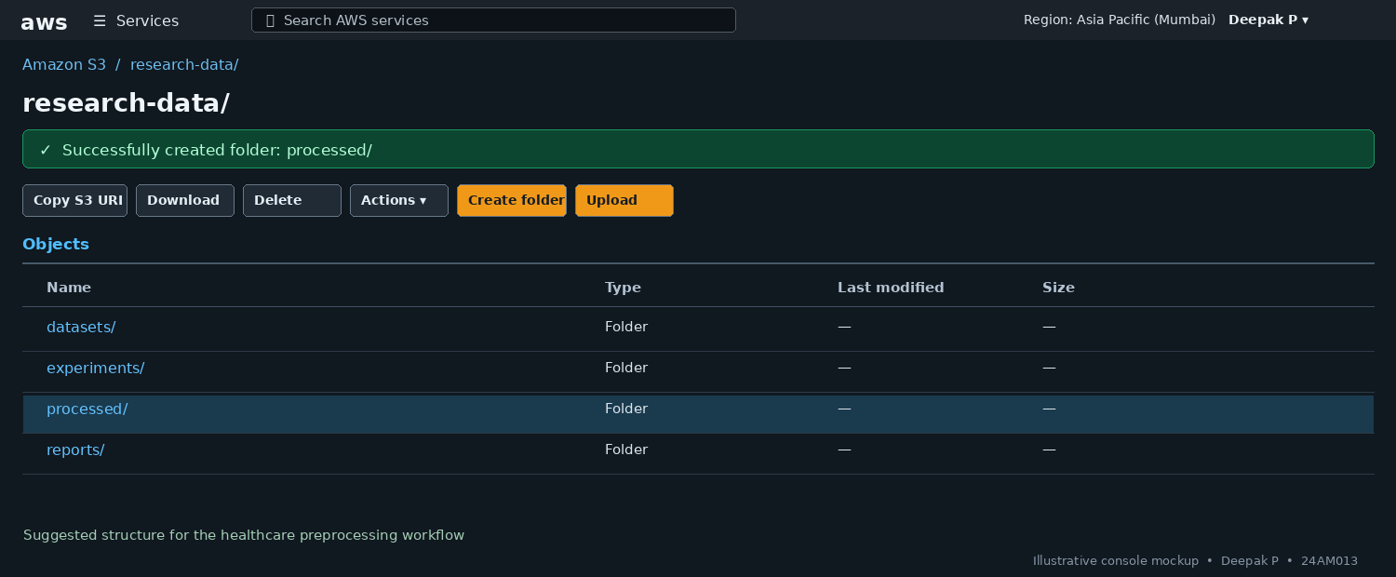
What was done: Create or select an IAM execution role for SageMaker. Grant only the permissions needed to read the source dataset and write the processed output to the required S3 locations.
Outcome: SageMaker has controlled access to the required S3 objects without embedding long-lived access keys in notebook code.
Implementation note: Follow least privilege; avoid broad administrator permissions.

Step 3: Configure a VPC and Private Subnet
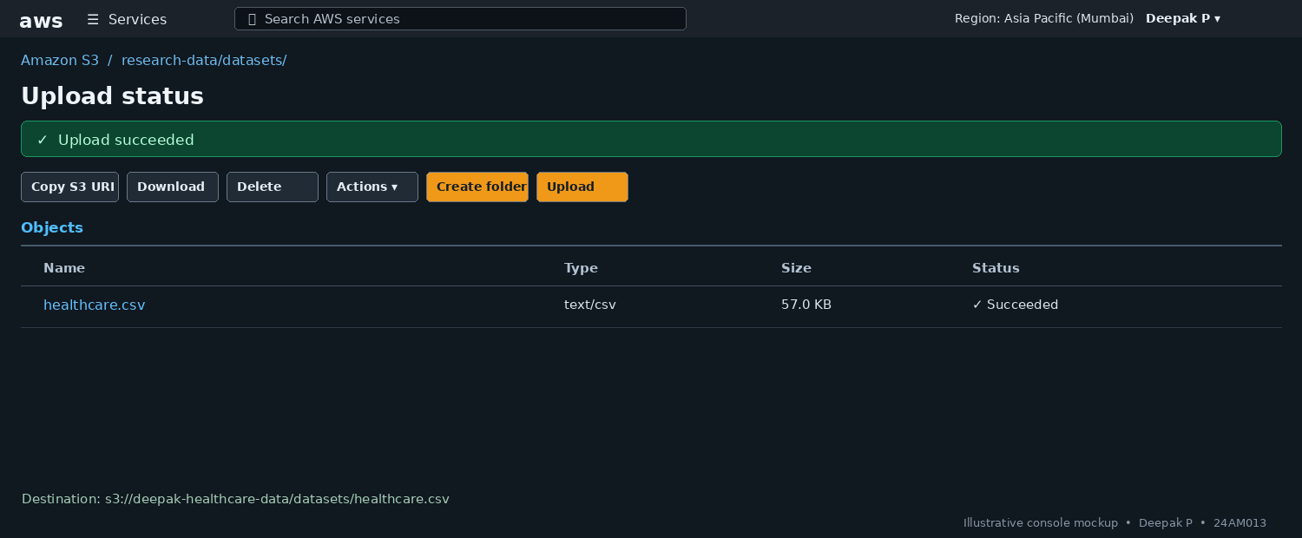
What was done: Create or select a VPC and configure a private subnet for the notebook environment. Review route tables, security groups, and connectivity to S3. An S3 VPC endpoint can provide private connectivity.
Outcome: The network design isolates resources and defines how they access required AWS services.
Implementation note: A subnet is private because of its routing and access configuration, not just its name.

Step 4: Launch the SageMaker Notebook
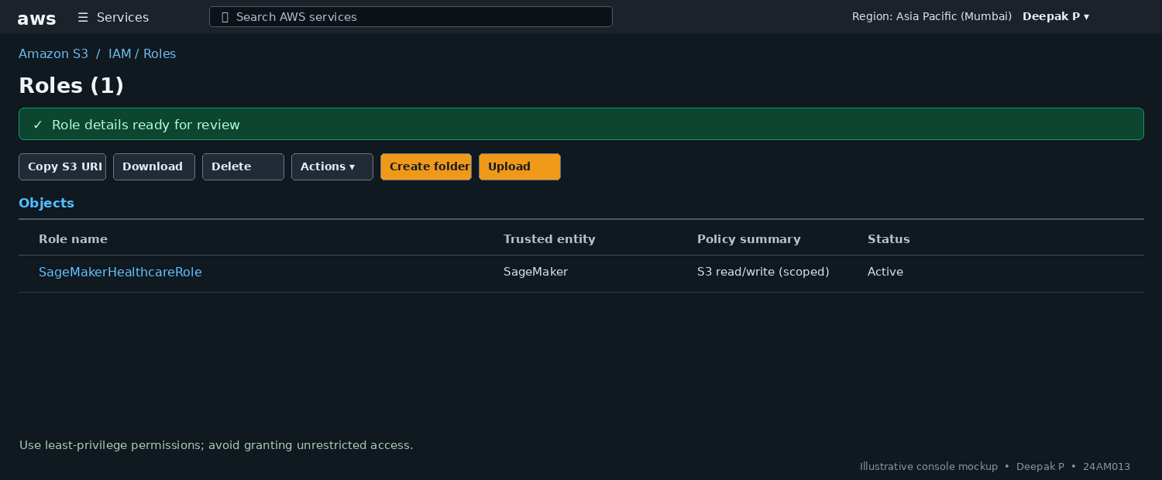
What was done: Create a SageMaker notebook environment or a suitable SageMaker Studio environment. Assign the IAM role and select the intended VPC and subnet settings where supported.
Outcome: A notebook environment is available to run Python code and preprocess the dataset.
Implementation note: Console options vary by notebook type and AWS account configuration.

Step 5: Load and Inspect the Dataset
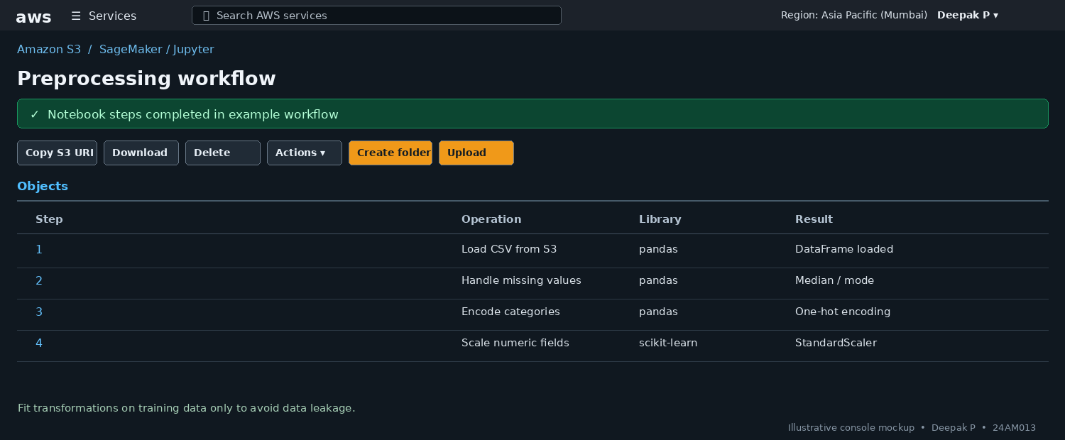
What was done: Use Pandas to load the CSV file from S3. Inspect the first rows, column names, data types, missing values, and duplicate records.
Outcome: The dataset structure and data-quality issues are identified before transformation.
Implementation note: Example: pd.read_csv('s3://your-bucket-name/healthcare.csv'). Replace the bucket and object key.

Step 6: Handle Missing Values
What was done: Use a suitable strategy for missing data. For numerical columns, a median or mean may be used; for categorical columns, the mode or a dedicated missing category may be appropriate.
Outcome: Missing values are handled using a strategy suitable for each column.
Implementation note: Choose the method based on the meaning and distribution of the data.

Step 7: Encode Categorical Attributes
What was done: Convert categorical fields into numerical representations using an appropriate encoder, such as one-hot encoding or ordinal/label encoding when the category meaning supports it.
Outcome: Categorical attributes are represented in a form suitable for the selected ML algorithm.
Implementation note: Avoid treating nominal categories as ordered values unless that order is meaningful.

Step 8: Scale Numerical Features
What was done: Use StandardScaler or MinMaxScaler on appropriate numerical input features. Fit the scaler on the training split only and reuse it for validation/test data.
Outcome: Numerical input features are scaled consistently for downstream model development.
Implementation note: Exclude identifiers and target labels from scaling unless there is a specific justified reason.

Step 9: Save the Processed Dataset to S3
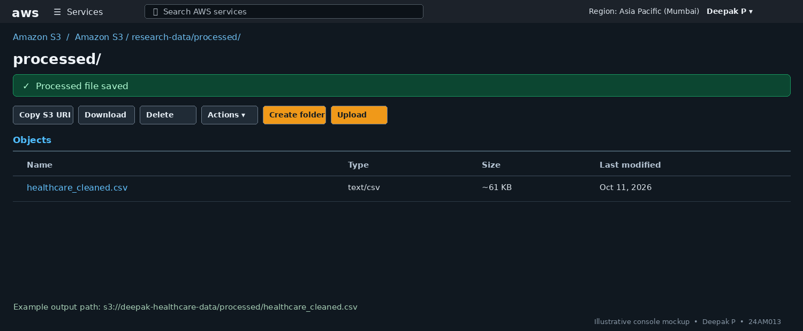
What was done: Save the cleaned dataset to a separate S3 prefix, for example processed/healthcare_cleaned.csv. Verify the output object exists and can be accessed by authorized users.
Outcome: The processed dataset is stored in S3 for subsequent Machine Learning development.
Implementation note: Use a separate output path so the original source file remains unchanged.

Example Preprocessing Code
The following is a compact example to adapt in a configured SageMaker notebook. Replace the S3 bucket and key with your own values. Review the dataset columns before applying encoders and scalers.
import pandas as pd
from sklearn.preprocessing import StandardScaler

df = pd.read_csv('s3://your-bucket-name/healthcare.csv')

# Fill missing values
for col in df.select_dtypes(include='number').columns:
df[col] = df[col].fillna(df[col].median())
for col in df.select_dtypes(include='object').columns:
if df[col].notna().any():
df[col] = df[col].fillna(df[col].mode().iloc[0])

# Encode categorical columns
df = pd.get_dummies(df, drop_first=True, dtype=int)

# Scale numeric input features only after separating target/IDs
# Example assumes all remaining numeric columns are features:
numeric_cols = df.select_dtypes(include='number').columns
scaler = StandardScaler()
df[numeric_cols] = scaler.fit_transform(df[numeric_cols])

df.to_csv('s3://your-bucket-name/processed/healthcare_cleaned.csv', index=False)
Note: For a real model pipeline, split training and test data before fitting imputers, encoders, or scalers. Do not use patient identifiers as model features, and do not expose sensitive health information.

Final Result
The proposed AWS workflow stores the healthcare dataset in Amazon S3, provides controlled access through IAM, uses a VPC/subnet design for network isolation, and processes the data in a SageMaker notebook. The cleaned and transformed dataset is saved back to S3 for Machine Learning model development.

Final Verification Checklist
- S3 bucket exists and contains the source dataset.
- Block Public Access and encryption settings are reviewed.
- SageMaker execution role has only required S3 permissions.
- VPC, subnet, routing, security groups, and S3 connectivity are checked.
- Notebook can load the CSV from S3.
- Missing-value handling is completed and checked.
- Categorical encoding is applied appropriately.
- Numerical scaling is applied without data leakage.
- Processed output exists at the intended S3 prefix.

Conclusion
This practical design demonstrates how AWS storage, identity, networking, and SageMaker can be combined to prepare a healthcare dataset for Machine Learning. The workflow emphasizes secure storage, controlled access, data quality, suitable feature transformations, and saving a reusable processed dataset.

