**Configuration of Git-SCM on local machine**

1. **Create a directory or folder in any drive.**
2. **Go to directory and right click and choose Git Bash here**

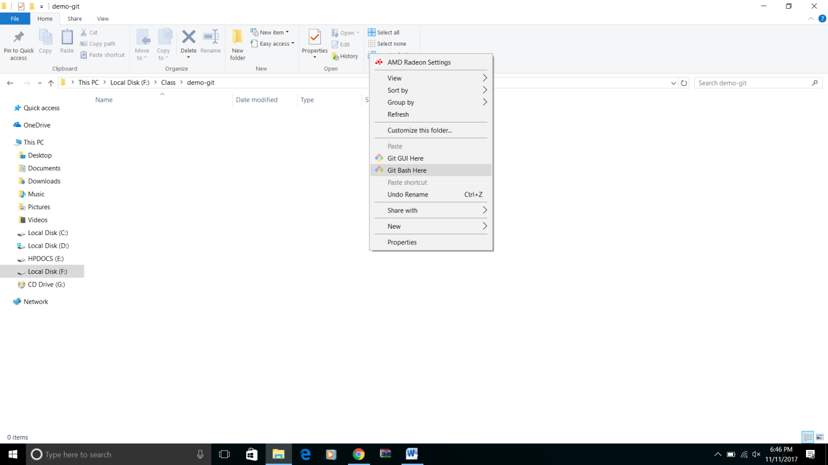

1. **Execute below commands**
2. git config –global user.name “<username>”

Ex: git config --global user.name "Retheshks"

**Note: User name is same as git account user name**

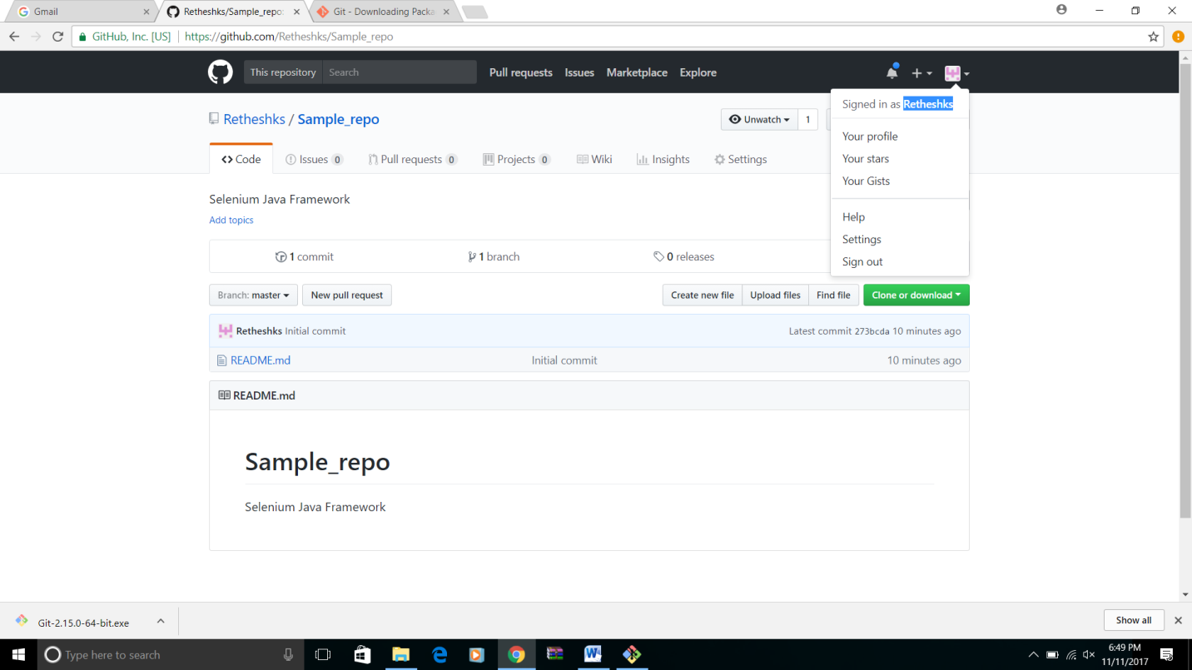

1. git config --global user.email “<email address>"

Ex: git config --global user.email “[retheshks78@gmail.com](mailto:retheshks78@gmail.com)”

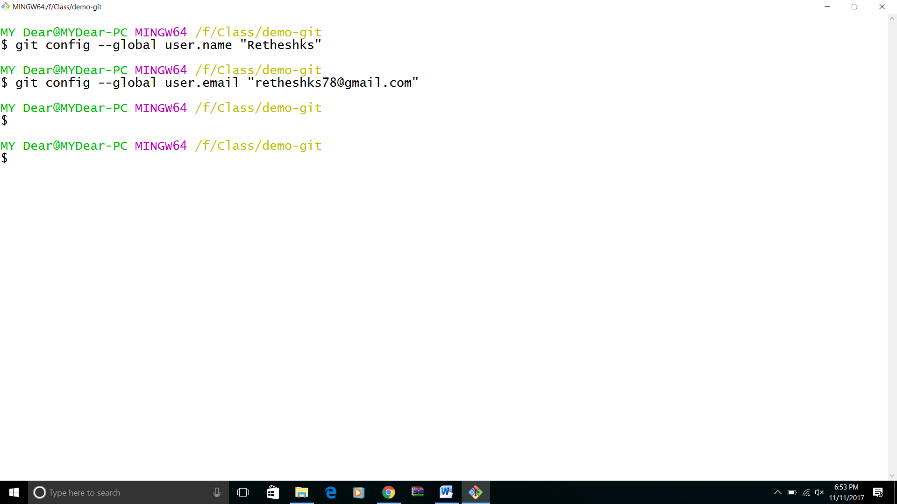

Steps to handle git repository

1. Clone git repository to local

a. In git bash execute below command

git clone <repository URL >

Ex: git clone https://github.com/Retheshks/Sample_repo.git

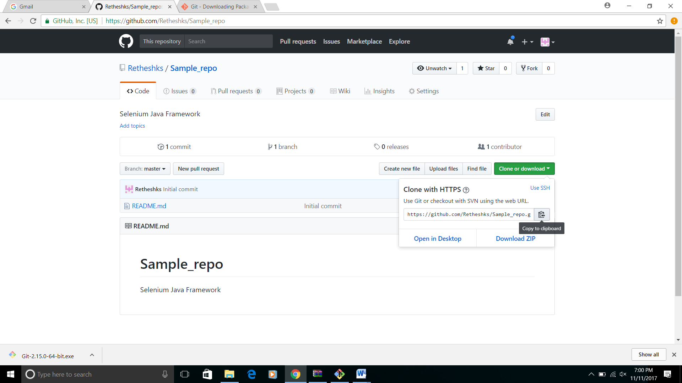

2. Change directory

Ex: cd sample_repo

3. Got to git bash and create branch using below command

git checkout –b <branch _name>

Ex: git checkout –b dev/rethesh/S13245

Branch_name dev/username/user_story or scenario ID

4. Import project to eclipse

5. Modify or add test script using eclipse

6. Add modified files or newly created files by running below commands

git add <file path>

Ex: git add src/com/test/Demo.java

7. Commit the changes by running below commands

git commit –m “<commit_message>”

Ex: git commit –m “Added new test case”

8. Push changes to git hub repository by running below command

git push origin <branch_name>

Ex: git push origin dev/rethesh/S13245

