SMART ATTENDANCE SYSTEM

# Deepak Patidar*1, Anurag Yadav*2, Ayushman Raghuwanshi*3, Deepesh Tolani*4

*1,2,3,4Department Of Computer Science And Engineering, Acropolis Institute Of Technology And Research, Indore, Madhya Pradesh, India.

# ABSTRACT

In this era of technology, every day new technology makes its debut in the market. Face recognition-based authentication is one among them. This technology uses facial video or image for detection. Facial authentication can be used in many fields such as authentication, face recognition-based attendance, government document verification, and many more. Here, we develop a project which can be used to detect the face of an enrolled student and mark the attendance of that student. In this project we used a cascade classifier of OpenCV for face detection, a CSV file for marking the attendance of the detected faces . we use Tkinter for the GUI part of the project . This project can be used for schools and colleges . The class coordinator can be the admin and enroll student in the app, after enrollment attendance can be taken which will saved in the CSV file.

**Keywords:** GUI, Tkinter, CSV, Cascade Classifier, Opencv, Face Detection, Numpy, Pandas.

# INTRODUCTION

The traditional method of taking attendance is quite time taking and tedious sometime. The teacher have to call the names of students one by one to mark the attendance, this cause a waste of time for student as well as teacher . In this project we tried to solve that problem by using technology named as facial detection based authentication. This project consists of two stages:

1. The admin enroll the student by taking facial video and save the profile of the student. The profile is seaved in the CSV file and stored in the student details folder . The photos captured in video are saved in training image folder.
2. After enrollment the admin take the attendance of the student and the details were saved in attendance folder.

In this way this face-recognition based attendance system can reduce the time which were being wasted in traditional method of taking attendance.

# METHODOLOGY

The working model of the project is shown below using data flow diagram:

## Tools and technology :

* **Python :** It is used to built the backend of the project.
* **Tkinter :** Is is a GUI used to build to build frontend of the project.

## Libraries used :

* OpenCV: OpenCV is a library of programming functions mainly aimed at real-time computer vision.
* Numpy: NumPy is a library for the Python programming language, adding support for large, multi- dimensional arrays and matrices, along with a large collection of high-level mathematical functions to operate on these arrays.
* Pandas: pandas is a software library written for the Python programming language for data manipulation and analysis
* Haarcascade_frontalface_default: This 'XML' file contain a pretrained model that was created through extensive training.

## Tools used :

1. Pycharm IDE: JetBrains pycharm is a Python IDE for data science and web development.

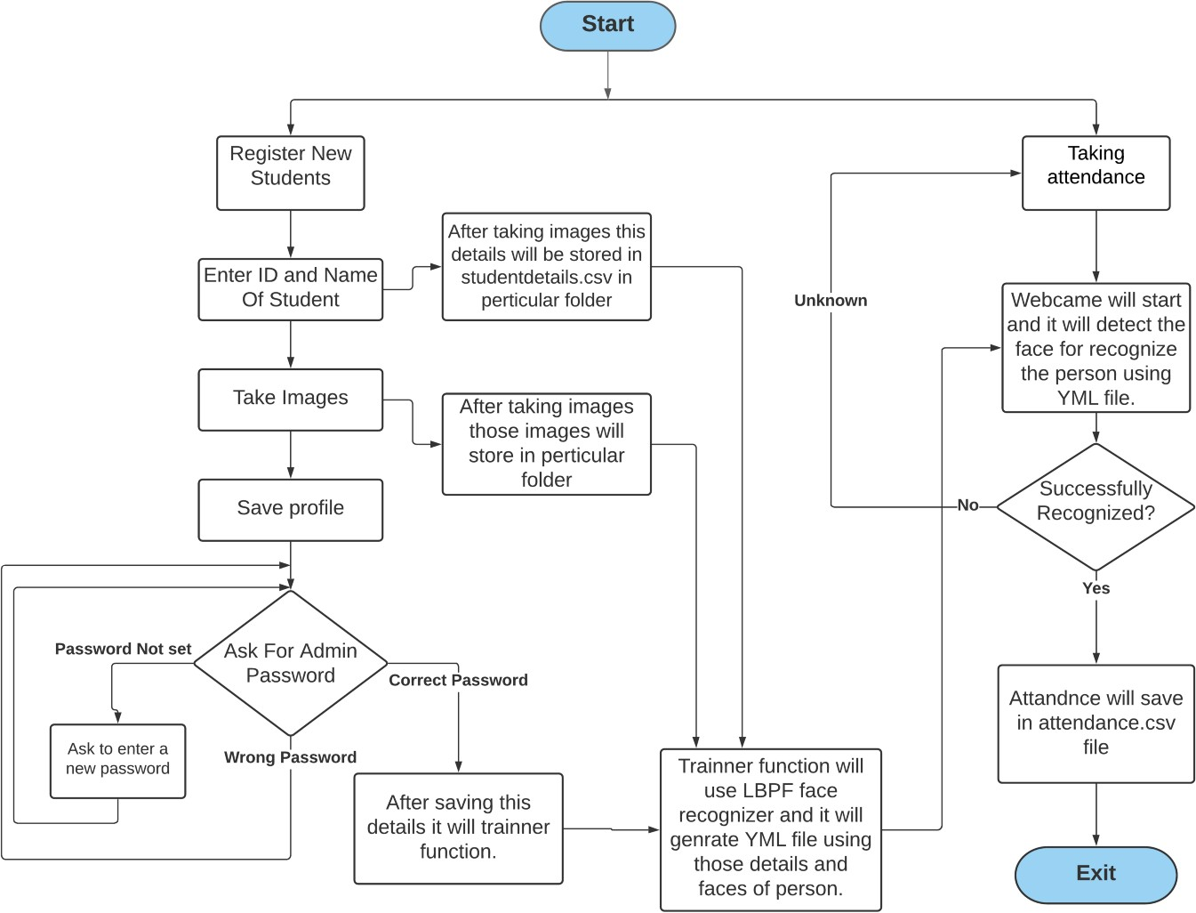

**Data flow diagram**

# PROPOSED DESIGN AND OVERVIEW OF THE PROJECT

We have divided this project into four parts :

1. **GUI**: In this project, We made one simple GUI using the python Tkinter library so that the nontech background person can also use it . Tkinter is the standard GUI library for Python.

For making this GUI we mainly used Tkinter’s frames, button, message box , table pack function ,menubar, label, textbox, etc. We divide our GUI main screen into two parts , one is for Registration and the second is for taking attendance.

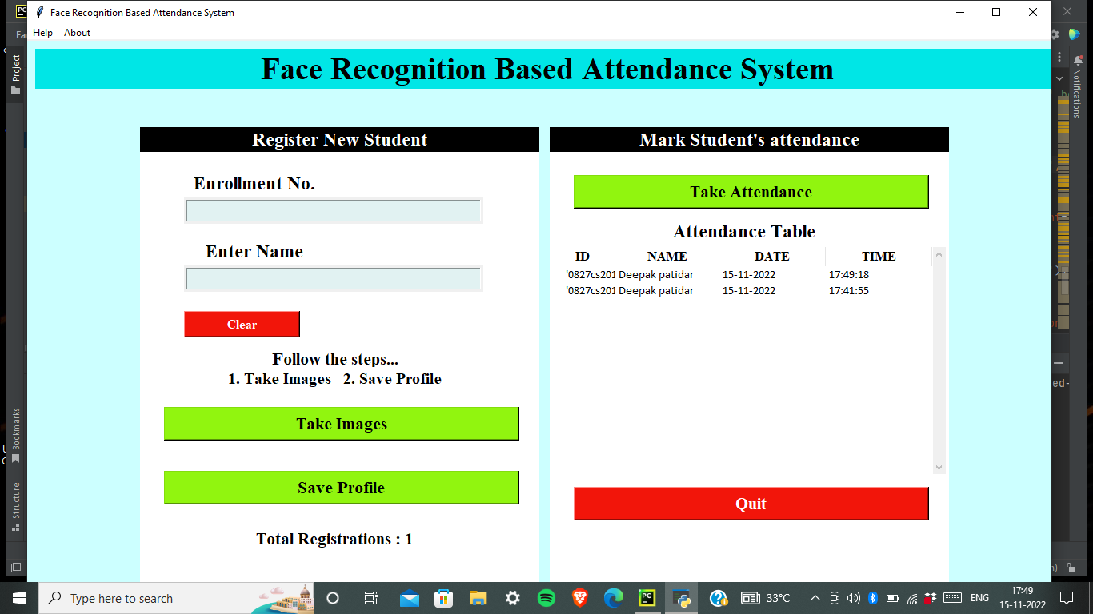

1. **Take Images**: We use OpenCV library to capture video and used a cascade classifier of OpenCV for face detection. To use this cascade classifier we need the haarcascade_frontalface_default.xml file which includes all the haar cascade features of a face.

When the admin enter the detail of the student and click on take images button the camera of the system opens and record the video. After taking the video the camera shuts automatically and the photos of the student will be saved in trained image folder.

1. **Save profile**: After taking the images the admin has to save the profile so that the details of the student get saved in the CSV file. At first, it ask for the password if the password entered is correct then the details of the student get saved in a CSV file. After saving the profile the number of registered students is shown below the save profile button.
2. **Take attendance**: The admin now can take the attendance of the registered student by clicking on the take attendance button. The camera will open and if the student in the camera frame is registered then his/her attendance is marked in CSV file.

# CONCLUSION

The purpose of this project is to make an alternative for the traditional attendance system. It helps the teachers to save time in taking attendance by calling names of student one by one . This face recognition based attendance system helps to increase the accuracy and speed of taking attendance. The attendance record were saved in csv file so there is no need of paperwork ,hence it saves institutes from the burden of storing tons of paper.

# REFERENCES

1. N. Sudhakar Reddy, MVSumanth, S. Suresh Babu, "The Counterpart Approach to Attendance and Feedback System uses Machine Learning Techniques", Journal of Emerging Technologies and Innovative Research (JETIR), Volume 5, Issue 12, Dec 2018.
2. Dan Wang, Rong Fu, Zuying Luo, "Classroom Attendance Auto-management Based on Deep Learning", Social Sciences Development, Humanities Education and Research, volume 123, ICESAME 2017.
3. Akshara Jadhav, Akshay Jadhav, Tushar Ladhe, Krishna Yeolekar, "Automatic Travel System Using Face Recognition", International Research Journal of Engineering and Technology (IRJET), Volume 4, Issue 1, Jan 2017.
4. B Prabhavathi, V Tanuja, V Madhu Viswanatham and M Rajashekhara Babu, "A clever system of presence to see the face in the same way", IOP Conf. Series: Materials Science and Engineering 263, 2017.
5. Prajakta Lad, Sonali More, Simran Parkhe, Priyanka Nikam, Dipalee Chaudhari, "Student Travel Program Using Iris Discovery', IJARIIE-ISSN (O) -2395-4396, Vol -3 Issue-2 2017.
6. “Navigation System Using NFC Technology and Camera Embedded on Mobile Device” (Bhise, Khichi, Korde, Lokare, 2015).