PYTHON : Points to Remember

1.All \* 3 -> AllAllAll

2. // operator -> quotient or Integer division

3.Precedence :

Arithmetic operators -> \*\* (power) % // / \* - +

Logical operators -> not and or

4. First line of traceback show: file location, line no., block of code within which it was executed or <module> if none

5. continue (got to next iteration) and break statements only inside for and while loop.

6. mathematician Carl Friedrich Gauss. When Gauss was a boy, a teacher wanted to give the class some busywork. The teacher told them to add up all the numbers from 0 to 100. Young Gauss came up with a clever trick to figure out the answer in a few seconds.

Young Gauss figured out a way to solve the problem in seconds. There are 50 pairs of numbers that add up to 101: 1 + 100, 2 + 99, 3 + 98, and so on, until 50 + 51. Since 50 × 101 is 5,050, the sum of all the numbers from 0 to 100 is 5,050.

There are 49 combinations in the range 1-100 that gives sum as 100 and the remaining to numbers 50 and 100 sums up to give 150. So, 49\*100 = 4900+150 = 5050.

7. for loop always adds, so to go reverse give step as negative no. ->

for i in range(5, -1, -1):

    print(i)

8. print has 2 keyword parameters : end and sep .

print('Hello', end='')  
print('World')

HelloWorld

9. To modify a global variable withing a local scope, use global keyword before the variable.

10.in exception handling, if the interpreter catches an exception on a line within try block, the program jumps to the except block and continues forward without executing the remaining lines of code, in any, which where we between the line that caused the exception and the except block.

11. ['X', 'Y', 'Z'] \* 3 >>> ['X', 'Y', 'Z', 'X', 'Y', 'Z', 'X', 'Y', 'Z']

12. return value from range(4) is a sequence value

13. >>> cat = ['fat', 'gray', 'loud']  
 >>> size, color, disposition = cat

14. for index, item in enumerate(supplies):

15. random.choice(List), random.shuffle(List)

16. The del statement is good to use when you know the index of the value you want to remove from the list. The remove() method is useful when you know the value you want to remove from the list.

17. sort() uses “ASCIIbetical order” rather than actual alphabetical order for sorting strings.

18. You can also split up a single instruction across multiple lines using the \ line continuation character at the end.

print('Four score and seven ' + \  
      'years ago...')

19. If you have only one value in your tuple, you can indicate this by placing a trailing comma after the value inside the parentheses. Otherwise, Python will think you’ve just typed a value inside regular parentheses

20. When passing lists and dictionaries as parameters, remember that python passes them as references instead of values.

21. copy.copy() : make a new copy of a list with same contents but different IDs. The contents of the list will have same reference. Each index of the new list points to the contents of original list . If these old contents are edited, it will be reflected in both lists. However, deleting one of the old contents from either of the list will only delete the reference of that list to that element and so the content will still be referenced to the other list.

http://pythontutor.com/live.html#mode=edit

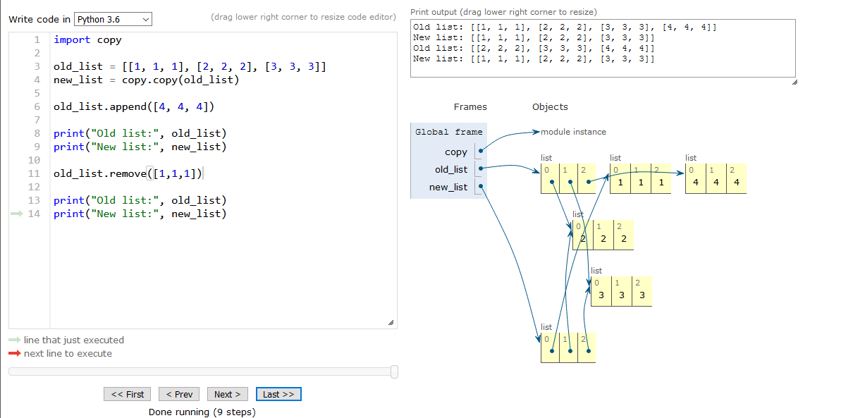

22. copy.deepcopy() creates a new list of same contents altogether where the contents are stored in new created objects rather than pointing to the contents of the original list.

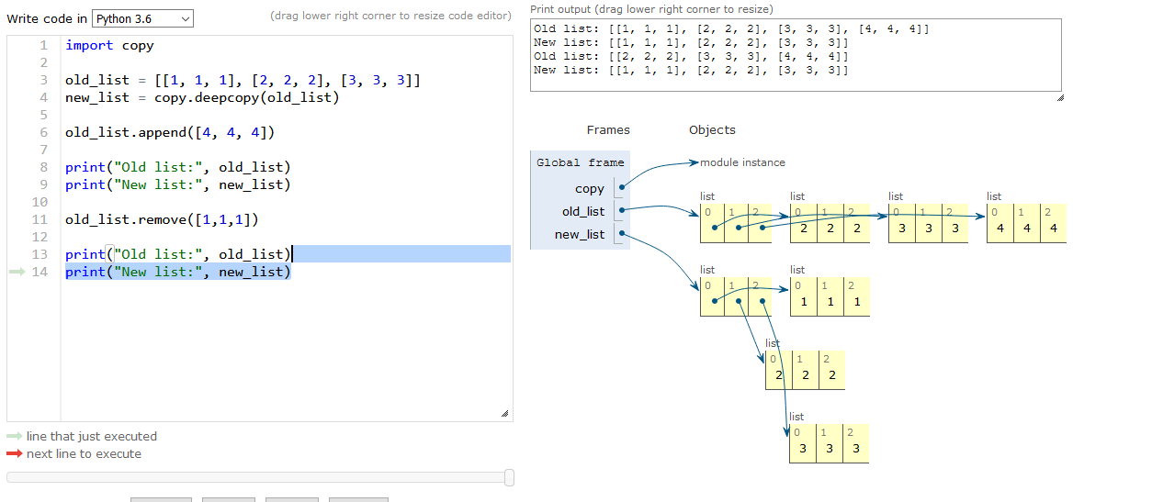

23. >>> 'Hello'.center(20, '=')  
'=======Hello========'

24.string interpolation:

>>> 'My name is %s. I am %s years old.' % (name, age)  
'My name is Al. I am 4000 years old.'

f-strings:

>>> f'My name is {name}. Next year I will be {age + 1}.'  
'My name is Al. Next year I will be 4001.'

Raw strings:

print(r'That is Carol\'s cat.')  
That is Carol\'s cat.

25. print('''Dear Alice,

Eve's cat has been arrested for catnapping, cat burglary, and extortion.

Sincerely,

Bob''')

26. ord('A') >>> 65 | chr(65) >>> 'A'

27. Python’s regular expressions are greedy by default, which means that in ambiguous situations they will match the longest string possible. The non-greedy (also called lazy) version of the braces, which matches the shortest string possible, has the closing brace followed by a question mark.

28. The regular expression \d+\s\w+ will match text that has one or more numeric digits (\d+), followed by a whitespace character (\s), followed by one or more letter/digit/underscore characters (\w+). The findall() method returns all matching strings of the regex pattern in a list.

