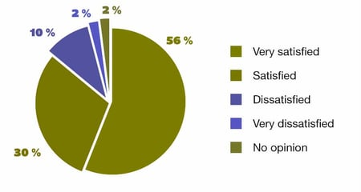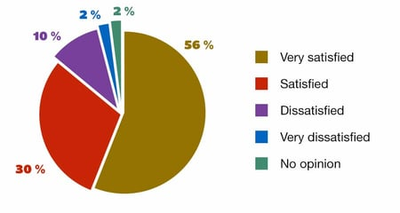

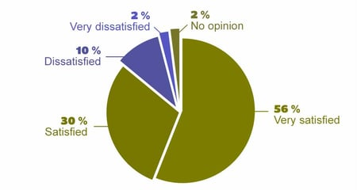

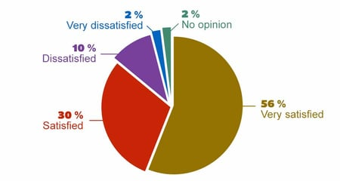





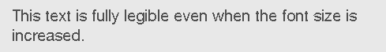

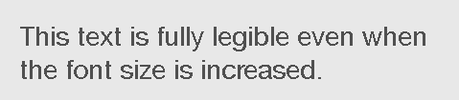

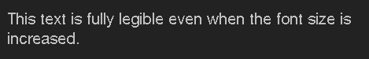



Many deaf or hearing-impaired people can’t get the full benefit of video or audio content unless it is subtitled and/or transcribed.





Our main objective is to make a responsive website as a template to encourage web-developers to make websites accessible to normal people as well as physically disabled  people.

This will enrich interaction of any user with the online environment without any barrier of any disability.