**TRIBHUVAN UNIVERSITY**

**INSTITUTE OF ENGINEERING**

Kathmandu Engineering College

Department of Computer Engineering



Minor Project Proposal

On

COMPUTER VISION BASED VIRTUAL KEYBOARD

[Code No: CT 654]

By

Deepak Thapa KAT078BCT029

Sudyumna Mishra KAT078BCT083

Sujan Malakar KAT078BCT085

Kathmandu, Nepal

2081

**ABSTRACT**

Computer-vision based virtual keyboard is a virtual keyboard system that uses computer vision technology to track and interpret the movements of user’s fingers or hands and allows the user to type on virtual keyboard displayed on a screen or projected surface. The project aims to create a reliable and efficient input method for situations where a physical keyboard is not available or convenient. Computer-vision based virtual keyboard is developed using Python, employing modules of OpenCV. This system uses OpenCV, a computer vision library in Python for hand detection, capturing video from a camera and preprocessing the video stream. Mediapipe is used for accurately interpreting hand movements and gestures through its pre-trained models and components. This project will use Agile Development Model. The program detects users input by opening the webcam and drawing as well as detecting hand landmarks. After that the program detects patterns made by fingertips of user and performs various tasks like Navigation, Input of Key, Volume Control and Brightness Control on the pattern made as well as features like Autocorrect and Word recommendations. With this, computer vision-based keyboard provides a flexible and adaptable input solution for various needs, ranging from accessibility and mobility to education, gaming and healthcare.

***Keywords:*** *Computer Vision, OpenCV, Agile Development Model. Python, Mediapipe*

**TABLE OF CONTENTS**

ABSTRACT…………………………...………………………………………………ii

LIST OF ABBREVIATIONS………………………………………………………....iv

LIST OF FIGURES………………………………………………………………..…..v

CHAPTER 1: INTRODUCTION……………………………..……………………….1

* 1. Background Theory……………...……………………………..……………....1

1.2 Problem Statement……………………………………………………………...2

1.3 Objective……………………………………………………………………..…3

1.4 Scope and Applications……………………………………………………...….3

CHAPTER 2: LITERATURE REVIEW………………………….…………………...4

2.1 Existing Systems……………………………………………..............................5

2.2 Limitations of Previous System…………………………………………….…..6

2.3 Solutions Proposed by Our System...…………………………………………...6

CHAPTER 3: METHODOLOGY……………………………….……………………7

3.1 Process Model…………………………………………….……………………7

3.2 System Block Diagram……………………………………...............................9

3.3 Algorithm……………………………………………………………………..11

3.4 Flowchart……………………………………………………………………..12

3.5 Tools to be used……………………………………………………………….13

CHAPTER 4: EPILOGUE……………………………………………………………14

4.1 Expected Output……………………………………………………………...14

4.2 Gantt Chart……………………………………………………………………14

REFERENCES…………………………………………………….............................15

**LIST OF ABBREVATIONS**

AR: Augmented Reality

CNN: Computer Neural Network

CV: Computer Vision

FPS: Frames Per Second

GUI: Graphics User Interface

ML: Machine Learning

OpenCV: Open-Source Computer Vision Library

VR: Virtual Reality

**LIST OF FIGURES**

Figure 1: Agile Model

Figure 2: System Block Diagram

Figure 3: Hand Landmarks defined by Google Mediapipe

Figure 4: Flowchart

**CHAPTER 1: INTRODUCTION**

* 1. **BACKGROUND THEORY**

In recent years, there have been many advancements in the input method using keyboard. Virtual keyboards have evolved from traditional physical keyboards due to advancements in technology. These advancements offer more flexible, efficient, versatile and intuitive input method to interact with the PC.

A virtual keyboard is a software component that allows the input of characters without the need of physical keys. Interaction with a virtual keyboard happens mostly via a touch screen interface but can also take place in a different form when in virtual or augmented reality. Virtual keyboards are commonly used on touch screen devices like smartphones and tablets. There are various types of virtual keyboards like touch screen-based keyboard in which user interact to the virtual key through touch which are commonly used in smartphones tablets and touch screen laptops. Projected keyboards like laser projection keyboard projects keyboard layout into the flat surface where user type by tapping the projected keys where sensors detect the input. Gesture based keyboard detect finger and hand movements in the air and translate them into keyboard input.

**1.1.1 MACHINE LEARNING**

Machine Learning is a field of study in Artificial Intelligence concerned with development and study of statistical algorithms that can learn from data and generalize to unseen data, and thus perform tasks without explicit instructions. ML is used in various field including natural language processing, speech recognition, email filtering, health sector, etc. One of such field that ML is used is Computer Vision.

**1.1.2 COMPUTER VISION**

Computer Vision is a field in Artificial Intelligence that uses machine learning and neural networks to teach computer to derive meaningful information from visual inputs such as digital images, videos, etc and perform various actions on basis of those input and programs logic. It is a branch of both AI and ML where the AI can observe, recognize and understand the actions of a body based on its movement, pattern and special characteristics. Computer Vision has been used in various fields including military, autonomous vehicles, medicine, etc where Pattern Recognition is used to detect, observe and understand actions in real time or digital images/videos.

**1.1.3 VIRTUAL KEYBOARD USING COMPUTER VISION**

Computer vision based virtual keyboard is an advanced input method which utilizes camera and image processing algorithms and interpret the hand and finger movements of the user in air as keystrokes and commands. Unlike the traditional virtual keyboard which rely on touch screens or keyboard projections, this technology uses computer vision to analyze the hand movement of the user in real time. The process begins with a camera which have a clear and unobstructed view of the user’s hand and continuously capture the video frames of user’s hand movement creating a stream of video data. Background subtraction and skin color detection techniques isolate hand from background and edge detection help to distinguish hand outlines. Contour analysis is used to extract shape and boundaries of the fingers. The system uses features extracted from these contours to recognize gestures which are mapped to corresponding keyboard commands.

**1.1.4 COMPUTER FUNCTIONALITY USING COMPUTER VISION**

There are various basic computer functionality including but not limited to Volume Control, Brightness Control, Minimization/Closing of apps. All of these functionalities require some degree of interaction with hardware components like Keyboard and Mouse. However, thanks to Computer Vision, all of these functionalities are performed with finger pattern recognition. The user can perform multitude of tasks with the control of finger (or any other body parts) movement and without the need of any hardware component except for a Web Camera.

**1.2. PROBLEM STATEMENT**

Despite the tools and framework required to tie in Computer Vision and Basic Computer Functionality like typing, navigating, etc exist, Computer Vision related programs have only been recently catching up to mainstream market. Because of this there are not many Computer Vision related accessibility programs despite the potential for it. At the same time, CV Based Virtual Keyboard and many other CV Based Programs cannot be found standalone but rather just integrated into hardware. Because of this, CV Based Virtual Keyboard are not available to many users who are not able to afford the hardware.

**1.3. OBJECTIVE**

* To make a virtual keyboard with all basic functionality and additional accessibility features taking disabilities to consideration.
* To allow user to perform various tasks like Volume Control, Brightness Control and Navigation using Finger Pattern Recognition.

**1.4. SCOPE AND APPLICATION**

The scope and applications of Computer Vision based Virtual Keyboard are as follows:

* **Virtual Reality (VR) and Augmented Reality (AR):** Computer vision-based virtual keyboard provide a way to input texts or command without the need of physical keyboard.
* **Accessibility:** Computer vision-based virtual keyboards provide alternatives for input to people with certain physical disabilities who find difficult to use physical keyboards.
* **Gaming:** Computer vision-based virtual keyboard can enhance gaming experiences by providing more immersive way to control characters.
* **Wearable Devices:** Computer vision-based virtual keyboard can allow text input and control on wearable devices like smart glasses, smart watches and different medical wearables.

**CHAPTER 2: LITERATURE REVIEW**

Virtual Keyboards have emerged as promising solution to typing texts without a need of physical keyboard. It has grown immensely popular with almost all smartphones using virtual keyboards and various apps being built for Windows/Linux. By applying Computer Vision Algorithms, these keyboards allow users to input text by detecting and interpreting hand gestures/movements captured by camera. This literature review provides a comprehensive overview of the research and developments in the field of computer vision-based virtual keyboards, highlighting key methodologies, applications, challenges, and future directions.

Google developed Mediapipe as a opensource for reading and deploying body patterns for machine learning. Mediapipe allowed programmers to create perception pipelines called Graphs. This allowed feed a stream of images to be taken as input which comes out with hand landmarks rendered on the images.  Since 2012, Google started using Mediapipe internally in several products and services. It was initially developed for real-time analysis of video and audio on YouTube. Gradually it got integrated into many more products and is a standard library for almost all Computer Vision based programs today.

In 2006, Nintendo Game Company created console called Wii which allowed programs to read input based on players body movement and create augmented reality based on them on-screen. This feature came back with much needed improvements in Nintendo Switch released at 2017, which allowed video-games to detect hand movement without hindering the fps of games.

Some individual research regarding virtual keyboard using computer vision include:

Avirmed Enkhbat from National Central University worked on computer vision and image understanding has paved the way for advancements in virtual keyboard technology. Citation: Avirmed Enkhbat "Efficient recognition using virtual keyboards." 2020 5th International Conference on Information Technology (InCIT) [1].

Dr. Fei-Fei Li was a Professor of Computer Science at Stanford University and co-director of the Stanford Vision and Learning Lab. Her research focuses on computer vision, machine learning, and cognitive neuroscience, all of which are fundamental to virtual keyboard development[2].

Y. Zhou, G. Jiang, Y. Lin made a novel finger and hand pose estimation technique for real-time hand gesture recognition, pattern Recognition contributing in field of Computer Vision and CNN[3].

Shumin Zhai has conducted research in HCI, particularly focusing on text input methods and interaction techniques. His work has influenced the design and evaluation of virtual keyboards and other input modalities[4].

Md. Atiqur Rahman Ahad, T. Jie and H. Kim, S. Ishikawa researched in variants and applications of Machine Vision and Applications paving road to varous CNN projects[5].

These researchers have made valuable contributions to the advancement of computer vision-based virtual keyboards through their expertise in areas such as gesture recognition, human pose estimation, and human-computer interaction. Their research has paved the way for innovative approaches to text input using computer vision techniques.

**2.1. EXISTING SYSTEMS**

There are some existing systems which have aimed to change the way of interaction between user and device by changing the need of physical keyboard. Some systems of virtual keyboards include:

* New AI based hardware models like Apple Vision Pro have been using CV based keyboards in their products.
* Wearable device like AirType monitors finger movements in air, effectively replacing physical keyboards.
* Microsoft Holo Lens integrates virtual keyboard which enables typing through hand gestures.

**2.2. LIMITATIONS OF EXISTING SYSTEMS**

1. Computer vision systems rely on accurate recognition of hand gestures or finger movements to interpret user input. However, they may encounter difficulties in accurately detecting and interpreting gestures, especially in noisy or complex environments.
2. Many computer vision-based virtual keyboards have a limited set of gestures or symbols that users can input, which may restrict their applicability for tasks requiring extensive text input.
3. User friendly functionalities like Auto correction, Word Suggestion and shortcuts are lacking on existing models.
4. Real-time processing of hand movements for accurate gesture recognition requires efficient algorithms and hardware capabilities to minimize latency and ensure responsive interaction.

**2.3. SOLUTIONS PROPOSED BY OUR SYSTEM**

1. When camera detects hand then it will draw a landmark over the hand indicating that data is being read providing better communication between application and user
2. Hand samples of different sizes, skin colors and general shape will be used to train the program for better detection. Additionally, our system is accurate due to background subtraction and proper calibration
3. Along with keyboard various other functionality like Volume control, Brightness control, Word Suggestion and Auto Correction will be implemented.
4. Computer Vision based Keyboard can be taxing for user as they will have to make various patterns with their fingers. To mitigate this issue, simple and non-stressful patterns will be chosen to ensure user comfort.

**CHAPTER 3: METHODOLOGY**

**3.1 PROCESS MODEL**

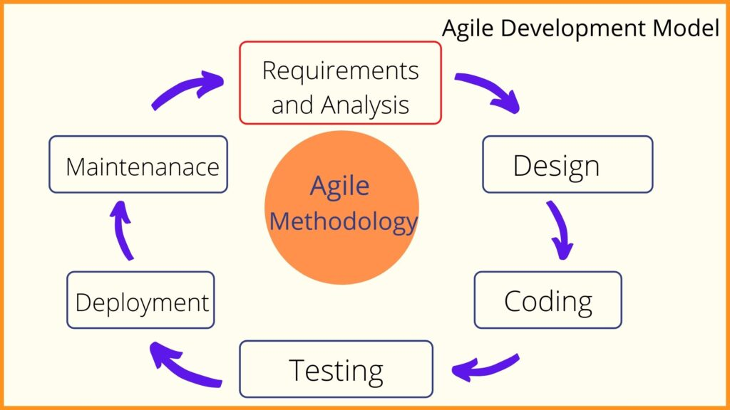

Figure 1: Agile Model

Agile model is a dynamic and iterative approach that focuses on delivering functional software in short development cycles known as sprints. It places a strong emphasis on collaboration, adaptability and ongoing improvement throughout the entire development process.

Agile Process Model is used because with this model work can be divided into groups easily. Additionally, with agile model it is easier to add more functionalities more easily than compared to other models.

Different phases of agile model are:

1. **Requirement analysis:** In this phase, we identify our project requirements and carefully analyze them. A detailed plan is then formulated for the development process, which includes defining the project’s scope, goals and timelines.
2. **System Design:** We begin the system design phase by defining the high-level architecture of the system. This includes identifying main components, their interactions and control within the system.
3. **Development:** In this phase, coding and implementation of software takes place based on the design specifications and requirements. This phase includes

writing and integrating code modules, implementing planned features and ensuring the software meets the desired functionality.

1. **Testing:** In this phase, examination of functionality, performance and quality of the software are done thoroughly. The goal of testing is to identify and resolve any defects or issues, solve them and ensure the software meet the requirements.
2. **Deployment:** After comprehensive testing of software, it is deployed to the production environment. This phase involves tasks such as configuring servers and installing the software.
3. **Review and Feedback:** Following the deployment, a review and feedback phase takes place. This involves gathering feedback from end-users, conduction of post-deployment assessments and addressing any concerns. Purpose of this phase is to evaluate software’s performance, gather insights for future improvements and ensure it’s effectiveness in meeting user needs.

**3.2 SYSTEM BLOCK DIAGRAM**

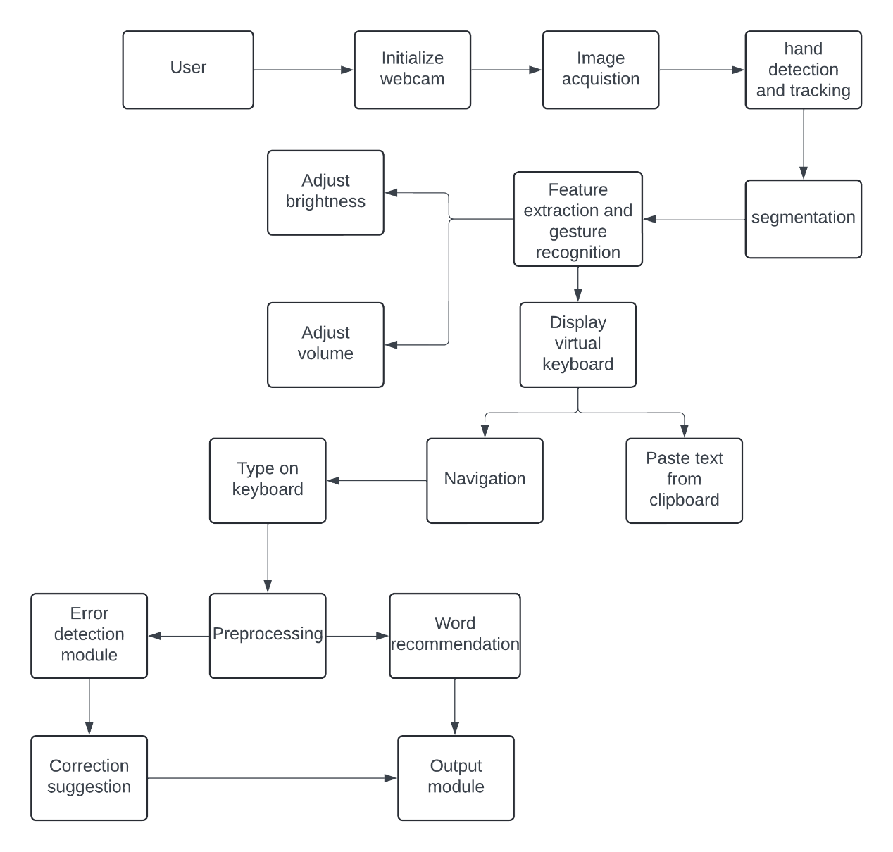

Figure 2: System Block Diagram

Figure 2 showcases the System Block Diagram of Computer Vision Based Virtual Keyboard. From above diagram it can be observed that after user provides input (through finger gesture), webcam captures frames of Hand and generates Hand Landmark. This mark is used to detect fingertip which is used to perform various tasks depending on patterns made by user which performs its corresponding task and program will check for other user input. This process continues till the program is closed.

Functionality of each block of system block diagram is as follows:

1. **Initialize Camera:** A module is made in python to automatically open camera of the device when the application is open.
2. **Image Acquisition:** The camera obtains each frame of video from the user.
3. **Hand Detection and Tracking:** When hand is obtained in front of camera, the software detects and tracks it based on Google Mediapipe Hand Landmarks.

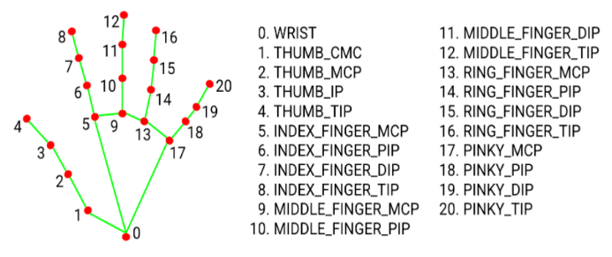

Figure 3: Hand Landmarks defined by Google Mediapipe

1. **Segmentation:** The image is converted to grayscale. This allows the program to distinguish the Hand from background images. This is done in matter of microseconds and is not visible to human eyes.
2. **Feature Extraction and Gesture Recognition:** Features of hands including color, shape and no of fingers will be evaluated and various functionalities will be defined based on those Gestures.
3. **Adjust Brightness:** Pattern of moving Pinky and Thumb finger closer or further away will cause Brightness Control of the computer.
4. **Adjust Volume:** Pattern of moving Index and Thumb finger closer or further away will cause Audio volume control of the computer.
5. **Display Virtual Keyboard:** Make a virtual keyboard using custom or pre-made graphics and display it on-screen.
6. **Paste from clipboard:** Access user’s clipboard and paste text from clipboard using certain pattern (example: Display Index, Middle and Ring finger).
7. **Navigation:** Certain pattern is defined for navigation (example: Movement of Index Finger). This allows user to hover over the keys on screen.
8. **Type on Keyboard:** When Finger is over key, certain pattern can be used to press the key (example: Display Index and Middle finger).
9. **Preprocessing:** Break down of input text into token and analyze the contents.
10. **Word Recommendation**: Recommend a word based on user’s previous text and famous phrases.
11. **Error Detection Module**: If there is any spelling error it would be detected and warn user.
12. **Correction Suggestion:** Suggest a correction for the spelling error.

**3.3 ALGORITHM**

1. Start
2. Create Module for opening camera
3. Create Module for Hand Recognition with help of mediapipe
4. Draw Hand landmarks for easier navigation
5. Create GUI for Virtual Keyboard on screen with every keys
6. Create function to access user’s clipboard
7. Define Functionality for each key
8. Define Patterns as follows:
   1. Index Finger Movement for Navigation
   2. Index and Middle Finger for Clicking
   3. Movement of Index Finger and Thumb closer or further from each other for Volume Control
   4. Display Index, Middle and Ring Finger for pasting text on user clipboard
   5. Movement of Pinky Finger and Thumb closer or further from each other for Brightness Control
9. Define Pattern Recognition for each of the pattern in step 8.
10. Register each key depending on pattern on step 8.
11. Create a Dictionary containing huge array of word used in daily life in English Language
12. Train AI based on words on the Dictionary
13. Create GUI above Virtual Keyboard for Word Suggestion and Autocorrect
14. Autocorrect the incorrectly spelled words by user
15. Suggest words/sentence completion based on Users text and preferences
16. Implement the keyboard to work with any and every text editor including MS Word.

**3.4 FLOWCHART**

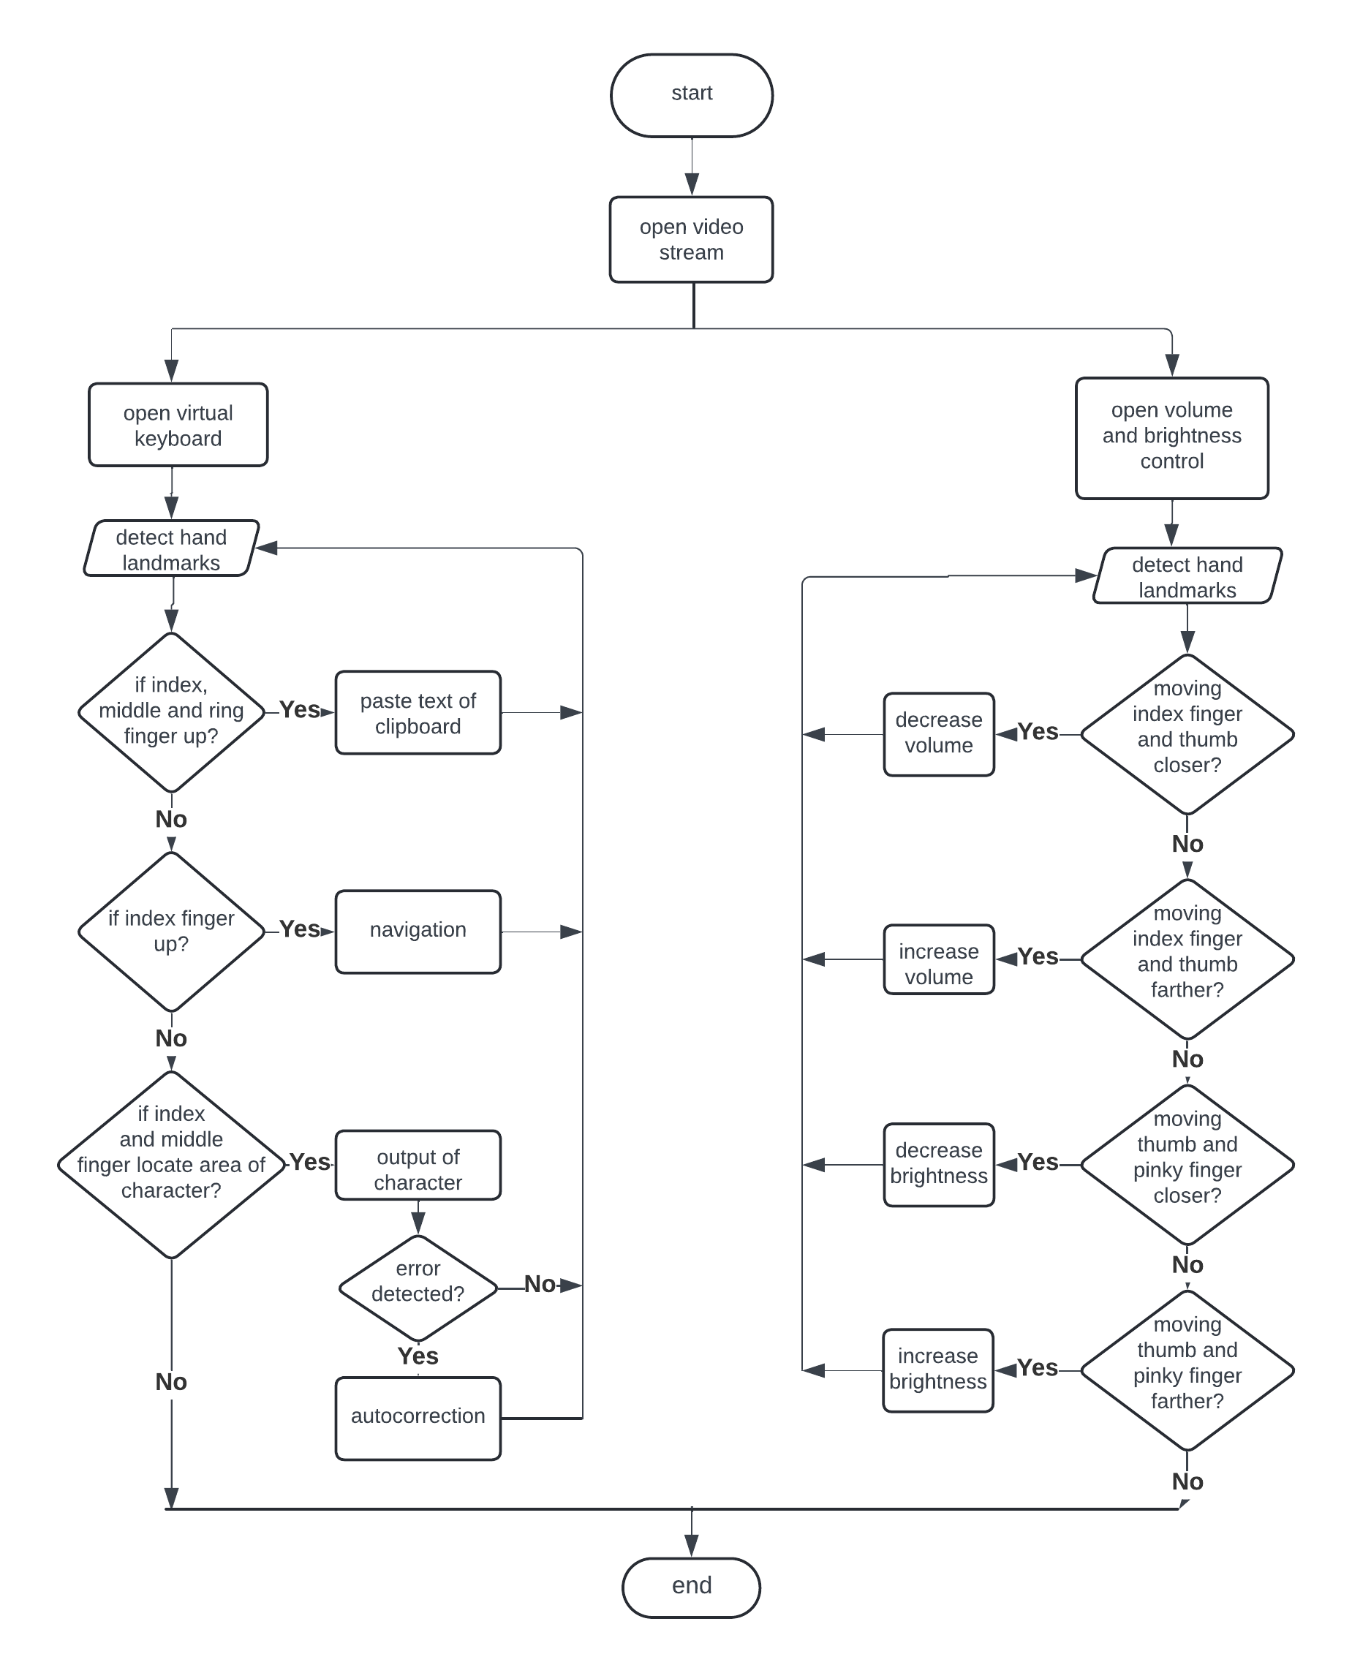

Figure 4: Flowchart

**3.5 TOOLS TO BE USED**

Various system tools used to develop the front end and back end of the project are being discussed in this chapter:

1. **OpenCV:** OpenCV (Open-Source Computer Vision Library) is a free cross-platform computer vision library for real time image processing. It provides an easy-to-use computer vision and comprehensive image processing capabilities like image stitching, video stream processing, camera calibration and diverse image pre-processing tasks.
2. **Mediapipe:** Mediapipe is an open source and flexible framework for building multimodal ML pipelines that allow developers to create complex processing graphs for audio, image and sensor data. It provides a set of pre-built components called “Graphs” that are easily combined to create end-to-end ML pipelines.
3. **Python:** Python is a computer programming language often used to build websites and software, automate tasks and analyze data. It supports multiple programming paradigms, including object-oriented and functional programming.
4. **Visual Studio Code:** Visual Studio Code or VS code is a free code editor that can be used with a variety of programming languages. It supports various development operations like debugging, task running, and version control.
5. **Pycaw:** Python Core Audio Windows Library is a python library used for system volume control including mute, change volume, max volume, etc
6. **Python NLTK:** Python NLTK is a python library used for Natural Language Processing. It is used to access strings provided by user and manipulate them based on programmers use.
7. **Pyperclip:** Pyperclip is a cross-platform Python module for copy and paste clipboard functions. It is used to access user’s clipboard.
8. **NumPy:** NumPy can be used to perform a wide variety of mathematical operations on arrays. It adds powerful data structures to Python that guarantee efficient calculations with arrays and matrices and it supplies an enormous library of high-level mathematical functions that operate on these arrays and matrices.

**CHAPTER 4: EPILOGUE**

**4.1 EXPECTED OUTPUT**

The final product will an application that opens camera where a virtual keyboard will pop up that requires the user to hover over them and perform the required hand gestures for the keys to be pressed. Following functions could be performed with this application:

* Fully functional Virtual Keyboard with autocorrect and word suggestions features
* Gestures that allow user to Copy/Paste, Volume Control and Brightness Control.

**4.2 GANTT CHART**

|  |  |  |  |  |  |  |  |  |  |  |  |  |
| --- | --- | --- | --- | --- | --- | --- | --- | --- | --- | --- | --- | --- |
| **S.N** | **Tasks** | **Fifth Semester** | | | | | | **Sixth Semester** | | | | |
| **MAY** | **JUN** | **JUL** | **AUG** | **SEP** | **OCT** | **NOV** | **DEC** | **JAN** | **FEB** | **MAR** |
| 1 | Documentation |  |  |  |  |  |  |  |  |  |  |  |
| 2 | Discussion |  |  |  |  |  |  |  |  |  |  |  |
| 3 | Study and Research |  |  |  |  |  |  |  |  |  |  |  |
| 4 | Requirement Analysis |  |  |  |  |  |  |  |  |  |  |  |
| 5 | System Design |  |  |  |  |  |  |  |  |  |  |  |
| 6 | Coding |  |  |  |  |  |  |  |  |  |  |  |
| 7 | Testing |  |  |  |  |  |  |  |  |  |  |  |
| 8 | Debugging |  |  |  |  |  |  |  |  |  |  |  |

**REFERENCES**

[1] Avirmed Enkhbat "Efficient recognition using virtual keyboards." 2020 5th International Conference on Information Technology (InCIT).

[2] [Fei Fei Li,:CVPR 2010: IEEE Conference on Computer Vision and Pattern Recognition"](http://tab.computer.org/pamitc/archive/cvpr2010/index.html). Retrieved December 27, 2018.

[3] Y. Zhou, G. Jiang, Y. Lin, A novel finger and hand pose estimation technique for real-time hand gesture recognition, Pattern Recognition, January 2016 .

[4] Shumin Zhai: Optimised Virtual Keyboards with and without Alphabetical Ordering - A Novice User Study

[5] Md. Atiqur Rahman Ahad, T. Jie, H. Kim, S. Ishika wa, Motion history image: Its variants and applications, Machine Vision and Applications, 2012, pp. 255–281