**Universal Export Annual Report 2022**

**WHO WE ARE?**

Universal Export is a garments manufacturing company based in Southampton, United Kingdom. The company produces various categories of dresses like plain, unlabelled, unmarked which is purchased by retailers, wholesalers. Retailers purchase blank garments and add their own design or logo before selling the product.

**WHAT ARE OUR VALUES?**

* Maximise Customer Satisfaction
* Produce high quality clothing.
* By following the ethical approach in engaging the shareholders

**WHAT WE MANUFACTURE?**

Since our company is based in UK, we launched more garments as hoodie, t-shirt which is suitable for British and European culture. Also, it is suitable for their climate.

Our focus is to deliver different products in variety of colors as shown above. The lower numbers in aqua, purple, black, orange, red, yellow, beige, pink says that not all categories have all colors.

**TO WHOM WE MANUFACTURE?**

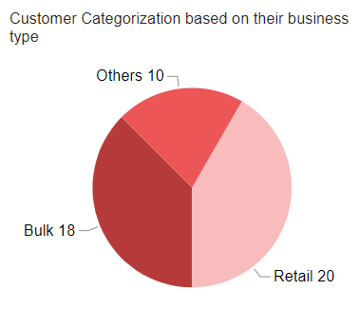

**Liberte, Fleur Fashion, EEC Garment, Panowikk** are the 4 customers out of 48 who joined us recently in the year 2022.

Distribution of our customers around the world,

We do business with customers mostly based in the UK and Europe in 22 countries, where **30%** of our customers are from metropolitan cities like London, Dublin, Paris, Barcelona, Warsaw, Madrid. Also, customers from France, Spain, Norway joined us newly in 2022.

**WHAT HAVE WE MADE?**

In year 2022, our products overall generated,

Our company has achieved a profit of **82%** in 2022. The graph shows there is a huge spike in the month of January and July as our customers tend to purchase clothing according to the climate. There is lot of sales during winter and start of summer.

We further investigate how the finance of our company is divided based on the category.

As jacket is made of thick layer of leather it required more raw material when compared to hoodie.

Hoodie has produced profit over 100 percent and Sweatshirt gives least profit though the profit margin is quite high. We try to visualize the trend for these categories to better understand them.

Customers prefer to buy hoodie all-round the year. But especially in the winter season.

As sweatshirt is meant to be worn during summer, sales of these type predominantly increased during the spring with a better profit percentage.

Around **50 percent** of t-shirts, hoodie is sold across the year.

In order to maximize our profit, we also consider the choice of color for our customers, we see that most of customers prefer to go with the common colors.

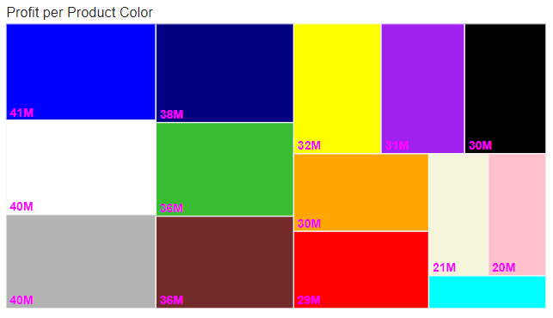

**WHERE WE DELIVER?**

We transport products mainly across the UK and Europe. In 2022 we transported to,

With our manufacturing unit located in Southampton, we transport goods from UK. The distribution of products to various countries is shown below.

Since our company is based in the UK it clearly has an upper hand than others. UK accounts for almost **20 percent** of the total profit. The profit is evenly spread across the UK with **Newcastle Upon Type** being the top with about **2 million** profits.

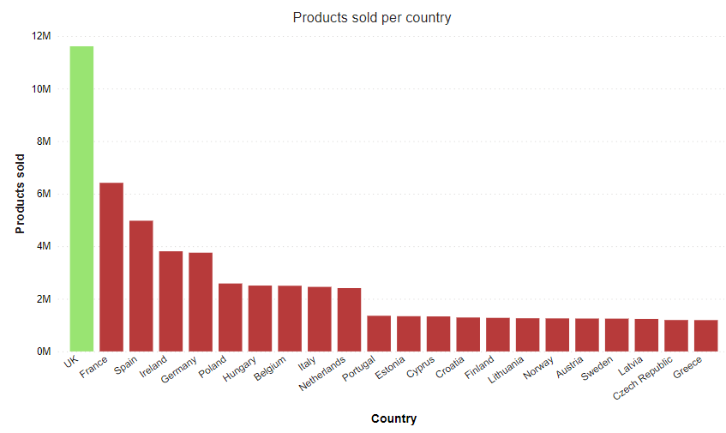

Most of our customers in UK purchased hoodie, t-shirt. It accounts for about **6 million** products.

**HOW WE DELIVER?**

We tied up with,

Our shipment companies use **land, air, sea** for shipment with their office in,

It is always better to consider all types of shipment mode which helps in reducing the carbon emission. The stats also shows that the company generated more sales and revenue in all modes of shipment.

As the result of joining the sustainable development of the world, our company planned to reduce exclusive air shipment from 1st July 2022.

Also, we would like to contribute to the welfare of the world in upcoming years be reducing exclusive shipment modes and concentrate in all modes together.

**WHATS NEXT?**

As an outcome for this year, we are glad to share that our business has grown with flying colors, with a robust economic growth and notable advancements in fulfilling our mission. We have also increased our sales, profit by tying up with new countries and expanding our customer base. With our pledge to make our products and shipment sustainable, we started to reduce the air shipment and look forward to seeing things to make our company sustainable. We also look for new opportunities for growth and invest in new technology, people as a long-term mission and commitment to our shareholders.

As a plan for next year, we would like to investigate the profit margin for t-shirt and increase the profit in least profitable countries.

As seen above most of our customers have brought large number of t-shirt but still it is one the least profitable product. This is the area which we would like to work on to increase the profit margin. Also, to promote our products in least profitable countries by organising campaigns.

Looking forward we would like to increase a value for shareholders. We would like to thank our shareholders for their invaluable support throughout the year. We will always look for opportunities to grow with our shareholders.

**Performance of Sales Representative in 2022**

Sales Representatives play an important role in the betterment of the Universal Export. They are responsible for generating revenue, developing customer relationship. It is vital to study the performance of sales representatives every year to reward them which would encourage them to improve the business. Also, it would be helpful after the resignation of head sales in order to fill the position.

In 2022 we have total of,

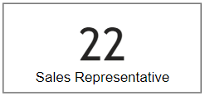

From,

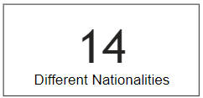

We can see that Universal Export has employed people from diverse countries which will bring in different thinking style and would help in the development of the company.

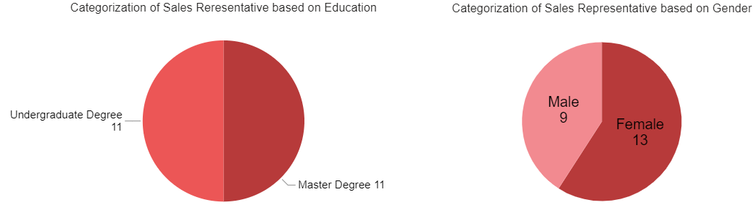

The success of our company lies in the experience of our sales representative bringing from the university being undergrad or master. Also, their knowledge about the financial analysis helps in increasing the productivity of the company.

In order to create an inclusive work environment, we provide equal opportunity to all people irrespective of gender as shown above. The above chart about categorization of gender clearly explains how our company value inclusion.

We value the knowledge and experience of the experienced professional in this field. As a result, our salespeople are from different age category. Also, with sales representative from different age group this helps in developing the young talents. With the level of experience they have it would help the young generation to learn and increase the sales in the future.

We further understand about the revenue and sales generated by different age groups.

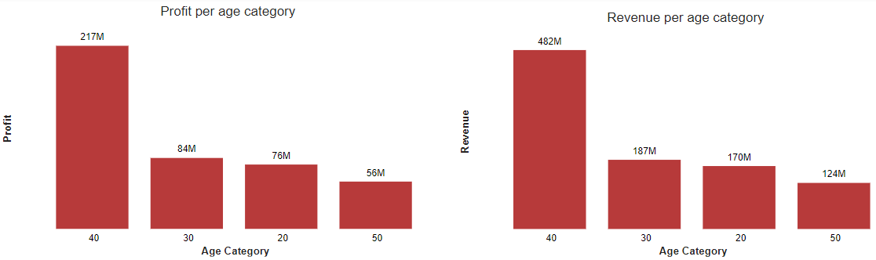

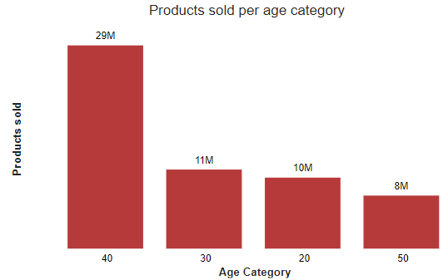

This clearly suggests that people with experience help the young generation in increasing their profit. As the age category increases their sales capability also increases.

We now focus on the individual person to better understand the contribution of each salesperson.

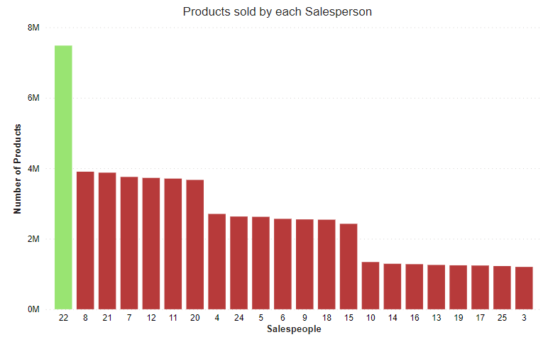

The above bar graphs implies that Sales ID 22 contributes for about 13 percent of total profit and products sold. There is a clear difference of 6 percent from the next salesperson.

Universal expert in total has 48 customers in which 46 customers ordered clothing in 2022.

Sales ID 22 has not only increased sales in his own country but also has a vast diversity in terms of customers from UK and Europe.

Year 2022 has been a good one for the company as it managed to acquire 4 new customers in spite **Liberte, Kuba** were two customers who did not order any products in 2022.

The customer acquired by Sales ID 4 accounted for around **10 million** profit and mostly preferred all modes for shipment which values the sustainable commitment of our company.

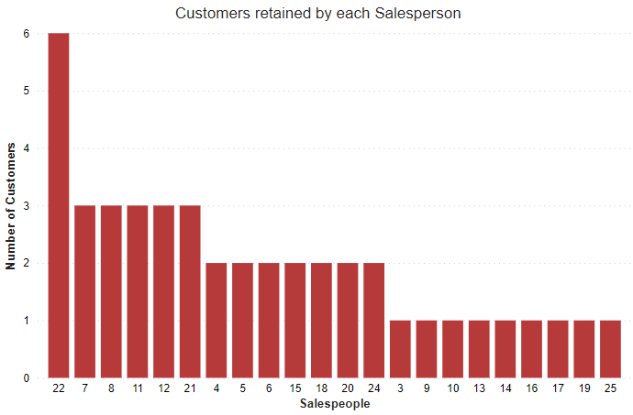

Total of 44 customers were retained by our sales representatives irrespective of their purchase in 2022.

It is always important to focus more on the profitable products. With the knowledge from previous and current year data, sales representative would have tried to increase the sales of profitable products. As these products provide a large profit margin

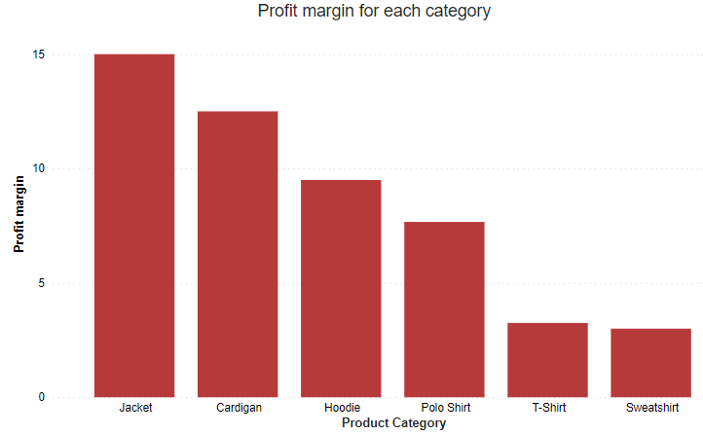

Moving forward we see how sales representative have generated sales of jacket, cardigan and hoodie. As these three products have a better margin.

As jacket generates a profit margin of **15 pounds** which is the highest among the products. It is one of the highly profitable products.

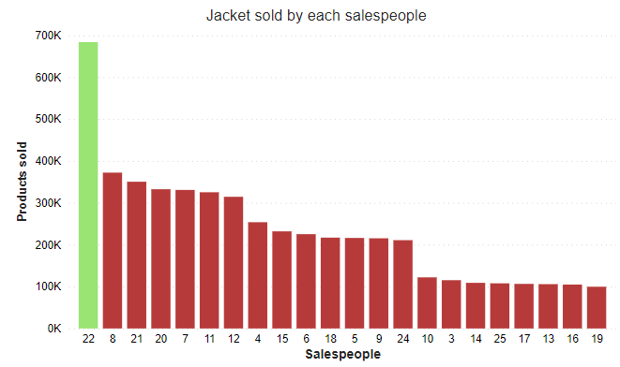

Next, Cardigan generates a margin of **13 pounds** which is the second highest.

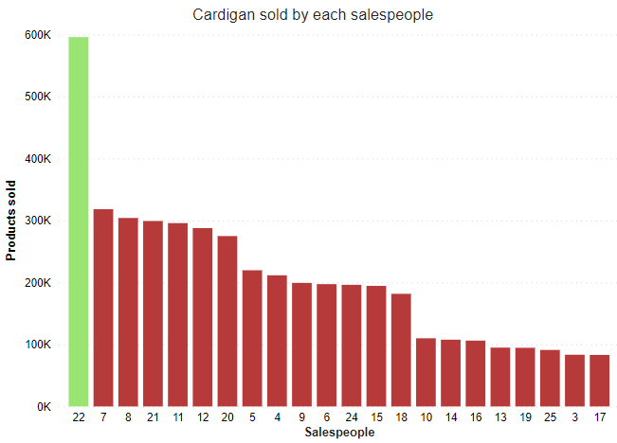

Finally, hoodie generates **10 pounds** profit margin.

Sales ID 22 not only focused on the product with high profit but also worked hard to generate sales from products with high profit margin as a result of selling most of them. Around 15 million hoodies were sold by our salespeople in 2022 with **13 percent** of the hoodie sold by sales ID 22.

Overall, the salespeople of different categories have generated lot of profit for our company. Not only in terms of highly profitable category, but they also worked hard to generate profit in least sold products. Most of the salespeople try to improve our business by expanding our customer’s base.

Most of our salespeople have produced a rewarding outcome. But Sales ID 22 has outperformed his peers in terms of sales and revenue of our products.

Notably, Sales ID 22 brought in new customer every 3-4 years. He also focused on Bulk and retail business types to increase the number of products sold. Also, with the experience of being in this field for long time and producing good outcome. It would be easy for him to access and communicate with the team with which he had worked earlier. It would be a good option to consider him for the position of head of sales.

Not to forget there were several salespeople who also performed well especially Sales ID 21, 11, 7, 12, 8 would be a good choice for the position of deputy head of sales. Also, in order to encourage our salespeople to perform better various rewards can be given to them. This would help others to perform to their best.