Industrial Training/Project

“SHOP_AROUND”

SUBMITTED IN PARTIAL FULFILLMENT OF THE REQUIREMENT FOR

COMPLETION OF DEGREE

SURYA WORLD INSTITUTE OF ENGINEERING AND TECHNOLOGY
(Approved by AICTE, New Delhi, Affiliated to PTU, JALANDHAR)
Submitted to:
Ms. PALLAVI CHANDEL

Submitted by:
PALLAVI
ROLL No. : 1251502
B. Tech (ECE)

Department of ELECTRONICS & COMMUNICATION ENGINEERING
Surya School of Engineering &Technology
Patiala-140401

ACKNOWLEDGEMENT

The satisfaction that accompanies the successful completion of any task would be incomplete without the mention of the people who made it possible and whose constant guidance and encouragement crown all the efforts success.

I am extremely grateful to our respected Principal, BRIG. PRADEEP SINGH for fostering an excellent academic climate in our institution. I also express my sincere gratitude to my respected Head of the Department MS. PALLAVI CHANDEL for her encouragement, overall guidance in viewing this project a good asset and effort in bringing out this project.

I would like to convey thanks to my Project guide MR. MANISH BAHTIA for his guidance, encouragement, co-operation and kindness during the entire duration of the course and academics.

Last but not the least I also thank my friends and family members for helping me in completing the project

PALLAVI (1251502)

DECLARATION

We hereby declare that the major project work titled by “SHOP_AROUND” submitted by us to the SURYA WORLD in partial fulfillment of the requirement for the award of bachelor of technology in Electronics & Communication Engineering is our original work. The analysis, design and implementation of this project have been done by us and it has not submitted anywhere else for the award of the degree.

Date: 5-11-2016 PALLAVI (1251502)

Place: Punjab

CERTIFICATE OF ORIGINALITY

This is to certify that the project entitled SHOP_AROUND being submitted for the partial fulfillment of degree of B.Tech, session 2012-2016, is a record of work carried out by PALLAVI under the guidance and supervision of MR. MANISH BHATIA from DUCAT (NOIDA).

This is to further certify that the student has attended the DUCAT, NOIDA for the 6 months after the seventh semester theory exams. Her work has been satisfactory and commendable.

I wish her success in his life.

Date:

Place:

DEPARTMENT OF ELECTRONICS & COMMUNICATION ENGINEERING
SURYA WORLD INSTITUTE OF ENGINEERING AND TECHNOLOGY
(Approved by AICTE, New Delhi, Affiliated to PTU, JALANDHAR)


CERTIFICATE

This is to certify that the dissertation entitled “SHOP_AROUND” that is being submitted by PALLAVI (1251502) in partial fulfillment for the award of the Degree of BACHELOR OF TECHNOLOGY (ECE) from SURYA WORLD INSTITUTE OF ENGINEERING AND TECHNOLOGY. This is a bonafide work done by her under the guidance and supervision of MR. MANISH BHATIA from January 2016 to May 2016.

Head of the Department
MS. PALLAVI CHANDEL

CONTENTS

S No. | TOPICS
1. | Company Profile
2. | Project Detail  - Introduction  - Description of project  - Objective
3. | Project Category
4. | Software Requirement Specification
5. | Platform (Technology/Tool Selection)
6. | Back-End
7. | Software & Hardware tools
8. | System design
9. | Module Description
10. | Data Flow Diagram
11. | ER Diagram
12. | Input/output Screen (Web pages)
13. | System Testing
14. | System Security
15. | Conclusion
16. | Appendix
17. | Reference
18. | Bibliography



DUCAT is one of the nation’s largest Corporate Education, Training and
Consultancy provider and because DUCAT is a completely Indian
company and we understand India’s training needs, and how they affect
our unique place in the global economy. DUCAT has its corporate office
in Noida (UP) with its branches in Delhi/NCR and we provide services to
,000 professional annually through a single point of contact to manage
20
our customer’s training needs.
With over 6 years experience in the industry, DUCAT is recognized as a
leading expert in the design, development and delivery of technical and
soft skills training - from individual courses and seminars to certification programs and full-
scale training solutions. DUCAT offers a full spectrum of vendor-authorized technical,
business skills, project management and application courses designed to suit every skill
level, as well as the ability to consult directly with organizations to tailor made learning plans
for any number of employees. DUCAT products and services have wide appeal and are
applicable to those in a variety of positions including network administrators, systems
analysts, systems architects, software developers, help desk staff, IT managers, senior
executives, administrative assistants and business professionals.
With DUCAT, you get remarkable flexibility in choosing the learning delivery method that
suits your employees and your organization. DUCAT offers a breadth of instructor-led
training courses across India. To satisfy increasing customer demand, DUCAT will soon
implement a Learning Management System (LMS) that offers all customers access to full-
service, multi-vendor online training.
DUCAT provides corporate education and custom-content training solutions to some of
India's largest private and public organizations. We serve clients in various sectors such as
information technology, financial services, pharmaceuticals, telecommunications, education,
professional services. DUCAT is proud of itself in its ability to assess learning needs and
develop and deliver training solutions to support and enhance our customers' return on their
training investments.
COMPANY PROFILE
PROJECT DETAIL
INTRODUCTION:
The SHOP_AROUND is the part of the sample application that provides customers with online shopping. Through a Web browser, a customer can browse the catalog, place items to purchase into a virtual shopping cart, create and sign in to a user account, and purchase the shopping cart contents by placing an order with a credit card.
By integrating information and improving processes, SHOP_AROUND will help improve enterprise-wide decision support and operational efficiency. Improved efficiency translates into:
- More resources to support the enterprise.
- Improved customer service
- Web-based and more user friendly interfaces to buyers.
An extremely powerful marketing tool, SHOP_AROUND’s ability to suggestively sell alternate and complementary products; e.g. if a customer selects the "standard" version of a product, you can recommend that they also consider the "pro" version or if your customer chooses a pair of pants, you can suggest that they also consider a belt and socks. Simply specify related product skis and optional text in a product’s definition in your Merchant Administrator, and PDG Shopping Cart will up-sell or recommend related products to your customers automatically.

DESCRIPTION OF PROJECT:

The category screen shows all of the products available for a particular category.

The product screen shows all of the items in a particular product. Product screen’s right column of the list shows the price of the item, and includes a link labelled Add to Cart. This link, which also appears on screen for the corresponding item, allows the customer to add the item to the cart without looking at the item details

The item screen shows detailed information about an individual item for sale. The Add to Cart link, when clicked, adds an order for the item to the shopping cart, and then shows the shopping cart contents

The cart screen lists the items currently in the cart, allows the customer to change the quantity of each item ordered, and shows a title. It also includes a link to remove the item from the cart, and a link Proceed to Checkout which, when clicked, shows the order information screen if the user is signed on. If the user is not signed on, the sign in screen is shown instead.
The sign in screen allows an existing customer to sign in as an existing user, and a new customer to create an account. An existing customer enters a user name and password, and the application displays the Order Information screen shown in. A new customer enters a user name and password and clicks the button Create New Account. The application creates a user with the requested password. If user creation succeeds, the application displays the Account Information screen.
The account information screen, shown in collects information about a new customer, including contact information, a credit card, and personal preferences. This is also the screen displayed whenever the customer clicks the Account link at the top right corner of the screen (beneath the Search box). Clicking the Update button directs the browser to a page that summarizes the information entered.
The Order Information screen allows the user to enter billing and shipping address. Default values for the addresses come from the contact information for the currently signed-in customer. This information is transmitted to the application when the user clicks Submit. The application creates a new order, sends it to the order processing center, and displays the Order Complete screen.
The Order Complete screen verifies to the user that the order has been placed. The screen includes the order number

OBJECTIVES:
Our Objective:
Our objective was to look at online retail from a customer’s point-of-view and determine which of the biggest US-based ecommerce sites was providing the best customer experience.
A secondary aim was to zero in on key trends and identify opportunities for high-impact customer experience improvements.

Our Approach:

We examined the entire experience. Unlike some studies that focus only on browsing,
We looked at the entire experience from the first moment on the site through selection, purchase, shipping and returns.

We combined objective measurement with expert subjective analysis. Metrics have a strong appeal, but in something that involves as many intangibles as the customer experience measurement can only take you so far. With this in mind, we split our analysis between straightforward objective grading and the expert opinions of our panelists. (In poker terms, think of a good objective score as a table stakes and a good subjective score as a hand that could win you the game.) We analyzed a large pool of sites defined by a third party.

PROJECT CATEGORY

Category of this project is RDBMS based, n-tier architecture, Distributed environment project with server-side components.

Project can be categorized in two ways:-

- Local Area Network projects.

- Distributed Projects.

Local Area Network projects are those projects where application has to be incorporated in the Local area network of the client i.e within its premises only. In case of LAN, server is not remotely located and client accesses the application through the network. Here the question of platform independence does not arise and we can use the technologies like: Visual Basic, Fox pro, D2k or C, C++, etc.

Distributed projects are those projects where application is remotely situated. In these kinds of projects, application is remotely situated on to the remote server from where client machine accesses the application. WAN and Internet is a kind of distributed application where client machine connects to the remote server and application is downloaded on to the client machine. Here the question of platform independence arises and we use technologies like Java Servlet, Java Server Pages, Java Beans, RMI, etc.

SOFTWARE REQUIREMENT SPECIFICATION

Software requirement specification (SRS) is the starting point of the software development activity. Little importance was given to this phase in the early days of software development. The emphasis was first on coding and then shifted to design.

As systems grew more complex, it became evident that the goals of the entire system cannot be easily comprehended. Hence the need for the requirement analysis phase arose. Now, for large software systems, requirements analysis is perhaps the most difficult activity and also the most error prone.

Some of the difficulty is due to the scope of this phase. The software project is initiated by the client’s needs. The SRS is a means of translating the ideas in the minds of the clients (the input), into formal document (the output of the requirements phase). Thus, the output of the phase is a set of formally specified requirements, which hopefully are complete and consistent, while the input has none of these properties.

PLATFORM (Technology/Tool Selection)

Introduction to Java/.net

Java is a high-level, third-generation programming language like C, FORTRAN, Perl and many others. It is a platform for distributed computing – a development and run-time environment that contains built-in support for the World Wide Web.

History of Java

Java development began at Sun Microsystems in 1991, the same year the World Wide Web was conceived. Java’s creator, James Gosling did not design java for the Internet. His Objective was to create a common development environment for consumer electronic devices which was easily portable from one device to another. This effort evolved into a language, code named Oak and later renamed Java that retains much of the syntax and power of c++, but is simpler and more platform-independent.

Java Features

Some of the important features of Java are as follows:

- Simplicity
- Orientation
- Platform Independence
- Security
- High Performance
- Multi Threading
- Dynamic linking.
- Garbage Collection.

One of the most important features of Java is platform independence, which makes it famous and suitable language for World Wide Web.

Why Java is Platform Independent?

Java is Platform Independent because of Java Virtual Machine (JVM).

Java Virtual Machine (JVM)

The client application or operating system must have a java byte-code interpreter to execute byte-code instructions. The interpreter is a part of a larger program called the JVM. The JVM interprets the byte code into native code and is available on platforms that support Java.
When the user runs a Java program, it is up to the JVM to load, possibly verify, and then execute it. The JVM can perform this function from within a browser or any other container program or directly on top of the operating system.

When a browser invokes the JVM to run a Java program, the JVM does a number of things:

- It validates the requested byte-code, verifying that they pass various formatting and security checks.
- It allocates memory for the incoming java class files and guarantees that the security of JVM is not violated. This is known as the class loader module.
- It interprets the byte code instructions found in the class files to execute the program.

Connectivity using JDBC
There are four kinds of drivers available in JDBC: -

- JDBC-ODBC Bridge Driver
- Partly Java Driver
- Native Driver
- Pure Java Driver

Client Side Interface:

In client side interface we are using:-

- Servlet / JSP – for Internet Based Application.

Servlet / JSP are middle-ware technologies which are used in web based projects because they use:-

- HTTP Protocol to handle Request and Response.
- They are invoked through Browser.
- They give output in HTML format.
- They need Browser Support.

ABOUT J2EE

Introduction to J2EE:

The multi-tier architecture such as COBRA has got its own advantages in terms of scalability, performance and reliability. In a multi-tier architecture, a client does not interact directly with the server. Instead, it first contacts another layer called Middleware. The middleware instantiates the server applications and messages the server object. It returns results to the clients. The presence of a middleware layer allows programmers to concentrate on business logic of application. The middleware handles low-lever services, such as thread handling, security, and transactions management.

Sun Microsystems introduced the J2EE application server and the enterprise Java Bean (EJB) specifications as a venture into the multi-tier component architecture. J2EE functions as a middle tier server in three tier architectures. It provides certain specifications that can be used to implement enterprise solutions for certain all types of business requirements. J2EE also offers cost effective solution for business solution.

J2EE is used for developing, deploying and executing applications in a distributed environment. The J2EE applications server acts as a platform for implementing various server side technologies Servlets, Java Server Pages (JSP) and Enterprise Java Bean (EJB). J2EE allows you to focus on your business logic program. The business logic is coded in java program, which are reusable component that can be accessed client program EJB runs on J2EE server.

In J2EE security is handled almost entirely by platform and its admin. The developer does not have to worry about writing the security logic.

- J2EE Architecture:

The J2EE SDK architecture consists of the following components:

- The J2EE server
- The EJB Container
- The Web Container

The J2EE server provides the EJB and web containers. The J2EE server enforces authenticating users. The either service provided by the J2EE server are listed here below.
- It allows client to interact with Enterprise Bean.
- It enables a web browser to access servlets and JSP files
- It provides naming and directory services to enable users and various services to locate and search for services and components.

The EJB container manages the execution of Enterprise Bean for J2EE server. EJB is a specification for making server side component that enable and simplifies the task of creating distributed objects. EJB component provide services such as transaction and security management and can be customized during deployment.
The web container manages the executing of JSP and servlets for J2EE applications web components and their container run on the J2EE server. Servlet can also be used to add dynamic content to web pages. Java Server Page (JSP) adds server side programming functionality to java. JSP consists of regular Html tags representing the static content and code enclosed within special tags representing the dynamic content. After compilation, a JSP generates a servlets and therefore incorporates all the servlets functionalities.

- J2EE Application:

J2EE applications are complex access data from a variety of source and cater to a variety of client. To manage these applications the business function conducted in the middle tier. The J2EE platform acts as a middle tier and provides the necessary environment needed by the application. The J2EE platform provides” write once, run anywhere”, portability and scalability for multi-tier application. It also minimizes complexity for building multi-tier application.

To create a J2EE application we need to create following three components:

(1) J2EE application client
(2) Enterprise Bean
(3) Web component

Process of creating a J2EE application:

Enterprise Bean
(.jar file)
Component
(.jar file)

Assembled
J2EE Application Server
(.jar file)
Deployed

J2EE Server

- J2EE Technologies:

The J2EE includes many technologies such as:

- Enterprise Java Beans (EJB)
- Remote Method Invocation (RMI)
- Java Naming and Directory Interface (JNDI)
- Java Database Connectivity (JDBC)
- Java Transaction API (JTA)
- Java Transaction Services (JTS)
- Java Messaging Services (JMS)
- Java Servlet & Java Server Pages (JSP)
- Extensible Markup Language (XML)

- JDBC:

Java Database Connectivity provides a Database programming API for Java program. A JDBC API contains a set of classes and Interfaces that are used to connect a database build using any DBMS or RDBMS. It also submit SQL query to a database and retrieve its and processes the result of SQL query.

- Servlet:

Servlets are used to develop a variety of web-based application. They make use of the extensive power of the Java API such as networking and URL access, multithreading, database connectivity, internationalization, RMI and object serialization. Java Server Pages (JSP) adds server side programming functionality to Java. Both Servlet and JSP allow the creation of database driven web application and have server side programming capability.

- XML:

J2EE uses Extensible Markup Language as a Markup language to describe the contents. The described file created when deploying the J2EE application is an XML file.

- J2EE SDK TOOLS:

J2EE SDK includes following tools:

- The Deployment Tool.
- The J2EE Server.
- The Cloud Scale Server.
- The Clean-up Script.
- The Packager Tool.
- The Realm Tool.
- The Run Client Script.
- The Verifier Tool.

- The J2EE Security:
The architecture of the J2EE is such that it enforces security in the application. In order to access the J2EE services, a user need to prove his/her identity. Such users are called J2EE users and process is called authentication.

JDBC

There are many classifications of databases available as Hierarchical database, Network database, Relational database, Object databases and soon. Due their flexibility Relational database management systems are most successful bread of databases in the history of computing. Ex: - Oracle, IBMdb2, and Microsoft SQL Server.
A technology that enables JSP base applications to interact directly with database engines is called Java Database Connectivity and is an integral part of Java platform. JDBC/JSP based web application access the database connections. These connections must be managed carefully by the application especially if a large number of concurrent users may be accessing them. To make this performance optimization JDBC uses a mechanism called connection pooling. The evaluation of this open database access technology has led to a mirade of driver architecture.

Interaction of JSP Page with JDBC

Application Server Machine
Web server
Client Machine

Browser
with
JSP Engine
JDBC Driver
HTML

DB Server Machine
RDBMS Server

Here the browser using the web application is not required to support java at all. The JSP has full control over how many JDBC connections are made to the server. The client never makes direct JDBC connection to the server. This solution can work readily through a firewall, only standard HTTP is used between the web server and the client.

As a bonus this solution sends itself to easily secured information simply by adding secured socket layer support to the web server. Because of this separation of the presentation from the business logic, which is separated from the database logic, this sort of system is often called three tiers of the system. Although the application server and database server can also running on the same server machine.

BACK-END

ORACLE 8i

Why we are using Oracle (RDBMS)?
Some of the merits of using Oracle (RDBMS) are as under:

- Centralization of database.
- Client Server Technology.
- Security.
- Normalization of Data Base.
- Relationship.
- Transaction Processor.
- It gives some internet related features.
Hence because of these features we are using Oracle as a back-end technology.

Weather you are working on LAN projects or Distributed projects, there are two sides of it:-

- Front End
- Back End

Front End remains on client side. Front end is made for end user who uses our application. Basically in front end, our input-output forms reside which takes the input from the client and gives output back to client.
Backend remains on server side and has two components viz.
- Server side programs
- Data Base

Database is a collection of tables and table is a collection of records in a tabular form i.e. in row and columns format.

Data Base can be divided into two parts:-

- RDBMS
- DBMS

We will be using RDBMS (Relational Database Management System) in our project i.e. oracle 8.0 Enterprise Edition.

ABOUT ORACLE 8i

Oracle 8i contains all the features of previous version. It also supports some new features & enhancement to some existing features. Oracle servers provides deficient & effective solution for the major features.

Large Database & Space Management Control

Many Concurrent Database Performances

High Transaction Processing Performance

High Availability

Controlled Availability

Industry Accepted Standards

Manageable Security

Database Enforced Integrity

Distributed Database System

Portability

Compatibility

Connectivity

NEW FEATURES OF ORACLE 8i

Improved Scalability

Improved Security

Improved Performance via Partition

Enhanced Support for Database Replication

Capability to Handle a Much Larger Number of Concurrent Users

New & Improved Data Types

Database Models
There are three kinds of database models:-

- Single tier architecture.
- Two tier architecture.
- N- Tier architecture.

Single tier Architecture:

In this kind of architecture, database and client application remains on one machine i.e. there is no client-server technology, there is no centralization of database, and basically it is a stand alone system.

Two tier Architecture

In this kind of architecture, database and client application is on two different machines i.e. Database on one machine and the application on another machine. In this type of architecture, the implementation of client-server technology is done and centralization of data base is there, but it has two demerits:-

- Security is not there
- Multiple Client access is not there.

N- Tier Architecture: - In this kind of architecture, there is a middle-ware in between the client and database. Middle ware checks the validity of the client i.e. weather the client can access the database or not. Hence there is security in it as well as middle-ware allows multiple clients access.

What is Middle-Ware?
Middle-ware is a concept. Middle-ware provides centralization of business logic i.e. instead of putting logic on each and every client machine we put logic on a centralized server. Hence middle ware is nothing but a server side program where all your business logic and business methods reside. It remains on server side and it has all the logical building. Middle ware provides: -

  - Multiple Client access.
  - Centralized business logic in case of distributed application.

Because we are working on Distributed Application Based Project we need platform independent Language like Java

Software and Hardware Tools

Development Environment:

- Operating System: Windows XP

The system will be built on windows compatible environment. The application will be web based developed using Java technology.

- Web Server:

BEA’s Web Logic 8.1 Application Server to serve as Servlet/JSP engine. The system requires Web Logic Application Server for serving the requests for Servlet.

- Server side Application Software: Java Server Pages (JSP)

- Business Logic Software: Java Beans. (JB)

- Client Side Application Software: Java Script, HTML

- Data Base: Oracle 8i

The system requires Oracle as a database; however the system will be ODBC complaint to work on any standard database.

- Client Browsers:

Internet Explorer 5.0 or Netscape Navigator 4.7
The system requires Internet Explorer or Netscape Navigator browser for client side.

- Dream Weaver 8.0
The system will be developed with Java Technologies using J2SE (JDK and JRE). Dream Weaver 8.0/ Front Page 2003 as HTML editor.

Hardware requirement

Main Processor Pentium IV
Hard-disk Capaity 8 G.B
RAM 256 MB
Clock Speed 2.8 Hz
Floppy Drive : 1.44MB
Keyboard 104 Key
Monitor V.G.A
4.2 Software specification

Software Requirement

Operating System Window XP
Backend tool Oracle 8i
Front-end tool Java

SYSTEM DESIGN

Introduction
System design provides the understandings and procedural details necessary for implementing the system recommended in the system study. Emphasis is on the translating the performance requirements into design specifications. The design phase is a transition from a user-oriented document (System proposal) to a document oriented to the programmers or database personnel.
System design goes through two phases of development:

      - Logical Design
      - Physical Design

A data flow diagram shows the logical flow of the system. For a system it describes the input (source), output (destination), database (data stores) and procedures (data flows) all in a format that meets the user’s requirement.
The activities following logical design are the procedure followed in the physical design e.g., producing programs, software, file and a working system. Design specifications instruct the user about what the system should do.

Logical and Output Design:
The logical design of an information system is analogous to an engineering blue print of an automobile. It shows the major features and how they are related to one another. The detailed specification for the new system was drawn on the bases of user’s requirement data.
Output design is one of the most important features of the information system. When the outputs is not of good quality the users will be averse to use the newly designed system and may not use the system. There are many types of output, all of which can be either highly useful or can be critical to the users, depending on the manner and degree to which they are used.
- External Outputs, whose destination is outside the organisation
- Internal outputs, whose destination is with the organisation
- Operational outputs, whose use is purely with in the computer department e.g., program-listing etc.
- Interactive outputs, which involve the user is communicating directly with the computer, It is particularly important to consider human factor when designing computer outputs.

Output Sources:
Output contents originate from these sources:
- Retrieval from a data source.
- Transmission from a process or system activity.
- Directly from an input source.

The information produced in an output can be presented as
- Tabular contents
- Graphic format
- Using Icons

Output Definition:
The output should be defined in terms of:
Types of outputs
- Content-headings, numeric, alphanumeric, etc.,
- Format-hardcopy, screen, microfilm, etc.,
- Location-local, remote, transmitted, etc.,
- Frequency-daily, weekly, hourly, etc.,
- Response-immediate with in a period, etc.,
Data items
The name given to each data item should be recorded and its characteristics described clearly in a standard form:
- Whether alphanumeric or numeric
- Legitimate and specific range of characteristics
- Number of characters
- Positions of decimal point, arithmetic design, etc.,

Input Design:
The input design is the link that ties the information system into the user’s world. Input specifications describe the manner in which data enters the system for processing. Input design features can ensure the reliability of the system and produce results from accurate data, or they can result in the production of erroneous information.

Input Design consists of
- developing specifications and procedures for data preparation
- Steps necessary to put data into a usable form for processing.
- Data entry, the activity of putting data into the computer processing.

Objectives of Input design

Five objectives of design input focus on
- Controlling the amount of input required
- Avoid delay
- Avoiding errors in data
- Avoiding extra steps.
- Keeping the process simple.

Input stages several activities have to be carried out as part of te overall input process. They include some or all of the following.
Data recording (i.e., collection of data)
Data encapsulation (i.e., transfer of data)
Data conversion (i.e., controlling the flow of data)
Data transmission (i.e., transporting data)
Data validation (i.e., checking the input data)
Data correction (i.e., correcting the errors)

SOFTWARE DESIGN
The purpose of this is to plan a solution for the problem specified by the requirement document. This is first step in moving from the problem domain to solution domain. Designing activity is divided into 2 parts.

a) System Design: It aims to identify the modules that should be in the system, the specification of these modules and how they interact with each other to produce the desired result.

b) Detailed Design:
The internal goal of each of the modules specified in the system design is decided

DATABASE DESIGN

A database is a collection of inter-related data stored with a minimum of redundancy to serve many applications. It minimizes the artificiality embedded in using separate files. The primary objectives are fast response time to enquires, more information at low cost, control of redundancy, clarity and ease of use, accuracy and fast recovery.

CODE DESIGN

The process of code is to facilitate the identification and retrieve of items of information. The code should be simple and easy to understandable. The codes were designed in such a way that the features such as optimum human – oriented use and machine efficiency are unaffected.

For the code to be designed effectively, the following characteristics were also considered while designing the code.

- Uniqueness
- Versatility
- Stability
- Simplicity
- Consciousness

The code should be adequate for present and anticipated data processing for machine and human use. Care was taken to minimize the clerical effort and computer time required to continue operation.

PROCESS DESIGN

The process can be conceptualized in such a way to keep the methodology of main module process along with some auxiliary task, which will run concurrently with the main program.

The top-down approach is maintained so as to keep track of the process, which satisfies the maintenance reliability testing requirements. The concurrency of the data is checked during data entry, by means of validation check for data in each field.

MODULE DESCRIPTION
SHOP_AROUND: (Main Module)
- ADMIN
- CUSTOMER
    - VISITOR
    - MEMBER
- ORDER TRACK

Module Name | Function | Benefits | Tables
ADMIN | - ADD NEW PRODUCT.  - CREATE NEW PRODUCT CATEGORY  - DELETE OR UPDATE EXISTING PRODUCT S  - CHECK ORDERS  - PLACE ORDERS TO DELIVERY  - DELIVERY UPDATE  - READ QUERY & RESPONSE  - MEMBER PAYMENT RECIVED ENTRY |  | - Products  - Product Detail  - Category  - Update Products  - Update Detail  - User  - Delivery
CUSTOMER |  |  | - Order  - Order Details
VISITOR | - BROWSE PRODUCTS BY CATEGORY  - ADD SELECTTED PRODUCTS TO CART  - UPDATE CART  - CHECKOUT  - ONLINE PAYMENT OPTIONS |  | - Visitor Order
MEMBER | - CREATE NEW MEMBER ACCOUNT  - LOGIN EXISTING MEMBER  - MEMBER UPDATE PROFILE  - BYE PRODUCTS ON ACCOUNT  - ORDERS REPORTS  - DELIVRY REPORTS  - PAYMENT REPORTS |  | - Member  - Member Orders  - Member Payments
ORDER TRACK | - CHECK ORDER STATUS ONLINE BY ORDER ID NUMBER  - SEND QUERY RELATED TO ORDER  - GET QUERY RESPONSE |  | - Query
DATA FLOW DIAGRAM

Data Flow Diagramming is a means of representing a system at any level of detail with a graphic network of symbols showing data flows, data stores, data processes, and data sources/destination.

The data flow diagram is analogous to a road map. It is a network model of all possibilities with different detail shown on different hierarchical levels. This processes of representing different details level is called “leveling” or “partitioning” by some data flow diagram advocates. Like a road map, there is no starting point or stop point, no time or timing, or steps to get somewhere. We just know that the data path must exist because at some point it will be needed. A road map shows all existing or planned roads because the road is needed.

Details that is not shown on the different levels of the data flow diagram such as volumes, timing, frequency, etc. is shown on supplementary diagrams or in the data dictionary. For example, data store contents may be shown in the data dictionary.

Data Flow Diagram (DFD) uses a number of symbols to represent the systems. Data Flow Diagram also known as ‘Bubble Chart’ is used to clarify system requirements and identifying the major transformations that will become programs in system design. So it is the starting point of the design phase that functionally decomposes the requirements specifications down to the level of details.

Terms used in DFD

- Process
A process transforms data values. The lowest level processes are pure functions without side effects. An entire data flow graphics high level process.
Graphical Representation: 

Graphical representation:

- Data flows

A data flow connects the output of an object or process to input of another object or process. It represents the intermediate data value within a computation. It is represented by an arrow and labeled with a description of data, usually its name or type.
Graphical Representation:

- Actors

An actor is active object that drives the data flow graph by producing or consuming values.

- Data store

A data store is a passive object with in a data flow diagram that stores data for later access.
Graphical Representation:

- External Entity

A rectangle represents an external entity such as a librarian, a library member.
Graphical Representation:
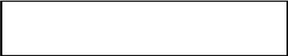

- Output Symbol

This box represented data production during human computer interaction.
Graphical Representation:

DFD:

Context Level DFD:
Add & update products, category.
Delivery updates & Query Response

ADMIN
Get Queries.
Check Orders & Check Payments.

SHOP_AROUND
(ONLINE SHOPING)

CUSTOMER

Browse Products.
Check Order Status Online.
Get Query Response

Add Products to Carts.
Place Orders & Make Payments.
Make Query

First Level DFD:
ADMIN

ShopAround
(ONLINE SHOPPING)

Check Order Status Online.
Get Query Response

Make Query
Add & update products, category.
Delivery updates & Query Response

Get Queries.
Check Orders & Check Payments.

Order Track

Add Products to Carts.
Place Orders & Make Payments.

Browse Products.

CUSTOMER
Create Account
Update Profile
Get Query Response
Get Payment Reports
Get Orders Reports
Get Delivery Reports

MEMBER
VISITOR

Second Level DFD (ADMIN):
Enter Username & Password
Process Login
Login

USER
ADMIN USER
I F LOGIN TRUE THEN ENTER TO ADMIN SECTION

Add update, delete Product & Product Category

PRODUCT
ADMIN SECTION

CATEGORY

Update Member Payment Receiving
MEMBER_PAYMENT
(External Entity)
Check Orders & Order Details

Get Query & Update Query Response

QUERY
Place Orders to Delivery & Update Delivery Status
Check Orders & Order Details
Get Member Details
DELIVERY
ORDER
(External Entity)
ORDER DETAIL
(External Entity)
MEMBER
(External Entity)

Second Level DFD (MEMBER):
Enter Username & Password
Process Login
Login

MEMBER
MEMBER USER
Get or Update Profile
I F LOGIN TRUE THEN ENTER TO MEMBER SECTION

MEMBER SECTION

Browse Products & Add to Cart and Place Cart to Order (Check Out)

PRODUCT
(External Entity)

CATEGORY
(External Entity)

Get Payment Details
MEMBER_PAYMENT
Make Query & Get Response
Get Delivery Status
Check Orders & Order Details
ORDER
(Derived Entity)
ORDER DETAIL
(Derived Entity)
DELIVERY
(External Entity)

QUERY

Second Level DFD (VISITOR):

VISITOR USER
ENTER TO VISITOR SECTION

VISITOR SECTION

Browse Products & Add to Cart and Place Cart to Order (Check Out)

PRODUCT
(External Entity)

CATEGORY
(External Entity)

Second Level DFD (ORDER TRACK):

CUSTOMER (VISITOR OR MEMBER)

ENTER ORDER_ID
FOR ENTERING TO THIS MODULE

ORDER TRACK SECTION

Make Query & Get Response
Get Delivery Status
Check Orders & Order Details
ORDER
(Derived Entity)
ORDER DETAIL
(Derived Entity)
DELIVERY
(External Entity)

QUERY

ER-DIAGRAM 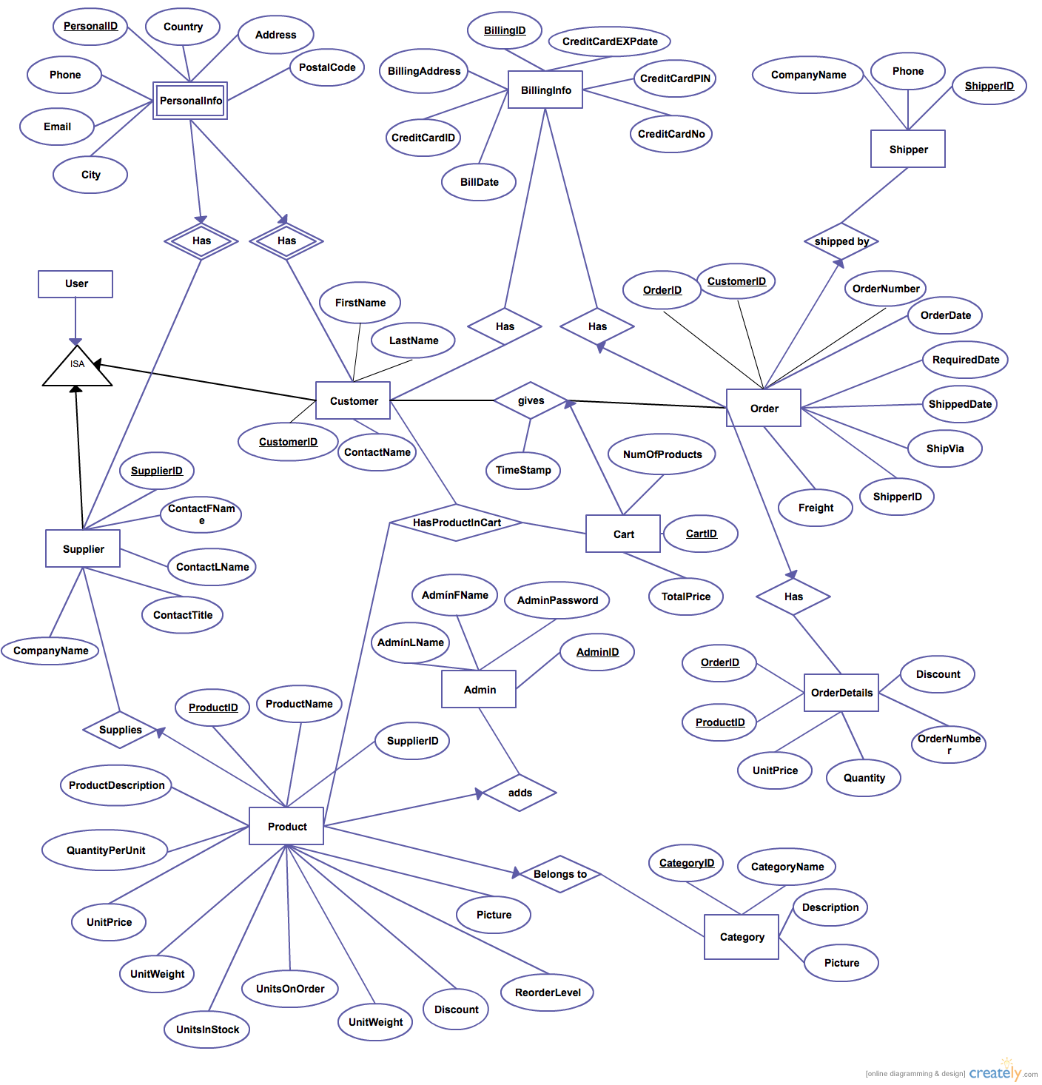

INPUT OUTPUT SCREEN (WEB PAGES)
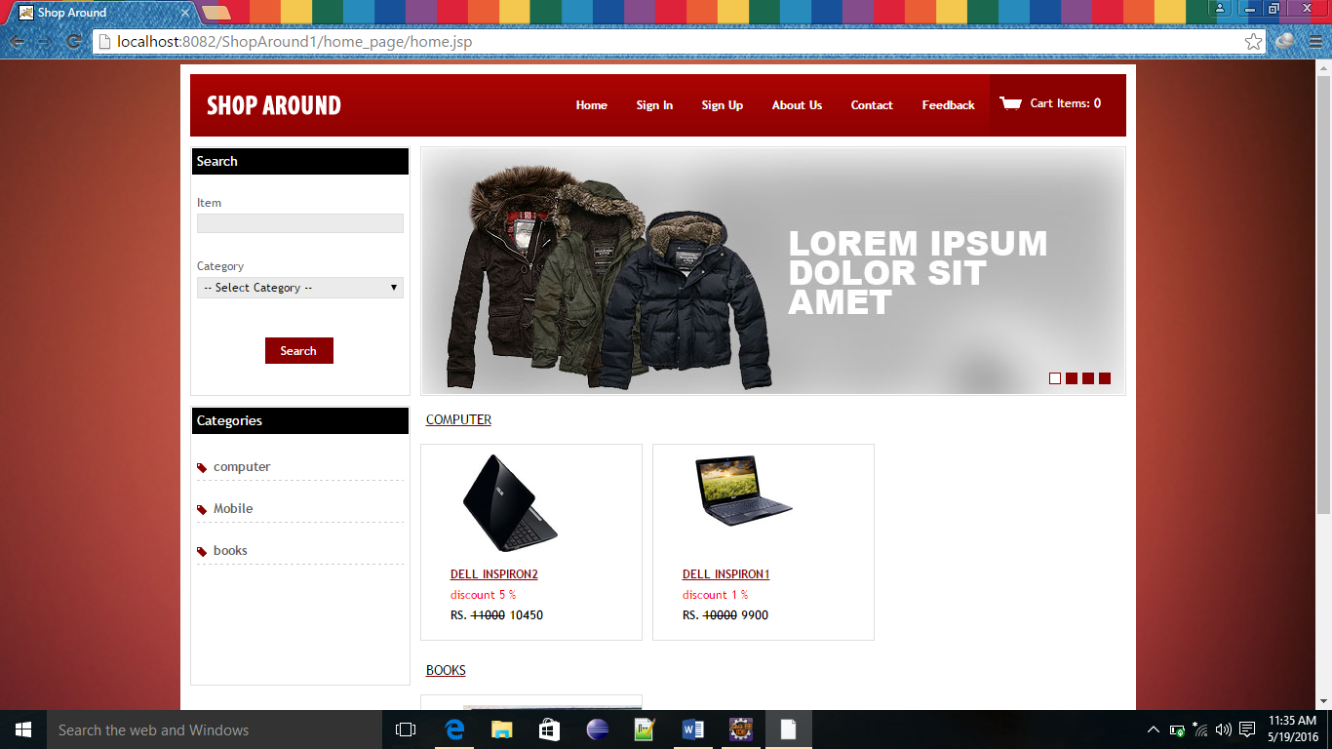

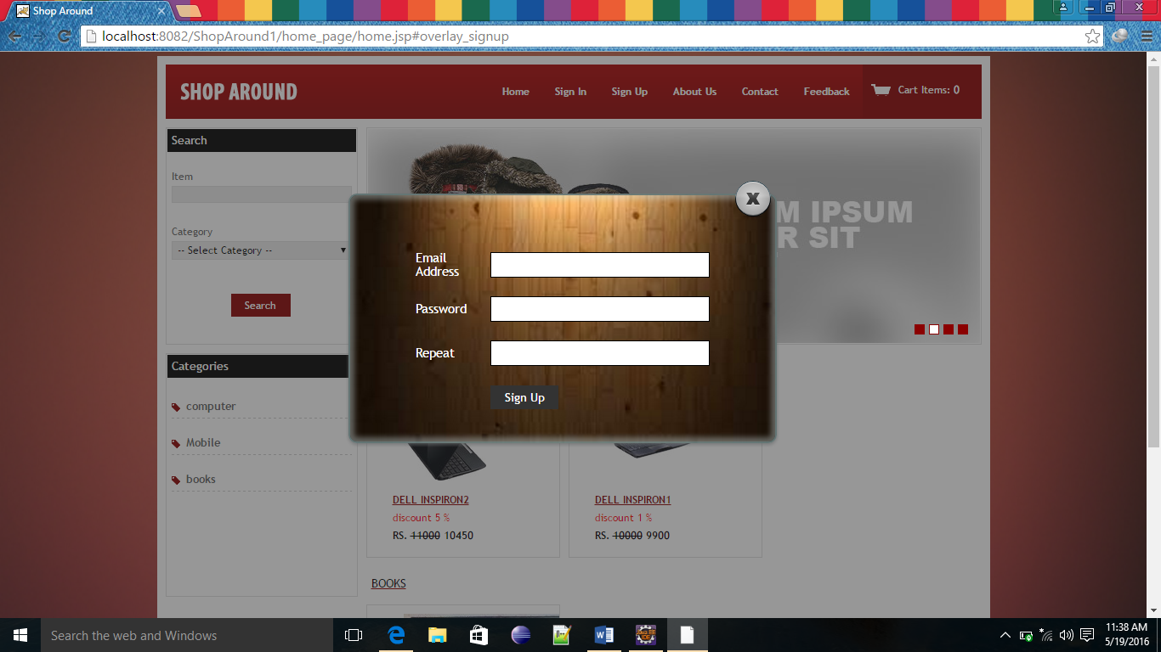

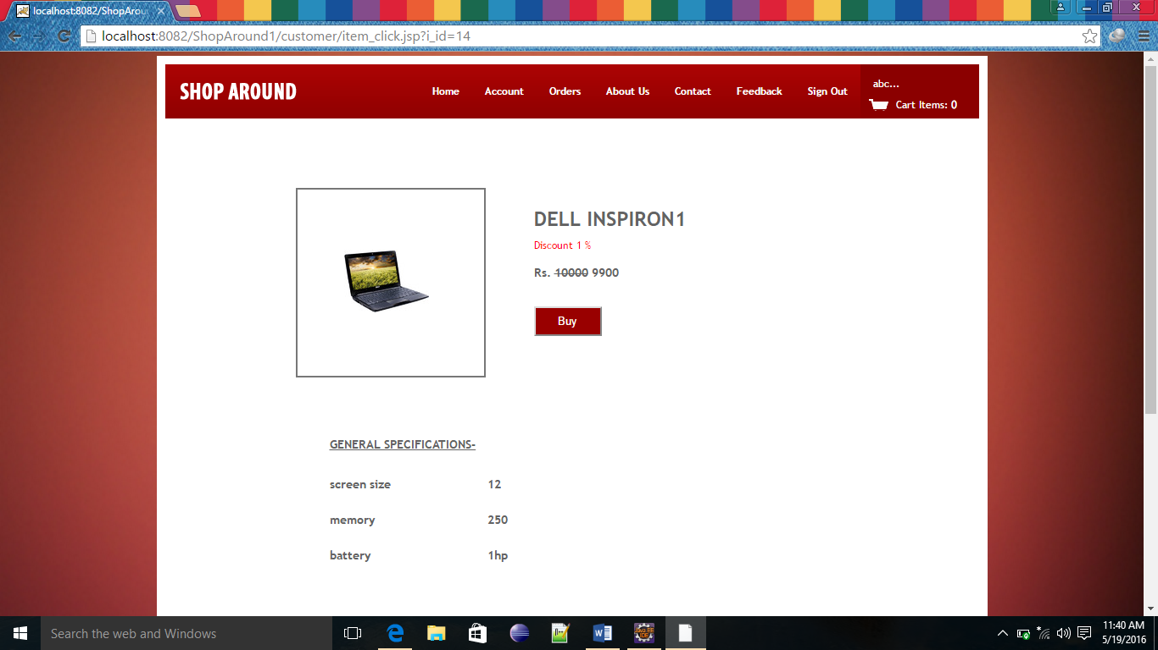

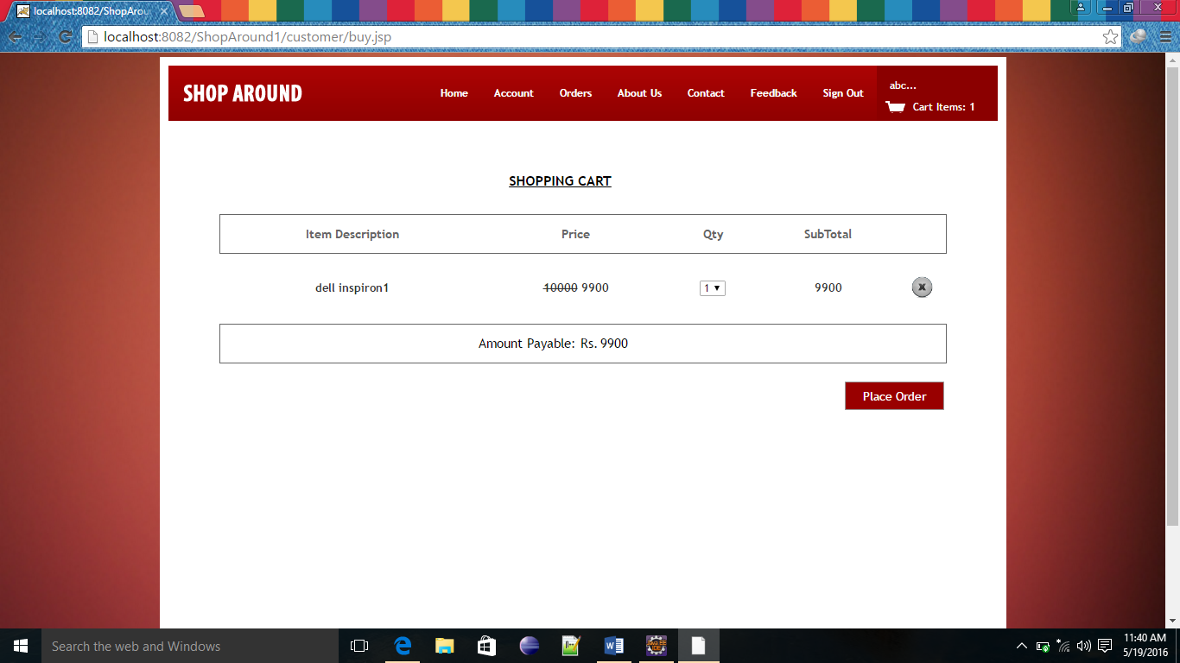

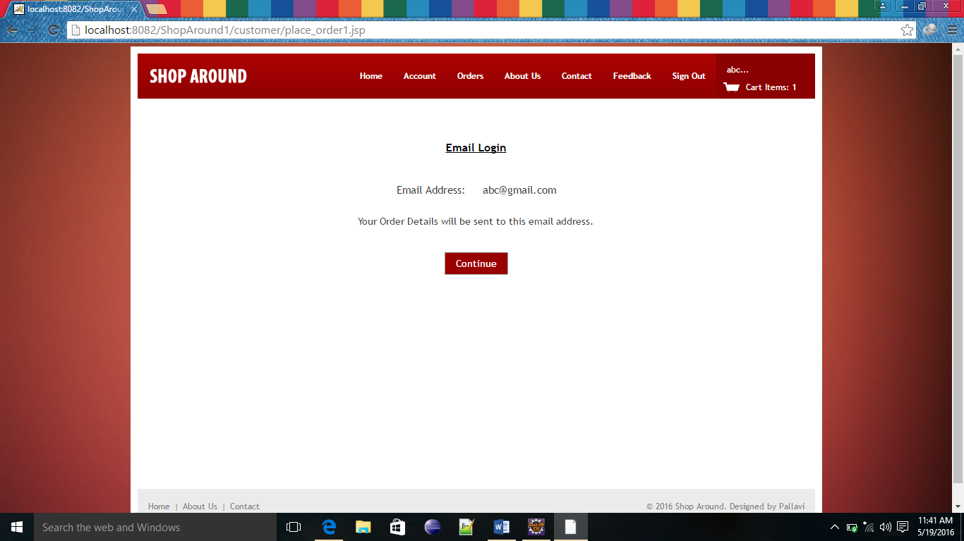

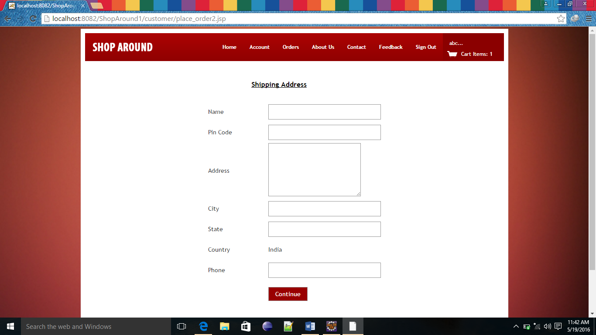

SYSTEM TESTING

Here the System testing involved is the most widely used testing process consisting of five stages as shown in the figure. In general, the sequence of testing activities is component testing, integration testing, and then user testing. However, as defects are discovered at any one stage, they require program modifications to correct them and this may require other stages in the testing process to be repeated.

Unit testing
Module testing
Acceptance testing
Sub-system testing
System testing

(Component testing) (Integration testing) (User testing)

Testing is the process of detecting errors. Testing performs a very critical role for quality assurance and for ensuring the reliability of the software. The results of testing are used later on during maintenance also.

Testing is vital to the success of the system. System testing makes a logical assumption that if the parts of the system are correct, the goal will be successfully achieved. In adequate testing or non-testing leads to errors that may not appear until months or even years later (Remember the New York three day power failure due to a misplaced ‘Break’ statement).

This creates two problems:
- The time lag between the cause and the appearance of the problem.
- The time interval effect of the system errors on files and the records on the system.

PSYCHOLOGY OF TESTING
The aim of testing is often to demonstrate that a program works by showing that it has no errors. The basic purpose of testing phase is to detect the errors that may be present in the program. Hence one should not start testing with the intent of showing that a program works, but the intent should be to show that a program doesn’t work. Testing is the process of executing a program with the intent of finding errors.

LEVELS OF TESTING
The basic levels of testing are

Client Needs Acceptance Testing

Requirements System Testing

Design Integration Testing

Code Unit Testing

SYSTEM SECURITY
Introduction

One might think that there is a little reason to be concerned about security in an intranet. After all, by definition an intranet is internal to ones’ organization; outsider can not access it. There are strong arguments for the position that an intranet should be completely open to its users, with little or no security. One might not have considered ones’ intranet on any other light.
On the other hand, implementing some simple, built-in security measures in ones’ intranet can allow one to provide resources one might not have considered possible in such context. For example, one can give access to some Web Pages to some people without them available to oner entire customer base, with several kinds of authentication.

There are basically two types of security associated with this system:

1. Physical security:-
Damage due to natural causes like earth tremor, flooding, water logging, fire hazards, atmospheric or environmental conditions etc..For overcoming these difficulties the replica of the data are automatically stored at various networks and for environmental conditions Air conditioning environment is created.

2. Data security:-

There are basically two problems associated with data security:-
a). Data not being available to the authorized person at the time of need.

b). Data becoming available to the unauthorized person.

To overcome these difficulties the following access facilities has been provided:-

i) Identification:-
Unique Ids for the different users have been provided.

ii) Authentication:-
System checks the password under the particular user identification. The computer permits the various resource to the authorized person.

iii) Authorization:-
The access control mechanism to prevent unauthorized logging to the system.

Need for Security

Many people view computer and network security in a negative light, thinking of it only in terms of restricting access to services. One major view of network security is “that which is not expressly permitted is denied.”

Security Features of an Intranet:-

First, one can take steps on ones’ Web server to set up security. Second, one can take steps with the other TCP/IP network services one has set up on ones’ intranet to enhance their security. Third, one can secure customers’ Web browsers themselves to limit what they can do with them.

a) Web server Security

There is a wide range of very flexible security features one can implement on ones’ Web server. Here’s a summary:

- Access to Web servers, individual Web pages, and entire directories containing Web pages can be set to require a username and password.
- Access to Web servers, individual Web pages, and entire directories containing Web pages can be limited to customers on specific computer systems. (In other words, access will be denied unless the user is at his or her usual computer or workstation.)
- One can organize individuals into groups and grant access to individual Web servers, Web pages, and entire directories containing Web pages based on group membership.
- One can organize computers into groups, and grant access to individual Web servers, Web pages, and entire directories containing Web pages based on group membership.

b) An Important Warning about Hostname/ IP Address Authentication

All of the Web server software described in this chapter trustingly accepts the word of a requesting computer when it sends its IP address. Verification of this information is not possible. It’s relatively easy for a user to change the hostname/IP address of a UNIX system, and laughably easy to change that of a pc or Mac. A curious, mischievous, or malicious person can reconfigure his computer to impersonate someone else’s simply by changing the IP address of his own. Although this is an overall network security issue, not specifically one for ones’ intranet, it’s important one Know about it because it can affect the security of ones’ access controlled documents. Security-minded network administrators can use special hardware and software to prevent this sort of IP spoofing, but for ones’ intranet, one’ll probably want to combine hostname/IP address authentication with username/password authentication, as outlined in the following section.

c) Secure/ Encrypted Transactions

One can further enhanced security on ones’ intranet by encrypting Web transactions. When one use an encryption facility, information submitted by customers using Web fill-in forms-including usernames, passwords, and other confidential information-can be transmitted securely to and from the Web server.

d) Intranet and the Internet

Is ones’ intranet is accessible from the internet? If so, all of the security problems of the Internet are now ones’ intranet’s problems, too. One can, however, connect safely to the Internet and still protect ones’ intranet. One can even use the Internet as a means of letting remotes sites in ones’ company access ones’ intranet.

e) Firewalls

It’s a fact of Internet life there are people out there who want to break into other people’s networks via the Internet. At the same time, the value of Internet to organizations and businesses is as great that vendors are rushing to fill the need for Internet security with Internet firewalls. An Internet firewall is a device that sits between ones’ internal network and outside Internet. Its purpose is to limit access into and out of ones’ network based on ones’ organization’s access policy.

CONCLUSIONS

As evidence of the success of this mission, there are millions of items listed each day in thousands of different categories. There are items for almost any interest that one could imagine, from sheet music to automobiles to hand tools to real estate. And the variety doesn’t stop there. Need a computer? One may find it listed in the proper category, in any configuration from very old and obsolete to the latest greatest machine available. What about antiques? One can find an antique quilt that is up for highest bid, or maybe an old violin, whose beautiful tones have enchanted many though its years. Tickets. Maybe a ticket to the next concert of ones favorite artist or play production. One can even find that special bottle of wine, some aged, exotic cheese, and the perfect ‘mood’ music for that special occasion.

In this instance it may be true that on eBay, they have something for everybody, whatever their tastes may be.

Scope for Future Work
Since this system has been generated by using Object Oriented programming, there are many chances of reusability of the codes in other environment even in different platforms. Also its present features can be enhanced by some simple modification in the codes so as to reuse it in the changing scenario.

The site is made in all possible way to meet the user requirements using latest version of available software and hardware. But as user requirements and operating environment keep changing further extensions can be made on this. In future some more schemas can be added in the “HR Recruitment Process” hence these schemas are to be included in the software developed.

Limitations

Following may be the drawback in this system.

- Though this system is developed as a multi user system but it is not a real time system.
- The interaction with the database, every time they are loaded thus the system tends to be a bit slow.

APPENDIX
- Database
- Java
- Html
- JavaScript
DATABASE

Backend remains on server side and has two components i.e.
- Server side program
- Data Base.

Data Base is a collection of tables and table is a collection of records in a tabular form i.e. in row and columns.

Data Base can be divided into two parts:-

- RDBMS.

- DBMS.

We will be using RDBMS (Relational Database Management System) in our project i.e. oracle 8i Enterprise edition.

Why we are using Oracle (RDBMS)?

Some of the merits of using Oracle (RDBMS) is as under:-

- Centralization of database.
- Client Server Technology.
- Security.
- Normalization of Data Base.
- Relationship.
- Transaction Processor.
- It gives some internet related features.

JAVA

What is Middle Ware?

Middle Ware is a concept, Middle Ware provides centralization of business logic i.e. instead of putting logic on each and every client machine we put logic on a centralized server hence middle ware is nothing but a server side program where all your business logic and business methods reside. It remains on server side and it has all the logical building. Middle ware provides:-

- Multiple Client access.
- Centralized business logic in case of distributed application.

Because we are working on Distributed Application Based Project we need platform independent Language:-

Technology Used

Introduction to Java

Java is a high level, third-generation programming language, like C, Fortran, Perl and many others. It is a platform for distributed computing – a development and run-time environment that cointains built-in support for the World Wide Web.

History of Java

Java development began at Sun Microsystems in 1991, the same year the World Wide Web was conceived. Java’s creator, James Gosling did not design java for the Internet. His Objective was to create a common development environment for consumer electronic devices which was easily portable from one device to another.
This effort evolved into a language, code named Oak and later renamed Java that retains much of the syntax and power of c++, but is simpler and more platform independent.

Java Features

Some of the important features of Java are as follows:

- Simplicity
- Orientation
- Platform Independence
- Security
- High Performance
- Multi Threading
- Dynamic linking.
- Garbage Collection.

One of the most important features of Java is Platform Independence which makes it famous and suitable language for World Wide Web.

Why java is Platform Independent?

Java is Platform Independent because of Java Virtual Machine (JVM).

Java Virtual Machine (JVM)

The client application or operating system must have a java byte-code interpreter to execute byte-code instructions. The interpreter is a part of a lager program called the JVM. The JVM interprets the byte code into native code and is available on a platform that supports java.

Connectivity using JDBC

There are four kind of drivers available in JDBC:-
- JDBC-ODBC Bridge Driver.
- Partly Java Driver.
- Pure Java Driver.
- Native Driver.
HTML

What is HTML?
HTML(Hyper Text Markup Language): A markup language used to structure text and multimedi documents and to set up hypertext links between documents, used extensively on the World Wide Web. HTML is a display language , not a programming lanfguage. HTML is a markup language(the ML in HTML) that uses a fixed set of markup tags.

- HTML itself is the set of custumizable “markup” tags that are inserted into HTML document govern its format, multimedia content, and hyperlinks. Any HTML viewer can display such documents but they are normally viewed usinga Web browser.

- HTML is a programming language in that an HTML document is a program that, when “run” by a browser, displays its text as hypermedia (multimedia with hyperlinks).

- The “language” HTML is really only a collection of predefined tags which , when inserted into regular text, tell a web browser how to:

  - Format the document and its text.

  - Incorporate i.e. insert a graphic image, video sequence, or sound clip into the displayed document.

  - Link into other locations, in the same document, in another web page, or even on another computer(Server), or

  - Link to other programs written in Java, JavaScript or other languages (called CGI applications).

Features of HTML:-

- HTML stands for Hyper Text Markup Language.
- An HTML file is a text file containing small markup tags.
- The markup tag tell the Web browser how to display the page.
- An HTML file must have an htm or html file extension.
- An HTML file can be created using a simple text editor.
- It’s a display-only technology.
JAVASCRIPT

What is JAVASCRIPT?
JavaScript is a compact, object-based scripting language. It can provide interactive web pages, validate from data, and make your web page clearer. JavaScript is a lightweight interpreted scripting language. The language is most well known for its use in websites. It was originally developed by Brendan Eich of Netscape Communications. It adds interactive functions to HTML pages, which are otherwise static. JavaScript is easier to use than Java, but not as powerful and deals mainly with the elements on the Web page. On the client, JavaScript is maintained as source code embedded into an HTML page. On the Server, it is compiled into byte code (intermediate language), similar of Java pogroms.

Features of JavaScript:-

- JavaScript was designed to add interactively to HTML pages.
- JavaScript is a scripting language-a scripting language is a lightweight programming language.
- A JavaScript is usually embedded directly in HTML pages.
- A JavaScript is an interpreted language (means that script execute without preliminary compilation).
- All major browsers, like Netscape and Internet Explorer, support JavaScript.

Functions of JavaScript:-

JavaScript gives you the ability to perform the following functions:
- Control document appearance and content
- Control the browser
- Interact with document content
- Interact with the user
- Read and write client state with cookies
- Interact with applets
- Manipulate Embedded Images

Limitations of JavaScript:-
- JavaScript does not have any graphics capabilities
- Client-side JavaScript cannot read or write files
- JavaScript does not support networking of any kind
- JavaScript doesn’t have any multithreaded capabilities.

REFERENCES

- http://www.sun.com

- http://www.coreservlets.com

- http://www.serverside.com

- http://www.w3schools.com

- http://www.google.com

- http://www.webopedia.com

- http://www.ddj.com

BIBLIOGRAPHY

BOOKS

- J2EE by GARRY CORNELL.

- JSP & Servlets by Marty Hall (SUN Microsystems)

- SYSTEM ANALYSIS AND DESIGN by ELIAS M AWAD.

- SOFTWARE ENGINEERING by IAN SOMMEVILLE.

- GNIX INFO SOFT MATERIALS

