ASSIGNMENT – 1
DDL COMMANDS (Create, Alter, Drop,)

- Create Command - CREATE command is to define the structure of an object before storing data in it.

CREATE TABLE Restuarant(
Order_ID INT,
Customer_Name VARCHAR(50),
Customer_Phone_Number VARCHAR(100),
Cuisine_Name VARCHAR(100)
);

INSERT INTO Restuarant VALUES
(092456,'Sachith',1234567890,'NorthIndian'),
(123456,'Nitish',4455667890,'SouthIndian'),
(033256,'Shreyas',7745362846,'Chats'),
(093214,'Raghu',9905468462,'Chinese'),
(198432,'Shrihan',6635284642,'Japanese'),
(882542,'Swayam',7130184627,'Continental');

SELECT * FROM Restuarant;

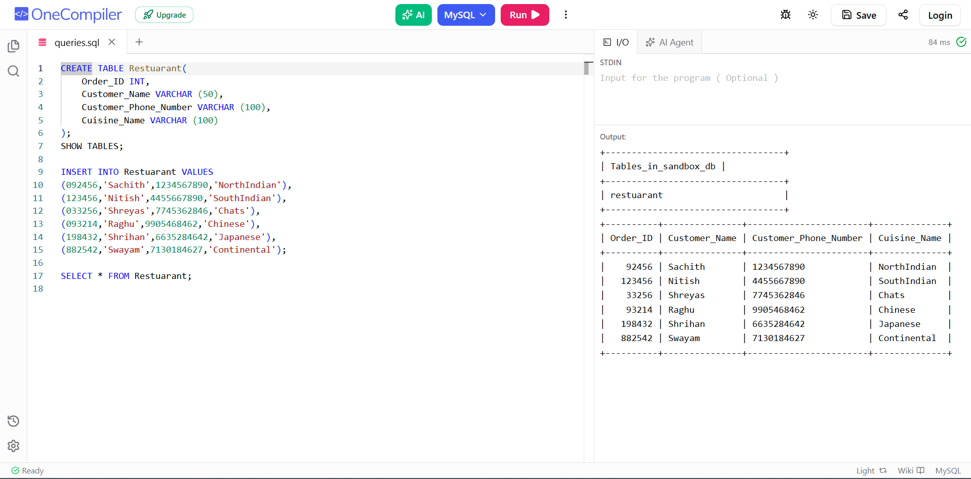
- Alter Command - Used to modify the structure of an existing table without deleting it.

ALTER TABLE Restuarant
ADD Order_Price INT;

SELECT * FROM Restuarant;

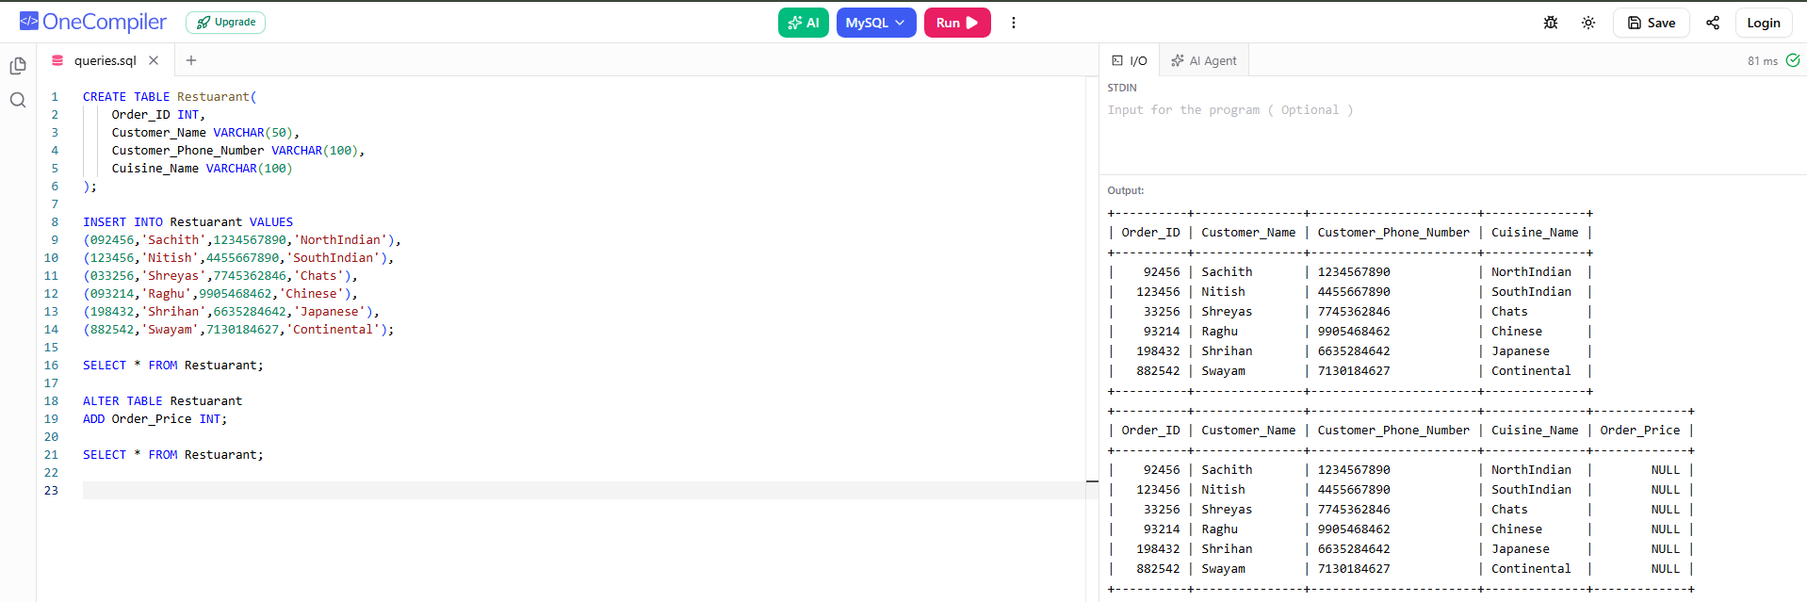

- Drop Command - Command used to permanently delete a database object such as a table, database, or column.
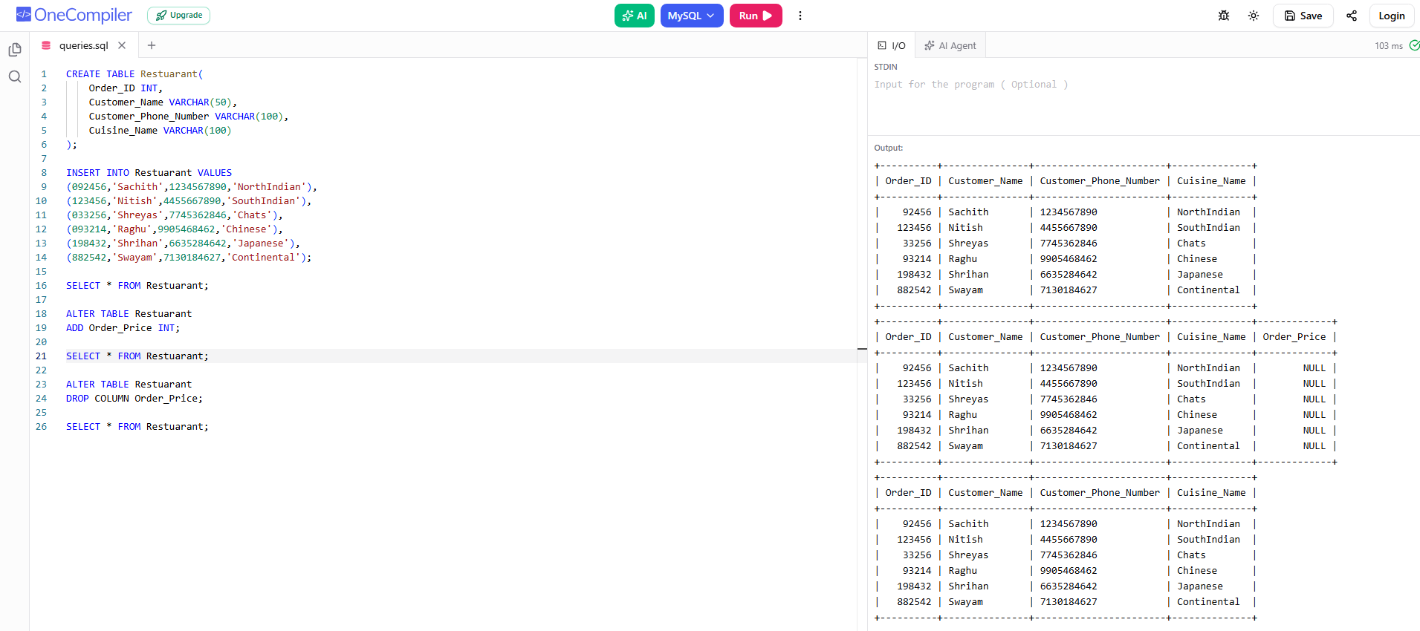
Github Link -https://github.com/deepakrc89/DBMS-ASSIGNMENT-1-2.git

