MedMNIST Transfer Learning – Fine-Tuning Pretrained ResNet18 on PathMNIST
1. Overview
In this implementation:
- Dataset: PathMNIST (MedMNIST)
- Backbone: ResNet18 from torchvision.models
- Method: Training all the layers of the trained model with fine-tuning.

2. Dataset: PathMNIST (MedMNIST)
- Source: MedMNIST
- Objective: 9-class classification of colon pathology tiles
- Image size: 28 × 28 pixels (grayscale)
- Train: 89,996 images
- Validation: 10,004 images
- Test: 7,180 images
The dataset is loaded using the official MedMNIST Python API, which ensures consistent train/val/test splits.

3. Model: Pretrained ResNet18
- Backbone: ResNet18 from torchvision.models
- Pretraining ImageNet (1.2M images, 1,000 classes).
- Adaptation for PathMNIST:
- Resize input images from 28×28 to 224×224
- Transform 1-channel into 3-channel
- ImageNet mean and standard deviation normalization.
- Replace the final fully-connected layer: 512 features ® 9 output classes
- Each of the layers is trained, and full fine-tuning of the trained network.

4. Project Structure:
medmnist_project/
- train_medmnist_transfer.py # main training and evaluation script
- best_pathmnist_resnet18.pth # model with the best results (generated during the training)
- README.md

5. Environment and dependencies can be defined as the environmental factors that impact on the facility.
Tested with:
- Python: 3.11
- OS: Windows 10 / 11
- Framework: PyTorch
Python packages:
- torch
- torchvision
- torchaudio
- medmnist
- scikit-learn
- matplotlib

6. Setup Instructions:
From the medmnist_project folder,
Create a virtual environment:
cd "C:\Users\deepak reddy\OneDrive\Desktop\masters\third sem\ai\medmnist_project"
py -3.11 -m venv .venv
checking the version the version of python:
.\.venv\Scripts\python.exe --version
.\.venv\Scripts\activate
Install dependencies:
.\.venv\Scripts\python.exe -m pip install --upgrade pip
.\.venv\Scripts\python.exe -m pip install torch torchvision torchaudio
.\.venv\Scripts\python.exe -m pip install medmnist scikit-learn matplotlib
7. Configuration for fine tuning all layers:
Configuration block:
DATA_FLAG = 'pathmnist'
BATCH_SIZE = 128
NUM_EPOCHS = 5
LR = 1e-3
USE_PRETRAINED = True
FREEZE_BACKBONE = False
8. How to run the script:
From medmnist_project directory:
With environment activated:
.\.venv\Scripts\python.exe .\train_medmnist_transfer.py
The script will:
- Download PathMNIST Dataset
- Preprocess images
- Load ResNet18 ImageNet-pretrained.
- Save final FC layer with 9-class layer
- Fine-tune all layers using Adam (lr=0.001, batch size=128, epochs=5)
- Save best model best_pathmnist_resnet18.pth
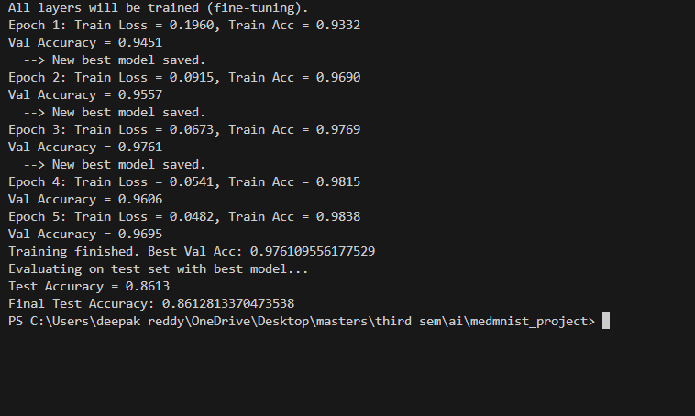
output:

Fig 1. Output for fine tuning all layers
9. Graphs
Create a Python file using the output results
Save it as plot_training_stats
Run the code
Going to the project folder
"C:\Users\deepak reddy\OneDrive\Desktop\masters\third sem\ai\medmnist_project"
Running the actual script
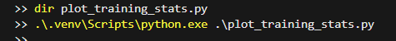

9.1. Validation vs Test Accuracy
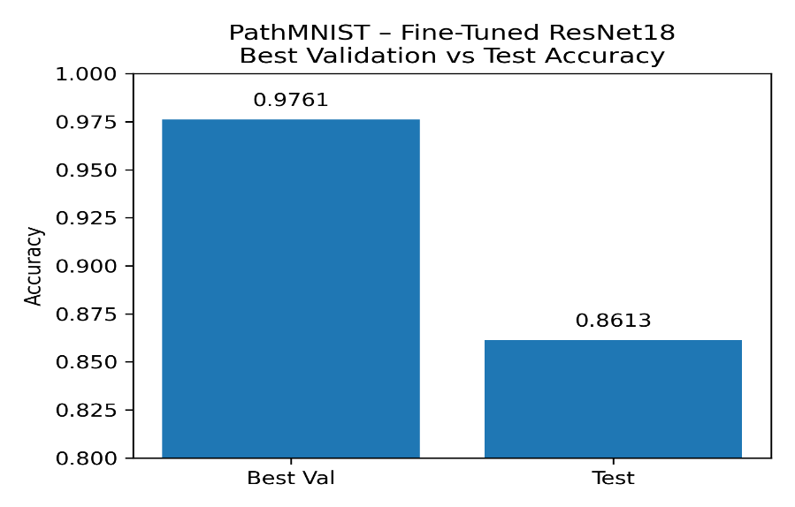
Graph 1: Validation vs Test Accuracy
9.2. Train vs Validation Accuracy
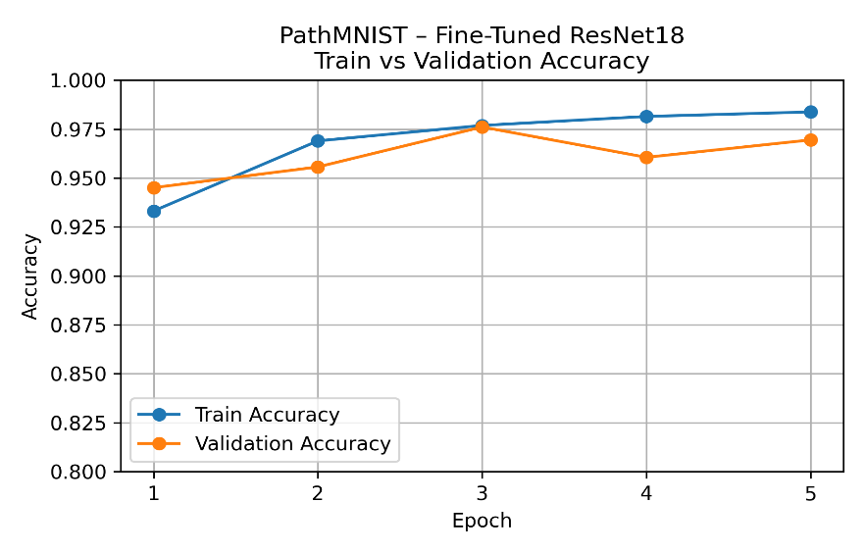
Graph 2: Train vs Validation Accuracy
9.3.Training Loss
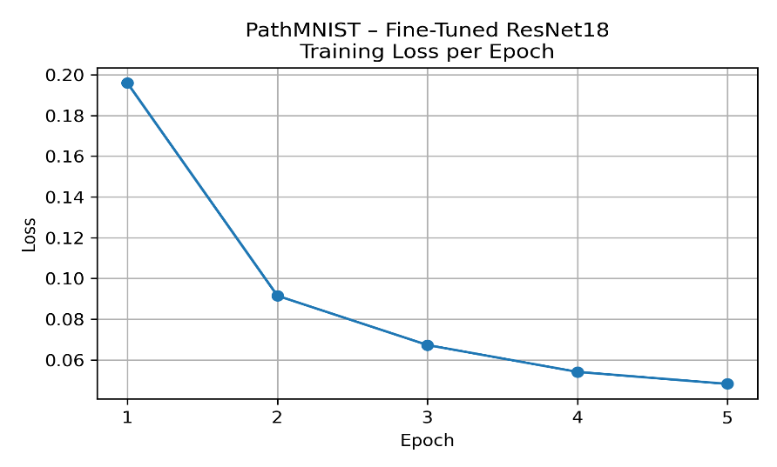
Graph 3: Training Loss
10. Configuration for fine tuning only final layer:
Configuration block:
DATA_FLAG = 'pathmnist'
BATCH_SIZE = 128
NUM_EPOCHS = 5
LR = 1e-3
USE_PRETRAINED = True
FREEZE_BACKBONE = True

11. Running the main experiment
From medmnist_project directory:
With environment activated:
.\.venv\Scripts\python.exe .\train_medmnist_transfer.py

Output:
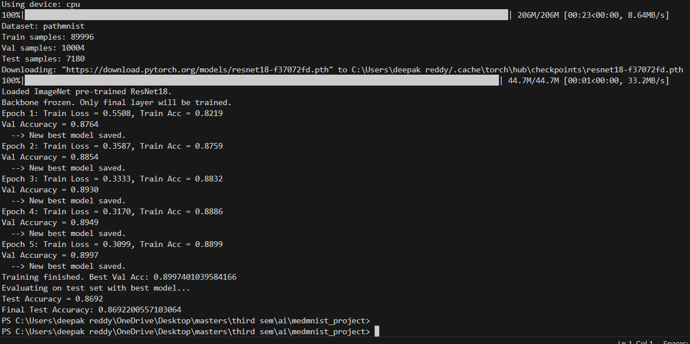
Fig 2. Output for backbone frozen
12. Graphs:
Create a Python file using the output results
Save it as graphs_backbone_frozen.py
Open "C:\Users\deepak reddy\OneDrive\Desktop\masters\third sem\ai\medmnist_project"
Running the actual script
12.1. Validation vs Test Accuracy

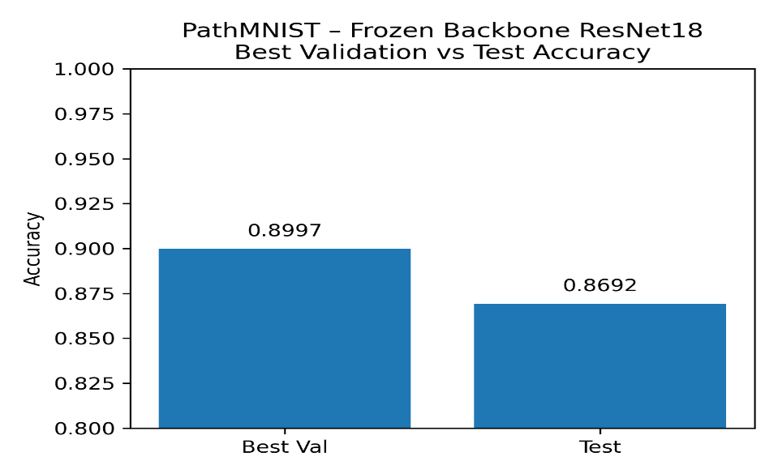
Graph 1: Validation vs Test Accuracy

12.2. Train vs Validation Accuracy
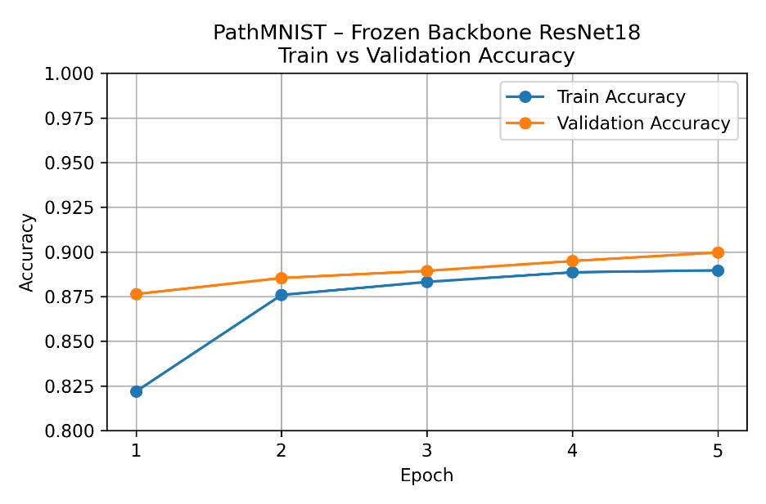
Graph 2: Train vs Validation Accuracy

12.3. Training Loss
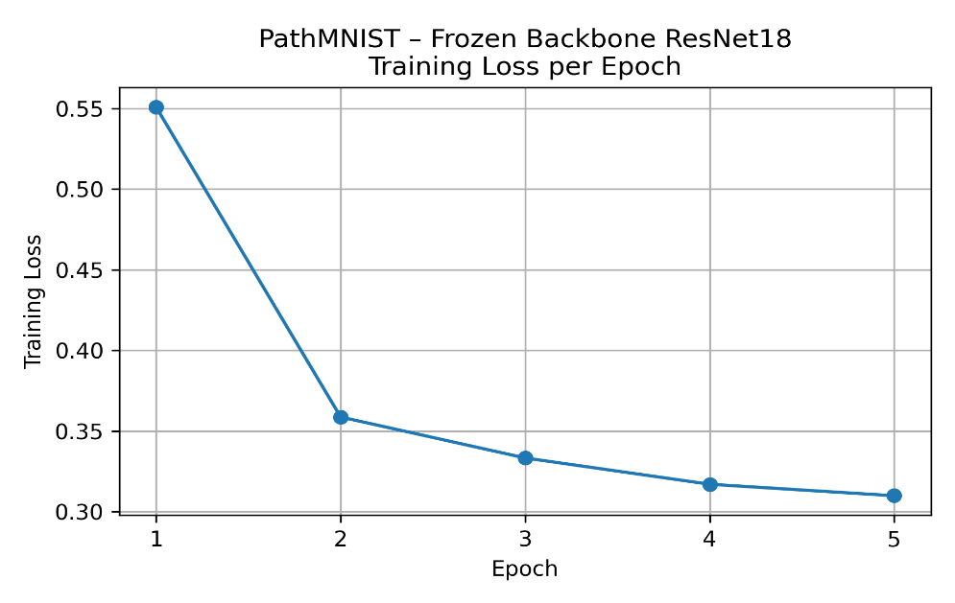

Graph 3: Training Loss

13. Summary:
- Applied transfer learning to MedMNIST with an existing ResNet18.
- fine-tuning on PathMNIST In CPU, fine-tuning: On PathMNIST, the 5-epoch fine-tuning of ResNet18 achieves:
- Validation accuracy » 97.61%
- Test accuracy » 86.13%
- Shows that ImageNet-pretrained models can be effectively adapted to small medical image datasets using
-fine-tuning for frozen backbone on PathMNIST In CPU, fine-tuning: On PathMNIST, the 5-epoch fine-tuning of ResNet18 achieves:
- Validation accuracy » 89.97%
- Test accuracy » 86.92 %

