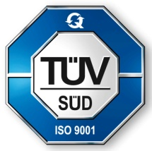**GRT INSTITUTE OF**

**ENGINEERING AND**

**TECHNOLOGY, TIRUTTANI - 631209**

**Approved by AICTE, New Delhi Affiliated to Anna University, Chennai**

**DEPARTMENT OF COMPUTER SCIENCE AND ENGINEERING**

**PROJECT TITLE**

***Water Quality Analysis***

**COLLEGE CODE:1103**

**G.DEEPAKKUMAR**

3rd yr, 5th sem

Reg no.:110321104302

ronaldodeepak710@gmail.com

**ABSTRACT**

In this work, samples of water were collected from three different tube-wells at two different

times of the year. The first set of samples was collected in the month of September, 2013 & the

second set was collected in April, 2014. Over the due course of time various parameters

regarding the water quality were analysed & the Indian Standards: 10500 (Drinking water

specifications) was referred to in order to check the acceptability of water.

The parameters which were analysed are as follows :

· Total Dissolved Solids

· Total Suspended Solids

· Determination of pH

· Determination of chloride content

· Conductivity

· Determination of sulphate content

· Turbidity

· Iron content

· Manganese content

Most of the parameters were not found to be in the desirable range for drinking water & hence,

appropriate measures were suggested to improve the quality of water.

Keywords – Water quality, drinking water, TSS, TDS, Turbidity, Conductivity, chloride,

sulphate, iron, manganese.

**1. Introduction**

The project was based on testing the quality of water. Three different samples were collected

from ‘Kantajhar Basti’ situated behind the campus of NIT Rourkela from three different

tubewells at two different times of the year. The first set of samples was collected after the rainy

season in the month of September, 2013. And the second set was collected in April, 2014.

***Water quality***

Water quality refers to the chemical, physical and biological characteristics of water. It is a

measure of the condition of water relative to the requirements of one or more biotic species and

or to any human need or purpose. It is most frequently used by reference to a set of standards

against which compliance can be assessed. The most common standards used to assess water

quality relate to health of ecosystems, safety of human contact and drinking water.

Different properties were analysed & compared during the course of the project.

Some of the properties analysed are as follows –

· Total Dissolved Solids

· Total Suspended Solids

· Determination of pH

· Determination of chloride content

· Conductivity

· Determination of sulphate content

· Turbidity

· Iron content

· Manganese content

**2. Literature Review**

*Total suspended solids*

TSS is identified as a conventional pollutant in the U.S. Clean Water Act. TSS was earlier

known as non-filterable residue (NFR). TSS is the dry-weight of particles which are trapped by

a filter having a specified pore size.

To find TSS of a water sample, measured volume of water should be passed through a preweighed filter having a specified pore size, then taking the weight of filter again after drying to

evaporate the water in the filter paper. Filters composed of glass fibres are typically used for

measuring TSS. The dry weight measure of the particulates present in the water sample is the

gain in weight & it is expressed in units derived or calculated from the volume of filtered water.

Turbidity also tends to measure almost the same quality of water property as TSS, TSS is more

useful as it gives an actual weight of the undissolved material in the sample provided.

Total Suspended Solids consist of a huge variety of material, for example, decaying plant, silt

and animal matter, sewage & industrial wastes. Water having high concentration of suspended

solids might cause problems for aquatic life & stream health.

High Total Suspended Solids in a water body might indicate higher amount of metals, pesticides,

and bacteria present in the water. Higher amount of TSS can also cause problems for industrial

usee, as the solids might clog or scour pipes and machinery.

Few Factors Affecting Total Suspended Solids

· High Flow Rates

· Soil Erosion

· Urban Runoff

· Wastewater and Septic System Effluent

· Decaying Plants and Animals

· Bottom-Feeding Fish

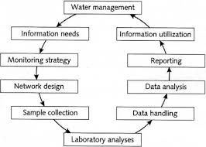

*3. Total Dissolved Solids*

A measure of the combined content of all inorganic and organic substances contained in a liquid

in molecular, ionized or micro-granular suspended form is called Total Dissolved Solids (TDS).

The solids should be small enough to survive filtration through a filter which has twomicrometer (nominal size or smaller) pores. We generally discuss TDS for freshwater systems

only, as salinity consists of some of the ions contributing in the definition of TDS. The Study

of water quality for streams, rivers and lakes is the most important application of TDS, although

TDS is not a primary pollutant, but TDS is used as an indication of aesthetic characteristics of

drinking water and as an indicator of the presence of a broad array of chemical contaminants.

Agricultural and residential runoff are primary sources for TDS in receiving waters, and so are

leaching of soil contamination and point source water pollution discharge from industrial plants.

Calcium, phosphates, nitrates, sodium, potassium, sulphates and chloride comprise few of the

important chemical constituents. The chemicals might be cations, anions, molecules or

agglomerations on the order of one thousand or fewer molecules, so long as a soluble microgranule is formed. Pesticides arising from surface runoff are more exotic and harmful elements

of TDS. Certain naturally occurring total dissolved solids arise from the weathering and

dissolution of rocks and soils.

Gravimetry and conductivity are the two important methods of measuring total dissolved solids.

Gravimetric methods are the more accurate methods and they involve evaporating the

liquid solvent and taking the mass of residues left. This is the best method generally, but it is

time-consuming. If inorganic salts are there as the great majority of TDS, gravimetric methods

are more appropriate.

Concentration of dissolved ionized solids in the water is directly related to the electrical

conductivity of water. Ions in the dissolved solids in water generate the ability for that water to

conduct electrical current, which is measured by a TDS meter or conventional conductivity

meter . Conductivity generally provides an approximate value for the TDS concentration, usually

to within ten-percent accuracy.

Hard water has high TDS levels, which might be the reason for scale buildup in filters, pipes, and

valves, reducing performance and adding to the cost of system maintenance.

In aquariums, spas, swimming pools, and reverse osmosis water treatment systems, we can see

these effects . Total dissolved solids are tested frequently in all these applications, and filtration

membranes are also checked just to prevent adverse effects.

TDS is generally monitored in order to create a water quality environment which is favorable

for organism productivity in the case of hydroponics and aquaculture. For

freshwater oysters, trouts, and other high value seafood, highest productivity and economic

returns are achieved by mimicking the pH and TDS levels of native environment of each & every

species. Total dissolved solids is considered one of the best indices of nutrient availability for the

aquatic plants being grown for hydroponic uses.

Significance of Total Dissolved Solids in Water

The total dissolved solids concentration of good & palatable drinking water should not be more

than 500 mg/L according to general belief. However, higher concentrations might be consumed

without harmful physiological effects and might be even more beneficial indeed. This limit was

set on the basis of taste thresholds. Wildlife and livestock might get injured by drinking water

that contains total dissolved solids exceeding this limit. Continuous use of such water might

cause weakness, scouring, reduced production, bone degeneration and death. However,

temporarily, animals can drink high saline waters, but that will be harmful if used continuously.

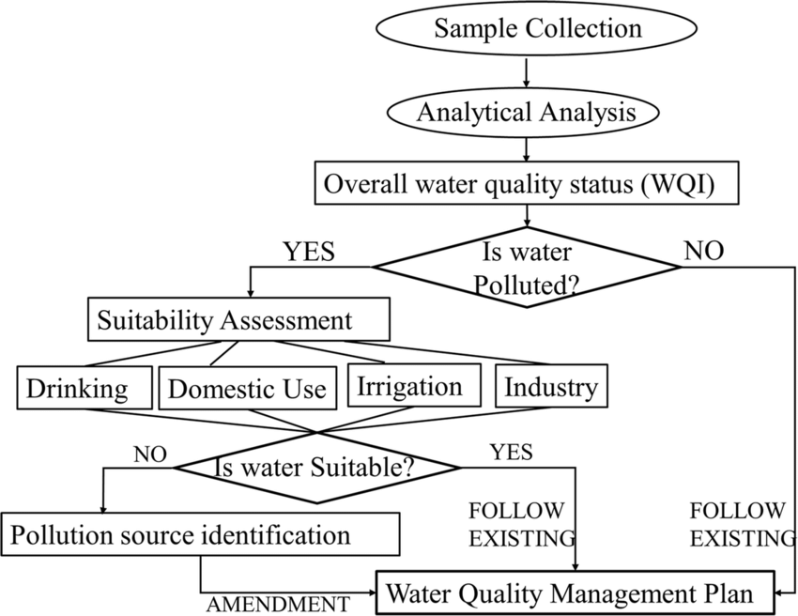

*4. Conductivity*

The measure of the ability of an electrolyte solution to conduct electricity is called its

conductivity. Conductivity is also referred to as specific conductance. The SI unit of conductivity

is siemens per meter (S/m).

In many industrial and environmental applications, conductivity measurements are used as an

inexpensive, reliable and fast way of getting the measure of the ionic content in a solution. For

example. A typical way to monitor and continuously trend the performance of water

purification systems is the measurement of product conductivity.

Conductivity is directly linked to the the total dissolved solids (T.D.S.) in various cases.

Conductivity is found out by measuring the AC resistance of the solution between

two electrodes. Dilute solutions follow Kohlrausch's Laws of concentration dependence and

additivity of ionic contributions. A theoretical explanation of Kohlrausch's law by extending

the Debye–Hückel theory was given by Lars Onsager.

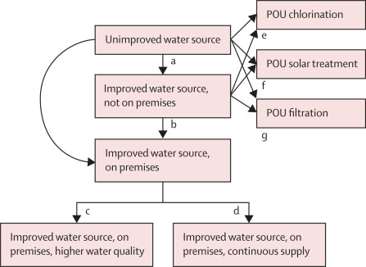

*Units*

Siemens per metre id the SI unit of conductivity and it generally refers to 25 °C. Often, the

traditional unit of μS/cm is used in industries. 106

μS/cm = 103 mS/cm = 1 S/cm. Sometimes, a

unit of "EC" (electrical conductivity) is seen on the scales of instruments: 1 EC = 1 mS/cm.

Occasionally, we also encounter is a so-called mho (reciprocal of ohm): 1 mho/m = 1 S/m.

Historically, mhos antedate Siemens by many decades; good vacuum-tube testers, for instance,

gave transconductance readings in micromhos.

The standard cell, which is most commonly used has a width of 10 mm, and thus for very pure

water in equilibrium with air would have a resistance of about 106

ohm, known as a megohm,

also sometimes known as "megaohm". Ultra-pure water can get to 18 megohms or more. Thus

megohm-cm was used earlier, sometimes spelled as "megohm". Occasionally, a conductivity is

given just in "microSiemens" (removing the distance term in the unit). While this can be seen as

an error, it can generally be assumed to be equal to the traditional μS/cm. The typical conversion

of conductivity to the total dissolved solids is done assuming that the solid is sodium chloride: 1

μS/cm is taken to be an equivalent of about 0.6 mg of NaCl per kg of water.

Molar conductivity’s SI unit is S m2 mol−1. Older publications have the unit Ω−1

cm

2 mol−1

.

The presence of inorganic dissolved solids such as chloride, nitrate, sulfate, and phosphate

anions (ions that carry a negative charge) or sodium, magnesium, calcium, iron, and aluminum

cations (ions that carry a positive charge) affect the value of conductivity in water. Various

organic compounds like phenol, oil, sugar and alcohol do not conduct electrical current well and

therefore possess a low conductivity in water. Temperature affects the conductivity as well: the

warmer the water, the higher the conductivity. For this reason, conductivity is often reported as

conductivity at 298.15 K.

Conductivity of water in streams and rivers is affected basically by the geology of the area

through which the water is flowing. Streams running through areas with granite bedrock

generally have lower conductivity because granite is composed of more inert materials that do

not ionize (dissolve into ionic components) when washed into the water. On the other hand,

13

streams that run through areas with clay soils tend to have higher conductivity because of the

presence of materials that ionize when washed into the water. Ground water inflows can have the

same effects depending on the bedrock they flow through.

Discharges to streams have the potential to change the conductivity depending on their make-up.

A failing sewage system would raise the conductivity because of the presence of chloride,

phosphate, and nitrate; an oil spill tends to lower the conductivity.

High quality deionized water has a conductivity of about 5.5 μS/m, typical drinking water in the

range of 5-50 mS/m, while sea water about 5 S/m. Distilled water has a conductivity in the range

of 0.5 to 3 µmhos/cm. Studies of inland fresh waters indicate that streams supporting good mixed

fisheries have a range between 150 and 500 µhos/cm. Conductivity outside this range could

indicate that the water is not suitable for certain species of fish or macroinvertebrates. Industrial

waters can range as high as 10,000 µmhos/cm.