**Password Validator :**

1. **Task Description**

Nested routes in React Router allow you to create multi-level menus by organizing routes hierarchically, enabling components to render within other components. This approach provides better structure and smooth navigation for complex UIs.

1. **Task Output Screenshot**

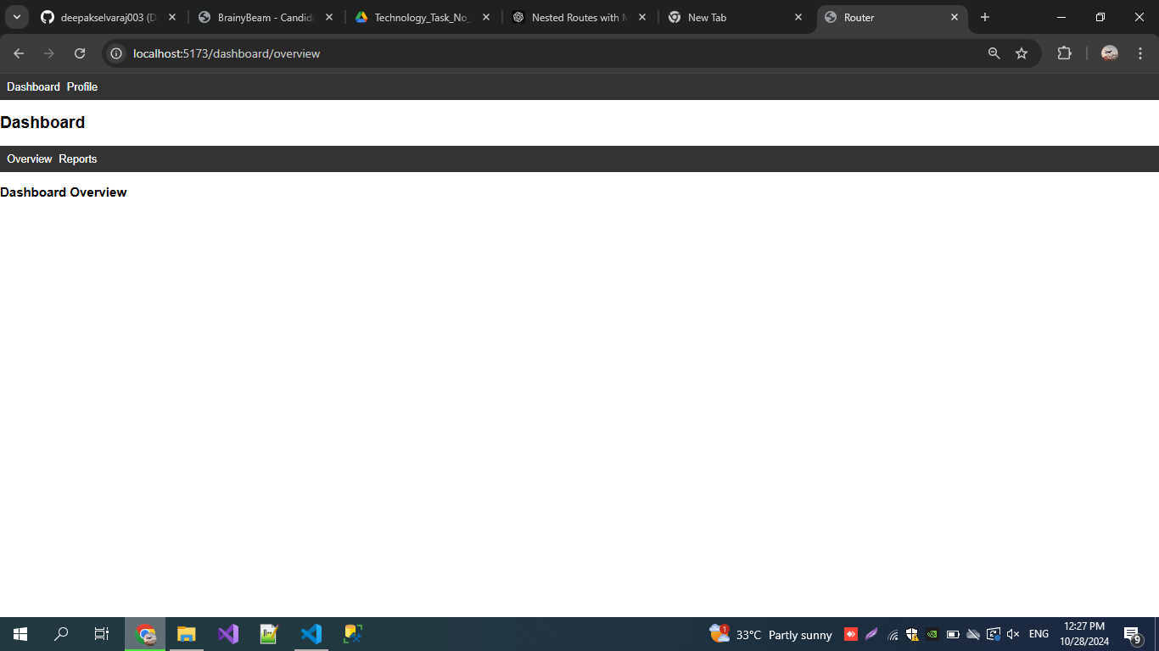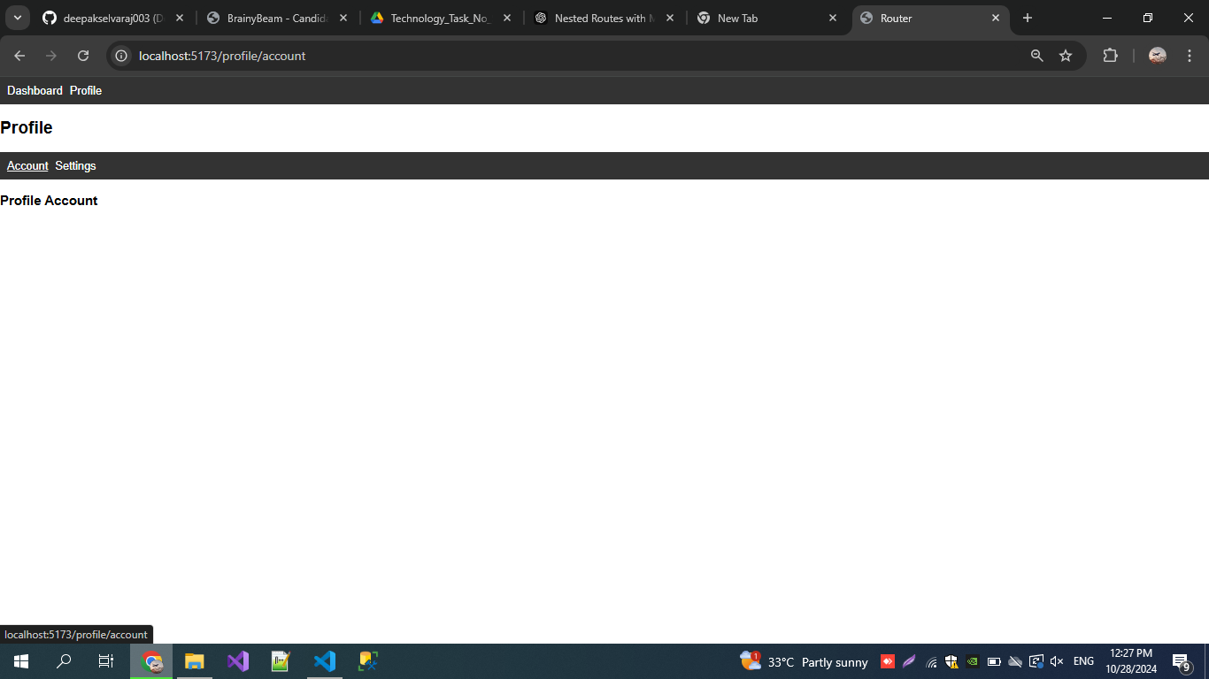

1. **Widget/Algorithm Used In Task**

* 1.React **Router**: Manages routing to create multi-level nested routes for structured navigation.
* 2.**Routes and Route Components**: Define parent-child relationships for rendering components hierarchically.
* 3.**Outlet Component**: Displays child route content within a parent layout dynamically.
* 4.**Link/NavLink Components**: Enable navigation between routes.