1. Problem: Check if a Number is Positive, Negative, or Zero

- Write a program that checks if a given number is positive, negative, or zero and prints the result.

A.

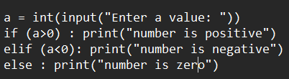

2. Problem: Check if a Number is Even or Odd

- Write a program to check if a number is even or odd. An even number is divisible by 2, while an odd number is not.

A.

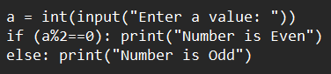

3. Problem: Find the Largest of Three Numbers

- Write a program that accepts three numbers and determines the largest number among them.

A.

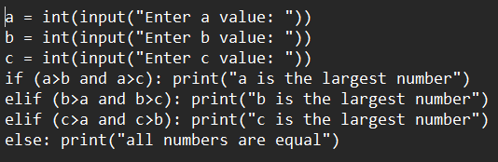

4. Problem: Check if a Year is a Leap Year

- A year is a leap year if:

- It is divisible by 4, but not divisible by 100, or

- It is divisible by 400.

- Write a program that checks if a given year is a leap year.

A.

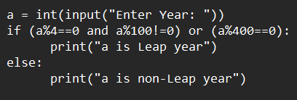

5. Problem: Check if a Number is Divisible by Both 3 and 5

- Write a program that checks if a number is divisible by both 3 and 5. If it is, print "Divisible by 3 and 5", otherwise print "Not divisible by 3 and 5".

A.

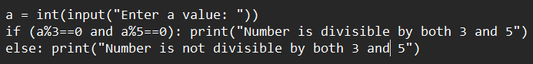

6. Problem: Check if a Number is Prime

- Write a program to check if a given number is a prime number. A prime number is a number greater than 1 that is divisible only by 1 and itself.

7. Problem: Check if a Character is a Vowel or Consonant

- Write a program that checks if a given character is a vowel or a consonant. The vowels are `a`, `e`, `i`, `o`, `u` (both uppercase and lowercase).

A.

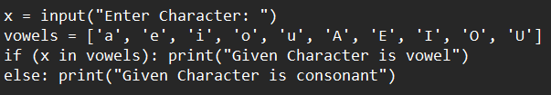

8. Problem: Check if a Person is Eligible to Vote

- Write a program that checks if a person is eligible to vote. The eligibility condition is that the person's age should be 18 or older.

A.

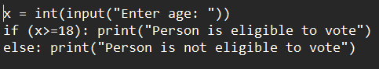

9. Problem: Check if a Number is a Multiple of 10

- Write a program to check if a given number is a multiple of 10.

A.

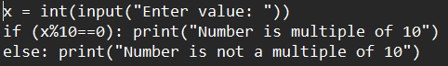

10. Problem: Compare Two Numbers and Print the Smaller One

- Write a program to compare two numbers and print the smaller one.

