FOUNDATIONS OF INTELLIGENT SYSTEMS

PROJECT – 1

By Aravindh Kuppusamy, Deepak Sharma, Karan Jariwala

**1) PROBLEM DEFINITION:**

* **States:**

Configuration of all legal positions in the maze along with the dice orientation at each possible position. If the width of the maze is W and height of the maze is H, then W*H positions are possible. Out of these positions, let O positions be obstacles and hence, the dice can't be moved to those locations. 20(5*4) orientations of dice for each non-goal position and 4(1*4) orientations for goal position are possible. Hence the size of the state space is:

State space Size: (((W*H)-O-1)*20) + (1*4)

* **Successor Function:**

Successor function generates all the possible moves from a given state. Here, Successor function generates states which represents both the dice location in the maze and its orientation. So, the successor function for the problem is legal moves in both maze and dice in same direction.

Legal positions in Maze for successor states:

The possible moves include moving in four directions (Top, Bottom, Right, and Left) to the adjacent position with step cost as 1. But if the resulting position is an obstacle, then the move is not legal. So the legal moves would be all possible moves without illegal ones.

Legal orientations of Dice for successor states:

The possible orientations include turning in four directions (Top, Bottom, Right, and Left) by one step. But if the resulting position is an orientation of dice with top value = 6 for a non-goal state and top value != 1 for goal state, then the move is not legal. So the legal moves would be all possible moves without illegal ones.

* **Goal test:**

Whether the Goal position in the maze has been reached with the dice orientation having top value = 1.

* **Path Cost:**

Total number of moves till the current state.

**2) HEURISTICS:**

* **MANHATTAN DISTANCE:**

Manhattan distance is the sum of the vertical and horizontal distances between two points. If (x1, y1) and (x2, y2) are the two points then Manhattan distance between them is

$$d= abs\left(x_{1} - x_{2}\right)+abs\left(y_{1}-y_{2}\right)$$

**Admissibility:**

A heuristic is admissible if estimated cost is never greater than the actual cost from the current state to goal state.

**Proof for Admissibility:**

For a given state at location (xs, ys) and goal location (xg, yg), the distance we have to travel is at least || + || since we can move only in horizontal and vertical directions. We are also relaxing the constraint of obstacles and dice configurations.

**Proof by Contradiction:**

**Base Case:**

h(goal) = 0

Let C be the minimum actual cost for travelling from start state to goal state. .i.e., at least C steps are required for travelling from start state to goal state

Assume, the actual cost C < h(start) -> 1

For each action we perform, the step cost will be just 1. So heuristics for the successor state will reduce by just 1.

Cost(parent -> child) = 1

Hence,

h(successor) = h(parent) – 1

Since, at least C steps are required for travelling from start state to goal state,

h(goal) >= h(start) – C

h(goal) >= h(start) – C > 0 From 1

h(goal) > 0

This contradicts the base case and so our assumption is wrong.

Therefore,

C >= h(start)

Hence, we conclude that Manhattan distance heuristics is admissible.

* **DIAGONAL DISTANCE:**

Diagonal distance is the sum of the number of diagonal steps possible and the remaining straight line distance between two points. If (x1, y1) and (x2, y2) are the two points then Diagonal distance between them is

$$dx= abs\left(x_{1} - x_{2}\right)$$

$$dy= abs\left(y_{1}-y_{2}\right)$$

$$d=(\sqrt{2}*\min\left(dx, dy\right))+ abs(dx-dy)$$

**Proof for Admissibility:**

There are two cases possible here. 1) dx >= dy and 2) dx < dy.

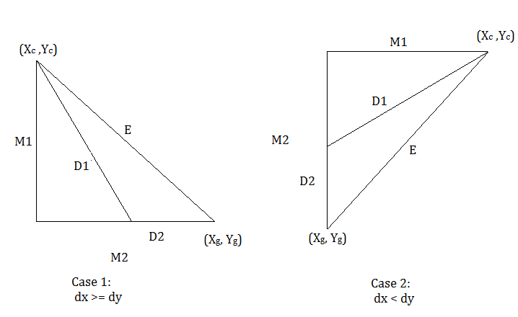

For the given current node (xc,yc) and the goal node (xg, yg), the diagonal heuristic hdiagonal = D1 + D2. Now by triangle inequality,

M1 + (M2 – D2) >= D1

M1+ M2 >= D1 + D2.

Here, M1 + M2 is the Manhattan heuristics for the point (xc, yc). So, Euclidean distance is always lesser than or equal to Manhattan distance.

From above statement, we can say that,

hdiagonal <= hmanhattan

i.e., Manhattan heuristics dominates diagonal heuristics. Since, Manhattan heuristics dominates diagonal heuristics and also Manhattan heuristics is admissible, we can infer that diagonal heuristics is also admissible.

* **EUCLIDEAN DISTANCE:**

Euclidean distance is the distance of the straight line that connects two points. If (x1, y1) and (x2, y2) are the two points then Manhattan distance between them is

$$d= \sqrt{{\left(x_{1} - x_{2}\right)}^{2}+{\left(y_{1}-y_{2}\right)}^{2} }$$

**Proof for Admissibility:**

According to triangle inequality, the sum of two sides is always greater than or equal to the third side.

Euclidean distance is the hypotenuse (third side) in the triangle formed by two sides dx and dy in Manhattan distance, where $dx= abs\left(x_{1} - x_{2}\right) and dy= abs\left(y_{1}-y_{2}\right)$.

So, Euclidean distance is always lesser than or equal to Manhattan distance. From above statement, we can say that,

heuclidean <= hmanhattan

i.e., Manhattan heuristics dominates Euclidean heuristics. Since, Manhattan heuristics dominates Euclidean heuristics and also Manhattan heuristics is admissible, we can infer that Euclidean heuristics is also admissible.

* **FANCY MANHATTAN DISTANCE:**

Fancy Manhattan heuristics is nothing but sum of Manhattan distance and a reward α = -0.5.

If the current state’s position is (xc, yc) and the goal state’s position is (xg, yg), then horizontal and vertical distances between them are

$$dx= abs\left(x_{g} - x_{c}\right)$$

$$dy= abs\left(y_{g}-y_{c}\right)$$

Reward comes into play if dx <=1 or dy <= 1. We add reward to heuristics if by rotating the dice from current location (xc, yc) to the goal location (xg, yg) and if it is passing goal test. We perform two types of rotation and we take the best case from them:

1) Travel horizontally till dx = 0 and then travel vertically till dy = 0.

2) Travel vertically till dy = 0 and then horizontally till dx = 0.

hfancy_manhattan(n) = hmanhattan(n) + α

$$where α= -0.5 if \left(x_{n}, y_{n}\right)=> \left(x_{G}, y_{G}\right) with dice top=1 else 0$$

**Proof for Admissibility:**

Here, we are actually either subtracting the Manhattan heuristics by 0.5 as per the above conditions or we just return Manhattan heuristics. So, the fancy Manhattan heuristics is less than or equal to Manhattan heuristics. We know that Manhattan distance is admissible.

Hence, the fancy Manhattan heuristics is also admissible since it never over predicts the cost than Manhattan heuristics.

**3) PERFORMANCE METRICS**

**4) DISCUSSION**