TABLE OF CONTENTS
S.NO | TOPICS | PAGE NO.
 | Certificate | 2
 | Acknowledgement | 3
 | Summary | 4
1. | Introduction | 5
2. | High level design | 6
3. | Hardware design | 7
4. | Software design | 15
5. | Results | 22
6. | Conclusion | 23
7. | Appendix  Code  Work Contribution | 24  40
8. | References | 40
9. | List of figures | 41

CERTIFICATE

This is to certify that the work titled “AUTO STRING PUPPET” submitted by “DEEPANSHARORA(7102257),DEEPAK(7102198),VISHNU TEJA(7102289) ” in partial fulfilment for the award of degree of bachelor of technology of Jaypee Institute of Information Technology University, Noida has been carried out under my supervision. This work has not been submitted partially or wholly to any other University or Institute for the award of this or any other degree or diploma.

Signature of Supervisor -
Name of Supervisor - Mr. Abhishek Srivastva
Designation - Senior lecturer
Date -

ACKNOWLEDGEMENT

We would like to express our gratitude to all those who gave me the possibility to complete this project.
Our project mentor Mr. Abhishek srivastva sir helped us a lot in our project work. We want to thank him for all their help, support, interest and valuable hints. Especially we are obliged to Mr. Mc.srivastva and Mr. Abhinav gupta sir for all their assistance in our work.
We would like to give our special thanks to mc.srivastva sir who has given us the opportunity to do this work and provided with their precious guidance.

Yours faithfully
DEEPANSH ARORA (7102257) Batch-A4
DEEPAK SHARMA (7102198) Batch-A2
VISHNU TEJA (7102289) Batch-A6

SUMMARY

Our automaton is inspired by a simple concept. We have designed and built a simple auto string puppet that could automatically dance, without prompts or switches but to the music being played in the room.
Puppet is a popular art form that exists in many cultures. In addition to the theatrical content, people are attracted to string controlled puppet performance due to its interesting human like motion. Putting aside the artistic performance of the puppeteer, manipulating a string controlled puppet to achieve lifelike bodily movement is a challenging task that involves physical laws and engineering principles.
The aim of our project is to make a microcontroller programmed string puppet which perform different moves according to musically controlled motion of motors. And also the different moves depend on the frequency to which the input signal belong .Different frequency input are passed to 4 different filters and based on filters output , motion or steps are activated to puppet through motors.
So overall our project constitute of 3 tasks
- Usage of filter
2 types of filters- analog and 2nd order digital Butterworth filter to extract different frequency ranges.
- Motion control of puppet using stepper motors
According to music i/p we have assigned different moves to our puppet whose motion is controlled by the stepper motors using string attached to it.
- Mechanical design
It consists of a puppet with one side of string connected to hands and legs and the other end of the string is operated with stepper motor .

1. INTRODUCTION

Main task of the project is to design a string puppet musically controlled by the microcontroller. The puppet is capable of dancing to any song you want. It works with coordination of 2 motors ,analog circuit design and digital filters to dance in a music of your choice. The synchronization is carried out by the use of 8 bit microcontroller- atmega 16 which have 16 kb of flash memory that can be burned using avr-dude burner . The coding of microcontroller(atmega 16) is done on bascom (compiler) which supports a high-level language.

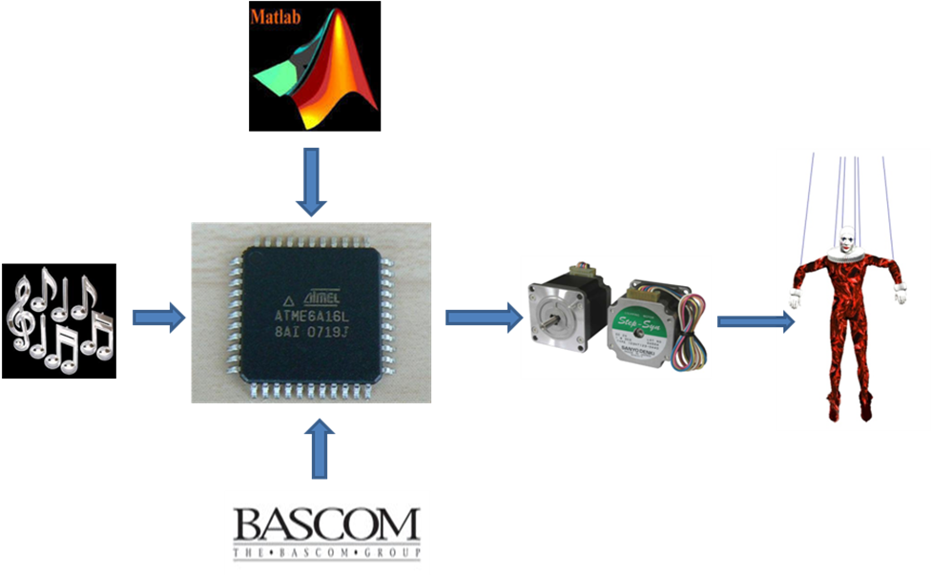
Fig1-Breif intro

- The music is taken as input from 3.5mm sterio jack of Laptop .
- Digital Filters are designed in Bascom.
- The coefficients for filters are obtained from Matlab.
- The HEX file is burnt in ATMEGA16.
- STEPPER MOTOR & DC Motor are connected to Microcontroller using L293D IC.
- The puppet is connected to the motors through strings in such a way that the motion of motor would create movement in puppet.

2. HIGH LEVEL DESIGN

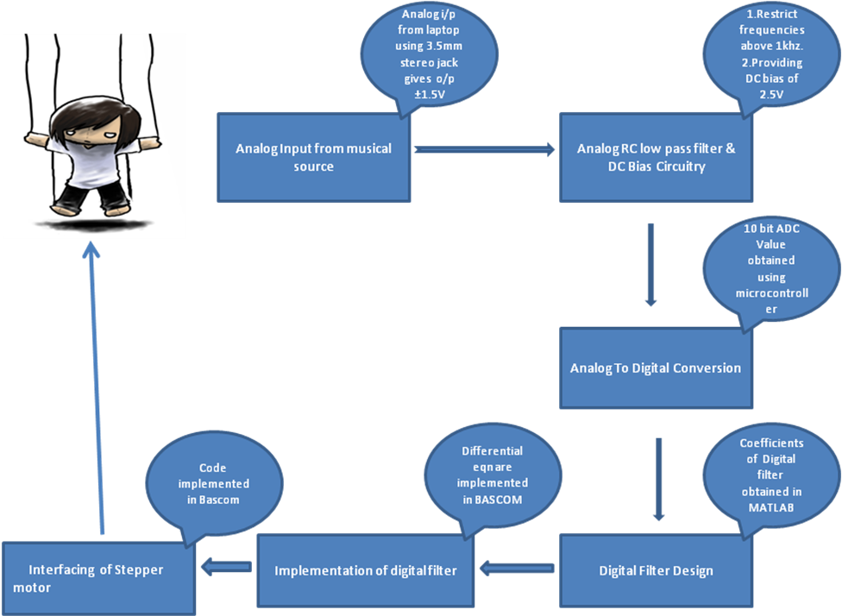

As per the above design ,work has been processed for completion of our project .

3. HARDWARE DESIGN

The hardware design consists of:
- Puppet
- Development board for microcontroller ATMEGA16.
- Adapter to provide 12 v
- Connecting wires
- Parallel port connector
- Compartment of LED lights.
- 1 -2Stereo jack
- L-Strips
- 9 16 x 2 LCD
- Stepper Motor(7.5degrees/step)-1, Dc Motor 40rpm –1
- Wooden pieces and boards
- Speakers and Show lights

3.1 MECHANICAL DESIGN OF PUPPET
The puppet is attached with 5 strings of which 1string is attached to head of the puppet this string bears the weight of the puppet. Of the remaining 4 two are attached to the hands and 2 are attached to the legs. These are attached in such a way to get the over all. The design is as follows:-
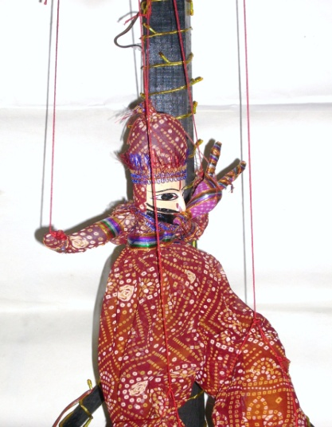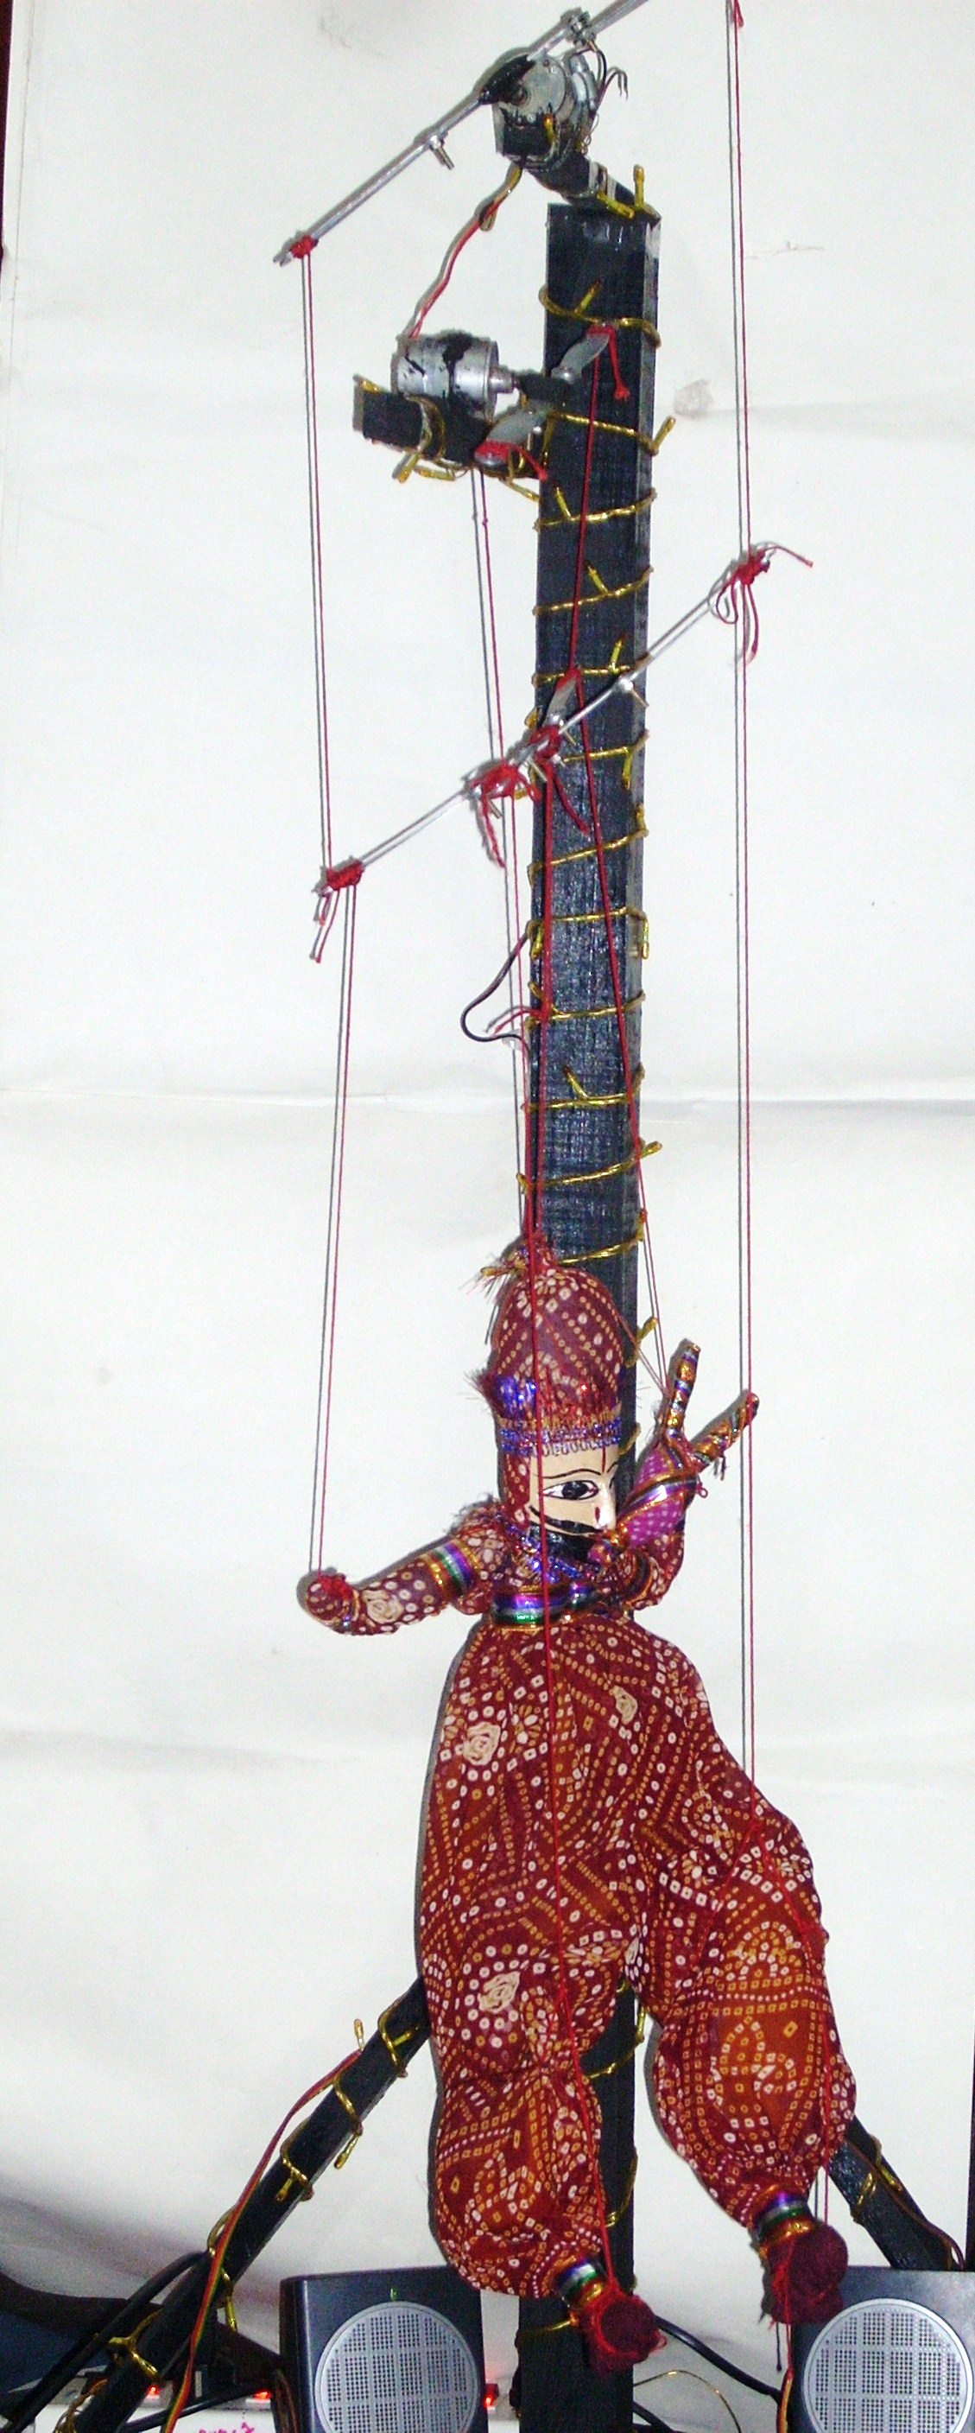
Fig2:-Puppet attached with Motors

3.2 ANALOG LOW PASS FILTER
The music is being fed from a source, namely the laptop’s music player VLC. This can be replaced by any other music player, like, IPod, MP3 etc. We initially used the IPOD for feeding the music for processing to the ADC, and shifted to playing music on the laptop due to the limitations of its battery power and plug sockets on the supply line.
The music from the player is fed via a 3.5mm stereo phone jack to the speakers and the ADC. The signal is divided into two cleverly, by connecting the speaker pins directly to the ground and the signal output of the phone jack with the help of banana clips. This is done so that we can “see” the puppet dance to the right beats. The musical signal from the source goes to the ADC and the speaker simultaneously.
3.2.1 USE OF ANALOG LOW PASS FILTER
Further, we needed a bias for the signal to be fed into the ADC because the player like MP3 or laptop provides an output at +/- 1.5 Volts. Giving a negative voltage to the ADC means killing it forever. Thus, we had to shift the level of this negative voltage such that the voltage varies from 0-5Volts suitable for the microcontroller unit. This has been done using the same voltage divider circuit as used in Lab 4 for the ADC. This is easily done using two 1Mohm resistors, one end of each resistor connected to each other and the other ends connected to GND and Vcc respectively. The common ends of the resistor are then connected to Pin A.0, i.e. ADC of the microcontroller unit. The voltage at this point is 2.5Volts due to the voltage divider circuit. A two-pole RC analog low- pass filter has been used to pass the lower frequencies, removing any high frequency. The resistor values were chosen as 1K each and capacitor values as 0.1uF to give a suitable time constant for the sampling frequency. At the current sampling rate of 2.5 kHz, we are able to filter out the treble and input the typical music for decoding. We can accurately detect the highest frequency of 1kHz. Thus, filtering, removing treble and DC biasing the signal gives a processed and conditioned output from the source ready to be fed into the ADC.The circuit of the filter is as follows
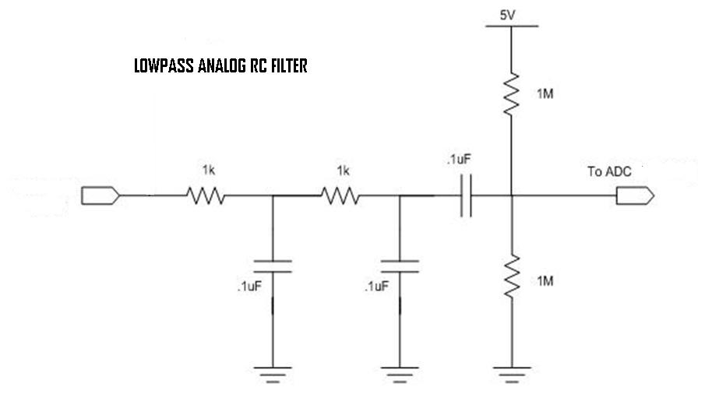
Fig3-analog lowpass filter and biasing circuit
3.3 DEVELOPMENT BOARD
For the sake of convenience we used a multilayered microcontroller fabricated circuit which has all input and output pins connected with jacks .
FEATURES
- 2 amps current support with Dual 7805
- Atmega 16/32 compatible controllers.
- 4 DC motor compatible
- 2 Stepper motor compatible
- 4 Programmable Led
- ISP support with Sample Electronics Programmer and programmer.
- 2 Programmable input switches
- RS 232 compatible
- Programmable 16x2 LCD Support
- Fully extendable board with 32 I/O pins
- 8 Analogue sensor channels
3.3.1 SWITCH, 7805 AND POWER CONNECTOR

Power Switch is used to turn on the power supply of the board. Power will flow to voltage regulators only when the power switch is in down position .7805 Voltage regulators will regulate the power supply to 5 V. 7805 will work only when the input power is at least 7 volts. Power supply can be given either through the Power Connector or through the DC Jack. Care should be taken so that only one power source at a time.

3.3.2 REGULATED 5 VOLTS POWER OUTPUT

This connector can be used to provide power to any external device. Taking into consideration, that the board can only withdraw power up to 2Amps, power output from this jack may vary.

3.3.3 RESET SWITCH

This switch is used to reset the program counter to zero and restart the program execution. In execution mode, Reset switch is needed to be kept in down position. While downloading the program to the chip, reset switch should be kept in up position

3.3.4 PIN BASE FOR MICROCONTROLLER

This base is provided to install and remove microcontroller chip easily. This board supports ONLY two microcontrollers – Atmel ATmega16 and Atmel ATmega32. Both microcontrollers have exactly same pin configuration but they differ in terms of the memory.
3.3.5 16 PIN BASE FOR L293D DRIVER ICS

There are two bases provided onboard to use L293D H-Bridge with microcontroller. This board supports ONLY L293D Driver. No other HBridge IC can be installed instead of L293D.

3.3.6 16 PIN LCD HEADER

A 16 Pin header is provided to interface one 16 * 2 Alphanumeric LCD. Given below are the pin configuration details –
Lcdpin = Pin
Db4 = Portb.4
Db5 = Portb.5
Db6 = Portb.6
Db7 = Portb.7
E = Portb.3
Rs = Portb.2

3.3.7 EIGHT 3 PIN HEADERS FOR SENSORS

This board provides capability to connect up to eight sensors directly to ADC port of the ATmega16/32. ADC need to be configured and started while working with Analog sensors whereas ADC need to kept off while working with Digital sensor with same Port A. However both types of sensors can be used at a time but they both should be different ports, i.e. analog sensors should be on Port A (with ADC started) and digital sensors should be on any other port (with that port in input mode). Given below is the connection details of all eight headers with corresponding microcontroller pin
J12 = PortA.7 (or) ADC (7)
J13 = PortA.5 (or) ADC (5)
J14 = PortA.3 (or) ADC (3)
J15 = PortA.1 (or) ADC (1)
J17 = PortA.6 (or) ADC (6)
J16 = PortA.4 (or) ADC (4)
J18 = PortA.2 (or) ADC (2)
J19 = PortA.0 (or) ADC (0)
The analogue circuit(i.e. Low pass Filter) is attached to these ports to get input.

3.4 STEPPER MOTOR
A stepper motor is an electromechanically device which convert electrical pulses into discrete mechanical movements. The shaft or spindle of a stepper motor rotates in discrete step increments when electrical command pulses are applies to it in the proper sequence. The motors rotation gas several direct relationships of the applied pulses is directly related to the direction of motor shafts rotation is directly related to the frequency of the inputs pulses and the length of rotation of directly related to the number of input pulses applied.
Stepper motors operate differently from DC brush motors, which rotate when voltage is applied to their terminals. Stepper motors, on the other hand, effectively have multiple "toothed" electromagnets arranged around a central gear-shaped piece of iron. The electromagnets are energized by an external control circuit, such as a micro controller. To make the motor shaft turn, first one electromagnet is given power, which makes the gear's teeth magnetically attracted to the electromagnet's teeth. When the gear's teeth are thus aligned to the first electromagnet, they are slightly offset from the next electromagnet. So when the next electromagnet is turned on and the first is turned off, the gear rotates slightly to align with the next one, and from there the process is repeated. Each of those slight rotations is called a "step," with an integer number of steps making a full rotation. In that way, the motor can be turned by a precise angle.
3.4.1 USE OF STEPPER MOTOR IN AUTO STRING PUPPET
In this project we have use the stepper motor because it provide precise stepping which is an important need of puppet dance we have to rotate the motor unto a particular angle which is only possible with stepper motor. We have made a complex structure of strings which is connected to motors and with the movement of the motor and help of this Structure these strings moves a due to the movement of the string the puppet come into action and move with multiple degrees of freedom. But we need a high degree of accuracy to perform this motion to avoid the internal collision of the structure components. Stepper enables us to perform these motions.
3.4.2 WIRE CONFIGURATION AND HARDWARE CONNECTION
There are many type of stepper motor name unipolar bipolar (series and parallel winding) are available. We have use unipolar motor (6 wire) stepper motor in our project.
A unipolar stepper motor has two windings per phase, one for each direction of magnetic field. Since in this arrangement a magnetic pole can be reversed without switching the direction of current, the commutation circuit can be made very simple (eg. a single transistor) for each winding. Typically, given a phase, one end of each winding is made common: giving three leads per phase and six leads for a typical two phase motor. Often, these two phase commons are internally joined, so the motor has only five leads.. Before we write the control system (code) for stepper we should have the complete idea of wires of stepper motor. There are 6 wires in our stepper motor 3 wires of each coil; these 3 wires are connected to both the terminals.
Of the stepper motor and one wire is centre tap to coil. To recognize the wire configuration of stepper motor we just need a DMM(digital multimeter) to measure the resistance. Each of the two coil should have the same resistance when measured with a multimeter. When measuring the resistance across one wire from each of the two coil, the resistance should be infinite because the circuit is open. Locate the two pairs of wires that represent the two phases, and both pairs of wires will have similar internal resistance. And the resistance between the two terminals of coil is double of the resistance between the centre tap wire and any of wire. Thus we have found the wire configuration and we have marked them. now we have to write the control system to stepper into microcontroller and we have to interface the stepper motor to microcontroller.
Stepper motor needs around 12v dc and 1.2amp to move and for this we need motor driver circuitry. For this purpose we use L293D H bridge motor driver witch solve our motto.

3.4.3 INTERNAL OF STEPPER MOTOR:
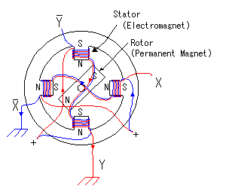
Fig4-internal structure of stepper motor
In the PM type stepper motor, a permanent magnet is used for rotor and coils are put on stator. The stepper motor model which has 4-poles. As for four poles, the top and the bottom and either side are a pair. coil, coil and coil, coil correspond respectively. For example, coil and coil are put to the upper and lower pole. coil and coil are rolled up for the direction of the pole to become opposite when applying an electric current to the coil and applying an electric current to the coil. It is similar about and , too.The turn of the motor is controlled by the electric current which pours into , , and . The rotor rotational speed and the direction of the turn can be controlled by this control.The stepper motor takes 48 steps and the step angle is 7.5 degrees.It operates when controlling the electric current of coil, coil, coil and coil as show below.The case of the clockwise control is shown below.The combination of , , and repeats four patterns.
   |  |  |  | Step angle
  0 | 1 | 0 | 1 | 0.0°
  1 | 0 | 0 | 1 | 7.5°
  1 | 0 | 1 | 0 | 15.0°
  0 | 1 | 1 | 0 | 22.5°
  0 | 1 | 0 | 1 | 30.0°
  1 | 0 | 0 | 1 | 37.5°
  1 | 0 | 1 | 0 | 45.0°
  0 | 1 | 1 | 0 | 52.5°
  0 | 1 | 0 | 1 | 60.0°
  1 | 0 | 0 | 1 | 67.5°
  1 | 0 | 1 | 0 | 75.0°
  0 | 1 | 1 | 0 | 82.5°
  0 | 1 | 0 | 1 | 90.0°
  1 | 0 | 0 | 1 | 97.5°
  1 | 0 | 1 | 0 | 105.0°
  0 | 1 | 1 | 0 | 112.5°
  0 | 1 | 0 | 1 | 120.0°
  1 | 0 | 0 | 1 | 127.5°
  1 | 0 | 1 | 0 | 135.0°
  0 | 1 | 1 | 0 | 142.5°
  0 | 1 | 0 | 1 | 150.0°
  1 | 0 | 0 | 1 | 157.5°
  1 | 0 | 1 | 0 | 165.0°
  0 | 1 | 1 | 0 | 172.5°
   |  |  |  | Step angle
  0 | 1 | 0 | 1 | 180.0°
  1 | 0 | 0 | 1 | 187.5°
  1 | 0 | 1 | 0 | 195.0°
  0 | 1 | 1 | 0 | 202.5°
  0 | 1 | 0 | 1 | 210.0°
  1 | 0 | 0 | 1 | 217.5°
  1 | 0 | 1 | 0 | 225.0°
  0 | 1 | 1 | 0 | 232.5°
  0 | 1 | 0 | 1 | 240.0°
  1 | 0 | 0 | 1 | 247.5°
  1 | 0 | 1 | 0 | 255.0°
  0 | 1 | 1 | 0 | 262.5°
  0 | 1 | 0 | 1 | 270.0°
  1 | 0 | 0 | 1 | 277.5°
  1 | 0 | 1 | 0 | 285.0°
  0 | 1 | 1 | 0 | 292.5°
  0 | 1 | 0 | 1 | 300.0°
  1 | 0 | 0 | 1 | 307.5°
  1 | 0 | 1 | 0 | 315.0°
  0 | 1 | 1 | 0 | 322.5°
  0 | 1 | 0 | 1 | 330.0°
  1 | 0 | 0 | 1 | 337.5°
  1 | 0 | 1 | 0 | 345.0°
  0 | 1 | 1 | 0 | 352.5°
3.5 DIRECT CURRENT (DC) MOTORS
- Small, cheap, reasonably efficient, easy to use, ideal for small robotic applications
- Converts electrical energy into mechanical energy
- They work by running electrical current through loops of wires mounted on rotating shaft(armature)
- When current is flowing, loops of wire generate a magnetic field, which reacts against the magnetic fields of permanent magnets positioned around the wire loops
- These magnetic fields push against one another and the armature turns.
3.5.1 EFFICIENCY-
- Various limitations, including mechanical friction, cause some electrical energy to be wasted as heat
- Toy motors: efficiencies of 50%
- Industrial-grade motors: 90%

3.6 H-BRIDGE MOTOR DRIVER CIRCUIT
- Four transistors form the vertical legs of the H,while the motor forms the crossbar.
- In order to operate the motor, a diagonally opposite pair of transistors must be enabled.L293d is used instead of H-Bridge Motor Driver Circuit.

4. SOFTWARE DESIGN

Software designing have great importance in our project .It has been used for tackling the tasks in a simpler way by
- Verifying outputs
- Implementation of filter
- High level programming in bascom

4.1 PSPICE SIMULATION
A two-pole RC analog low- pass filter has been used to pass the lower frequencies, removing any high frequency. The resistor values were chosen as 1K each and capacitor values as 0.1uF to give a suitable time constant for the sampling frequency. At the current sampling rate of 2.5kHz, we are able to filter out the treble and input the typical music for decoding. We can accurately detect the highest frequency of 1kHz. Thus, filtering, removing treble and DC biasing the signal gives a processed and conditioned output from the source ready to be fed into the ADC (of microcontroller unit).
Circuitry discussed above have been implemented in pspice and their output are checked in different circumstances as follows
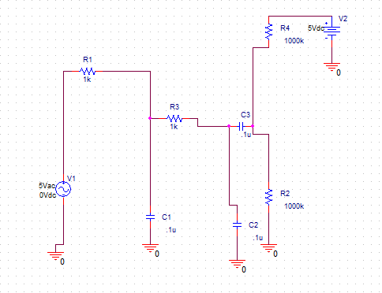
Fig5-pspice circuitry for 2nd order low pass filter
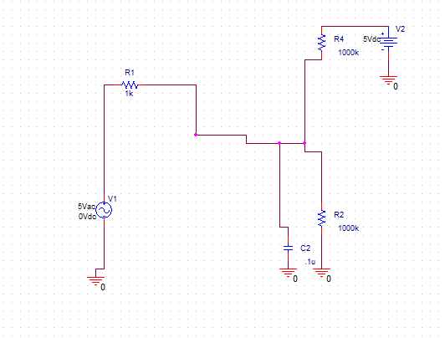
Fig6- pspice circuitry for 1st order low pass filter

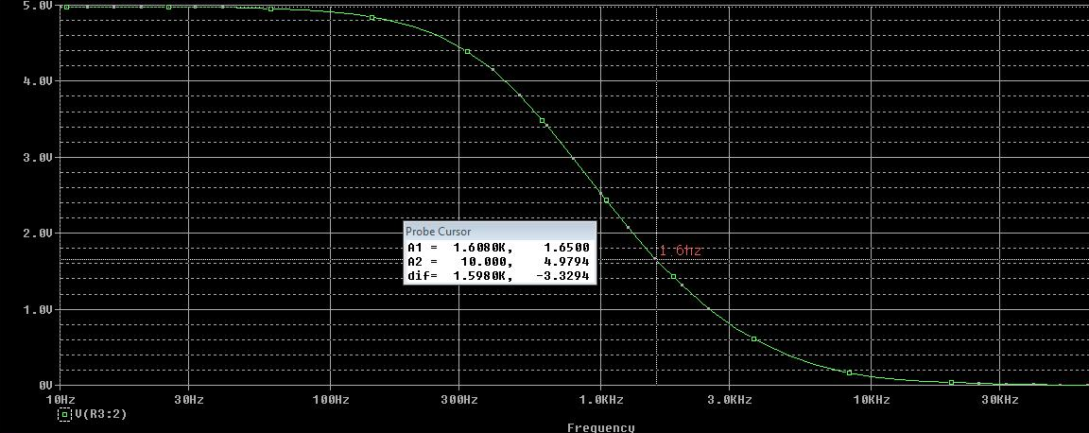
Fig7-output for 2nd order
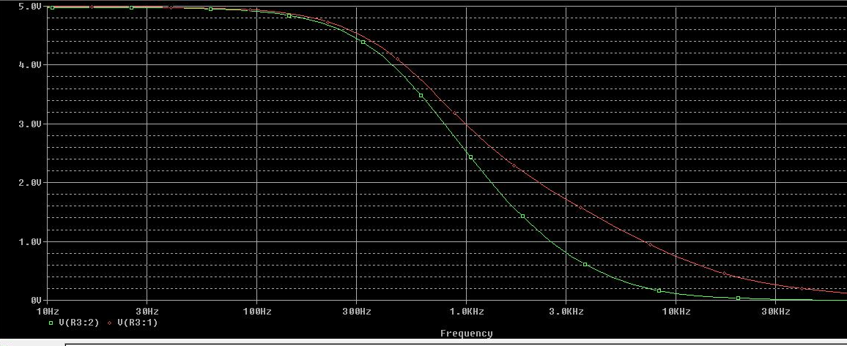
Fig8-cmparison of output of 1st and 2nd order low pass filter
4.2 MATLAB IMPLEMENTATION FOR DESIGNING DIGITAL FILTER
We also implemented a digital low pass filter and 3 band pass filter in software(Matlab). We found the coefficients in Matlab for the two-pole Butterworth Filter implemented digitally in the program.
We have implemented 4 filters
- 100hz 2nd order low pass butterworth filter
- 200-400hz 2nd order band pass butterworth filter
- 550-700hz 2nd order band pass butterworth filter
- 850-1000hz 2nd order band pass butterworth filter

4.2.1 MATLAB CODE FOR 100HZ LOW PASS BW FILTER

%design 2nd order butterworth lpf of 100hz

clc;
clear all;
format long
fs=2500; %sampling frequency=2.5 khz
wd=2*pi*100; %digital frequency
wa=2*fs*tan((wd)/(2*fs)) %frequency warping
[B A]=lp2lp([1],[1 1.4142 1],wa) %prototype conversion
[b a]=bilinear(B,A,fs) %bilinear tranformation
[h f]=freqz(b,a,512,fs); %plotting response

4.2.1.1 COEFFICIENTS AS OUTPUT

b = 0.01335921918774 0.02671843837548 0.01335921918774

a = 1.00000000000000 -1.64746234387869 0.70089922062965

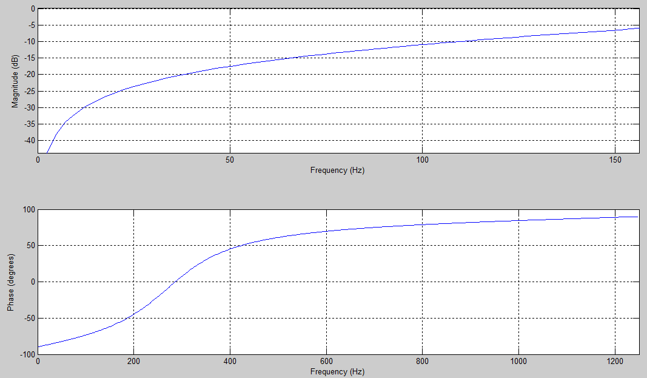

fig9- Response of lpf of 100hz

4.2.2 MATLAB CODE FOR BUTTER WORTH BAND PASS FILTER OF RANGE 200-400HZ
%2nd order band pass 200-400hz
clc
format long
fs=2500 %sampling frequency=2.5 khz
wh=2*pi*200 %upper cutoff
wl=2*pi*400 %lower cutoff
wah=2*fs*tan(wh/(2*fs)) %analog upper cutoff
wal=2*fs*tan(wl/(2*fs)) %analog lower cutoff
W=wah-wal %pass band width
wo=sqrt(wah*wal) %geometric center frequency
[B A]=lp2bp([1],[1 1],wo,W)%conversion of analog prototype-analog filter-"prototype transformation"
[b a]=bilinear(B,A,fs) %bilinear transformation
freqz(b,a,512,fs) %plotting magnitudeand phase response

4.2.2.1 COEFFICIENTS AS OUTPUT

b = -0.34545382789251 0.00000000000000 0.34545382789250

a = 1.00000000000000 -2.02521305250615 1.69090765578501
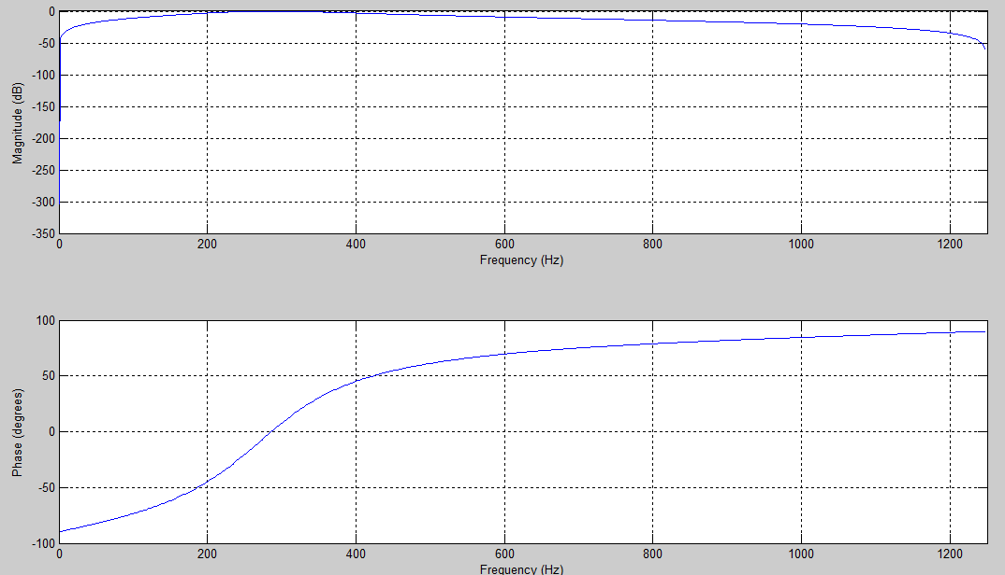

Fig10-Response of bpf of 200-400hz

4.2.3 MATLAB CODE FOR BANDPASS BW FILTER OF 550-700HZ
%2nd order band pass 550-700hz
clc
format long
fs=2500 %sampling frequency
wh=2*pi*550 %lower cutoff
wl=2*pi*700 %upper cutoff
wah=2*fs*tan(wh/(2*fs)) %analog upper frequency (frequency warping)
wal=2*fs*tan(wl/(2*fs)) %analog upper frequency (frequency warping)
W=wah-wal %passband width
wo=sqrt(wah*wal) %center frequency
[B A]=lp2bp([1],[1 1],wo,W) %prototype transformation
[b a]=bilinear(B,A,fs) %bilinear transformation
freqz(b,a,512,fs) %plotting response

4.2.3.1 MATLAB OUTPUT

b = -0.23572765790998 -0.00000000000000 0.23572765790998

a = 1.00000000000000 -0.00000000000000 1.47145531581997

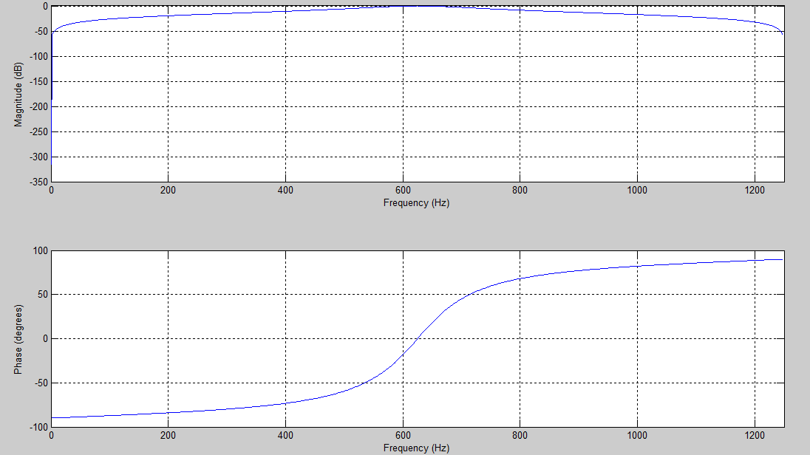

Fig11- Response of band pass of 550-700hz

4.2.4.1 MATLAB CODE FOR BANDPASS BW FILTER OF 750-1000HZ

%2nd order band pass of
clc
format long
fs=2500 %sampling frequency
wh=2*pi*850 %higher cutoff frequency
wl=2*pi*1000 %lower cutoff frequency
wah=2*fs*tan(wh/(2*fs)) %frequency warping
wal=2*fs*tan(wl/(2*fs))
W=wah-wal %passband width
wo=sqrt(wah*wal) %center frequency
[B A]=lp2bp([1],[1 1],wo,W) %prototype tranformation
[b a]=bilinear(B,A,fs) %bilinear transformation
freqz(b,a,512,fs) %plotting response

4.2.4.2 MATLAB OUTPUT

b= -0.23572765790998 -0.00000000000000 0.23572765790998

a = 1.00000000000000 1.72233486958279 1.47145531581997

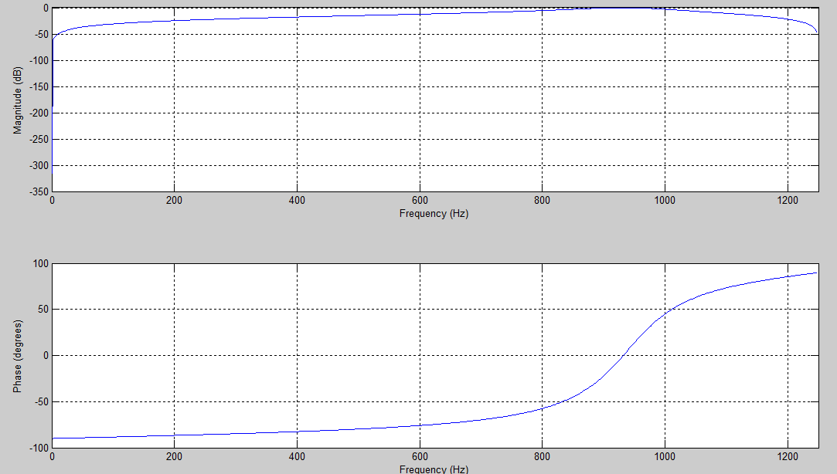

Fig12-Response of band pass 850-1000hz

The Softwares that are used to make this project are
- BASCOM-AVR
The Bascom-AVR is used for programming AVR Microcontroller. The microcontroller programming debugging has been done using thisAVR. The Bascom has also been used to burn the code on the microcontroller.
- MATLAB
The coefficients of various filters are obtained in matlab.In order to obtain the frequencies and PSD ,matlab is used.

- PSPICE

During the design of analog LPF pspice is used,various outputs of 1st order & 2nd order filters are obtained by making the circuit.

5. RESULTS
5.1 SPEED OF EXECUTION
Our motor runs at a suitable speed fast enough to make the puppet dance. The power supply was set to 12v, so that the two motors will be powered at almost equal speed and enables the puppet to dance to the beat of the music. The have also decided to change the colour of flash accordingly to the beats of the music accurately. A slight delay occurs in the response of motor which can be ignored.
5.2 ACCURACY
The accuracy of analog filter is good enough for our work which accurately provide us the input digital values in range 224-870 .And digital filter output logically defined in microcontroller also provide the output within permitted range.however,delay of 2 steps is occurring when we made the puppet run.
5.3 DANCE MOVES
The puppet performed eight dance steps. Depending on range of frequency input signal belongs, different steps were performed suitably . Those signals include voice, guitar and piano tunes. The dance moves switches between those eight steps automatically and live as the music changes.

6. CONCLUSION
Our expectation were met to a great extent. we have finally implemented a auto string puppet which dances automatically to the tone of music. puppet can move, twist and dance to whatever tune is being played ,thus provide us with full entertainment . We accomplished controlling the puppet with our efficient synchronizing system, motors, and other electrical domains. Overall, we learned a lot and put a lot of effort into this project and the project in general was very meaningful and helpful to us in sharpening our concept in various fields
- Analog filter design
- Pspice
- Matlab
- Digital filter design
- Atmega-16
- Programming in bascom

We accomplished the task of making an efficient and exciting Dancing puppet!

7. FUTURE EXPECTATION

We expect more from our project in future .we want our puppet to convey all emotions through its action, which can be used in theatre to conduct plays.

