Home Work 5 Deepak Sharma

Estimate how long it will take to complete this assignment (1/2 pt)

7 Hours (Code Writing 2 Hours, Observation and reporting 5 hours)

**Question 6**

1. What do you think about these angles? Do you notice anything in particular?

Maximum number of angles are with value 0 45 and 90 degree respectively, these angles has been generated on the first row, fist col and diagonal of the angle matrix.

b. Are all angles equally represented? Is the distribution uniform?

No, Distribution of angles is:

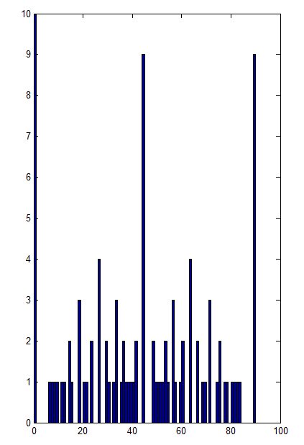

c. What is the smallest or largest angle from this method?

Smallest 0, Largest 90

d. Are there gaps? Where are the largest gaps?

Yes, For angle 83.6598 and 90 the difference is max (6.3402)

e. Of the 100 possible angles, how many actually occur? What is length( uniq_angles )?

57 different angle has occurred, Length of uniq_angles vector is 57

f. Write up what you learned here.

I have learned about working of mash Grid function in matlab:

M and N are two vectors here

M = [0:L1] N=[0:L2]

[A B]=MashGrid(M,N):

Provides two matrixis A and B or size size(N)*size(M)

Where A =[A;A;A;A..size(N)] and B =[B' B' B' ...size(M)]

Hence A =

0 1 2 . . . L1

0 1 2 . . . L1

0 1 2 . . . L1

. . . . . . .

size(M) Rows

Hence B =

0 0 . . . size(N)Cols

1 1 . . . size(N)Cols

2 2 . . . size(N)Cols

. . . . . size(N)Cols

L2 L2 . . size(N)Cols

Question 7

A Part

**Which image looks the worst with this colormap?**

TBK_BRICKS.JPG

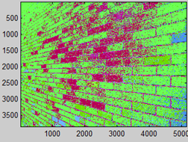

**How good are the flesh tones of faces?**

In general the color tone of the face remain consistent(same color for entire face) but due to variation in the external light/ intensity of the pixel values on image get changed. Due to these changes in the level of intensities of the pixel, indexed image show different shades on face. In order to extract the segment of face from image this approach/332 colormap is not much effective.

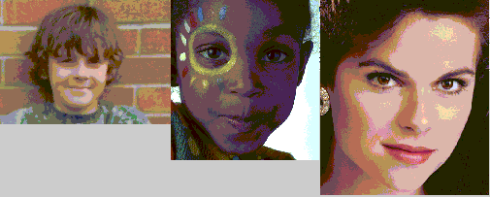

**How well does this colormap represent gray scales?**

Entire range of 255 colors of GrayScale has been allocated 10 colors from the 332 colormap, most of the range fell under white and Black level. Rest of 8 colors assigned by colormap are different from gray shades so this quantization approach is not good for grayscale image as it do not represent any gray color

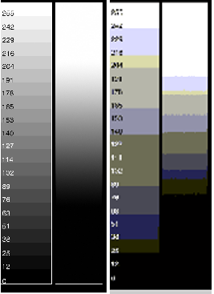

**Why is the 332 colormap called 332? What about it does 3, 3, and 2 about it?**

332 represents numbers of bits assigned, out of total 8 bits, to each Color: Red Green and Blue respectively:

Red used 3 bits (8 Levels)

Green used 3 bits (8 Levels)

Blue used 2 bits. (4 Levels)

Total 8 bits (256 Levels)

Part B

***Considering the image which the worst with the 332 colormap, how does it look with these***

***colormaps?***

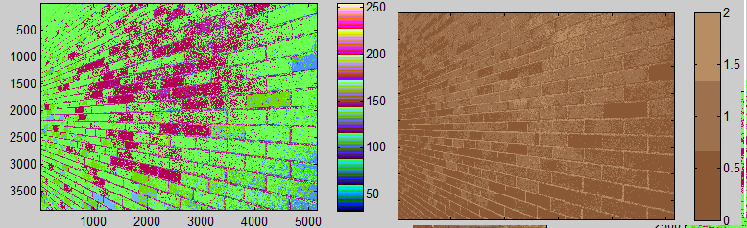

Left 332 Colormap Right Custom Colormap

Details of the image much impressive with these custom colormap as only with 3 color levels, details of image convincing. On the other hand with 332 we have divided the wall into two category/segment green bricks and magenta bricks with noise.

For the task of segmentation we can’t use 332 image as number of levels (255) cannot be reduced on the other hand based on the property/details of the image level of segmentation can be changed in custom colormap.

***II. Were there any other dramatic improvements?***

I have found Dramatic improvements in below images

Colormap Results

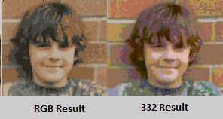

img1. RGB results has assigned more uniform color to face than 332 Image, hence it is better to pre-process the image with RGB colormap than 332 color map before performing Clustering/Segmentation Tasks.

Colormap Results

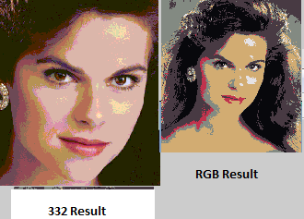

RGB results has assigned more uniform color to face than 332 Image, hence it is better to pre-process the image with RGB colormap than 332 color map before performing Clustering/Segmentation Tasks

ColorMap Results

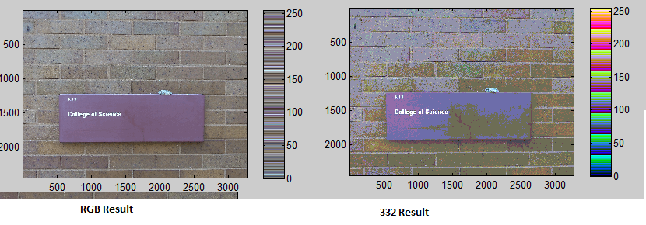

Img3

I have also observe dramatic improvement in above 3 images especially in image 3 (frog image) where for same number of quantization levels, image have improved drastically. In left image for 332 colormap results the college of science has been divided into two category of colors while in RGB colormap the segment is uniform as the color of all the pixels in the segment have value which is near to each other. If we will perform future quantization the task of segmentation will provide better results.

***III. Would these custom colormaps help segment the frog better?***

Yes, as with only 4 levels/buckets we can segment frog from upper and lower background. If we perform K mean Segmentation on the result of 332 colormap, optimum result/iteration will assign more than 1 segment to the body of frog as there are different shades of color can be observe.

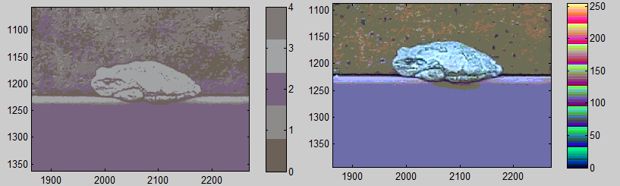

Left RGB colormap Results

Right 332 colormap Results

Part C:

***You should find that some of these images look significantly better with fewer color because HSV better matches the needs of the human visual system. Which images do you think look significantly better? What is there about those images that make them improve so much?***

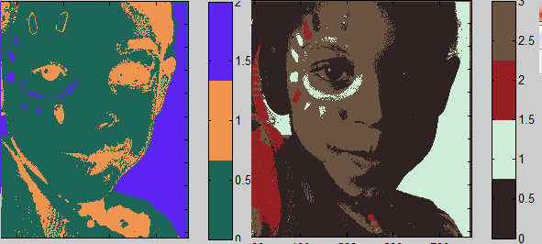

Left Side: - HSV image (Without converting colormap to RGB) with quantization level 2

Right Side: - RGB image with 3 quantization level.

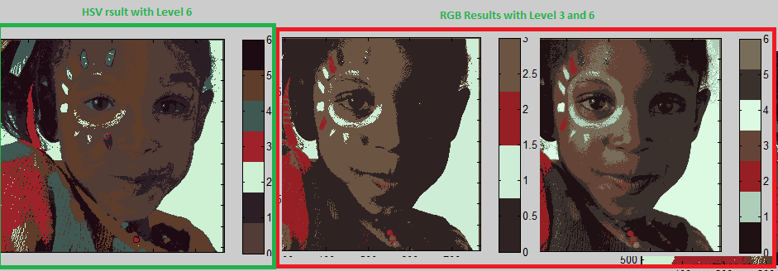

Left Side: - HSV image (After converting colormap to RGB) with quantization level 6

Right Side (2 Images): - RGB image with 3 quantization level and 6 respectively.

The HSV image is working better for face tones when the intensity of image is – due to variation in the amount of light falling upon the face – is varying.

In RGB image face has been divided into two parts and these two segment of face is quit distant from each other as left part (brown) and right part (back) are at two extreme sides of quantization levels, though these parts of face made of same tone (Hue) .

Further quantization will increase the distance between these two parts of face, **so we cannot use**

**RGB image while performing task like segmentation of face.**

On the other hand HSV model in left hand Side provided better results and **all the part of face with same tone (excluding eyes, lips and eyebrows) has been put into same range of quantization level.**

Hence while performing task of segmentation we can use HSV images.

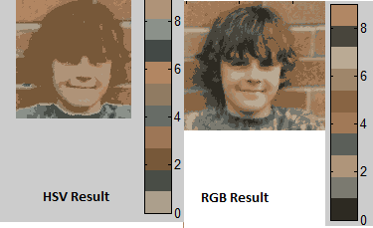

For segmentation level 8 Face and hair and background is distinguishable for HSV hence we can do segmentation of HSV output

While in RGB different part of face is not distinguishable.

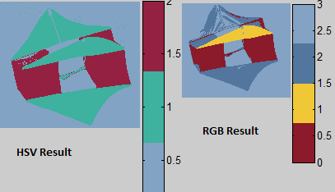

High intensity points due to the reflection of light

In RGB the points of high intensity value (due reflection ) details has been lost so the structure of object has damaged while in HSV points of same Hue has been maintained so the structure of object is also maintained.

Part: D

**Are there any other images that improve more?**

**All the output of Clab indexes are black images**

**How about the skin tones and grey values?**

**All the output of Clab indexes are black images**

**8. Report how many hours this took. (1/2)**

**12 Hours**

9. Write up any overall learning about color quantization in your PDF write up.

**My Observations**1. Quantization results solely does not depends on the technique of quantization but the characteristics of image also matters.

2. Results of HSV colormaps are better for cases where object of same color has been exposed to different lightning conditions (Shades / Reflections).

3. Number Quantization levels for 332 colormap has 256 levels and this colormap is less sensitive to blue color as only 2 bits has been assigned to blue color.

4. Matlab cmd rgb2ind perform quntization

We can give parameter dithering and nodithering in this cmd. While performing quantization with limited number of levels (max 256 8 bits) we will not have color to represent many colors of RGB (as these colors are 24 bits), Now dithering with assign a color to such pixels the average value of its neighbouring pixels. While no dithering option will leave such pixels.

5. Quantization can be performed as a pre-processing step for segmentation or clustering task, if we are extracting uniformed color objects from an image the level of quntization can be set equals to number of object in image and then we can increase the number of level of quntization for deciding best results. HSV colormaps will give better results than RGB in such conditions.