Name: Deepak Sharma

Home Work - 7

6. Estimate how long it will take to complete this assignment (½ pt)

This Assigment will take:

Related study = 2 – 3hours

Observations =1 hours

Implementation 2-3 hours

Enhancement of implementation 2 hours

Reporting 2 hours

Total : - 9-10 Hours

8. Using techniques covered in class, or in the board, counter the number of slices of melon on the cutting board. Hint – you probably want to have this run in a separate function that returns the an indication of the number of pieces of.

1. To Count the number of slices on the board, First we have to extract all the piece in a binary image containing white slices and on back background. This task has been performed in 9th question.

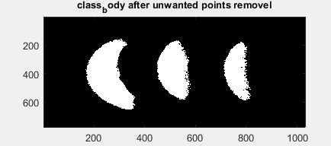

1. Then have performed morphological opening and closing operations where performed on the image, so that all paper and salt and paper get removed. This step is also performed in question 9.

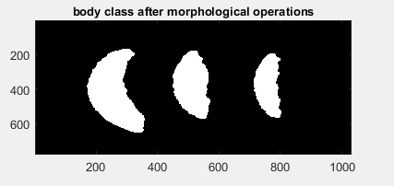

se = strel('disk',10);

class_im=imopen(class_body,se);

se = strel('disk',12);

class_im=imclose(class_body,se);

1. Now in order to calculate the number of objects we have to perform labelling, labelling assigns unique number to all the connected components, like in the above image we have four connected components background, and 3 slices.

To perform the task of labelling there are multiple algorithm exist, we will use union find algorithm for the same.

Union Find Algorithm and Implementation Details:

Initially we consider all the pixels are unconnected and there are X components in the image. X= number of non-Zero pixels. All non-zero pixels are considered as a node in a graph. Initially the graph will be unconnected.

A function **Parent** will provide the parent of any node, root node will be parent of itself.

If K is a root node then K=Parent(K).

While working on any pixel if it founds the value of neighbouring pixel is equal to the current pixel and if their parents are different then these two trees will be connected to each other in a such that small tree will become a child of bigger tree( For improving the efficiency of algorithm).

Now we will traverse the image matrix column wise, and check the value of neighbouring pixel.

After 2 runs over the cols of the image, all the neighbouring pixels with same intensity will become part of the same tree.

This algorithm will end up with a forest where we will have multiple trees.

Now, all the pixels corresponding to the same connected tree will be assigned a numerical value.

This can be performed using **bwlabel in matlab.**

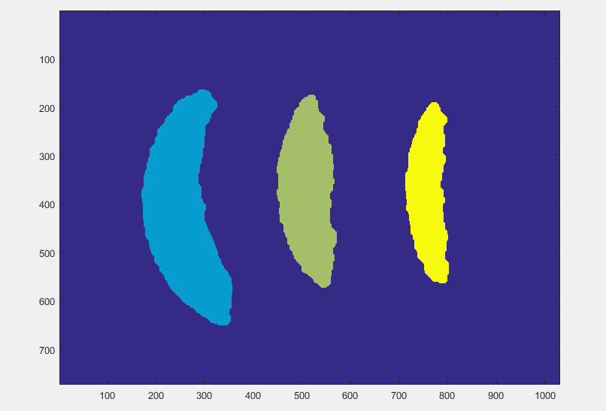

Here bwlable assigned 0 the background 1, 2 and 3 label number to the rest of the splices.

Now using max(bwlable(melon)) will return the number of slices.

Alternatively Task can also be perfromed by bwconncomp.NumObjects

Bwcommcomp also provide matrixes for Connected componets

Question 8.

Develop an algorithm, using the concepts you have learned in class, that draws a magenta line between the skin and the flesh on each slice of melon – where the laser would cut if this were a true application.

Observations:-

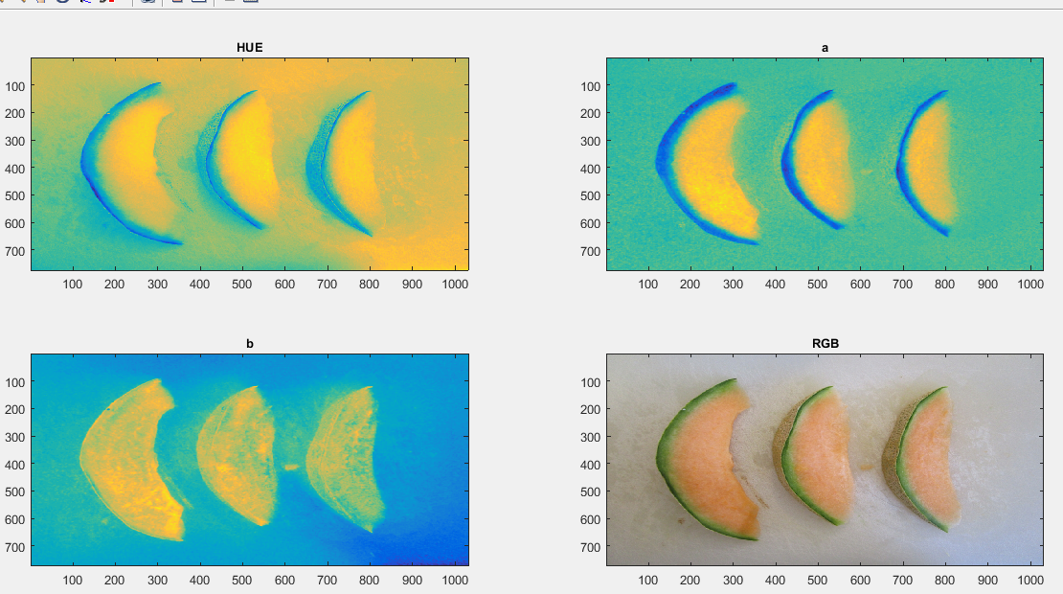

I converted the image into RGB, HSV and LAB color space. After probing various channel of these color space, using Data curser in Matlab, reached to the conclusion that I should include a channel of the LAB color space because it was providing maximum contrast. Between background, skin of the melon and body of melon.

To create a stable modelling, I have decided to perform modelling for background, skin and melon body. We are also assuming that our dataset images don’t contains anything else then melon slices and cutting board.

Implementations:

1. For a test Image sample of background, melon skin and melon body were taken and their respective values of, ‘a’ channel, stored in feature matrix as a col vector.

fg_a = im_a( fg_indices );

bg_a = im_a( bg_indices );

sk_a = im_a( sk_indices );

1. Using this feature matrix, for each pixel in image, calculated mahalanobis distance between a value of pixel and feature matrix.

mahal_body = ( mahal( im_ab, body_ab ) ) .^ (1/2);

1. Repeated 2 for all the feature matrixes of background, skin and body.

mahal_skin = ( mahal( im_ab, skin_ab ) ) .^ (1/2);

mahal_background = ( mahal( im_ab, background_ab ) ) .^ (1/2);

1. Body pixel were decided using by comparing the mananlobis distance of each pixel between pairs of (body and background) and (body and skin). If body distance was found minimum for any pixel then that pixel was assigned to body.

class_body = mahal_body < mahal_bg & mahal_body < mahal_sk;

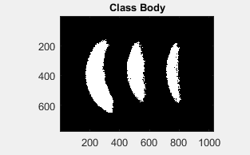

1. Repeated task 4 for skin also

class_skin = mahal_skin < mahal_body & mahal_sk < mahal_bg ;

1. To remove unwanted points, there can be some noise spots in image which neither near to skin or body nor to background, all the points where 2 SD away from the distance distribution for skin were and body was removed from both.
2. In the resultant distribution for body and skin, again removed all the points for which distance is greater than mean + 3SD. By doing so all the noise points were removed.

points_of_interest = body_dists < dist_mean+3*dist_std ;

1. Now using the details of points/locations of skin and body, we created two classes skin and body. These class are nothing but 2D binary image.

class_skin = reshape(points_of_interest, size(im_a,1), size(im_a,2));

class_body = reshape(points_of_interest, size(im_a,1),size(im_a,2) );

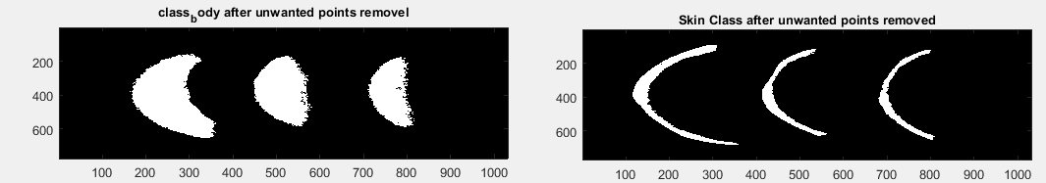

1. For cutting the melon from the right side of the skin, I calculated right edge from the skin class we generated in previous step. filter=[1 0 -1] cut=imfilter(class_sk,filter,'same'); We made a cut on the mellon.

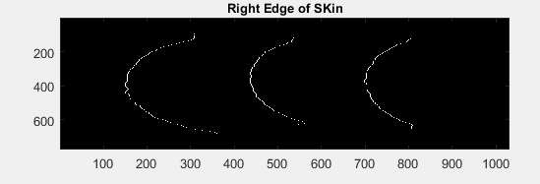

1. Strengthen the edges using morphological closing operation.
2. Then we super Impose the cut on the original RGB image using, below code

for counter=1:3

if counter~=2

im_rgb(:,:,counter)=im_rgb(:,:,counter)+cut(:,:);

else

im_rgb(:,:,counter)=im_rgb(:,:,counter)-cut(:,:);

end

end

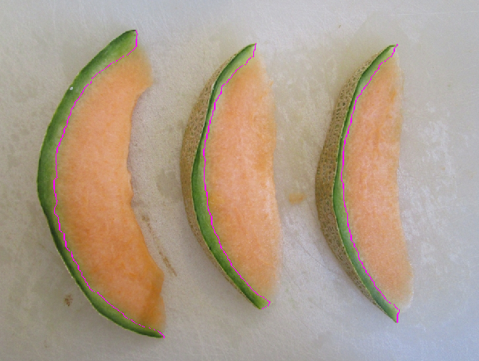

1. Run the model on various sample images, which used the feature matrix, constructed previously and repeated steps from 3 to 11.

Outputs:

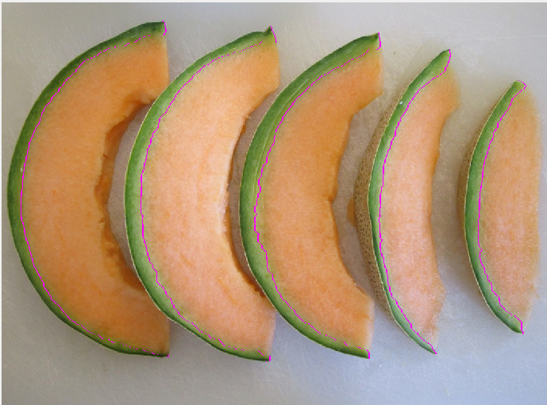

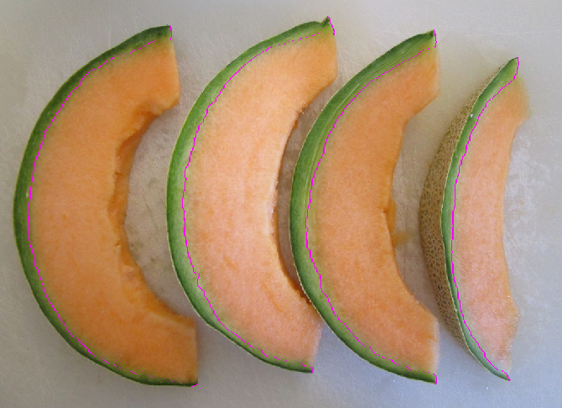

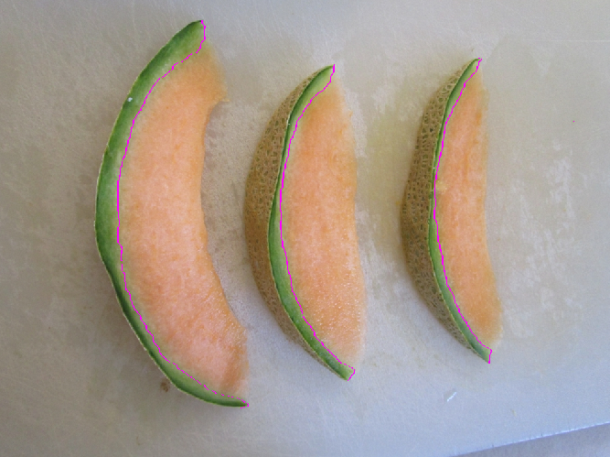

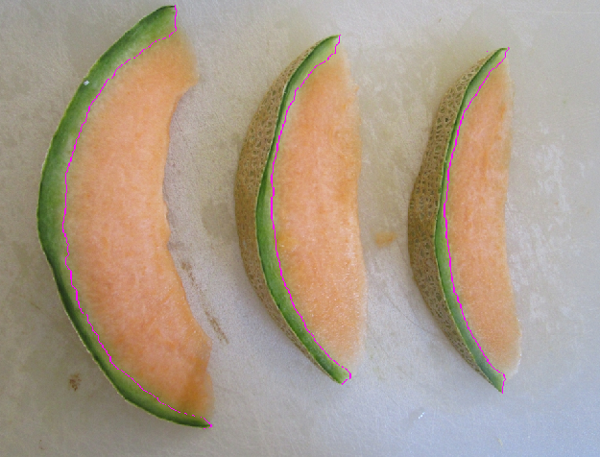

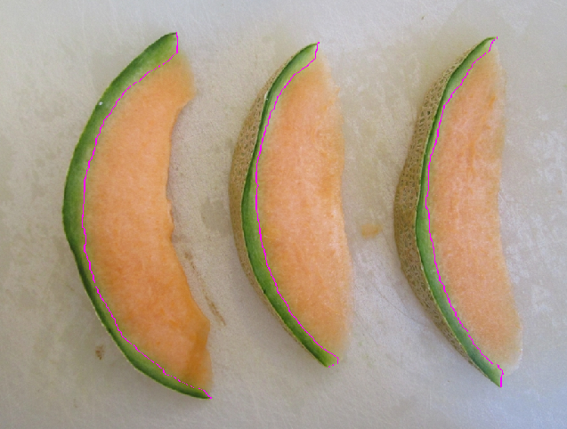

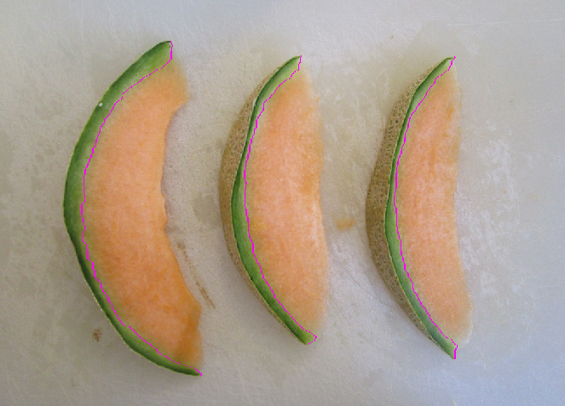

Report how long it took you to complete the homework. This is for you to practice estimating, so be honest. (½ pt)

**This Assignment took 12 hours**