Answer 1)
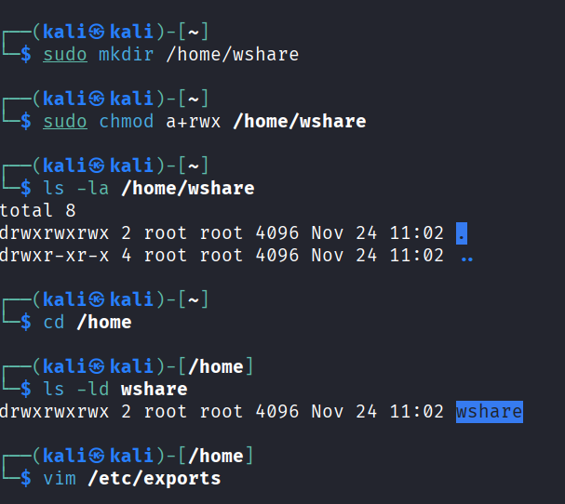
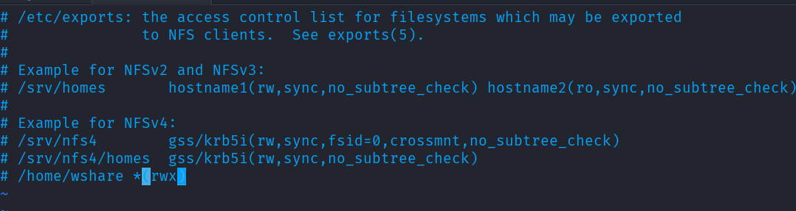
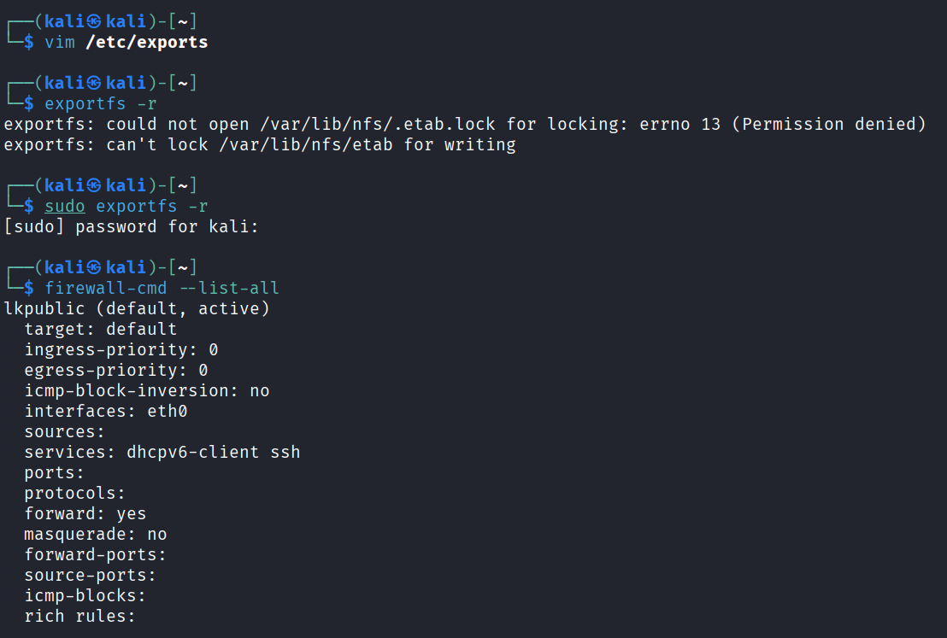
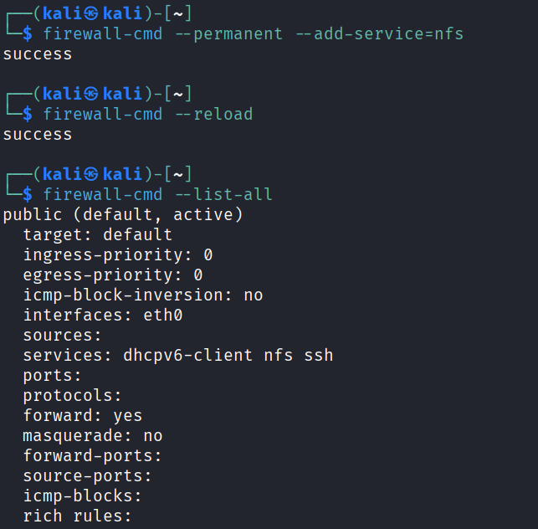
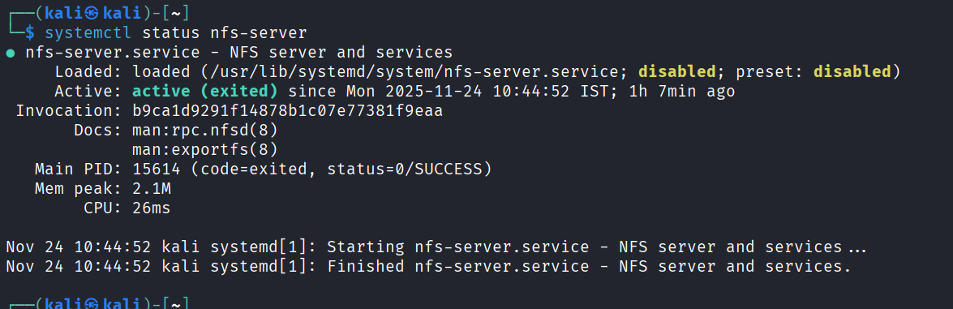
On client side we will run the following command
# mkdir /wclient
# mount <nfs-server-ip>:/home/wshare /wclient

Answer 3)
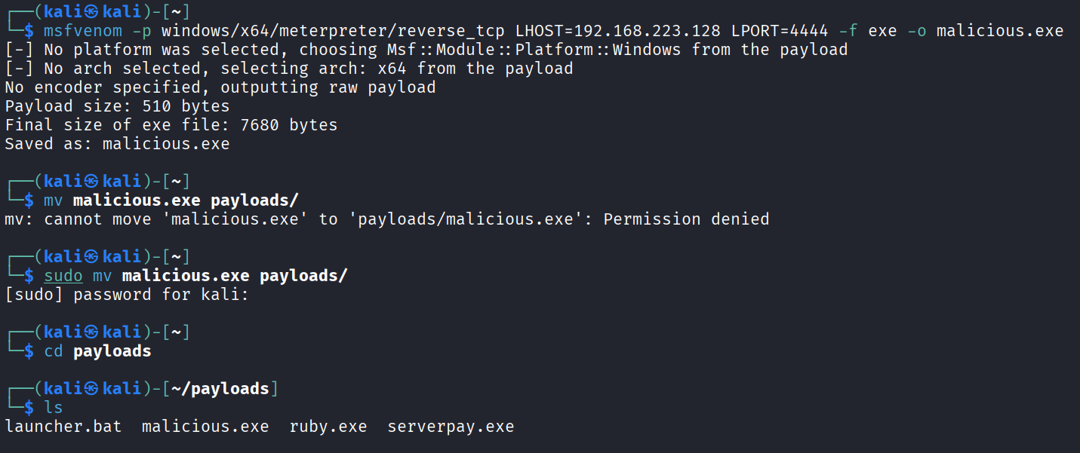
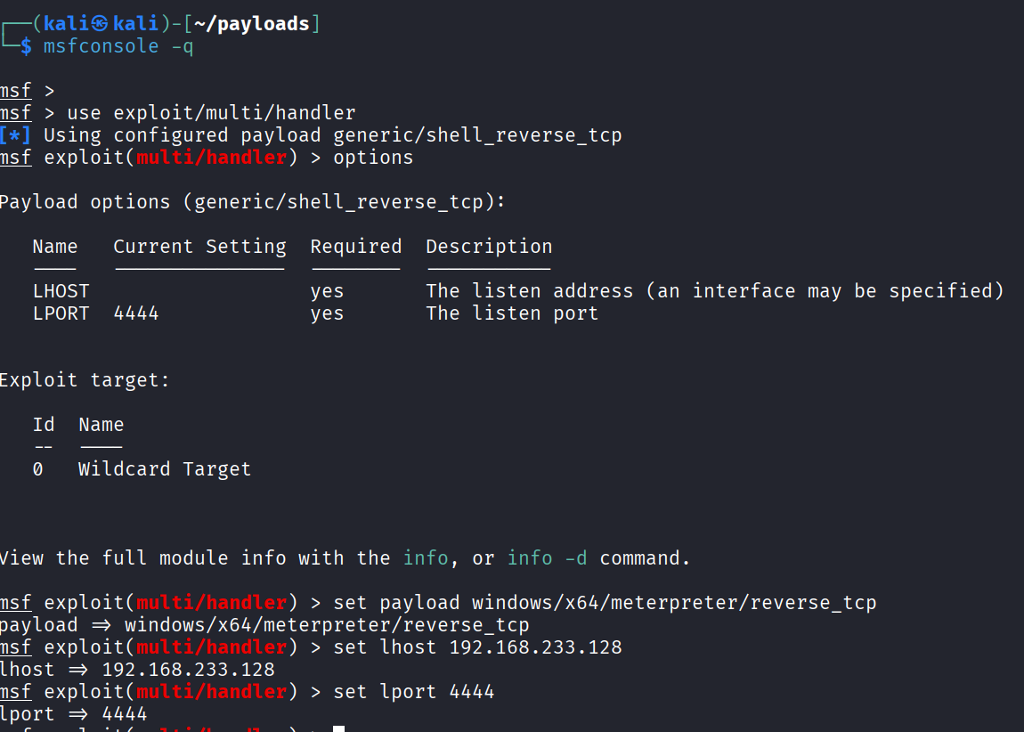
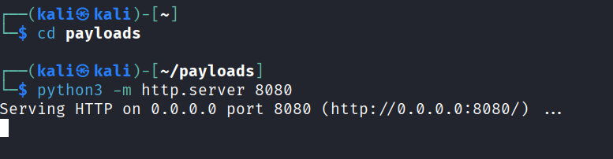
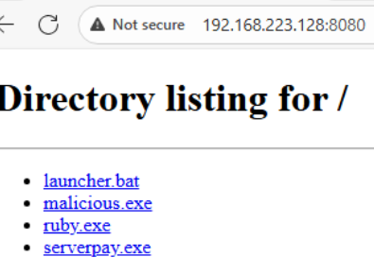
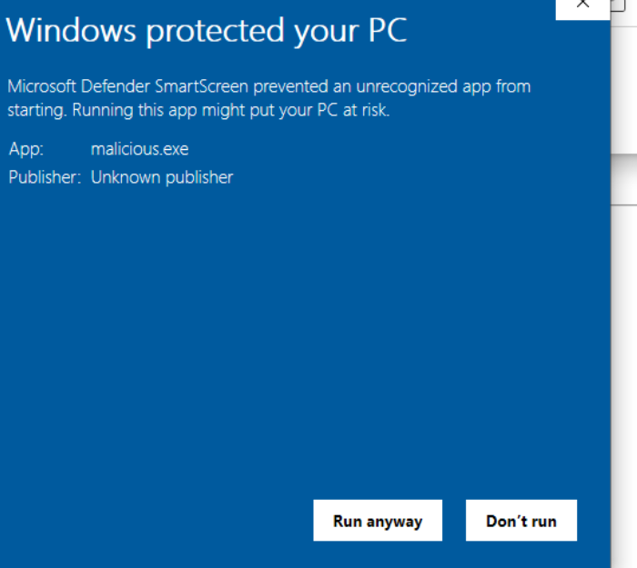
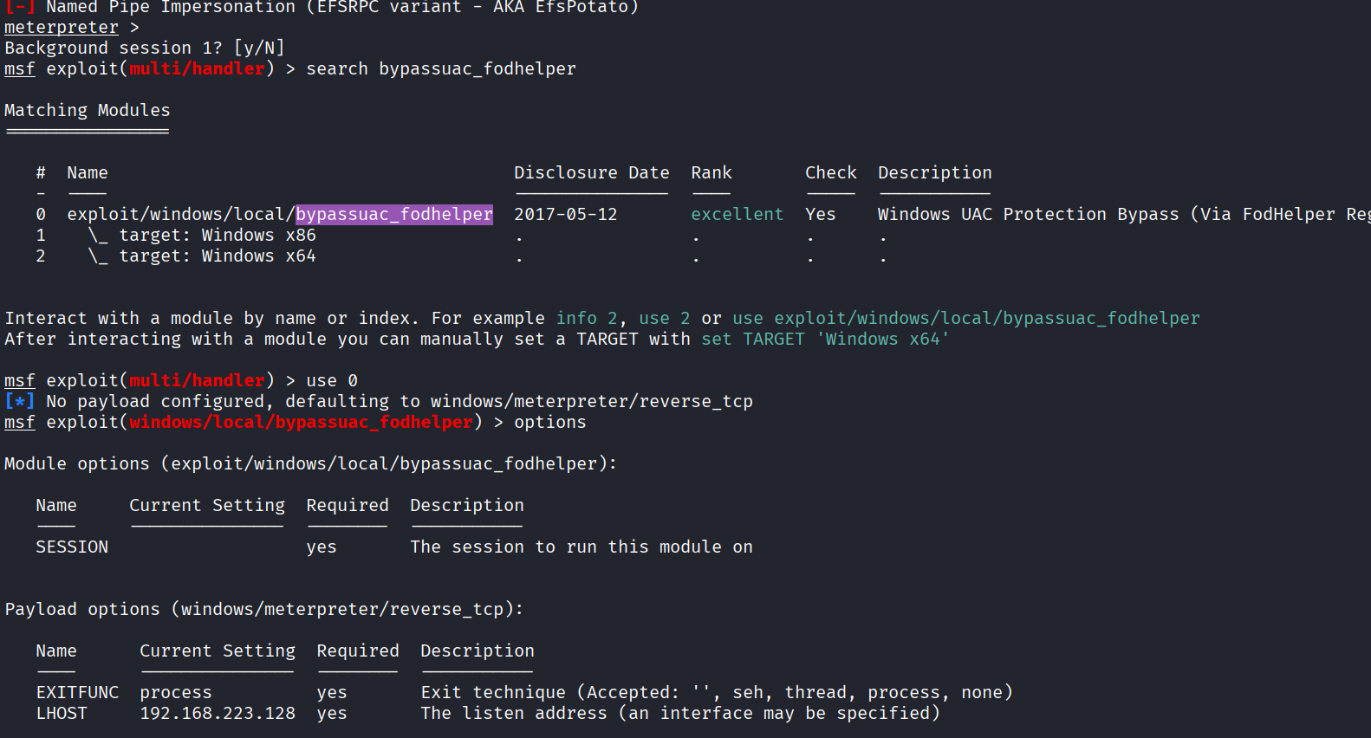
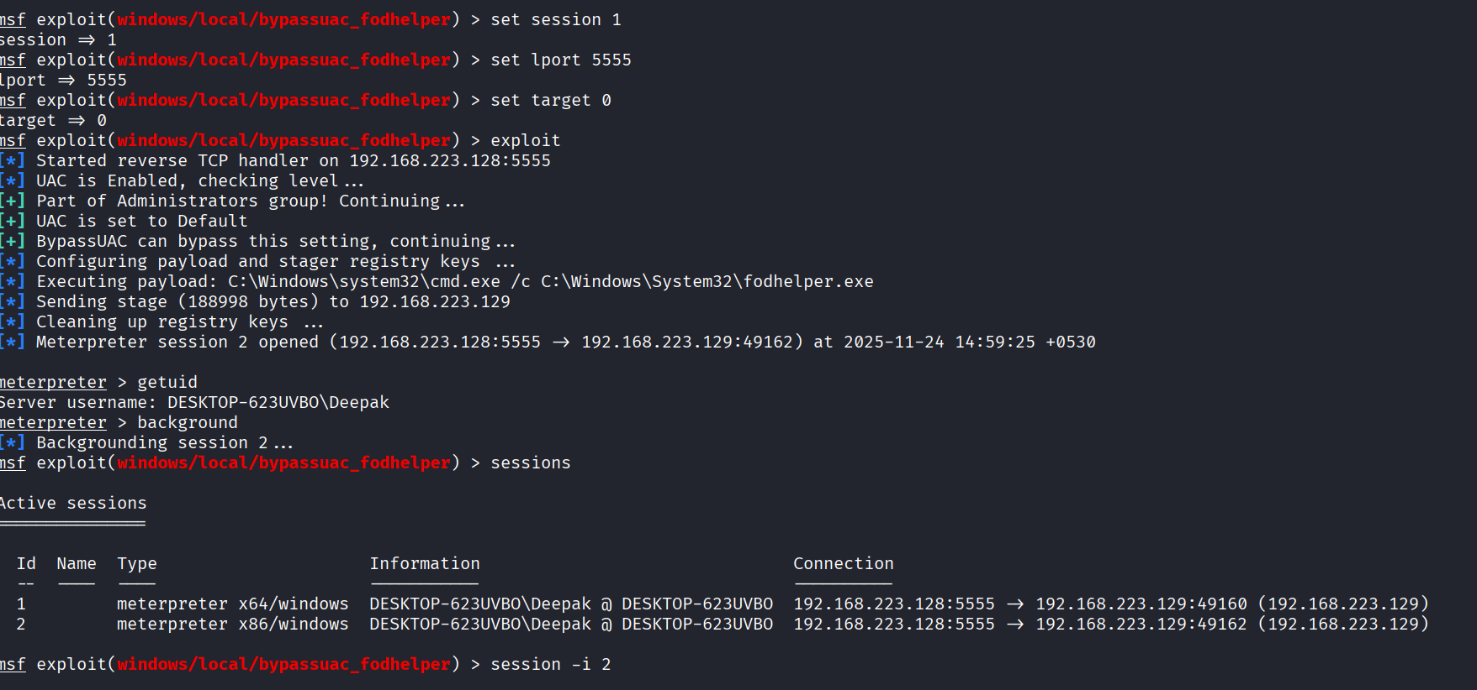
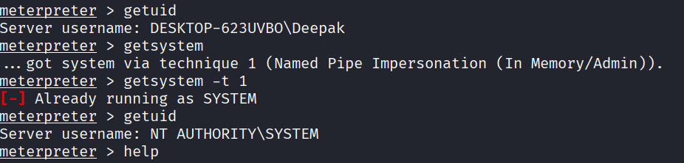
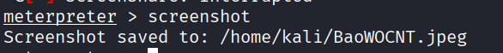
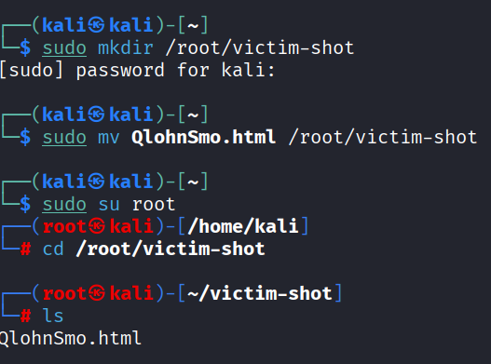

Answer 4) same procedure as follows in answer 3 and answer 4 (technically they are also random data as you didn’t specify in question no. 4)
Answer 6)
Same as answer 3
Here, I’ve bypass passed uac prompt by using exploit available in Metasploit
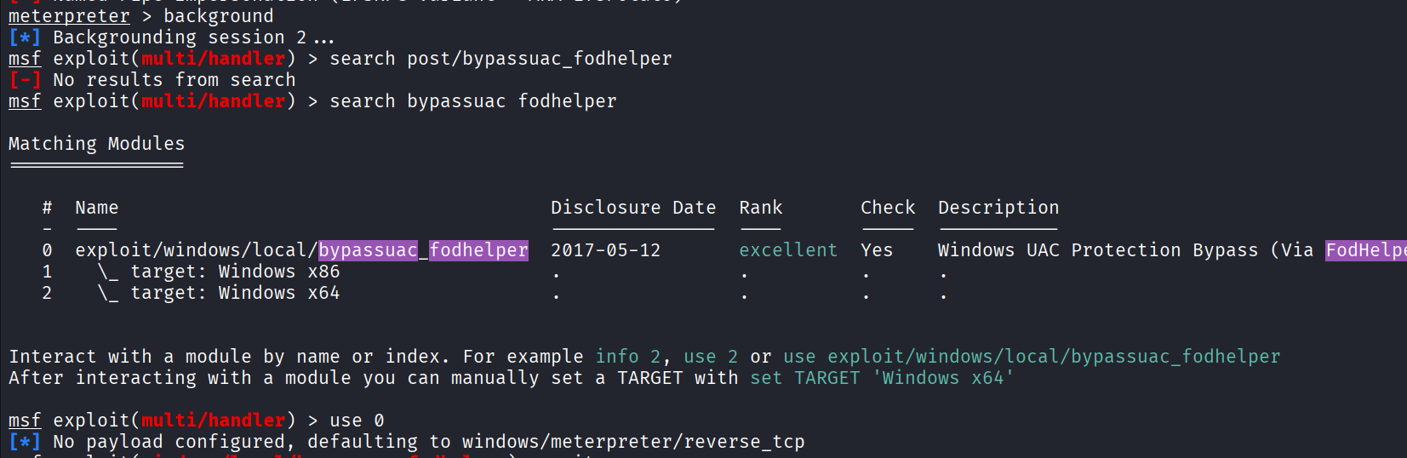
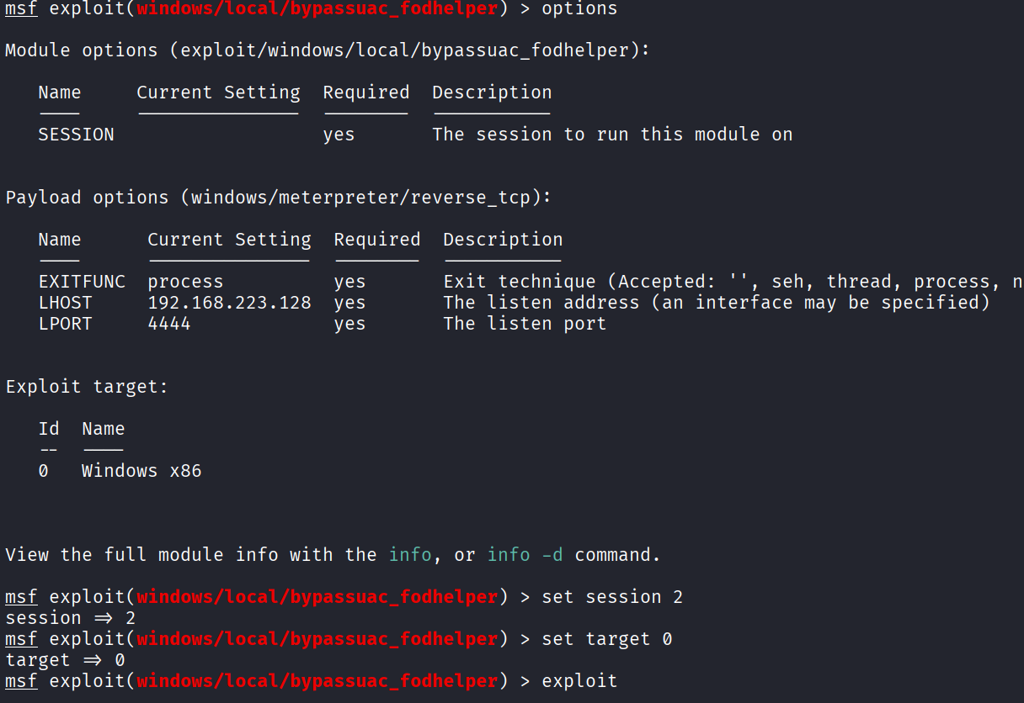
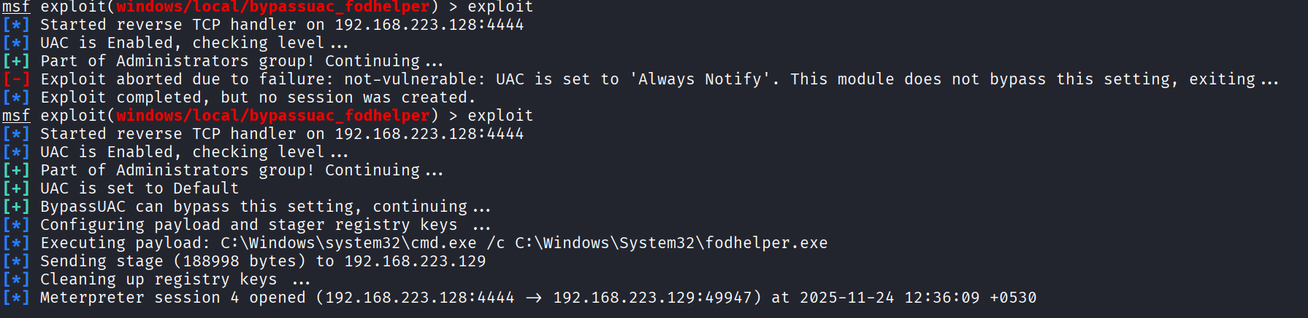
Now we ran getsystem command to elevate current user meterpreter session to system level and we succeded as on target machine consentpromptbehavioradmin was set to 5 that’s why fodhelper.exe helped us to bypass uac as it is trusted program by Microsoft and run by admin privileges
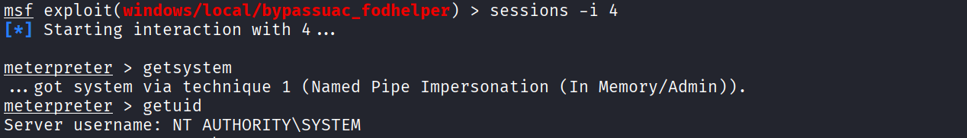
With the help of mimikatz we dumped ntlm hash
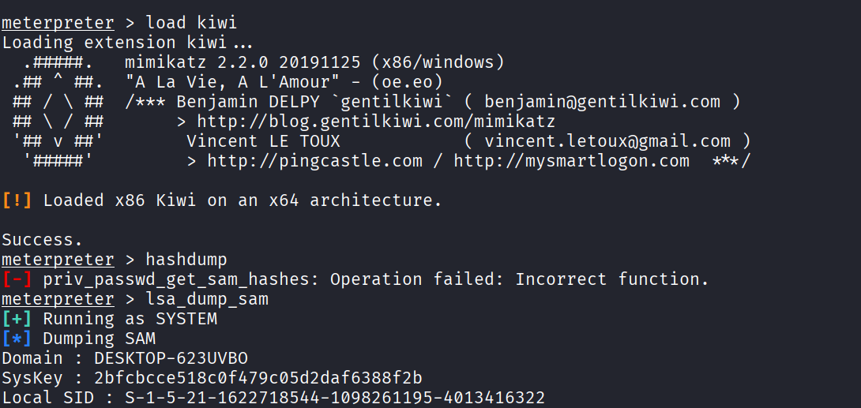
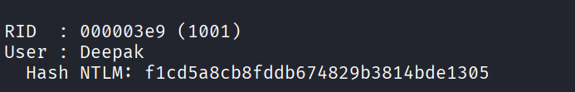
Using crackstation website
