Chapter 2
PRELIMINARIES AND BASIC THEORY

2.1 Introduction
The theory of generating functions and orthogonal polynomials is based upon several important concepts from mathematical analysis and special function theory. In order to study classical orthogonal polynomial systems systematically, it is necessary to understand infinite series, power series, Gamma and Beta functions, orthogonality conditions, and Sturm–Liouville theory.
The present chapter discusses the preliminary mathematical concepts required for the study of generating functions associated with Hermite, Laguerre, and Legendre polynomials.

2.2 Infinite Series
An infinite series is an expression of the form
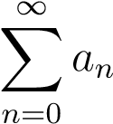 (2.1)
where (a_{n}) denotes the nth term of a sequence. The partial sum of the series is given by
S_{n} = a₀ + a₁ + a₂ + ··· + a_{n} (2.2)
An infinite series is said to converge if the sequence of partial sums approaches a finite limit as (n → ∞). That is,
lim S_{n} = S (2.3) n→∞
1
where (S) is finite. Infinite series form the basis of generating function theory because generating functions are represented through power series expansions.

2.2.1 Geometric Series
One of the most important infinite series is the geometric series
1 + x + x² + x³ + ...  which converges for (|x| < 1). Its sum is given by | (2.4)
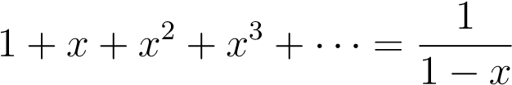 (2.5)
This series plays a fundamental role in ordinary generating functions.

2.2.2 Convergence Tests
Several tests are used to determine convergence of infinite series.
(i) Ratio Test
For the series ^{P}a_{n}, if
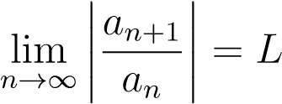 (2.6)
then:
- the series converges if (L < 1),
- diverges if (L > 1).
(ii) Root Test
If
lim ^{pn} |a_{n}| = L | (2.7)
n→∞
then:
  - the series converges if (L < 1),
  - diverges if (L > 1).
These convergence tests are useful in studying generating functions and power series expansions.
2.3. POWER SERIES

2.3 Power Series
A power series in the variable (x) is defined by
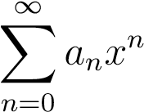 (2.8)
The coefficients (a_{n}) may be real or complex constants. Power series are fundamental in generating function theory because generating functions are represented as power series whose coefficients generate sequences or polynomial systems.

2.3.1 Radius of Convergence
For the power series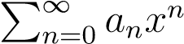, the radius of convergence (R) is defined by
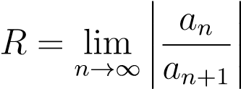 (2.9)
provided the limit exists. The series converges for
|x| < R  and diverges for | (2.10)
|x| > R | (2.11)

2.3.2 Properties of Power Series
Power series possess several important properties:
- They may be differentiated term-by-term.
- They may be integrated term-by-term.
- They provide analytical representations for functions.
- They are useful in solving differential equations.
These properties make power series highly useful in generating function analysis.

2.4 Gamma Function
The Gamma function extends the factorial function to non-integer values. It is defined by
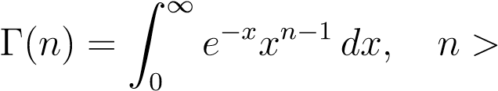0 (2.12)
The Gamma function is one of the most important special functions in mathematics and appears frequently in orthogonal polynomial theory.

2.4.1 Properties of Gamma Function
(i) Recursive Property
Γ(n + 1) = nΓ(n)  (ii) Gamma of Unity | (2.13)
Γ(1) = 1  (iii) Gamma of Half | (2.14)
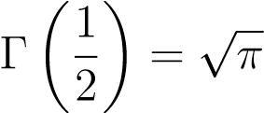 (2.15)
(iv) Relation with Factorial
For positive integers,
Γ(n + 1) = n!  2.4.2 Importance in Orthogonal Polynomials  The Gamma function appears in:  - normalization constants,  - orthogonality integrals,  - recurrence relations,  - and special function identities.  It is particularly important in Laguerre polynomial theory.  2.5 Beta Function  The Beta function is defined by | (2.16)
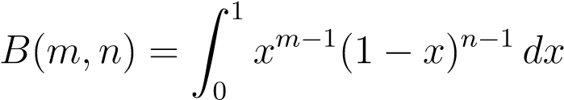 (2.17)
where (m > 0) and (n > 0). The Beta function is closely related to the Gamma function.
2.6. ORTHOGONALITY

2.5.1 Relation Between Beta and Gamma Functions
The relation is given by
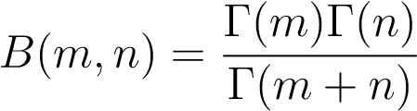 (2.18)
This relation is useful in evaluating orthogonality integrals associated with orthogonal polynomial systems.

2.6 Orthogonality
Orthogonality is one of the most important concepts in orthogonal polynomial theory. Two functions (f(x)) and (g(x)) are said to be orthogonal on an interval ([a,b]) with respect to a weight function (w(x)) if
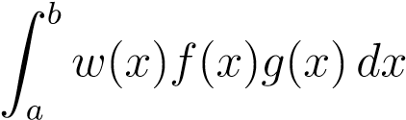= 0 (2.19)
The function (w(x)) is called the weight function.

2.6.1 Orthogonal Polynomial Systems
A polynomial sequence ({P_{n}(x)}) is called orthogonal if
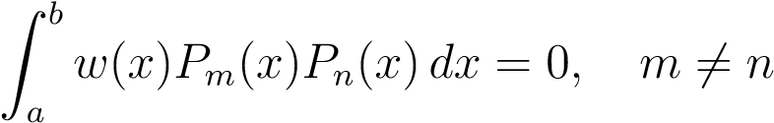 (2.20)
Orthogonal polynomial systems are useful in:
- approximation theory,
- Fourier analysis,
- numerical integration,
- and mathematical physics.

2.6.2 Examples of Weight Functions
The weight functions determine the orthogonality properties of the polynomial systems. Classical orthogonal polynomials and their properties are detailed in Table 2.1:
Table 2.1: Classical Orthogonal Polynomials and Weight Functions
Polynomial | Weight Function w(x) | Interval [a,b]
Hermite H_{n}(x) | e−x² | (−∞,∞)
Laguerre L_{n}(x) | e−x | (0,∞)
Legendre P_{n}(x) | 1 | [−1,1]

2.7 Inner Product Spaces
For functions defined on an interval ([a,b]), the inner product is defined by
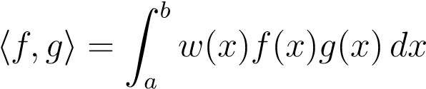 (2.21)
The norm of a function is given by
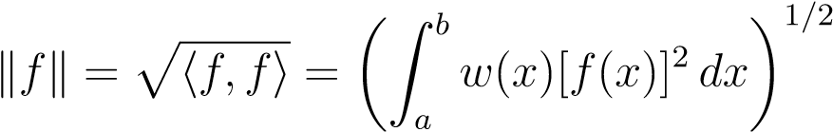 (2.22)
Orthogonal polynomial systems form orthogonal bases in suitable inner product spaces.

2.8 Sturm–Liouville Theory
Many orthogonal polynomial systems arise as solutions of Sturm–Liouville differential equations. A general Sturm–Liouville equation is
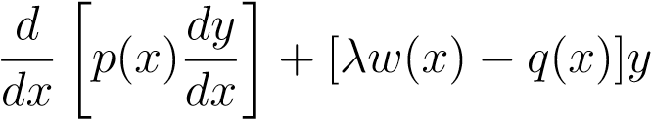= 0 (2.23)
Here:
- (p(x)) is a coefficient function,
- (w(x)) is a weight function, • (q(x)) is another coefficient function,
- (λ) is an eigenvalue.
2.9. SPECIAL FUNCTIONS AND ORTHOGONAL POLYNOMIALS

2.8.1 Importance of Sturm–Liouville Theory
Sturm–Liouville theory is important because:
- It produces orthogonal solutions.
- It forms the basis of eigenvalue problems.
- It explains orthogonality properties of polynomial systems.
- It appears naturally in mathematical physics.
- Hermite, Laguerre, and Legendre polynomials all arise from Sturm–Liouville type equations.

2.9 Special Functions and Orthogonal Polynomials
Special functions are functions that arise frequently in mathematics, physics, and engineering. Orthogonal polynomials are important examples of special functions. Classical orthogonal polynomial systems satisfy:
- second-order differential equations,
- recurrence relations,
- Rodrigues formulas,
- generating functions,
- and orthogonality conditions.
These properties make them highly useful in analytical and applied mathematics.

2.10 Conclusion
In this chapter, the preliminary mathematical concepts required for the study of generating functions and orthogonal polynomials have been discussed. Important concepts including infinite series, power series, Gamma and Beta functions, orthogonality, inner product spaces, and Sturm–Liouville theory were introduced.
These concepts provide the mathematical foundation for the study of generating functions associated with Hermite, Laguerre, and Legendre polynomial systems discussed in subsequent chapters.

Chapter 3
Theory of Generating Functions

3.1 Introduction
Generating functions constitute one of the most powerful analytical tools in modern mathematics. By mapping discrete sequences onto continuous structures, they provide compact analytical representations for sequences, polynomial systems, and special functions. Through the mechanism of generating functions, an infinite sequence can be transformed into a formal power series, enabling systematic analysis using the robust machinery of algebraic and analytical methods.
The utility of generating functions spans several diverse domains, finding extensive applications in:
- Combinatorics and number theory.
- Differential equations and approximation theory.
- Orthogonal polynomial theory and mathematical physics.
Within the theory of orthogonal polynomials specifically, generating functions play a central, unifying role. They provide elegant, standardized pathways for deriving recurrence relations, explicit formulas, differential equations, orthogonality conditions, and asymptotic properties. The present chapter establishes the foundational theory of generating functions and explores their profound analytical importance in the systematic study of orthogonal polynomial systems.

3.2 Definition of Generating Function
Fundamentally, a generating function is a formal power series whose coefficients encode the terms of a discrete sequence. Let 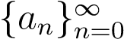 be a given sequence of real or complex numbers. Its associated generating function, G(t), is defined by the power series:
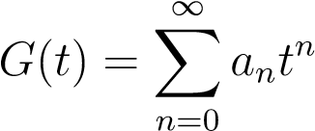 (3.1)
where the variable t is referred to as the generating parameter. Through this definition, the generating function elegantly encapsulates the entire infinite sequence into a single, cohesive analytical expression.

3.2.1 Purpose of Generating Functions
The strategic advantage of translating a sequence into a generating function lies in its ability to:
- Represent infinite sequences in a highly compact form.
- Simplify complex recurrence relations into manageable algebraic equations.
- Derive combinatorial and algebraic identities systematically.
- Provide robust analytical methods for solving discrete problems.
- Establish a fluid bridge between algebraic structures and analytical continuous functions.

3.3 Ordinary Generating Functions
An ordinary generating function (OGF) for a sequence {a_{n}} scales each term directly by successive powers of the generating parameter. It is formally defined as:
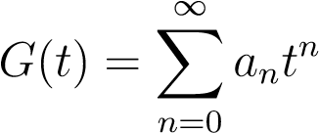 (3.2)
Ordinary generating functions serve as a foundational tool and are widely deployed across combinatorics and sequence analysis.

3.3.1 Example: The Constant Sequence
Consider the simplest fundamental sequence where every term is unity: 1,1,1,1,.... Its corresponding ordinary generating function is expressed as the infinite series:
G(t) = 1 + t + t² + t³ + ... (3.3)
Invoking the classical geometric series formula, we know that this series converges when |t| < 1. Consequently, we can express the generating function in the closed, compact form:
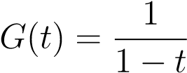 (3.4)

3.3.2 Example: The Sequence of Positive Integers
Next, let us examine the sequence of natural numbers: 1,2,3,4,.... The ordinary generating function for this sequence is given by:
G(t) = 1 + 2t + 3t² + 4t³ + ... (3.5)
We can evaluate this series by differentiating the basic geometric series term-by-term. Beginning with the known identity:
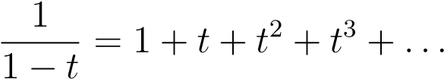 (3.6)
Differentiating both sides with respect to t yields:
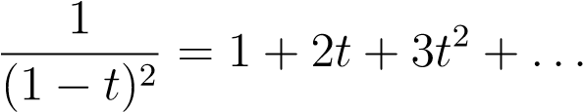 (3.7)
Hence, the closed-form ordinary generating function for the sequence of positive integers is:
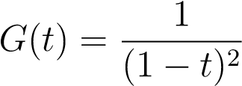 (3.8)

3.4 Exponential Generating Functions
For sequences where the terms grow rapidly, or when dealing with structures where order matters, it is often more advantageous to scale the sequence coefficients factorially. An exponential generating function (EGF) for a sequence {a_{n}} is defined by:
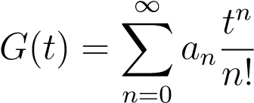 (3.9)
Exponential generating functions are particularly vital in combinatorial structures and play an indispensable role in the study of Hermite polynomials.

3.4.1 Example: The Constant Sequence (EGF)
Let us reconsider the constant sequence 1,1,1,1,... within the context of an exponential framework. Its exponential generating function is constructed as:
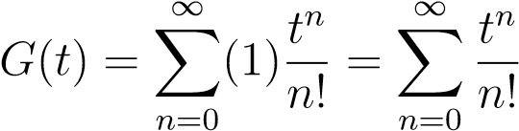 (3.10)
Recognizing this expression as the foundational Maclaurin series expansion for the exponential function, the generating function simplifies beautifully to:
G(t) = e^{t} (3.11)

3.5 Properties of Generating Functions
Generating functions possess several elegant analytical properties that allow us to manipulate sequences algebraically by operating on their corresponding functional representations.

3.5.1 Addition Property
Let A(t) and B(t) be the generating functions for the sequences {a_{n}} and {b_{n}} respectively, such that A(t) = ^{P}a_{n}t^{n} and B(t) = ^{P}b_{n}t^{n}. The sum of these two functions corresponds to the term-by-term addition of their underlying sequences:
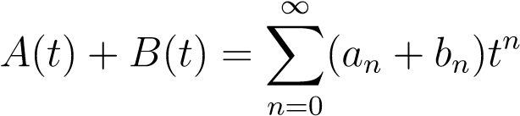 (3.12)

3.5.2 Multiplication Property
Given the same generating functions A(t) and B(t), their product yields a new generating function whose coefficients are determined by the convolution of the original sequences:
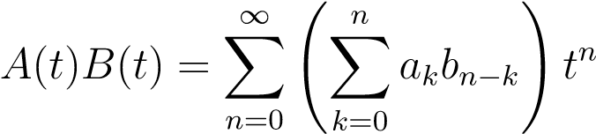 (3.13)
This foundational relationship is formally known as the Cauchy product.

3.5.3 Differentiation Property
Differentiating a generating function term-by-term shifts the index of the sequence while scaling each coefficient by its respective index:
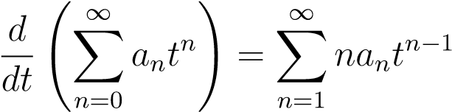
In practice, the differentiation property is one of the most frequently used operations to derive recurrence relations.

3.5.4 Integration Property
Conversely, integrating a generating function term-by-term introduces a division by the index, smoothing out the sequence coefficients:
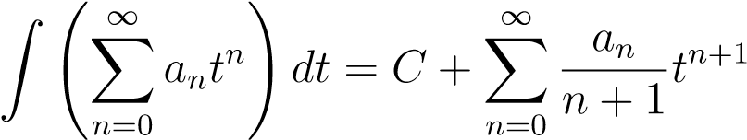

3.6 Generating Functions and Recurrence Relations
One of the most powerful applications of generating functions is their capacity to elegantly resolve and derive recurrence relations. A recurrence relation defines a term of a sequence as a function of its preceding terms. By applying algebraic operations to a generating function, an entire recurrence relation can be transformed directly into a solvable algebraic equation.

3.6.1 Example: The Fibonacci Sequence
To demonstrate this utility, consider the classical Fibonacci sequence, where each term is the sum of the two preceding terms:
Fn = Fn−1 + Fn−2
Let F(t) = ^{P}F_{n}t^{n} be the ordinary generating function for this sequence. By embedding the recurrence relation into the structure of the power series and executing standard algebraic manipulations, one seamlessly obtains the closed-form expression:
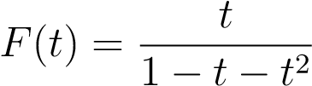
This striking result underscores the immense analytical utility of generating functions in sequence and recurrence analysis.

3.7 Generating Functions in Orthogonal Polynomial Theory
When moving from scalar sequences to sequences of functions, generating functions become even more profound. For a polynomial sequence {P_{n}(x)}, the generating function expands to include a spatial variable x alongside the traditional generating parameter t, typically taking the form:
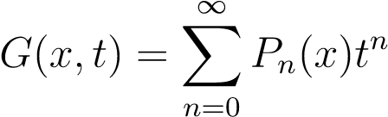
In the realm of orthogonal polynomials, this bivariate function serves as a master key, providing direct access to:
- Compact, closed-form polynomial representations.
- Interconnected recurrence relations and explicit formulas.
- Underlying orthogonality structures and asymptotic properties.

3.8 Generating Functions of Classical Orthogonal Polynomials
Each classical orthogonal polynomial system is uniquely characterized by its own distinct generating function, each exhibiting a clear geometric or analytical structure.

3.8.1 Hermite Generating Function
The Hermite polynomials, denoted by H_{n}(x), are characterized by an exponential generating function structure:
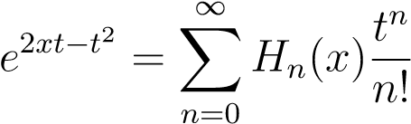

3.8.2 Laguerre Generating Function
The Laguerre polynomials, denoted by L_{n}(x), are generated by a hybrid rational-exponential expression:
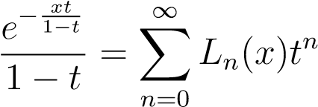

3.8.3 Legendre Generating Function
The Legendre polynomials, denoted by P_{n}(x), are defined via a purely algebraic generating function:
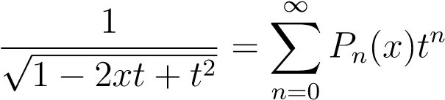

3.9 Importance of Generating Functions
The prominent status of generating functions in the study of orthogonal polynomials cannot be overstated. They are indispensable precisely because they:
- Generate entire polynomial sequences simultaneously from a singular, compact seedfunction.
- Derive differential equations and recurrence relations via straightforward differentiation.
- Establish orthogonality properties by exploiting the analytical bounds of the generating function.
- Provide unified analytical frameworks.

3.10 Analytical Advantages of Generating Functions
Discrete Perspective | Continuous Perspective | Analytical Advan
Complicated inductive algebra | Straightforward functional manipulation | Simplifies computati
Infinite discrete array of terms | Single continuous function | Converts sequences
Hidden structural patterns | Obvious algebraic relationships | Helps derive explicit
Inductive step-by-step definitions | Differential functional identities | Establishes recurren
Difficult asymptotic limits (n → ∞) | Local behavior analysis (t → t₀) | Simplifies asymptoti
By shifting our perspective from a discrete sequence of polynomials to a continuous generating function, we unlock several core analytical advantages:
Table 3.1: Discrete vs. Continuous Perspective Analytical Comparison

3.11 Applications of Generating Functions
Because of their versatility, generating functions have transcended pure polynomial theory, becoming an essential tool across a vast spectrum of physical and mathematical sciences, including:
- Combinatorics & Number Theory: For counting configurations, partitions, and solving complex discrete problems.
- Differential Equations & Approximation Theory: For finding closed-form solutions and constructing optimal function approximations.
- Probability Theory: Where they manifest as probability-generating and momentgenerating functions to analyze distributions.
- Quantum Mechanics & Mathematical Physics: For solving the Schro¨dinger equation for systems like the quantum harmonic oscillator, where classical orthogonal polynomials dictate physical wavefunctions.

3.12 Conclusion
This chapter has systematically introduced the fundamental theory of generating functions. By exploring both ordinary and exponential generating functions, we have established their core properties, analytical advantages, and wide-ranging operational applications.
Furthermore, we have highlighted the transformative role that generating functions play within orthogonal polynomial theory, introducing the iconic generating functions for the Hermite, Laguerre, and Legendre polynomial systems. The concepts and mathematical machinery developed in these pages form the analytical foundation required for the deep, rigorous study of classical orthogonal polynomials presented in the subsequent chapters.

Chapter 4
Hermite Polynomials

4.1 Introduction
Hermite polynomials are among the most important classical orthogonal polynomials in mathematical analysis and mathematical physics. These polynomials arise naturally in probability theory, Fourier analysis, approximation theory, heat conduction problems, and quantum mechanics.
Hermite polynomials form an orthogonal system over the infinite interval (−∞,∞) with respect to the Gaussian weight function:
w(x) = e^{−x2} (4.1)
They satisfy second-order linear differential equations, recurrence relations, Rodrigues formulas, orthogonality relations, and elegant generating functions. The generating function of Hermite polynomials possesses an exponential structure and provides elegant analytical methods for deriving polynomial identities and recurrence formulas. In this chapter, Hermite polynomials are studied systematically along with detailed derivations and proofs of their major properties.

4.2 Historical Background
Hermite polynomials are named after the prominent French mathematician Charles Hermite, who studied these polynomials in connection with differential equations and exponential functions. Later, Hermite polynomials became fundamentally important in several branches of science and mathematics, including:
- Quantum Mechanics: For solving the quantum harmonic oscillator.
- Probability Theory: In the study of Gaussian distributions and stochastic processes.
- Approximation Theory: For orthogonal expansions and functional approximations.
- Fourier Analysis: For spectral decompositions and harmonic analysis.
- Mathematical Physics: In solving boundary value problems for physical systems.
Today, Hermite polynomial theory forms an essential pillar of the theory of special functions and orthogonal systems.

4.3 Definition of Hermite Polynomials
Hermite polynomials are defined as the polynomial solutions of the second-order homogeneous linear differential equation:
y′′ − 2xy′ + 2ny = 0 (4.2)
The unique polynomial solution of degree n is denoted by H_{n}(x).

4.4 Rodrigues Formula
The Hermite polynomials can be represented compactly via the Rodrigues formula:
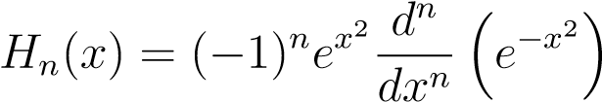 (4.3)

4.4.1 Proof of Rodrigues Formula
Let us consider successive differentiation of the Gaussian function e^{−x2}. Differentiating once with respect to x:
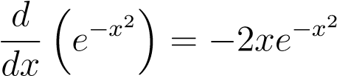 (4.4)
Differentiating a second time:
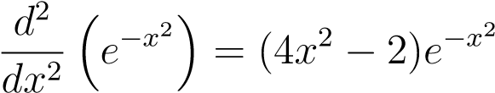 (4.5)
Multiplying both sides by e^{x2} yields a polynomial of degree 2:
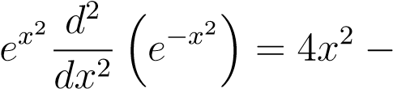2 (4.6)
This gives the second Hermite polynomial explicitly. Similarly, repeated differentiation produces polynomials of degree n. Hence, we establish by extension:
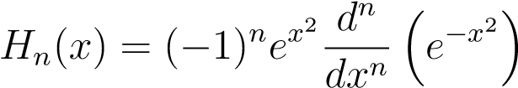 (4.7)
Thus the Rodrigues formula is proved.

4.5 Generating Function of Hermite Polynomials
The generating function for H_{n}(x) is given by the exponential expansion:
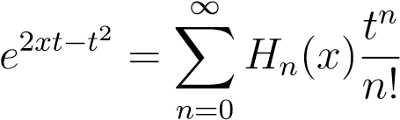 (4.8)

4.5.1 Proof of the Generating Function
Let us define the generating function as G(x,t) = e^{2xt−t2}. Utilizing exponential properties, we can factor this expression:
G(x,t) = e^{2xt}e^{−t2} (4.9)
Expanding both terms into their respective power series:
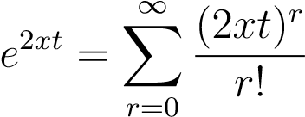 (4.10)
and
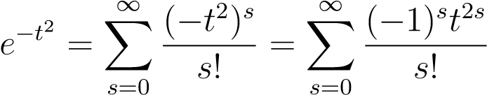 (4.11)
Multiplying the two series together:
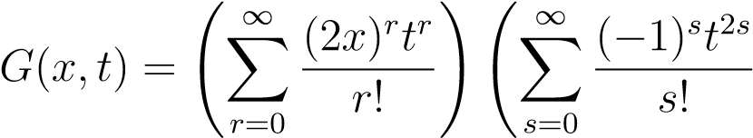
!
(4.12)
Using Cauchy multiplication to collect coefficients of t^{n}:
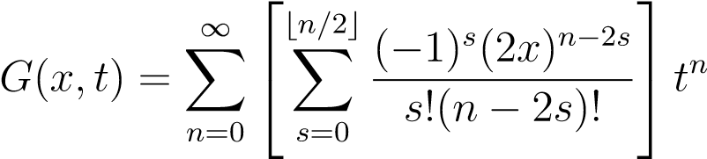 (4.13)
We define the bracketed polynomial component grouped with 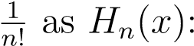
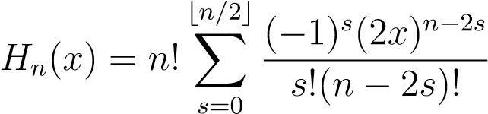 (4.14)
Therefore, substituting this definition back into the series yields:
 (4.15)
Hence the generating function relation is proved.

4.6 Explicit Formula
From the expansion of the generating function, the explicit power series representation for the Hermite polynomials is given by:
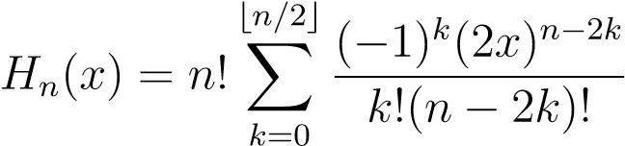 (4.16)
where ⌊n/2⌋ denotes the largest integer less than or equal to n/2.

4.7 Some Hermite Polynomials
Using the explicit formula, the first six Hermite polynomials are easily computed as follows:

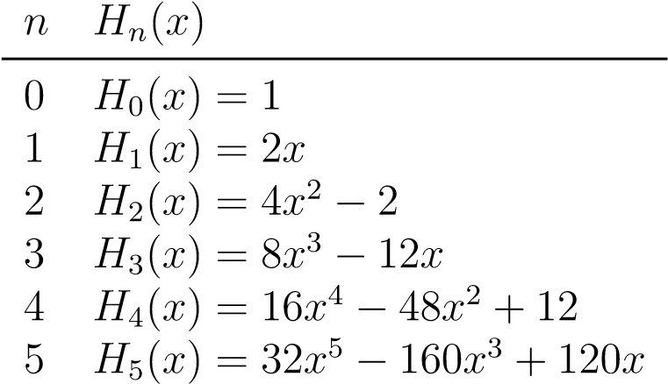

4.8 Orthogonality Property
Hermite polynomials satisfy the orthogonality relation over the real line with respect to the weight function w(x) = e^{−x2}:
Z ∞ ₂
e^{−x} H_{m}(x)H_{n}(x)dx = 0, for m ̸= n  −∞  4.8.1 Proof of Orthogonality  Consider the Hermite differential equations satisfied by H_{n}(x) and H_{m}(x): | (4.17)
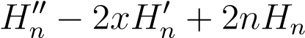= 0 (4.18)
and
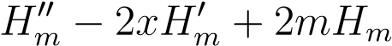= 0 (4.19)
Multiply the first equation by H_{m}(x)e^{−x2}, and the second equation by H_{n}(x)e^{−x2}. Subtracting the second equation from the first yields:
This can be written compactly using the product rule derivative format. Integrating over the domain (−∞,∞) yields:
= 0 (4.21)
Because the exponential factor decays rapidly to zero at ±∞, the boundary terms vanish.
Thus, for m ̸= n:
Z ∞ ₂
e^{−x} H_{m}(x)H_{n}(x)dx = 0 (4.22)
−∞
Hence, the Hermite polynomials are orthogonal.

4.9 Orthogonality Constant
Hermite polynomials satisfy the stronger, comprehensive orthogonality relation:
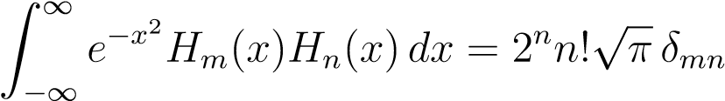 (4.23)
where δ_{mn} is the Kronecker delta defined by:
(
1 if m = n
δ_{mn} = (4.24)
0 if m ̸= n

4.10 Recurrence Relations
Hermite polynomials satisfy several recurrence relations that facilitate programmatic evaluation and algebraic manipulation.

4.10.1 First Recurrence Relation
H_{n+1}(x) = 2xH_{n}(x) − 2nH_{n−1}(x)  4.10.2 Proof  Consider the generating function expansion: | (4.25)
 (4.26)
Differentiating both sides with respect to t:
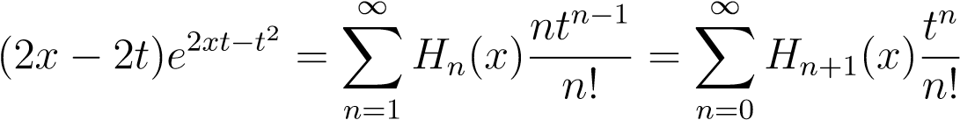 (4.27)
Substituting the original generating function expansion back into the left side of Eq. (4.27) and comparing the coefficients of matching powers of t^{n} yields:
H_{n+1}(x) = 2xH_{n}(x) − 2nH_{n−1}(x)  Hence proved.  4.10.3 Second Recurrence Relation | (4.28)
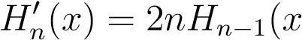) (4.29)

4.10.4 Proof
Differentiate the generating function with respect to x:
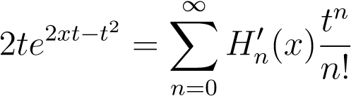 (4.30)
Substituting the series definition of the exponential generator on the left side and comparing coefficients directly yields:
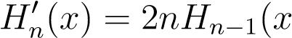) (4.31)
Hence proved.

4.11 Derivative Formula
Hermite polynomials satisfy the standard derivative formula:
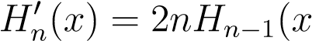) (4.32)
This formula shows that the derivative of a Hermite polynomial of degree n is directly proportional to the Hermite polynomial of degree n − 1.

4.11.1 Proof
Consider the generating function expansion:
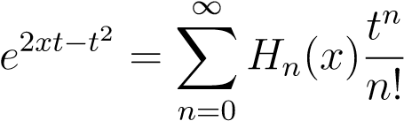 (4.33)
Differentiating both sides with respect to x:
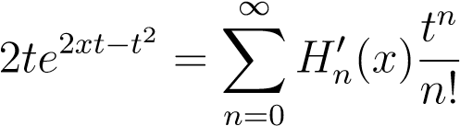 (4.34)
Using the generating function series substitution on the left side:
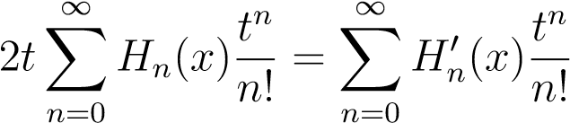 (4.35)
Comparing coefficients of t^{n} after shifting the indices on the left side gives:
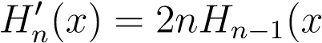) (4.36)
Hence proved.

4.12 Applications of Hermite Polynomials

4.12.1 Quantum Mechanics
Hermite polynomials arise naturally in the quantum harmonic oscillator problem. The Schro¨dinger equation reduces to the Hermite differential equation whose exact physical solutions are expressed in terms of Hermite polynomials. They play an important role in wave mechanics and quantum theory.

4.12.2 Probability Theory
Hermite polynomials are closely related to Gaussian distributions and normal random variables. They are widely used in probability theory, stochastic processes, and statistical mechanics. Their orthogonality with respect to the Gaussian weight function makes them analytically important.

4.12.3 Fourier Analysis
Hermite functions form orthogonal bases in Fourier analysis. They are useful in signal processing, harmonic analysis, and spectral theory. Crucially, Hermite functions preserve their mathematical form under a continuous Fourier transformation.

4.12.4 Numerical Analysis
Hermite polynomials are used in approximation theory and numerical computation. They are fundamentally important in Gaussian quadrature formulas (specifically Gauss-Hermite quadrature) and interpolation methods. These polynomials help in obtaining accurate numerical approximations for infinite integrals.

4.12.5 Heat Conduction Problems
Hermite polynomial expansions occur in explicit analytical solutions of heat and diffusion equations over infinite boundaries. They are useful in mathematical models involving thermal analysis and partial differential equations, where their analytical properties simplify many complex physical problems.

4.12.6 Engineering Applications
Hermite polynomials are applied in communication systems, control theory, and optical physics. They are also useful in computational mathematics and engineering analysis.
Their strict orthogonality properties make them ideal for signal representation techniques.

4.13 Conclusion
In this chapter, Hermite polynomials were studied systematically through their differential equations, Rodrigues formula, generating function, recurrence relations, orthogonality conditions, derivative formulas, and applications. Detailed derivations and proofs of the generating function and recurrence relations were presented. The explicit formulas and orthogonality properties of Hermite polynomials were also discussed in detail. The exponential generating structure of Hermite polynomials forms an important basis for the comparative analysis developed in later chapters of the dissertation.

Chapter 5
LAGUERRE POLYNOMIALS

5.1 Introduction
Laguerre polynomials constitute one of the most vital classes of classical orthogonal polynomials in mathematical analysis and mathematical physics. These polynomials arise naturally across various domains, including quantum mechanics, approximation theory, numerical analysis, and differential equations.
The Laguerre polynomials form an orthogonal system over the infinite interval (0,∞) with respect to the exponential weight function:
w(x) = e^{−x} (5.1)
They satisfy a dedicated second-order linear differential equation, distinct recurrence relations, a Rodrigues representation, and unique generating functions. Notably, the generating function of Laguerre polynomials possesses a rational-exponential structure that distinguishes it from Hermite and Legendre generating functions. This chapter provides a systematic treatment of Laguerre polynomials, including rigorous derivations and proofs of their core mathematical properties.

5.2 Definition of Laguerre Polynomials
Laguerre polynomials are defined as the polynomial solutions of the secondorder homogeneous linear differential equation:
xy′′ + (1 − x)y′ + ny = 0 (5.2)
1
The specific polynomial solution of degree n to this differential equation is conventionally denoted by L_{n}(x).

5.3 Rodrigues Formula
The Rodrigues representation provides an explicit operational definition for the Laguerre polynomials and is given by:
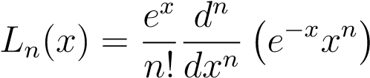 (5.3)
5.3.1 Proof
Consider the foundational function:
f(x) = e^{−x}x^{n} | (5.4)
Differentiating this expression with respect to x via the product rule yields:
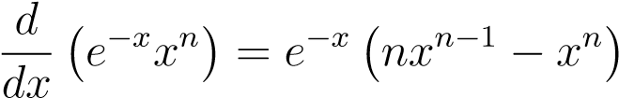 (5.5)
Successive application of the differential operator generates a sequence of polynomial expressions scaled by the exponential factor e^{−x}. By mathematical induction, the n-th derivative takes the structural form of e^{−x} multiplied by a polynomial of degree n.
Multiplying this resulting n-th derivative by e^{x} eliminates the exponential factor, isolating a pure polynomial of degree n. Normalizing this expression by 1/n! satisfies the standard boundary conditions for the polynomial, establishing that:
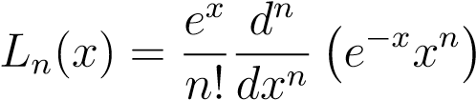 (5.6)

5.4 Generating Function of Laguerre Polynomials
The generating function for the sequence of Laguerre polynomials L_{n}(x) is represented by the identity:
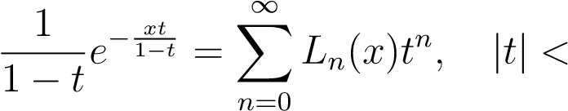1 (5.7)
5.4. GENERATING FUNCTION OF LAGUERRE POLYNOMIALS

5.4.1 Proof
Let us define the generating function as:
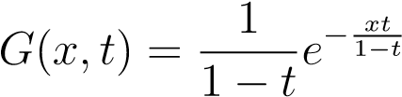 (5.8)
Expanding the exponential component into its corresponding Maclaurin series yields:
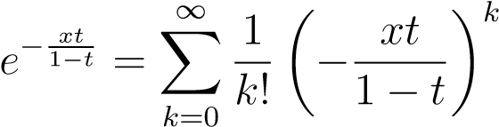 (5.9)
Substituting this series back into the expression for G(x,t), we obtain:
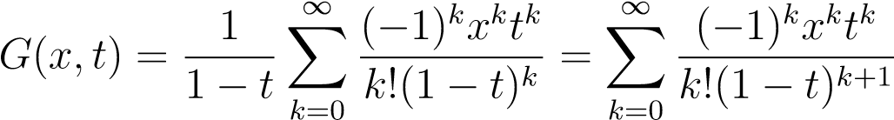 (5.10)
We now invoke the negative binomial expansion for the denominator term, which states that:
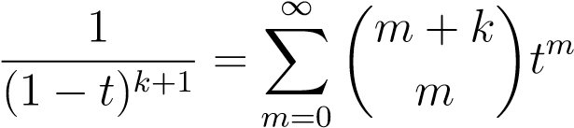 (5.11)
Substituting this expansion into our expression gives a double summation:
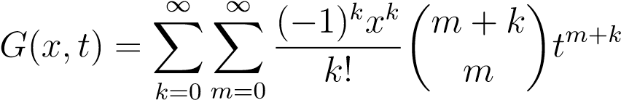 (5.12)
To collect coefficients of like powers of t, we introduce a change of indices by setting:
n = m + k (5.13)
Because m ≥ 0, the summation limits adjust such that k ranges from 0 to n. Rewriting the double sum gives:
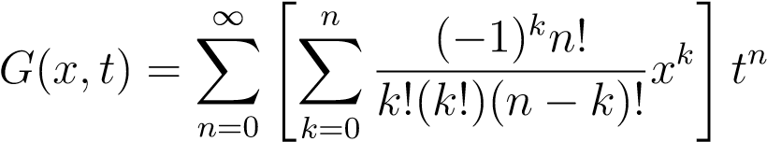 (5.14)
We now define the explicit polynomial inside the brackets as L_{n}(x):
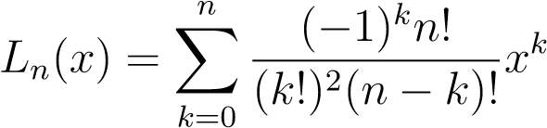 (5.15)
It immediately follows that:
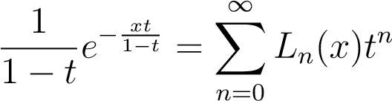 (5.16)

5.5 Explicit Formula
By evaluating the series expansion derived from the generating function, the explicit algebraic representation of the Laguerre polynomial of degree n is given by:
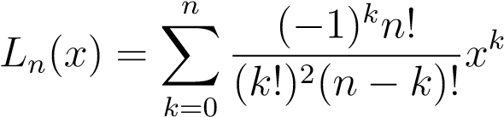 (5.17)

5.5.1 First Few Laguerre Polynomials
Utilizing this explicit expansion formula, the first few Laguerre polynomials can be constructed sequentially:
- L₀(x) = 1
- L₁(x) = 1 − x
•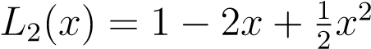
•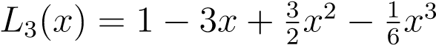
•

5.6 Orthogonality Property
The Laguerre polynomials satisfy the definitive integral orthogonality relation:
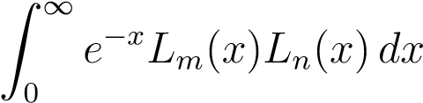= 0 for m ̸= n (5.18)
Here, the fundamental weight function is w(x) = e^{−x} over the designated interval of orthogonality (0,∞).

5.6.1 Proof
Let L_{n}(x) and L_{m}(x) be solutions to their respective Laguerre differential equations:
xL′′_{n} + (1 − x)L′_{n} + nL_{n} = 0 (5.19) xL′′_{m} + (1 − x)L′_{m} + mL_{m} = 0 (5.20)
5.7. RECURRENCE RELATIONS
Converting these equations into Sturm-Liouville self-adjoint form requires multiplying by the integrating factor e^{−x}. Next, we multiply the first equation by L_{m}(x)e^{−x} and the second equation by L_{n}(x)e^{−x}. Subtracting the two resulting equations and integrating over the domain (0,∞) gives:
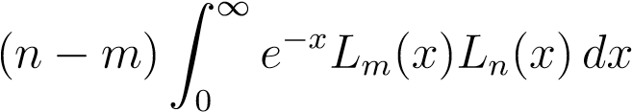= 0 (5.21)
For any distinct indices where m ̸= n, it dictates that:
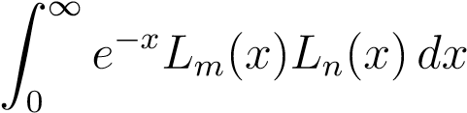= 0 (5.22)

5.7 Recurrence Relations
Laguerre polynomials satisfy multiple recurrence relations that enable efficient computation across varying degrees.

5.7.1 First Recurrence Relation
The primary three-term recurrence relation connecting successive degrees is given by:
(n + 1)L_{n+1}(x) = (2n + 1 − x)L_{n}(x) − nL_{n−1}(x) (5.23)

5.7.2 Proof
Recall the generating function definition:
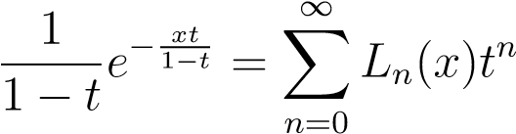 (5.24)
Differentiating both sides with respect to the parameter t and matching the corresponding coefficients of t^{n} yields the desired relation:
(n + 1)L_{n+1}(x) = (2n + 1 − x)L_{n}(x) − nL_{n−1}(x) (5.25)

5.7.3 Second Recurrence Relation
Another important recurring differential sequence presents as follows:
) (5.26)

5.7.4 Proof
Differentiating the operational Rodrigues formula structure and organizing the resulting terms yields the relation:
) (5.27)

5.7.5 Third Recurrence Relation
A third foundational recurrence identity expresses a direct connection via shifted derivative elements:
) (5.28)

5.7.6 Proof
By taking the previously established second derivative relation and performing direct algebraic rearrangements, the connection is derived explicitly:
) (5.29)

5.8 Derivative Formula
The structural derivative relations link the derivatives of Laguerre polynomials to associated configurations:
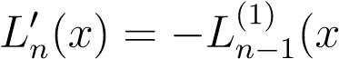) (5.30)
For ordinary, non-associated Laguerre polynomials, the differential environment relates the derivative of a polynomial to two consecutive indices:
) (5.31)

5.8.1 Proof
Differentiating the operational Rodrigues representation and carrying out mathematical simplifications yields the differential expression:
) (5.32)
5.9. PROPERTIES OF LAGUERRE POLYNOMIALS

5.9 Properties of Laguerre Polynomials
Laguerre polynomials possess several important analytical properties.
5.9.1 Degree Property
The polynomial L_{n}(x) is strictly a polynomial of degree n.

5.9.2 Orthogonal Basis Property
The sequence of Laguerre polynomials forms a complete orthogonal basis over the semi-infinite domain (0,∞).

5.9.3 Differential Equation Property
Every individual Laguerre polynomial satisfies the second-order ordinary Laguerre differential equation identically.

5.10 Applications of Laguerre Polynomials
Laguerre polynomials possess important applications across multiple disciplines in mathematics and physics.

5.10.1 Quantum Mechanics
- Laguerre polynomials arise naturally during the evaluation of the radial wave equation for the hydrogen atom.
- They serve as an essential mathematical tool in atomic and quantum physics.

5.10.2 Numerical Analysis
In numerical and computational mathematics, Laguerre polynomials are fundamental to:
- Gaussian Quadrature: Specifically, Gauss-Laguerre quadrature methods to evaluate integrals over infinite boundaries.
- Approximation Methods: Designing functional approximation frameworks across semi-infinite boundaries.

5.10.3 Differential Equations
• Laguerre polynomial expansions are useful in solving complex boundary value problems and related differential equations.

5.10.4 Engineering Mathematics
In engineering systems, Laguerre functions are widely utilized in:
- Signal Processing: Analyzing continuous temporal operations.
- Control Systems: Designing response modeling configurations.
- Engineering Approximations: Constructing numerical system approximations.

5.11 Conclusion
In this chapter, Laguerre polynomials were studied systematically along with detailed derivations and proofs of their important properties. The Laguerre differential equation, Rodrigues formula, generating function, orthogonality relation, recurrence formulas, derivative relations, and applications were discussed analytically. The unique structural qualities of Laguerre polynomials provide an important analytical framework for studying classical orthogonal polynomial systems.

Chapter 6

LEGENDRE POLYNOMIALS

1.1 Introduction
Legendre polynomials are among the most important classical orthogonal polynomials in mathematical analysis, mathematical physics, and approximation theory. These polynomials arise naturally when solving boundary value problems involving spherical symmetry and play a fundamental role in potential theory, spherical harmonics, electrostatics, quantum mechanics, and numerical analysis.
Legendre polynomials form an orthogonal system over the continuous interval [−1,1] with respect to the simplest weight function:
w(x) = 1 (1.1)
They satisfy second-order differential equations, recurrence relations, Rodrigues formulas, and generating functions. The generating function of Legendre polynomials possesses a purely algebraic structure, which sharply distinguishes it from the exponential generating function of Hermite polynomials and the rationalexponential generating function of Laguerre polynomials. This chapter discusses Legendre polynomials systematically along with formal derivations and proofs of their core properties.

1.2 Historical Background
Legendre polynomials are named after the French mathematician Adrien-Marie Legendre. They were introduced during his pioneering investigations of gravitational and astronomical problems. Later, Legendre polynomials became essential tools in mathematical physics, approximation theory, and numerical integration. Today, they occupy a central position in the theory of special functions and orthogonal polynomials.
1

1.3 Definition of Legendre Polynomials
The Legendre polynomials are defined as the polynomial solutions of the linear second-order homogeneous differential equation:
(1 − x²)y′′ − 2xy′ + n(n + 1)y = 0 (1.2)
The polynomial solution of degree n is conventionally denoted by P_{n}(x).

1.4 Rodrigues Formula
The Rodrigues representation of Legendre polynomials provides an explicit operational definition given by:
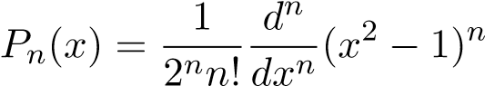 (1.3)
1.4.1 Proof
Consider the foundational function:
f(x) = (x² − 1)^{n} | (1.4)
This is clearly a polynomial of degree 2n. Differentiating this expression n times produces a new polynomial of degree n:
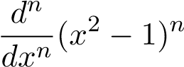 (1.5)
By scaling this derivative by the normalization factor 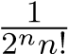, we define our target solution expression P_{n}(x). Direct substitution into the Legendre differential equation verifies that this polynomial satisfies it identically. Hence, the Rodrigues formula is established.

1.5 Generating Function of Legendre Polynomials
The generating function for the Legendre polynomial sequence expands as a power series in t:
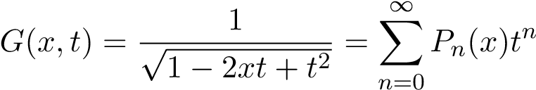 (1.6)

1.5.1 Proof
Consider the function G(x,t) = (1 − 2xt + t²)^{−1/2}. We recall the generalized binomial expansion:
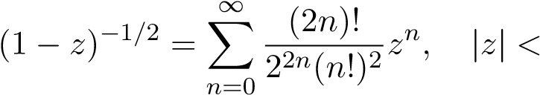1 (1.7)
1.6. EXPLICIT FORMULA
By performing the substitution z = 2xt − t² and expanding the resulting powers, we can collect terms by matching powers of t:
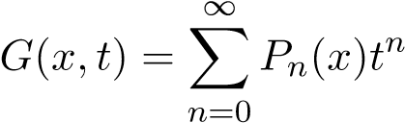 (1.8)
Because the coefficients of successive powers of t perfectly define the Legendre polynomials, it follows that:
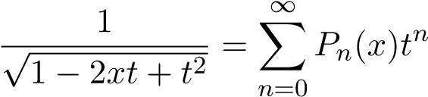 (1.9)
Thus, the generating function relation is proved.

1.6 Explicit Formula
By carrying out the expansion of the generating function or via the Rodrigues formula, the explicit series representation of the Legendre polynomials is found to be:
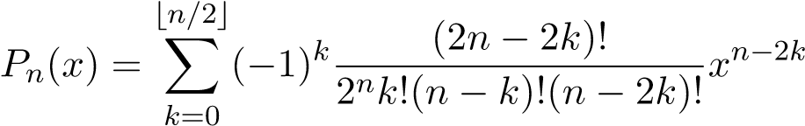 (1.10)

1.6.1 First Few Legendre Polynomials
Evaluating the explicit series formula for the initial values of n yields:
- P₀(x) = 1
- P₁(x) = x
•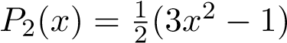
•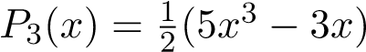
•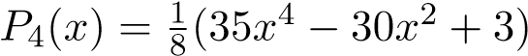
•
These initial functions illustrate the increasing degree, alternating parity, and expanding algebraic complexity of the Legendre polynomial sequence.

1.7 Orthogonality Property
The Legendre polynomials satisfy the fundamental mathematical orthogonality relation:
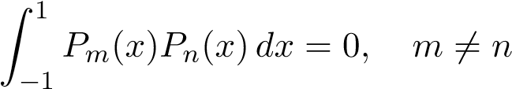 (1.11)
where the weight function is w(x) = 1 over the interval of orthogonality [−1,1].

1.7.1 Proof
Consider the self-adjoint form of the Legendre differential equations satisfied by P_{n}(x) and P_{m}(x) respectively:
(1.12)
(1.13)
Multiplying the first equation by P_{m}(x) and the second equation by P_{n}(x), subtracting the two equations, and integrating over the domain [−1,1] yields:
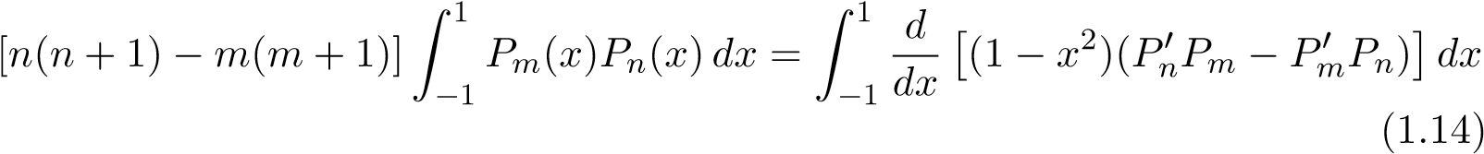
Evaluating the complete right-hand boundary terms gives zero because of the (1 − x²) factor at x = ±1, simplifying the expression to:
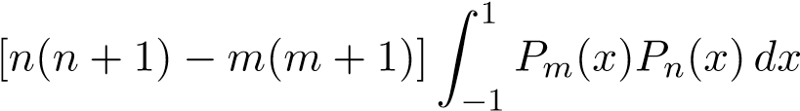= 0 (1.15)
For m ≠ n, the leading scalar coefficient is non-zero, meaning it follows logically that:
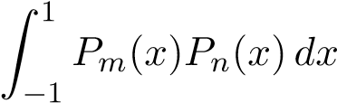= 0 (1.16)
Hence, the orthogonal nature of the Legendre polynomials is verified.

1.8 Recurrence Relations
Legendre polynomials satisfy several fundamental recurrence relations that link polynomials of different orders.

1.8.1 First Recurrence Relation
(n + 1)P_{n+1}(x) = (2n + 1)xP_{n}(x) − nP_{n}−₁(x)  Proof. Differentiate the generating function with respect to t: | (1.17)
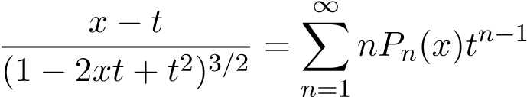 (1.18)
Multiplying both sides by (1 − 2xt + t²), substituting the original generating function definition back in, and comparing coefficients of identical powers of t^{n} on both sides leads directly to the relation:
(n + 1)P_{n+1}(x) = (2n + 1)xP_{n}(x) − nP_{n−1}(x) (1.19)
Hence proved.
1.9. DERIVATIVE FORMULA

1.8.2 Second Recurrence Relation
) (1.20)
Proof. Differentiating the operational Rodrigues formula directly with respect to x and performing algebraic simplification yields the differential identity:
) (1.21)
Hence proved.

1.8.3 Third Recurrence Relation
) (1.22)
Proof. Differentiating the first recurrence relation with respect to x and eliminating terms using the second recurrence relation yields:
) (1.23)
Hence proved.
1.9 Derivative Formula
The derivative relation for Legendre polynomials is written directly as:
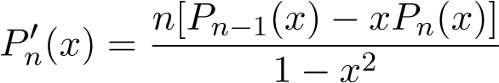 (1.24)

1.9.1 Proof
We start directly from our second established recurrence identity:
) (1.25)
Dividing both sides of this equation by the polynomial factor (1 − x²), we obtain the target derivative expression:
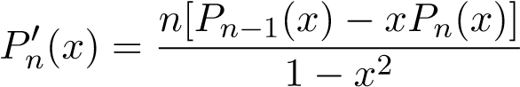 (1.26)
Hence proved.

1.10 Symmetry Property
Legendre polynomials possess a definite parity under inversion of their argument:
P_{n}(−x) = (−1)^{n}P_{n}(x) (1.27)
Thus, Legendre polynomials are even functions for even values of n, and odd functions for odd values of n.

1.10.1 Proof
Replace x by −x in the generating function relation:
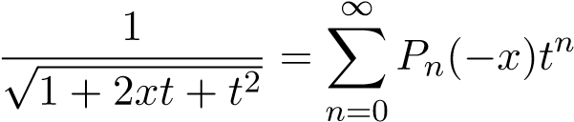 (1.28)
Now return to the original generating function and substitute −t for t:
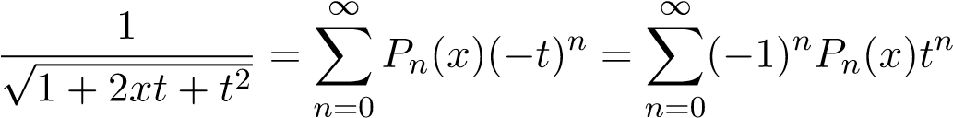 (1.29)
Equating the series right-hand sides and comparing matching coefficients allows us to conclude:
P_{n}(−x) = (−1)^{n}P_{n}(x) (1.30)
Hence proved.

1.11 Applications of Legendre Polynomials
Legendre polynomials possess numerous important applications in mathematics, physics, and engineering frameworks.

1.11.1 Potential Theory
Legendre polynomials appear universally in solutions of Laplace’s equation (∇²Φ = 0) inside spherical coordinate configurations. They play an invaluable role in modeling complex gravitational and electrostatic potentials possessing axial symmetries.

1.11.2 Quantum Mechanics
They form the foundational building blocks for spherical harmonics and quantum angular momentum problems. They are frequently encountered when analyzing atomic systems and localized wave functions.

1.11.3 Numerical Analysis
In computational mathematics, Legendre polynomials are heavily utilized in:
- Gauss–Legendre Quadrature: For optimizing precision and providing highly accurate numerical approximations of definite integrals over bounded domains.
- Approximation Theory: Providing minimal error minimax expansions.
- Spectral Methods: To solve high-order differential equations numerically.
1.12. COMPARATIVE IMPORTANCE

1.11.4 Electromagnetic Theory
Generalized Fourier–Legendre series expansions are incredibly useful in solving boundary value problems involving complex electric and magnetic field arrays. They cleanly simplify many physical systems showcasing native spherical symmetry.

1.11.5 Geophysics and Astronomy
In macroscopic physical models, Legendre polynomials are applied to map global planetary gravitational fields, chart geomagnetic variances, and model planetary or astronomical orbital variations.

1.12 Comparative Importance
The generating function of Legendre polynomials exhibits a unique algebraic structure, which sets it completely apart from other families:
- It lacks the purely exponential structure found in Hermite polynomials.
- It avoids the rational-exponential structure seen in Laguerre polynomials.
This purely algebraic generating framework provides the Legendre system with unique analytic traits that distinguish it among classical orthogonal polynomial configurations.

1.13 Conclusion
In this chapter, Legendre polynomials were studied systematically through their differential equation, Rodrigues formula, generating function, explicit representation, orthogonality relation, recurrence formulas, derivative relations, symmetry identities, and applications. Detailed proofs for the algebraic generating function, domain orthogonality, and inter-degree recurrence chains were rigorously presented.
The characteristically distinct algebraic generating structure analyzed here provides an essential mathematical foundation for the comparative analysis of classical orthogonal polynomial systems executed in the subsequent chapter.

Chapter 7
Comparative Analysis of Generating
Functions of Hermite, Laguerre, and
Legendre Polynomials

7.1 Introduction
Generating functions constitute one of the most powerful tools in the theory of orthogonal polynomials. They provide a compact representation of an entire polynomial sequence through a single analytic expression. From generating functions, numerous properties such as recurrence relations, differential equations, explicit formulas, and orthogonality relations can be derived systematically.
In the previous chapters, the generating functions associated with Hermite, Laguerre, and Legendre polynomials were studied individually. In this chapter, a comparative analysis of these generating functions is presented. The objective is to identify similarities, differences, structural characteristics, and analytical consequences of the three generating functions.
The present comparative study forms the main contribution of this dissertation.

7.2 Generating Functions of Classical Orthogonal Polynomials
The generating functions of the three polynomial families are formulated explicitly as follows:
1.2.1 Hermite Polynomials
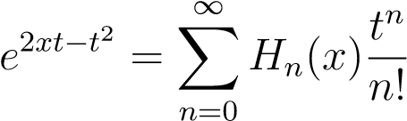 (1.1)
1.2.2 Laguerre Polynomials
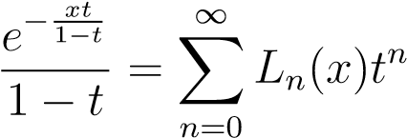 (1.2)
1.2.3 Legendre Polynomials
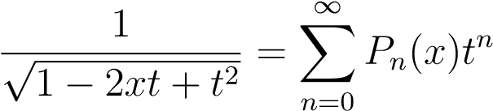 (1.3)
Each generating function produces an infinite sequence of orthogonal polynomials through a continuous expansion in powers of the parameter t.

7.3 Structural Comparison
The three generating functions possess completely distinct mathematical structures:
- Hermite: Generating functions involve only exponential terms.
- Laguerre: Generating functions combine rational and exponential components.
- Legendre: Generating functions are algebraic and involve a square-root denominator.
Thus, the structural complexity increases progressively from exponential to rationalexponential to algebraic forms.

7.4 Comparison of Domains
The generating functions are valid under different analytic domain conditions:
- Hermite: The expression e^{2xt−t2} is entire across both variables x and t.
- Laguerre: The expression 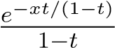 strictly requires |t| < 1.
- Legendre: The expression 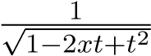 also strictly requires |t| < 1.
Hence, Hermite generating functions possess the largest overall domain of analyticity.

7.5 Comparison of Orthogonality Intervals
Each polynomial family is defined over a unique spatial continuum. The absolute topology of the orthogonality interval directly influences the fundamental structural definition of the corresponding generating function, as summarized in Table 1.1.
Table 1.1: Geometric Domains of Orthogonality
Polynomial Family | Orthogonality Interval | Interval Geometry
Hermite | (−∞,∞) | Fully Unbounded / Infinite
Laguerre | (0,∞) | Semi-Infinite
Legendre | [−1,1] | Strictly Bounded / Bounded

7.6 Comparison of Weight Functions
The characteristic weight functions are defined as:
- Hermite: w(x) = e^{−x2}
- Laguerre: w(x) = e^{−x}
- Legendre: w(x) = 1
The exponential decay found in Hermite and Laguerre systems contributes to the appearance of exponential terms inside their generating functions. Conversely, Legendre polynomials possess a constant weight function, naturally leading to a purely algebraic generating function.

7.7 Comparison of Differential Equations
Each polynomial family satisfies a distinct second-order linear ordinary differential equation, highlighting unique analytical frameworks: • Hermite Equation: y′′ − 2xy′ + 2ny = 0 • Laguerre Equation: xy′′ + (1 − x)y′ + ny = 0 • Legendre Equation:
(1 − x²)y′′ − 2xy′ + n(n + 1)y = 0
The explicit operational complexity of the differential equation is mirrored in the structure of the generating function. Hermite equations produce exponential profiles, Laguerre equations yield rational-exponential architectures, and Legendre equations yield algebraic variations.

7.8 Comparison of Recurrence Relations
Each polynomial family satisfies a fundamental three-term recurrence relation, which can all be derived elegantly and directly by taking partial derivatives of their generating functions:
• Hermite:
H_{n+1}(x) = 2xH_{n}(x) − 2nH_{n−1}(x) • Laguerre:
(n + 1)L_{n+1}(x) = (2n + 1 − x)L_{n}(x) − nL_{n−1}(x) • Legendre:
(n + 1)P_{n+1}(x) = (2n + 1)xP_{n}(x) − nP_{n−1}(x)

7.9 Comparison of Derivative Formulas
The respective derivative shifting identities represent differing relational operations within their domains:
- Hermite Derivatives:
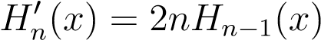
- Laguerre Derivatives:
- Legendre Derivatives:
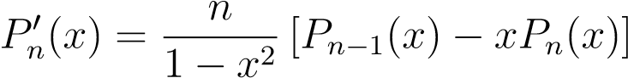
The structural configurations become progressively more complex from the Hermite family to the Laguerre family, and finally to the Legendre family.

7.10 Comparative Analysis of Growth Behaviour
The generating functions exhibit unique growth and convergence characteristics across complex space:
- Hermite generating functions exhibit rapid exponential growth profiles.
- Laguerre generating functions display moderate growth curves due to the jointpresence of rational and exponential components.
- Legendre generating functions display comparatively slower, bounded algebraicgrowth.
This divergence profoundly impacts both their local convergence properties and practical computational uses.

7.11 Comparative Analysis of Applications
The practical domain applications directly reflect the mathematical properties encoded within the respective generating functions:
- Hermite Polynomials: Quantum harmonic oscillators, probability theory, Fourier analysis, and heat conduction problems.
- Laguerre Polynomials: Hydrogenic wavefunctions, numerical quadrature schemes, approximation theory, and specialized differential equations.
- Legendre Polynomials: Potential theory, spherical harmonics formulation, classical electromagnetic theory, and geophysics.

7.12 Comparative Table
The core parameters, structural environments, and boundary constraints of the three classical polynomial families are summarized comprehensively in Table 1.2. All property labels are emphasized in bold face for clear visual categorization.
Table 1.2: Comprehensive Comparison of Classical Orthogonal Polynomial Systems
Property | Hermite | Laguerre | Legendre
Generating Function Type | Exponential | Rational–Exponential | Algebraic
Domain of Gen. Function | Entire (|t| < ∞) | Bounded Disk (|t| < 1) | Bounded Disk (|t| < 1)
Orthogonality Interval | (−∞,∞) | (0,∞) | (−1,1)
Weight Function | e−x² | e−x | 1
Differential Equation | Hermite Type | Laguerre Type | Legendre Type
Recurrence Relation | Three-term | Three-term | Three-term
Main Application | Quantum Oscillator | Hydrogen Atom | Potential Theory

7.13 Main Findings of the Study
The comparative investigation reveals that the generating functions of Hermite, Laguerre, and Legendre polynomials possess fundamentally different analytical structures.
The Hermite generating function is purely exponential and exhibits the simplest analytical form. The Laguerre generating function combines exponential and rational characteristics, producing an intermediate structure. The Legendre generating function possesses an algebraic square-root structure and is analytically distinct from the other two families.
Despite these clear structural variations, all three generating functions successfully generate complete orthogonal polynomial sequences and provide a unified operational mechanism for deriving recurrence relations, differential equations, and explicit formulas.

7.14 Conclusion
In this chapter, a detailed comparative analysis of the generating functions associated with Hermite, Laguerre, and Legendre polynomials was presented. Their structures, domains, orthogonality properties, recurrence relations, derivative formulas, and applications were systematically compared.
The study shows that although these polynomial families belong to the same class of classical orthogonal polynomials, their generating functions exhibit significantly different analytical characteristics. These differences influence their mathematical properties and applications in various branches of science and engineering.
The comparative framework developed in this chapter highlights the central role of generating functions in understanding classical orthogonal polynomial systems and forms the principal contribution of the present dissertation.

Chapter 8
Applications of Classical Orthogonal
Polynomials and Generating Functions

8.1 Introduction
Classical orthogonal polynomials and their generating functions possess extensive applications in both pure and applied mathematics. Hermite, Laguerre, and Legendre polynomials arise naturally in mathematical physics, approximation theory, numerical analysis, engineering mathematics, and quantum mechanics.
Generating functions provide systematic analytical methods for deriving polynomial expansions, recurrence relations, asymptotic formulas, and solutions of differential equations. Their applications extend across several branches of science and engineering.
The present chapter discusses important applications of Hermite, Laguerre, and Legendre polynomials together with the role of generating functions in mathematical analysis and physical sciences.
—

8.2 Applications of Hermite Polynomials
Hermite polynomials possess important applications in probability theory, quantum mechanics, Fourier analysis, and numerical methods.

8.2.1 Quantum Harmonic Oscillator
One of the most important applications of Hermite polynomials occurs in quantum mechanics. The Schro¨dinger equation for the harmonic oscillator reduces to:
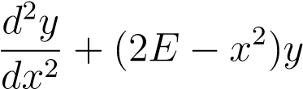= 0 (8.1)
The solutions are expressed in terms of Hermite functions:
ψn(x) = e−x2/2Hn(x) | (8.2)
Thus, Hermite polynomials play a central role in quantum harmonic oscillator theory.

8.2.2 Probability Theory
Hermite polynomials are associated with Gaussian distributions and normal random variables. They are widely used in:
- Probability density expansions
- Stochastic processes
- Statistical mechanics
- Wiener chaos theory
The weight function e^{−x2} corresponds directly to Gaussian probability distributions.

8.2.3 Fourier Analysis
Hermite functions form orthogonal bases in Fourier analysis. They are useful in:
- Signal processing
- Harmonic analysis
- Spectral methods
Hermite functions also remain invariant under Fourier transformation up to constant multiples.

8.2.4 Numerical Analysis
Hermite polynomials are used in interpolation theory, approximation methods, Gaussian quadrature, and computational mathematics.
—

8.3 Applications of Laguerre Polynomials
Laguerre polynomials possess extensive applications in mathematical physics and engineering mathematics.

8.3.1 Hydrogen Atom Problem
Laguerre polynomials appear naturally in the radial part of the Schr¨odinger equation for the hydrogen atom. The radial wave functions are expressed using associated Laguerre polynomials. Thus, Laguerre polynomials are fundamental in atomic physics and quantum mechanics.

8.3.2 Numerical Integration
Laguerre polynomials are used in Gauss–Laguerre quadrature for evaluating integrals of the form:
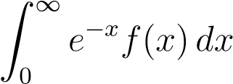 (8.3)
This method is widely used in computational mathematics and applied analysis.

8.3.3 Differential Equations
Laguerre polynomial expansions are useful in solving boundary value problems, heat equations, and engineering differential equations.

8.3.4 Signal Processing and Engineering
Laguerre functions are used in control systems, system identification, electrical engineering, and communication theory.
—

8.4 Applications of Legendre Polynomials
Legendre polynomials possess extensive applications in potential theory, approximation theory, and mathematical physics.

8.4.1 Laplace’s Equation
Legendre polynomials arise naturally in solutions of Laplace’s equation in spherical coordinates. The equation:
∇²V = 0 (8.4)
reduces to Legendre differential equations in spherical symmetry problems.

8.4.2 Spherical Harmonics
Legendre polynomials form the basis of spherical harmonics used in quantum mechanics, astrophysics, and geophysics. Associated Legendre polynomials are especially important in angular momentum theory.

8.4.3 Approximation Theory
Legendre polynomials are widely used in least squares approximation, spectral methods, orthogonal expansions, and numerical computation.

8.4.4 Gaussian Quadrature
Legendre polynomials are used in Gauss–Legendre quadrature for numerical integration over finite intervals. This method provides highly accurate approximation techniques.
—

8.5 Applications of Generating Functions
Generating functions themselves possess wide analytical importance.

8.5.1 Derivation of Recurrence Relations
Generating functions provide systematic methods for deriving recurrence formulas associated with orthogonal polynomial systems. For example, differentiating the generating function of Hermite polynomials gives:
H_{n+1}(x) = 2xH_{n}(x) − 2nH_{n−1}(x) (8.5)

8.5.2 Explicit Polynomial Representation
Generating functions allow compact representation of entire polynomial sequences. A single generating function generates infinitely many polynomial terms.

8.5.3 Solution of Differential Equations
Generating functions are useful in solving ordinary differential equations, partial differential equations, and boundary value problems.

8.5.4 Asymptotic Analysis
Generating functions provide analytical tools for studying asymptotic behavior of polynomial sequences.

8.5.5 Combinatorial Applications
Generating functions are fundamental in combinatorics for counting problems, partition theory, and recurrence analysis.
—

8.6 Comparative Application Analysis
The applications of the three polynomial systems differ according to their analytical structures.
Table 8.1: Comparative Analysis of Classical Orthogonal Polynomials
Polynomial | Main Area of Application | Domain Focus
Hermite | Quantum oscillators, probability | Gaussian structures
Laguerre | Hydrogen atom, engineering | Semi-infinite intervals [0,∞)
Legendre | Potential theory, spherical harmonics | Finite intervals [−1,1], Spherical symmetry

8.6.1 Comparative Observations
Hermite polynomials dominate problems involving Gaussian structures. Laguerre polynomials arise naturally in semi-infinite interval problems. Legendre polynomials appear mainly in finite interval and spherical symmetry problems.
Despite these differences, all three polynomial systems provide orthogonal bases, solve differential equations, and support approximation methods.
—

8.7 Importance in Mathematical Physics
Orthogonal polynomials are fundamental in mathematical physics because they solve eigenvalue problems, represent wave functions, and provide orthogonal expansions. Generating functions simplify the analytical study of these polynomial systems and provide compact mathematical representations.

8.8 Importance in Approximation Theory
Orthogonal polynomial systems are widely used in approximation theory because orthogonality minimizes approximation errors. Applications include polynomial interpolation, least squares approximation, Fourier-type expansions, and numerical integration.

8.9 Modern Computational Applications
Classical orthogonal polynomials are also used in machine learning, computational physics, numerical simulations, spectral algorithms, and scientific computing. Generating functions assist in efficient computational implementations.

8.10 Conclusion
In this chapter, important applications of Hermite, Laguerre, and Legendre polynomials together with their generating functions were discussed systematically.
The applications demonstrate that orthogonal polynomial systems are not only theoretically significant but also practically important in mathematics, physics, engineering, and computational science. Generating functions provide powerful analytical tools that unify these applications and simplify the study of classical orthogonal polynomial systems.

Chapter 9
CONCLUSION AND FUTURE SCOPE
In this dissertation, a systematic study of the generating functions associated with classical orthogonal polynomials has been presented. The fundamental properties of Hermite, Laguerre, and Legendre polynomials, including their generating functions, recurrence relations, orthogonality properties, derivative formulas, and applications, were investigated in detail. The study demonstrated the important role played by generating functions in deriving and understanding various analytical properties of orthogonal polynomial systems.
A comparative analysis of the generating functions of these polynomial families was carried out as the central objective of the dissertation. The investigation revealed that although Hermite, Laguerre, and Legendre polynomials belong to the same class of classical orthogonal polynomials, their generating functions possess distinct analytical structures. The generating function of Hermite polynomials has a purely exponential form, the generating function of Laguerre polynomials exhibits a rational-exponential form, and the generating function of Legendre polynomials possesses an algebraic square-root form. These structural differences influence the recurrence relations, differential equations, orthogonality properties, and applications associated with each polynomial family.
The comparative study further showed that generating functions provide a unified framework through which various properties of orthogonal polynomials can be obtained systematically. Despite the differences in their mathematical structures, all three generating functions successfully generate complete polynomial sequences and serve as powerful tools for theoretical analysis. The results obtained in this work highlight both the common features and distinguishing characteristics of the three polynomial systems and emphasize the significance of generating functions in the broader theory of special functions and orthogonal polynomials.
The present work may be extended in several directions. Similar comparative studies may be carried out for other classical orthogonal polynomials such as Chebyshev, Jacobi, and Gegenbauer polynomials. The analysis may also be extended to generalized orthogonal polynomials, associated polynomial systems, and (q)-orthogonal polynomials. Further investigations may focus on asymptotic behavior, convergence properties, computational aspects, and applications of generating functions in mathematical physics, numerical analysis, and engineering sciences. In addition, generating function techniques may be employed to derive
1
CHAPTER 9. CONCLUSION AND FUTURE SCOPE 2
new identities, recurrence relations, and analytical results for broader classes of special functions.
Generating functions provide an elegant and powerful approach to the study of orthogonal polynomials. The comparative analysis presented in this dissertation demonstrates how a single analytical concept can unify different polynomial families while simultaneously revealing their unique mathematical characteristics. It is hoped that the results of this study will contribute to a deeper understanding of classical orthogonal polynomials and provide a useful foundation for future research in special functions, approximation theory, and related areas of mathematics.

Bibliography
- Abramowitz, M., and I. A. Stegun. Handbook of Mathematical Functions. New York: Dover Publications, 1965.
- Andrews, G. E., R. Askey, and R. Roy. Special Functions. Cambridge: Cambridge University Press, 1999.
- Andrews, L. C. Special Functions of Mathematics for Engineers. New York: Oxford University Press, 1998.
- Arfken, G. B., and H. J. Weber. Mathematical Methods for Physicists. 6th ed. Elsevier Academic Press, 2005.
- Bell, W. W. Special Functions for Scientists and Engineers. New York: Dover Publications, 2004.
- Boyd, J. P. Chebyshev and Fourier Spectral Methods. Dover Publications, 2001.
- Chihara, T. S. An Introduction to Orthogonal Polynomials. Gordon and Breach Science Publishers, 1978.
- Courant, R., and D. Hilbert. Methods of Mathematical Physics. New York: Wiley-
Interscience, 1989.
- Davis, P. J. Interpolation and Approximation. Dover Publications, 1975.
- Erd´elyi, A., W. Magnus, F. Oberhettinger, and F. G. Tricomi. Higher Transcendental Functions. Vol. II. McGraw-Hill Book Company, 1953.
- Gradshteyn, I. S., and I. M. Ryzhik. Table of Integrals, Series, and Products. Academic Press, 2007.
- Higgins, J. R. Completeness and Basis Properties of Sets of Special Functions. Cambridge: Cambridge University Press, 1977.
- Hildebrand, F. B. Advanced Calculus for Applications. Prentice Hall, 1976.
- Ismail, M. E. H. Classical and Quantum Orthogonal Polynomials in One Variable. Cambridge: Cambridge University Press, 2005.
- Jackson, D. Fourier Series and Orthogonal Polynomials. New York: Dover Publications, 2004.
- Koekoek, R., P. A. Lesky, and R. F. Swarttouw. Hypergeometric Orthogonal Polynomials and Their q-Analogues. Springer-Verlag, 2010.
- Kreyzig, E. Advanced Engineering Mathematics. Wiley India, 2015.
- Lebedev, N. N. Special Functions and Their Applications. New York: Dover Publications, 1972.
- Mason, J. C., and D. C. Handscomb. Chebyshev Polynomials. Chapman and Hall/CRC, 2002.
- Nikiforov, A. F., S. K. Suslov, and V. B. Uvarov. Classical Orthogonal Polynomials of a Discrete Variable. Springer, 1991.
- Olver, F. W. J. Asymptotics and Special Functions. Academic Press, 1974.
- Rainville, E. D. Special Functions. Bronx, New York: Chelsea Publishing Company, 1971.
- Sansone, G. Orthogonal Functions. New York: Dover Publications, 1991.
- Schiff, J. L. The Laplace Transform: Theory and Applications. Springer, 1999.
- Slater, L. J. Generalized Hypergeometric Functions. Cambridge: Cambridge University Press, 1966.
- Sneddon, I. N. Special Functions of Mathematical Physics and Chemistry. London: Oliver and Boyd, 1961.
- Szeg˝o, G. Orthogonal Polynomials. American Mathematical Society Colloquium Publications, Vol. 23. 4th ed., 1975.
- Titchmarsh, E. C. Eigenfunction Expansions Associated with Second Order Differential Equations. Oxford University Press, 1962.
- Watson, G. N. A Treatise on the Theory of Bessel Functions. Cambridge: Cambridge University Press, 1944.
- Whittaker, E. T., and G. N. Watson. A Course of Modern Analysis. Cambridge:
Cambridge University Press, 1996.

