Spring API

### Response Entity ####

For setting specific response to client .. like HttpsStatus.OK , HttpStatus.CREATED HttpStatus.FOUND);

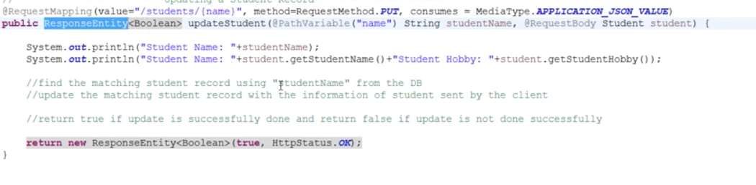

Customize Header response in rest service

GET Request



See below code snippet , we can add

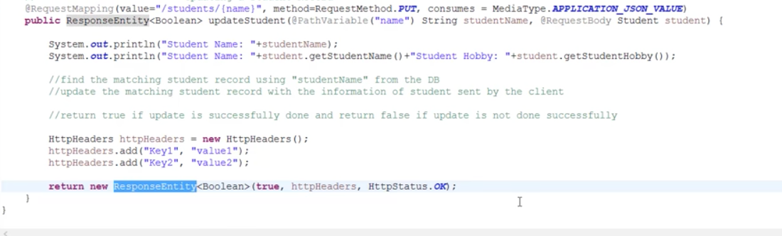

POST request creation

When u want for user to **create** a new resource

Using POST request , it will add a new record and send 200OK if successful

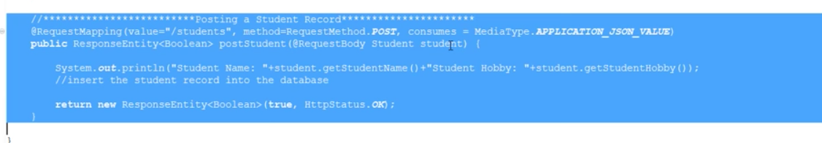

here above code snippet : when any client access this method this @RequestBody annotation will map the incoming request to the class variable and save the value.

For POST , dev mostly use 201 creation status

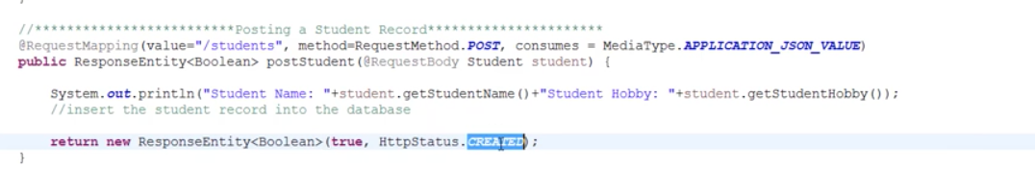

Now if I want to show the value where user can GET the request like below

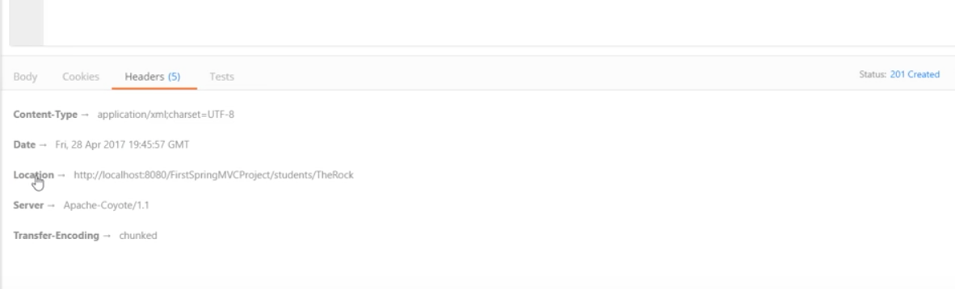

We need to add more code for location

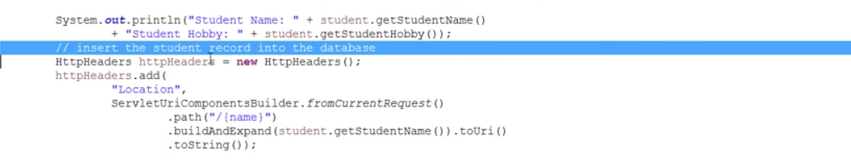

Delete RestAPI