Report

**Problem Statement: Ai controlled home appliances control system using IoT**

Use android app interface and voice Ai system to control appliances at home, using raspberry pi as a server / getaway and ESP as a node for the devices. Ensure that the devices status is updated on the UI.

**Abstract -** In this era of digitization and automation, the life of human beings is getting simpler as almost everything is automatic, replacing the old manual systems. Nowadays humans have made the internet an integral part of their everyday life without which they are helpless. Internet of things (IoT) is an emerging technology and also a need for today. It provides a platform that allows devices to connect, sensed and controlled remotely across a network infrastructure. The main objectives of home automation are controlling, management and coordination of home appliances in a comfortable, effective and secure way. On the other hand, Artificial Intelligence is evolving as a technology for developing automatic systems that can perceive the environment, learn from the environment, and can make a decision using case-based reasoning. Using Vision capability, knowledge based, learning ability, decision making and reasoning the AI provides a better solution for almost all automatic systems.

It’s a good choice to design a terminal based on the phone. We can extend the. Android platform into household objects. It means that the remote control based on the Android phone will become a mainstream way. After logging into the control interface, users can easily control the lights, TVs, and air conditioners anytime, anywhere, which brings great convenience to people and improves the quality of life. In this project, we will construct an android app interface and voice AI system to control appliances at home. Raspberry Pi is used as server/ gateway and ESP as a node for the devices. Status of the appliances is also updated on the UI.

The main objective of this project is to develop a home automation system using a Node MCU board with Internet being remotely controlled by any Android OS smart phone.

In this product, a relay module is interfaced to the Node MCU board at the receiver end while on the transmitter end, a GUI application on the cell phone sends ON/OFF commands to the receiver where loads are connected. By touching the specified location on the GUI, the loads can be turned ON/OFF remotely through this technology. The loads are operated by IOT board through Relay Module.

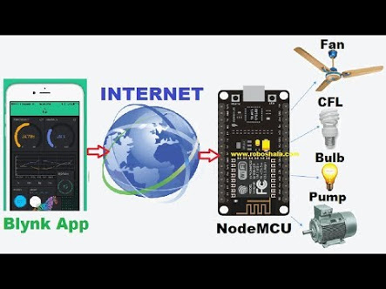

There are several platforms for developing smart phone applications such as Windows Mobile, Symbian, iOS and Android. In the proposed system, the Android platform app is developed as most of the phones and handy devices support Android OS.

App Inventor for Android is an open-source web application originally provided by Google, and now maintained by the Massachusetts Institute of Technology (MIT). It allows newcomers to computer programming to create software applications for the Android operating system (OS).

App Inventor consists of the Designer and the Blocks Editor. These are described in detail below. App Inventor Designer. Design the App's User Interface by arranging both on- and off-screen components. App Inventor Blocks Editor. Program the app's behaviour by putting blocks together.

Blynk is a Platform with iOS and Android apps to control Arduino, Raspberry Pi and the likes over the Internet.

Blynk is an Internet of Things platform with a drag-n-drop mobile application builder that allows to visualize sensor data and control electronics remotely in minutes. Blynk IoT cloud solution is open-source. Blynk hardware libraries support Arduino, Genuino, Raspberry Pi, Particle Photon, Electron, SparkFun.

The designed app for the smart home system provides the following functionalities to the user:

* Device control and monitoring.
* Supports voice activation for switching functions.

Circuit diagram:

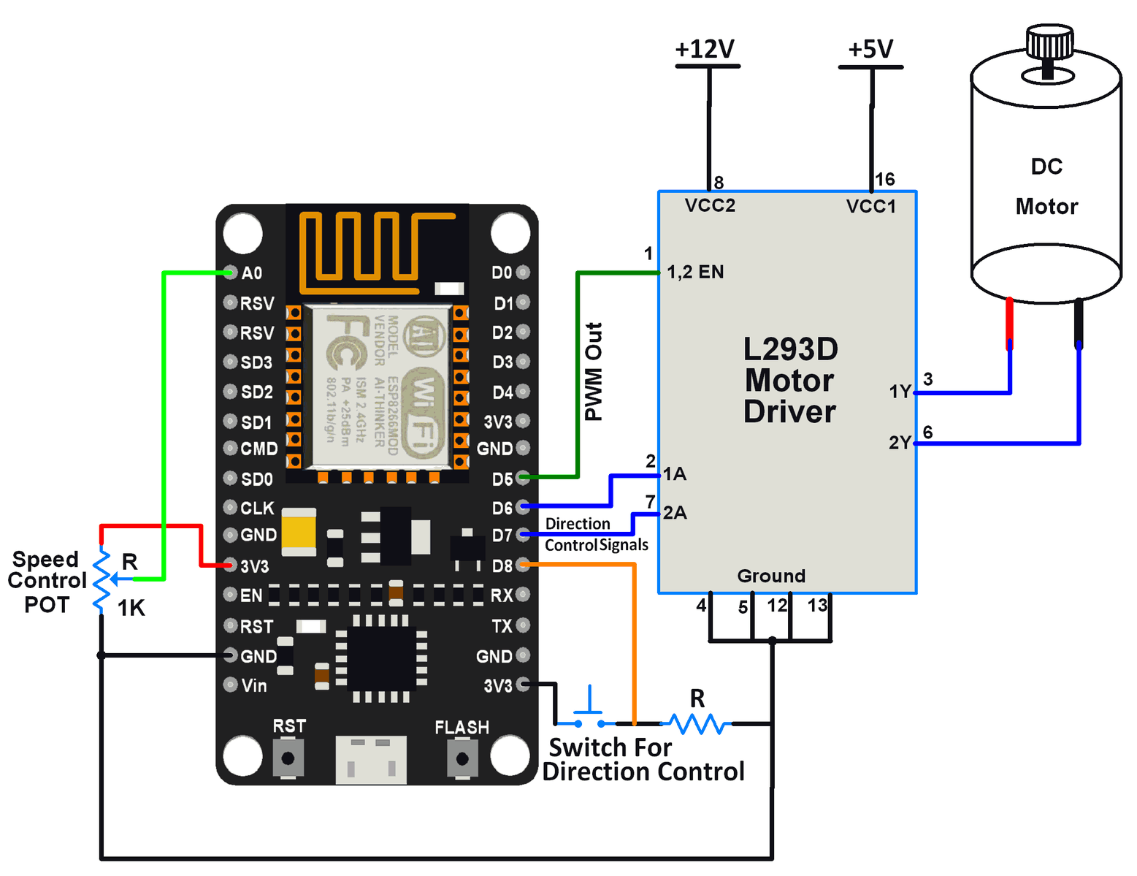

Proposed methods:

In today’s world everyone has shortage of time and in this era of technology there should be a mobile app that could be used to control the home appliances with the help of speech recognition.

This project will use the home appliances and will be powered with the Cloud and the WiFi making interconnectivity between the devices and creating an internet of things.

In this project the Node MCU esp8266 and Ubidots platform have been used to implement the smart home micro web-server.

Arduino is an open-source electronics prototyping platform based on flexible, easy-to-use hardware and software.

NodeMCU is an open source [IoT](https://en.wikipedia.org/wiki/Internet_of_Things" \o "Internet of Things) platform. It includes firmware which runs on the [ESP8266](https://en.wikipedia.org/wiki/ESP8266) [Wi-Fi](https://en.wikipedia.org/wiki/Wi-Fi) [SoC](https://en.wikipedia.org/wiki/System_on_a_chip" \o "System on a chip) from [Espressif Systems](https://en.wikipedia.org/w/index.php?title=Espressif_Systems&action=edit&redlink=1" \o "Espressif Systems (page does not exist)), and hardware which is based on the ESP-12 module. The term "NodeMCU" by default refers to the firmware rather than the dev kits. The firmware uses the [Lua](https://en.wikipedia.org/wiki/Lua_(programming_language)" \o "Lua (programming language)) scripting language. It is based on the eLua project, and built on the Espressif Non-OS SDK for ESP8266. It uses many open source projects, such as lua-cjson, and spiffs.

In this proposed project a mobile app is created and it includes all the features of controlling the home appliances with the help of speech recognition and interconnectivity of devices.

The mobile app that is created, contains all the commands like switching on/off the AC, Fan, Television, etc.

Thus this concept basically contains the smart appliances in a home that can be controlled by WiFi and Cloud and connected wirelessly with the mobile phones.

The mobile app in the mobile phone will be containing the options to give different commands to the appliances and controlling it with our mobile app. There will be switches provided in the app to control the devices and the appliances of the home and these switches can be customized manually or using voice by the user.

**CONCLUSIONS:**

This paper helps in making the lifestyle of people smarter, easier and efficient in less cost and less difficulty by changing over to the world of IoT.

In this paper, an internet based smart home system that can be controlled remotely using a mobile application is proposed and implemented. The Android based smart home app communicates with the cloud via internet.

This paper can be further developed by integrating it with the camera to monitor your home while accessing from anywhere.