Steps to host an app in the IBM Bluemix cloud.

1. Start your virtual machine.
2. Cloud Foundry is a packaging tool for cloud based web application. So, install cloud foundry first.
3. Install debian files - installs .deb file that I downloaded and places in /tmp of virtual machine

***dpkg -i /tmp/cf-cli-installer_6.15.0_x86-64.deb***

1. Install git for version control

***apt-get install git***

1. Clone a sample web application (Python + Flask) from github

***git clone*** [***https://github.com/IBM-Bluemix/bluemix-python-flask-sample***](https://github.com/IBM-Bluemix/bluemix-python-flask-sample)

1. It clones the web app folder into the current directory.
2. Sample directory structure is :

***LICENSE manifest.yml NOTICE Procfile README.md requirements.txt runtime.txt static welcome.py***

1. ProcFile, requirements.txt and runtime.txt are important for Flask.
2. ProcFile

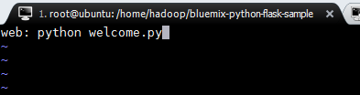

The above command notifies that the application is of a **web** app and runs the welcome.py first.

1. Requirements.txt contains tools required. Ex: current Flask version.
2. Runtime.txt contains technology stack. Ex: current version of Python
3. Connect to IBM Bluemix using

***cf api*** [***https://api.ng.bluemix.net***](https://api.ng.bluemix.net)

1. Login into your domain in the IBM cloud using:

**cf login -u deepak.thipeswamy@mavs.uta.edu -o deepak.thipeswamy@mavs.utavedu -s dev**

1. Push the contents of the current directory to the cloud (The site will be up, check url).

**cf push deepakcloud1**

1. Install SwiftClient, KeyStone and urllib3 clients (mention in requirements.txt for Flask)

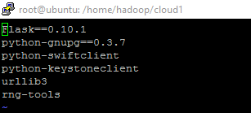

1. Command to check logs

**cf logs <app_name> --recent**

**Note:** Swift is a storage as service which will be bound to your application on cloud. If you unbind the service, it is not accessed publicly. So, trying to connect to swift containers locally using credentials will not work.

***To Run your application in local ():***

1. Install pip

***apt-get install python-pip***

1. Install Flask

***pip install flask***

1. To Run the application locally

***python welcome.py***

1. Install dependencies for installing keystone

***sudo apt-get install python-dev libxml2-dev libxslt-dev***

1. Keystone client is used for authentication of credentials on the cloud (KeyStone is authentication as a service)
2. Swift client is used for interacting with Swift (storage as a service) on the cloud.

Install SwiftClient and KeyStone Clients (mention in requirements.txt for Flask)

***pip install python-swiftclient***

***pip install python-keystoneclient***