**Features**

1. Login

2. Logout

3. Add Item

4. View All Item

5. Search an Item by item name

6. New Bill Creation

7. Show Invoice

8. View All Bills

9. Search a bill on the basis of bill no

10. Search Sale - Today sale, Last Week Sale, Last Month Sale, Item Wise Sale, between two date sales

**Technology Used for development –**

1. User Interface – HTML, CSS, JavaScript

2. Middleware/Languages – Java, Jsp, J2EE, Struts2, Hibernate (for database manipulation), Spring Framework

3. Database – MySql Server

4. Development Tool – NetBeans IDE, Apache Tomcat Server

**Screenshots -**

1. Login Screen

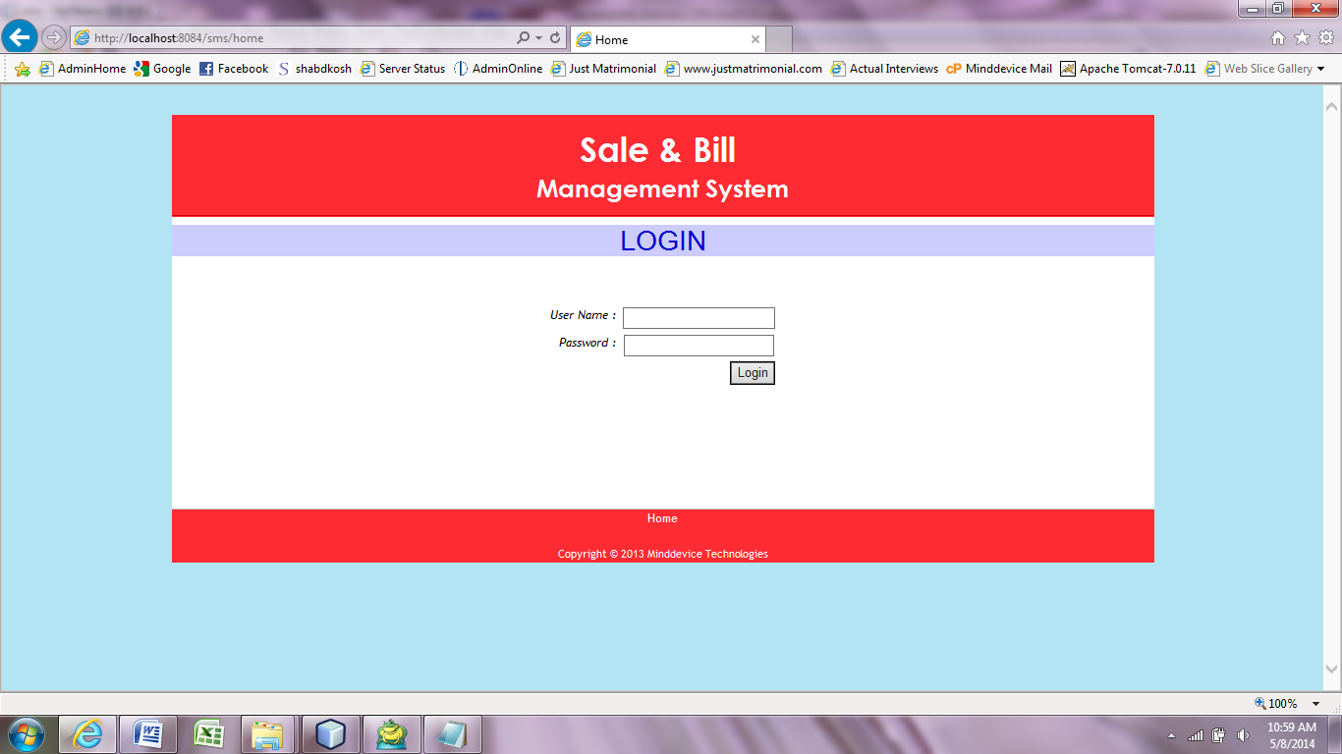

2. Home Page

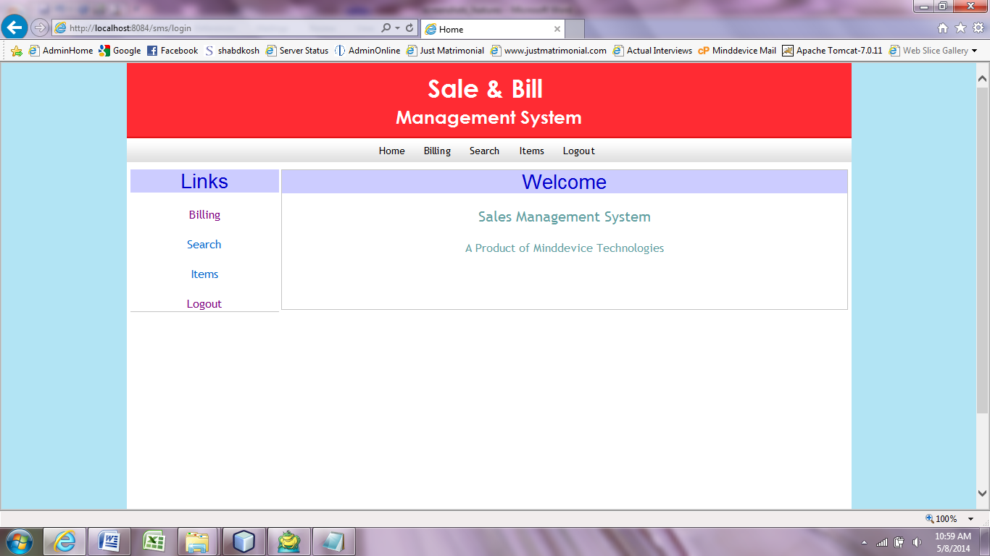

3. Add Item

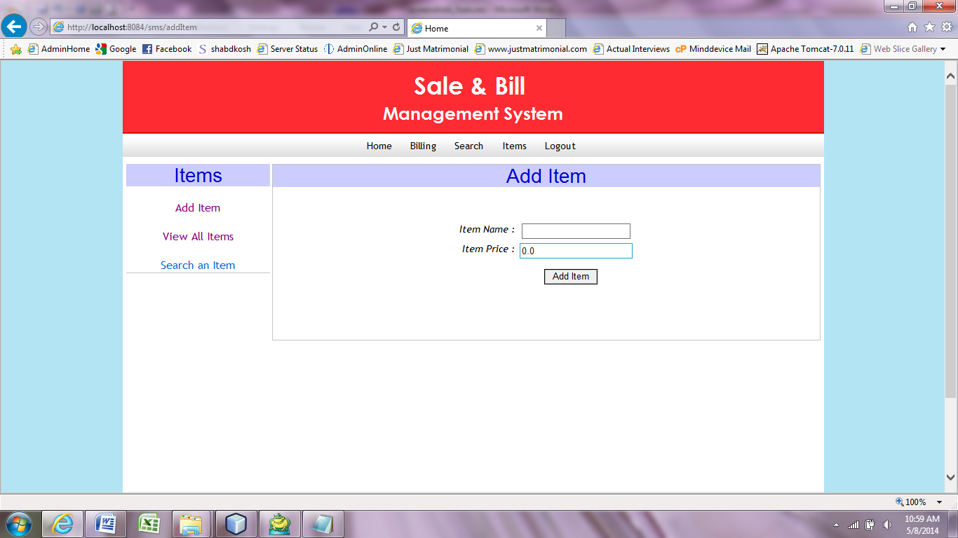

4. View All Items

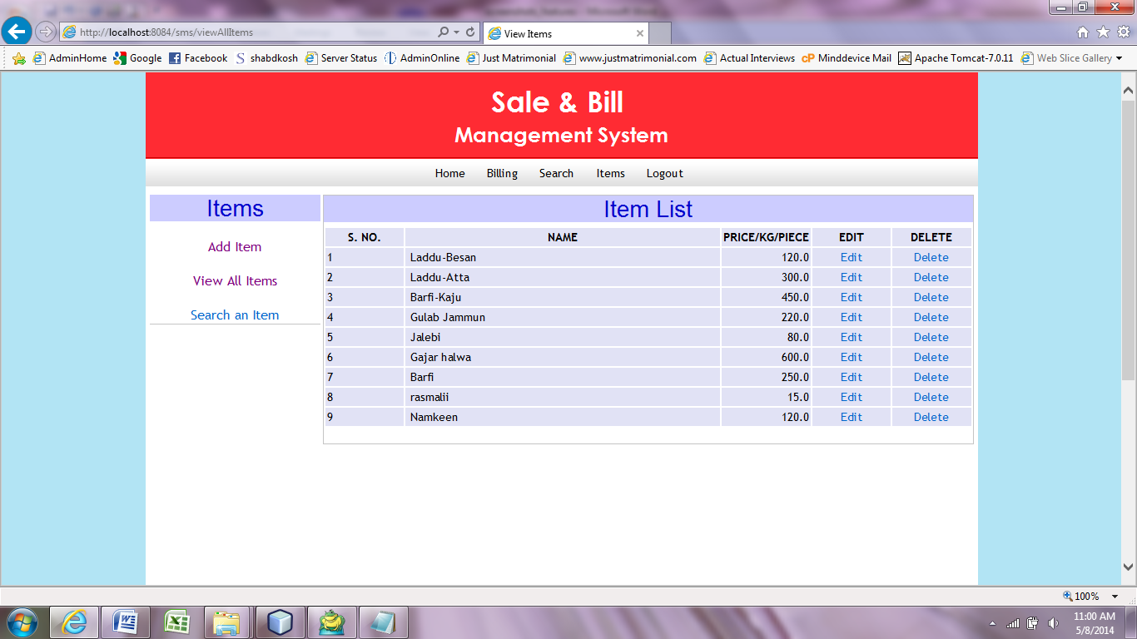

5. Search Item

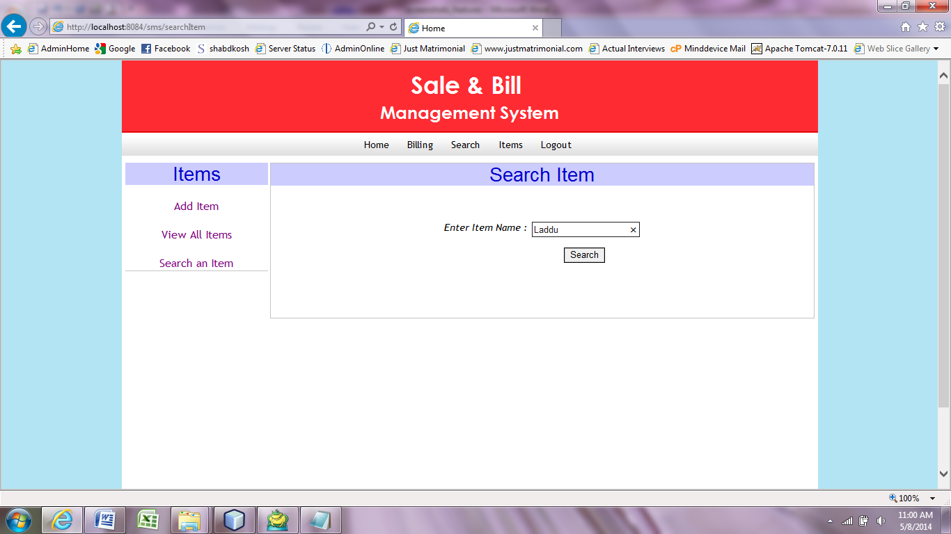

6. Search Item Result

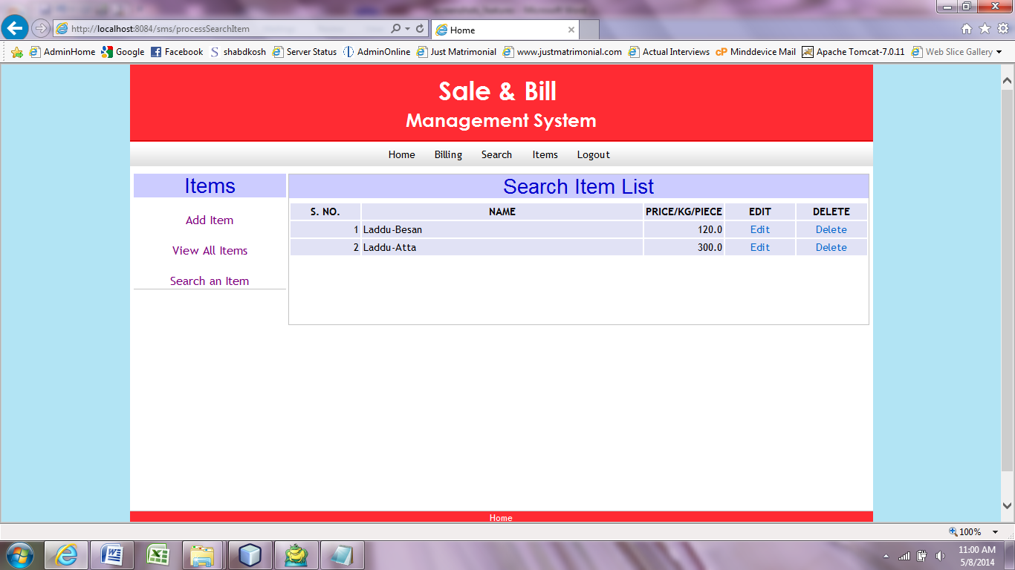

7. Create New Bill

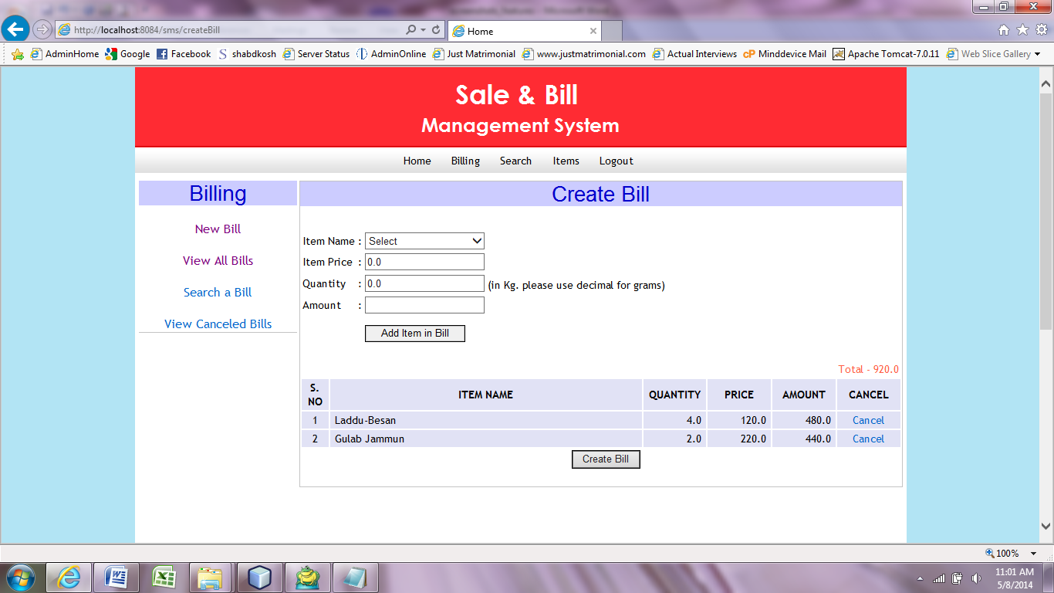

8. Show Invoice

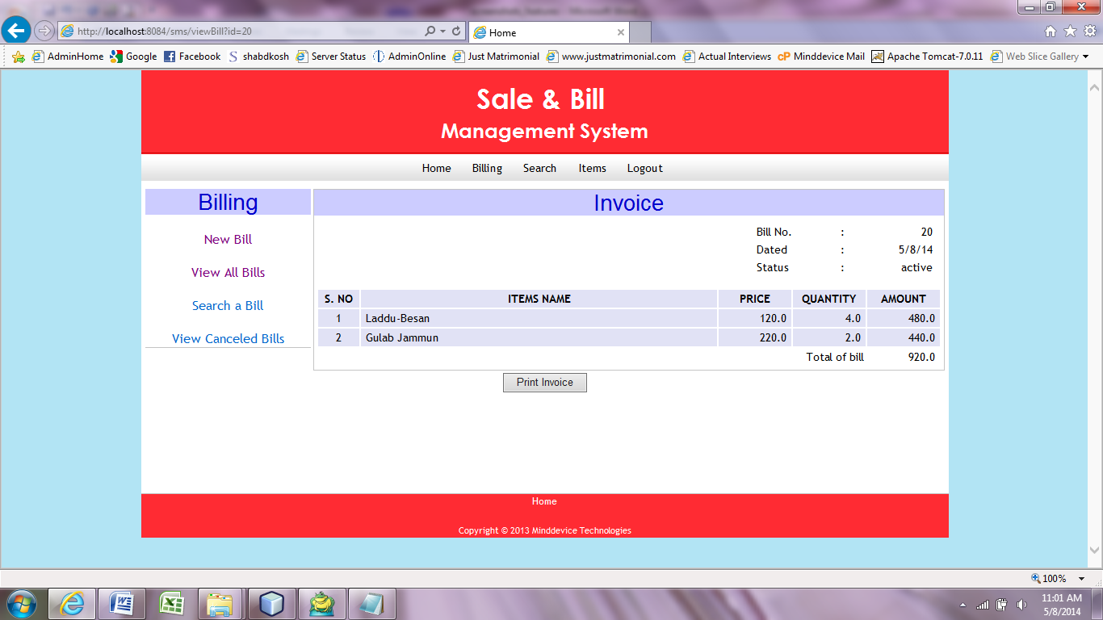

9 View All Bills

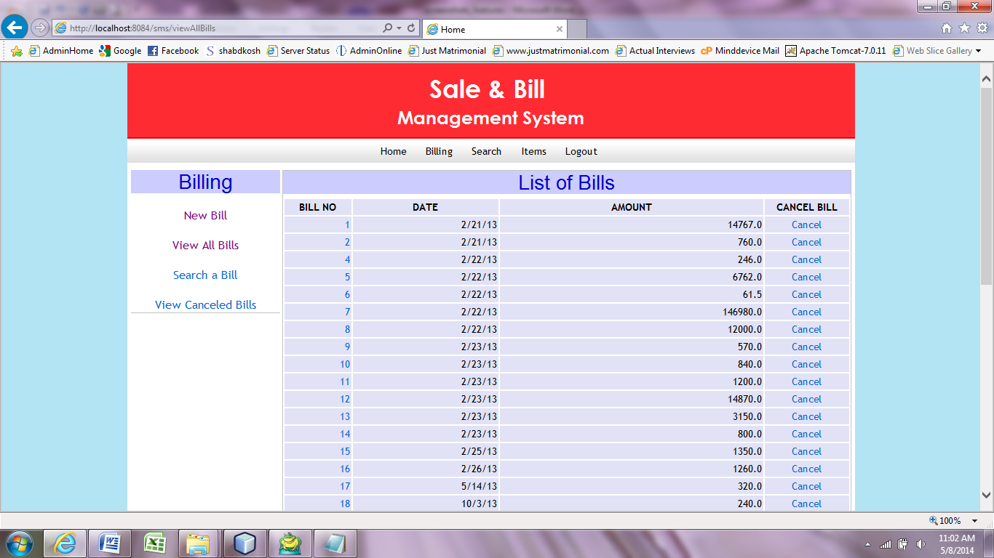

10. Search Bill

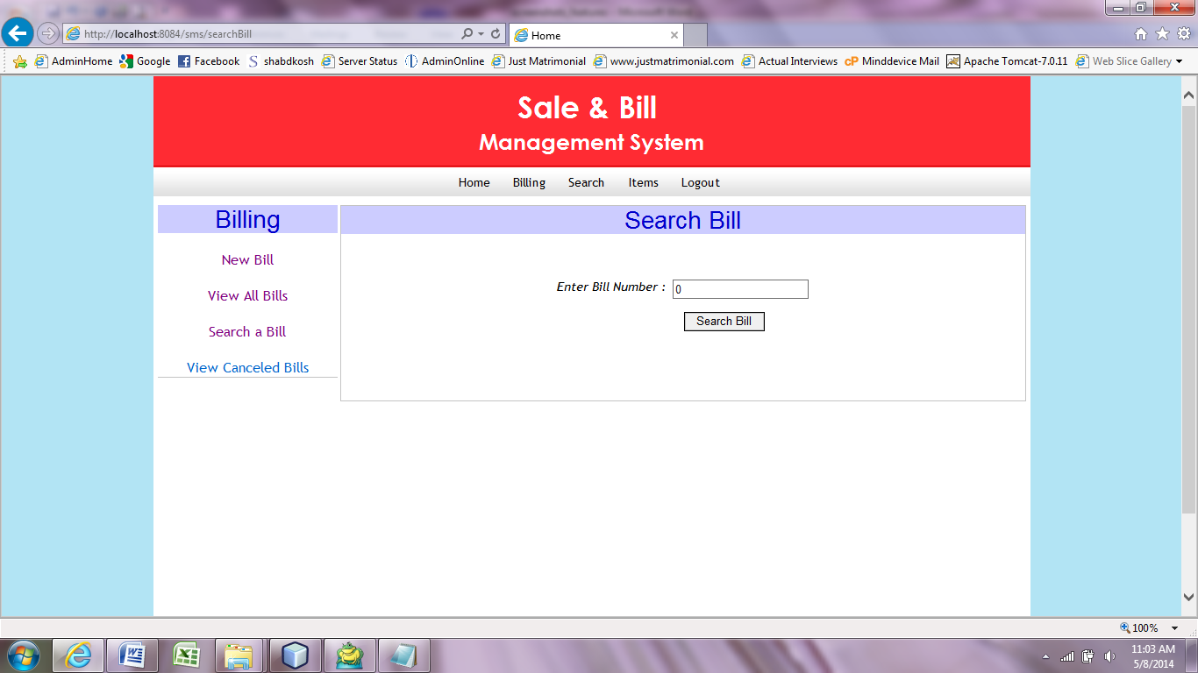

11. Search Sale

