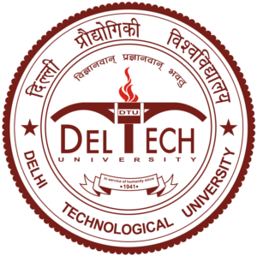

**DELHI TECHNOLOGICAL UNIVERSITY**

Project Name: Electric Vehicle (Website Development)

Branch: Electrical Engineering

Under the guidance of: Ashish R Kulkarni

|  |  |
| --- | --- |
| Group Members |  |
| 1. Suhrit |  |
| 1. Ashish Kumar |  |
| 1. Aarti Sharma |  |
| 1. Deepa |  |
| 1. Shubham |  |