**Module 2: Gateway to Filter Server**

Lifecycle of the module

**Initiation, Monitoring and Stopping of module**

* **Initiation of Sub-Component**: An application platform is made available to the developer by the system. This setup is done by the system admin itself at the time when system is up and starts all the modules and makes them serviceable. So the filter server will always active and wait for any data request.
* **Monitoring:** Monitoring of all the sub-module is made automated and managed by system automatically. Separate modules are written for managing the devices and ensuring error free data transmission. In case of any physical fault system admin is responsible for recovery of physical devices.
* **Stopped:** Although the system is made available all the time throughout but in case if system has to be stopped it is done by system-admin. Before the system would stop it will serve all the active connection and make safe connection termination. So that data transfer will not results in error and user’s service will not interrupted.

**List of Sub-Modules:**

1. **Connectivity Manager**: This component will provide the connectivity between various components.
2. **Database connector**: This component will provide the connectivity to the database.
3. **Send Data**: This module will forward the data to the filter server from the gateway.
4. **Database Retrieval**: This module will retrieve the data regarding the sensor from the database when it is received from sensor. It will retrieve the data from the database according to the sensor id it receives.
5. **Data Archiving Module**: This module will collect the data coming in to the master gateway and it will store it to the backend.

**Brief overview of each sub-module/ component**

1. **Connectivity Manager:** This component will provide the connectivity between
   1. Gateways and Master gateway.
   2. Master gateway and Filter Server
2. **Database Connector:** This component will provide the connectivity between the Master gateway and the database server.
3. **Send Data:** This module will forward the data to the filter server from the master gateway. It will also forward the data from the gateways to the master gateway.
4. **Database Retrieval:** This module will retrieve the data regarding the sensor from the database when it is received from sensor. It will retrieve the data from the database according to the sensor id it receives.
5. **Data Archiving Module:** This module will collect the data coming in to the master gateway and it will store it to the backend.

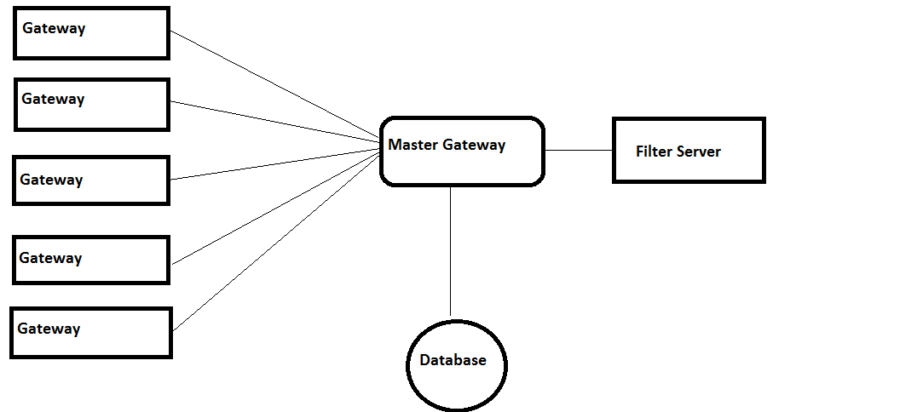

Fig. Block Diagram

**Functionality of sub-module**

Functionality of system, when it is in phase two, i.e., from Master gateway to filter server, is as follows:

1. Master gateway module will be running continuously. It will be continuously receiving data from the gateways.
2. Master gateway forwards the data to the filter server.
3. Master gateway will also archive the data coming in from the gateways to the backend.
4. Master gateway will retrieve some information regarding the sensors and append it to the data it is sending to the filter server.

**Classes**

* **Connectivity Class:** Class maintaining the connection between the gateways to the filter server.
* **Database Connectivity Class:** Class maintaining the connection between the master gateway and the gateways.
* **Send Class:** Class will forward the data to the filter server from the master gateway.
* **Gateway class:** Class will maintain the data regarding the entire active gateway.
* **Database Retrieval class:** Class will forward the sensor related data to the filter server.
* **Data archiving class:** Class will collect the data coming in to the master gateway and it will store it to the backend.

**Interactions between sub modules**

This part will contain interactions between sub-modules and interactions between APIs and classes.

**Interactions between sub modules**

**Connectivity Manager:** Connectivity manager interacts with the different modules of the system and verifies whether the connectivity between all the modules is being maintained or not.

**Send data:** It will send the data incoming from the sensors to the gateways and forward to the filter server via the master gateway. This module will interact with the connectivity manager to see if a connection exists to send the data.

**Data Base Archival:** This will interact with database connector to verify that the connection is there to database. It will then store the data being received to the backend.

**Data Base Retrieval:** This module will retrieve the data from the database. It interacts with the database connector to check the connection with the database.