

**Basic Linux Commands Assignments**

Assignment-1

Connect and disconnect with login Access

* What happens when you login a non-existent users or username?
  + Provide Screenshot and What you understand, explain in short brief?

**Solution**: On trying to login to a non-existent user, VM throws an error “Sorry, that didn’t work. Please try again.”

Attached screenshot for reference

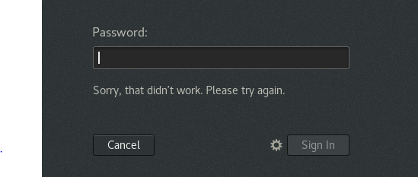

Assignment-2

Password changing

* Login into your account and then change password?
  + Change your password into **IneuR0n#42** and hit the **Enter** key
    - Explain what happen and give screenshot?

**Solution**: We can use command **passwd** to change password of respective user. Ensure we logged in terminal with account for which we want to change password. Attached screenshot below for reference.

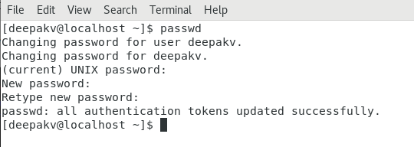

* + Try again to change password but use like password ***1234*** or ***abcd***
    - Explain what happen and give screenshot?

**Solution**: When changing password to 1234 or abcd it throws error “ The password is shorter that 8 characters”. Attached screenshot below for reference. 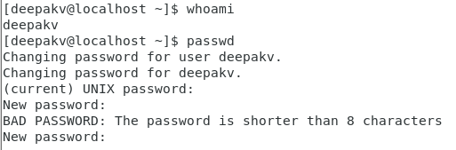

* + Try again to change password but now don’t use any password just hit **Enter** key
    - Explain what happen and give screenshot?

**Solution:** Gives error “No Password Supplied”. Attached screenshot below for reference.



Assignment-3

Working with Directories

* Enter the command **cd /** and then **ls** and then hit **Enter** key
  + Take screenshot and explain what output we got?

**Solution**: In “/” is the **root directory** so what file present in root directory is displayed after running this command. Root directory is uppermost directory in Linux containing all files, device data and system information in the form of directories. Attached snap below for reference.

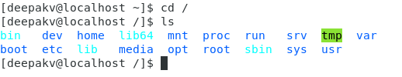

* Enter the command now **cd /home** and then hit **Enter** key
  + Do **ls,** provide screenshot and explain what is **/home** directory used for?

**Solution**: Home directory is a directory for a particular user of the system and consist of all individual files. To navigate to home directory, use “cd” or “cd~”

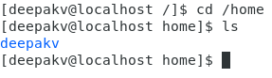

* Enter **cd ..** and hit **Enter** key [ *Note: here we have space after cd then use double dot*]
  + Check what happen and give screenshot?

**Solution**: cd .. command helps us going back one directory. Here it takes us back from home directory to root directory

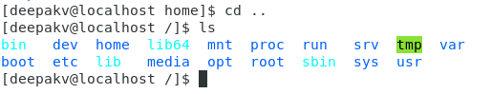

* Now enter **cd /var/www/html** and then type **cd** and hit **Enter** key
  + Explain what happen and give screenshot?

**Solution**: As there is no such directory www inside var, hence we get message “No such file or directory”. Attached snap below for reference.



* Now type **cd /root** and then hit **Enter** key
  + Do **ls,** check any output we have on screen if yes then take screenshot?

**Solution**:

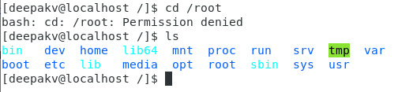

Assignment-4

Working with File Listing

* Go to **cd /etc** and type **ls**
  + Take screenshot and explain what files you have seeing?

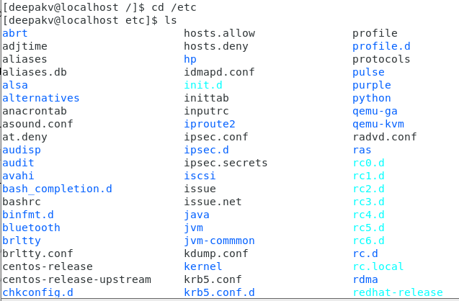

* + Take screenshot and explain what different output you found compare to previous command you used?

**Solution**: Previous command listed all directories that are present in root directory, however now in etc directory, we are looking at all Linux system’s configuration files that are present in etc directory.

* Then type **ls -al** and hit **Enter** key
  + Take screenshot and explain what new file or directory you found?

**Solution:** Using command ls -al, it lists all files in columns however it shows permission of those files and date when these files has been modified or created.

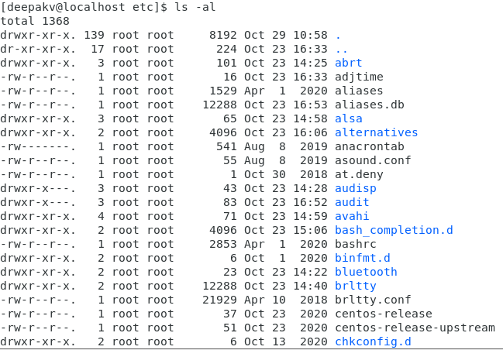

* Then use **ls -i** and hit **Enter** key
  + Now see what different output its shows and take screenshot?

**Solution**: Prints index number of file

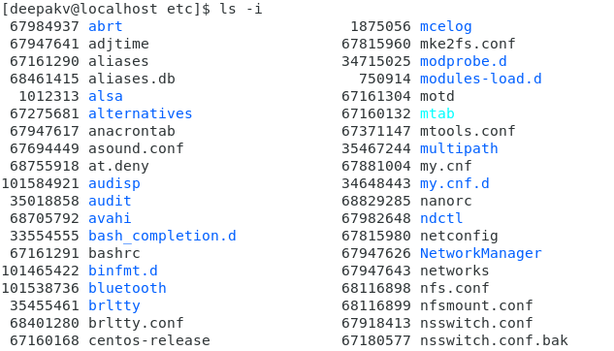

* Then use **ls –help** and see other options about **ls** command
  + Explore it and try with other attribute we can use with **ls** command

**Solution**: ls –help. It give list of all attribute that can be used with ls command

Assignment-5

Know where you are and where you working

*Here we use* ***pwd, cd and ls*** *as combine task to understand where you working on terminal and how you can switch from one directory to another one.*

* Open terminal after restart the linux
  + 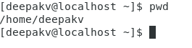Check which location you working, type **pwd** and take screenshot
* Now use **cd /var** and hit **Enter** key
  + Do **ls,** and see what output comes, give screenshot?

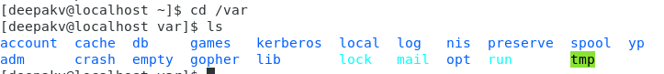

* Do explore other help options of each command to learn more other things we can do with these commands