**Veridic Solutions, NC, USA**

**Mentors: Nihar and Sandeep**

**Name: Deepak vaddi**

**Linux 1 QUIZ Answers**

1. Suppose that the Current Working Directory is /lib/modules, give a single "CAT" command using a relative pathname and a command using an absolute pathname, that would print out the contents of the regular file /lib/security/pam-access.

**Answer:**

Absolute Path is location from the root directory. (Always starts with “/”).



Relative Path is location from the current directory. (Specify the current directory).



2. What is the standard command to determine the pathname/location of the mv command/program?

Answer:

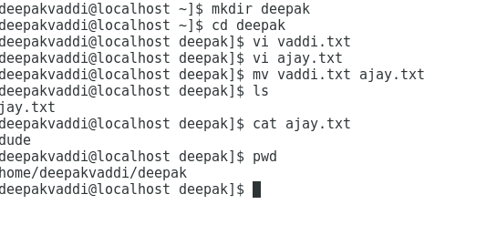

1. What is the purpose of the /sbin subdirectory? (I.e., what is normally stored there?)

Answer: sbin – Standard subdirectory of the root directory in LINUX.

This sbin contains the executable programs which is ready to run mostly they are administrative tools, they are available only in the root.

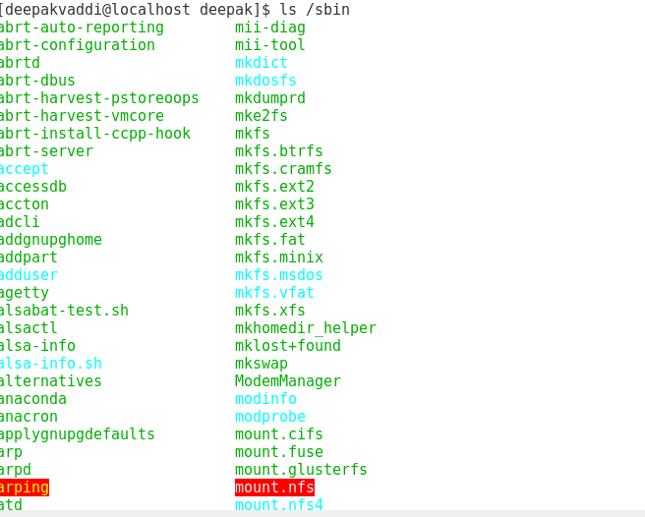

1. Explain the difference between “the root directory” and “root’s directory”.

Answer:

1. . Explain what the term “search path” means in the context of a shell (like Bash).

Answer:

A search path is the sequence of directories where the shell looks for commands to execute. Directories usually contain normal files, but can also contain executable files, called either programs or commands.



1. What are two commands that could be used to display your current search path?

Answer:

1. echo $PATH
2. env
3. Suppose your current env PATH variable is set to /usr/bin:/bin:/usr/local/bin. Explain what the shell does when you type the command “foo” at a prompt (and type return).

Answer:

1. Logged in as a non-root user, is /sbin in your search path? Explain why it is or is not there.

Answer:

/sbin are there in the search path because it is an administrative tool, executable process which is ready to run. It comes under the root.

1. Suppose you have created a shell script named foo and have made it executable, but

when you type it as a command (“foo”), Bash says: “command not found”. What is wrong and what must you do to run the command?

Answer:

1. Explain why the Linux does not have drive letters like Windows does.

Answer:

In Linux everything is under the root directory (/), no files above the root directory. When we connect a device, it shows under media directory. The contents of the directory display the contents of the mounted partition.

1. What is the contents of a file ~/song.mp3?

Answer:

1. What command would show all lines containing the string “brace expansion” (ignoring case) in the man pages for Bash?

Answer:

1. What command would delete some files from the directory /tmp, where the relevant

filenames have this pattern: they begin with “A” or “B”, contain the string “406”, and have a (final) extension of “.txt” or “.text”.

Answer:

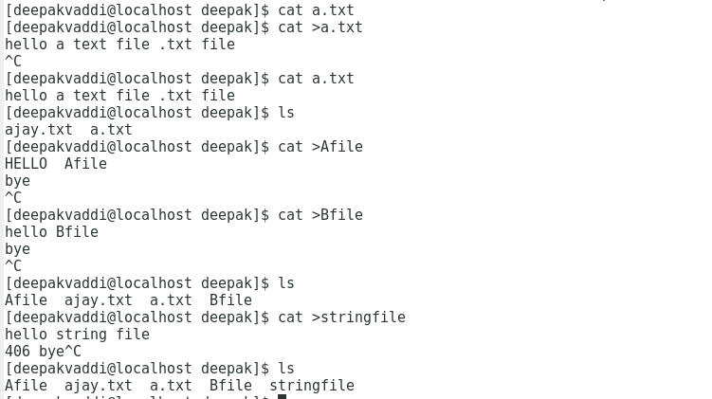

1. What are the commands that will reset the current working directory to your home directory, regardless of what directory you are currently in?

Answer:

1. $ cd
2. $cd ~

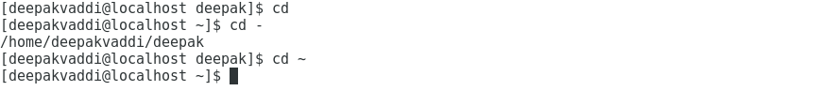

1. What are hidden files in Linux/UNIX, why are they called that, and what are they

commonly used for?

Answer: