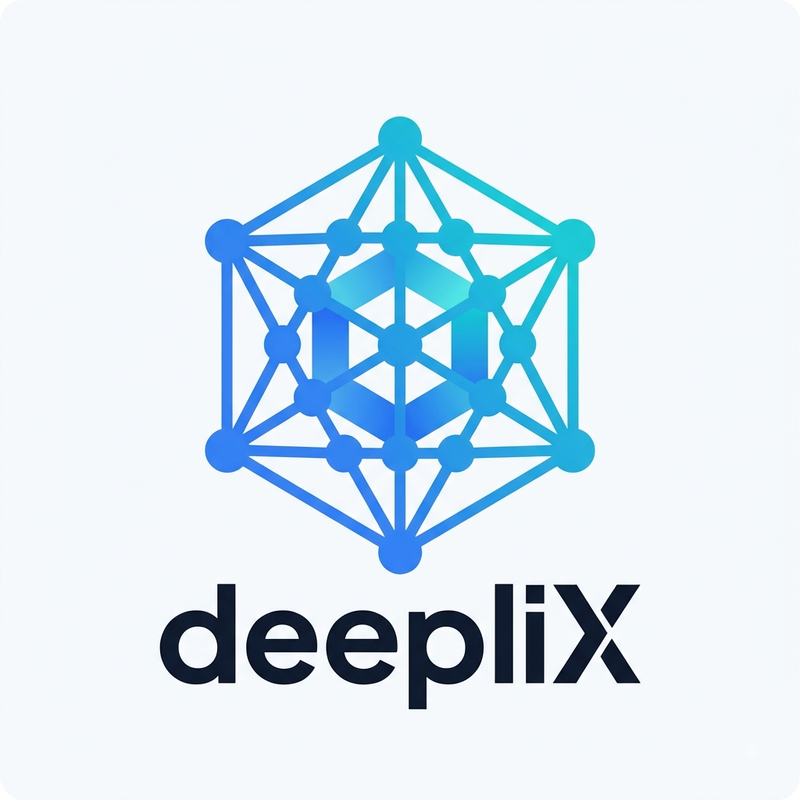
DEEPLIX
MASTER COMPANY INFORMATION
Internal Source of Truth — Not for External Distribution
CONFIDENTIAL — INTERNAL USE ONLY

Document Control
Document | Master Company Information
Document Code | INT-DLX-001
Version | 1.0
Effective Date | 15 August 2026
Owner | deepliX — Founder
Status | Draft — Pending Confirmation

1. Company Identity
Core legal, contact, and registration details for deepliX. Fields marked [TO BE CONFIRMED] must be finalized before this information is used in any legal, financial, or client-facing document.
Official Company Name | deepliX [TO BE CONFIRMED — exact registered form]
Legal Entity Name | [TO BE CONFIRMED]
Brand Name | deepliX
Registration Number | [TO BE CONFIRMED]
NTN / Tax Information | [TO BE CONFIRMED]
Registered Address | Karachi, Sindh, Pakistan [TO BE CONFIRMED — full registered address]
Business Address | Karachi, Sindh, Pakistan
Official Email | rajvalmani@gmail.com [TO BE CONFIRMED — recommend a company domain email, e.g. founder@deeplix.com]
Website | [TO BE CONFIRMED]
Phone | +92 348 7932997
Founder | Deepak Raj Valmani
Founder Title | Founder [TO BE CONFIRMED — e.g. Founder & CEO]
Date Established | [TO BE CONFIRMED]

2. Company Description
One-Sentence Version
deepliX helps businesses connect their systems, organize their data, and automate operations through practical data, automation, and AI solutions.
50-Word Version
deepliX is an early-stage B2B technology company that helps businesses connect disconnected systems, build reliable data infrastructure, automate repetitive operations, and apply AI where it creates real value. deepliX works as a long-term technology partner — from initial assessment through implementation, deployment, and ongoing managed support.
100–150 Word Version
deepliX is an early-stage B2B technology company focused on the digital infrastructure behind modern business operations: data, integration, automation, business intelligence, and AI. Many businesses run on a patchwork of CRMs, spreadsheets, accounting tools, and internal applications that do not communicate with one another, resulting in fragmented data, manual work, and slow decision-making. deepliX addresses this by connecting systems, engineering reliable data pipelines, automating repetitive workflows, building business intelligence and reporting, and implementing AI where there is a genuine business case — never AI for its own sake. Rather than completing a single project and disappearing, deepliX is built to become a long-term technology partner, offering managed services after implementation so that systems keep working, keep improving, and keep generating value.
Long Version
deepliX exists to solve a problem almost every growing business shares: technology sprawl without technology infrastructure. A company may run a CRM, an accounting system, an ERP, several spreadsheets, an e-commerce platform, and a handful of SaaS tools — each useful individually, but none connected to the others. The result is fragmented data, duplicated manual work, unreliable reporting, and a business that finds it difficult to see what is actually happening inside its own operations, let alone use AI effectively on top of it.
deepliX was founded to close that gap. The company works across five core capability areas — data engineering, systems integration, business automation, business intelligence, and applied AI — and structures every engagement around a simple principle: technology should be the means, and business improvement should be the outcome. deepliX does not lead with programming languages or platforms; it leads with the operational problem being solved.
deepliX is deliberately not positioned as a generic freelance developer, a website agency, or an "AI hype" company. It is being built, from the outset, as a serious but early-stage B2B technology company with a repeatable delivery process and an intended long-term relationship with each client: discovery, implementation, deployment, and — critically — ongoing managed services once the initial system is live. The long-term ambition is for deepliX to become the trusted technology and digital infrastructure partner behind its clients' operations, not a one-time vendor.

3. Mission & Vision
Mission — Why deepliX Exists
To help businesses replace fragmented systems and manual work with reliable data, automation, and intelligence — so that decisions get faster, operations get cleaner, and technology stops being a source of friction.
Vision — What deepliX Should Become
To be recognized as a trusted, long-term technology and digital infrastructure partner for the businesses it works with — the team a client calls not for a single project, but for how their data and systems work as a whole, on an ongoing basis.

4. Core Services
A. Data Engineering
ETL/ELT pipelines, data ingestion and transformation, database design, data integration, warehouses and lakes, data quality processes, and API-based data pipelines. Objective: make business data reliable, accessible, structured, and usable.
B. System & Data Integration
Connecting CRM, ERP, e-commerce, and internal applications to a central data layer so information moves automatically instead of being copied by hand. Objective: reduce disconnected systems and manual data transfer.
C. Business Automation
Automated data collection and reporting, workflow triggers, API integrations, scheduled processes, notifications, and operational workflow automation. Objective: reduce unnecessary manual work, errors, and friction — not automation for its own sake.
D. Business Intelligence & Analytics
Dashboards, KPI and management reporting, business analytics, data models, and automated reports. Objective: help businesses understand what is happening in their operations and make better decisions.
E. AI Systems
Internal AI assistants, retrieval-augmented generation (RAG), knowledge assistants, AI-powered document processing, workflow automation, and intelligent search — implemented only where a genuine business case exists, on top of good data and sound processes. deepliX does not sell AI simply because AI is popular.
F. Managed Data & Automation Services
Ongoing monitoring, maintenance, data-quality checks, pipeline monitoring, dashboard maintenance, technical support, and system expansion after go-live. This is the foundation of deepliX's recurring-revenue model.

5. Target Customers
Industries
The initial niche has not been permanently decided. deepliX is evaluating industries on the strength of: real operational problems, data complexity, manual workflows, ability to pay, technology adoption, need for outside technical expertise, and potential for recurring work. Candidate industries include logistics, manufacturing, retail, e-commerce, professional services, real estate, healthcare, education, recruitment, construction, and other data-intensive SaaS-adjacent businesses. deepliX does not claim specialization in any one industry until this is formally decided.
Buyer Personas
- Founder / CEO
- COO — Head of Operations
- CTO / CIO
- Head of Data / IT Manager
- Digital Transformation Lead
Company Size
[TO BE CONFIRMED — target employee count / revenue band once the initial niche is validated].

6. Business Model
deepliX generates revenue across four connected stages, designed to move a client from a one-time engagement toward a long-term partnership:
Stage 1 — Discovery / Assessment
Understanding a client's current systems, data flows, and workflows. Deliverables may include a system assessment, data-flow mapping, automation-opportunity review, and an implementation roadmap. May be offered as a paid assessment depending on the situation.
Stage 2 — Implementation
Building the agreed solution — a data pipeline, integration, dashboard, automation, AI system, or internal application. This is project-based revenue.
Stage 3 — Managed Services
Ongoing monitoring, maintenance, support, and improvement after go-live. This is recurring revenue and the strategic core of the business model.
Stage 4 — Expansion
As trust and understanding of the client's business grow, additional systems are added over time — for example, moving from a data pipeline, to a dashboard, to automation, to an AI assistant, to fully managed infrastructure.

7. Brand Positioning
Positioning Statement
deepliX — Digital infrastructure for modern businesses.
Supporting message: "Connect your data. Automate your operations. Build smarter systems." Alternative positioning line: "deepliX helps businesses design, build, integrate, and operate the digital systems behind better business operations."
What deepliX Is
- An early-stage, serious B2B technology company
- Focused on data, integration, automation, business intelligence, and applied AI
- Built around a repeatable discovery → build → deploy → manage process
- Positioned for long-term client relationships, not one-off projects
What deepliX Is Not
- A generic freelance developer or cheap outsourcing shop
- A website-only agency
- An "AI agency" that adds AI to everything regardless of fit
- A company making unrealistic enterprise claims, fake clients, or fake case studies
- A large multinational — deepliX is early-stage, and its materials should say so honestly
Tone of Voice
Professional, technical but understandable, business-oriented, confident, honest, practical, and outcome-focused. deepliX avoids inflated buzzwords ("revolutionary," "disruptive," "world-class," "next-generation") unless genuinely justified, and avoids sounding either like a freelancer or like a large corporation it is not yet.

8. Current Company Stage & Team
deepliX is currently an early-stage company being formally prepared for market entry. It does not claim an enterprise client base, large revenue, a large permanent engineering team, major partnerships, or certifications it does not hold. Any illustrative example used in company materials must be clearly labeled "Illustrative example" and never presented as real client work.
Team Strategy
The founder currently leads business direction, sales, strategy, and technical/business coordination. The intended sequence is: (1) establish the business, (2) acquire real clients, (3) understand actual delivery requirements, (4) use contractors or specialists where necessary, and (5) hire permanent employees as recurring workload and revenue justify it.
Potential Future Roles
- Data Engineer
- Automation Engineer
- Backend Engineer
- AI/ML Engineer
- Frontend Engineer
- DevOps / Cloud Engineer
- Project Manager
- Business Development
- Customer Success

9. Engagement Models
Preferred client journey: Discover → Design → Build → Deploy → Manage → Improve. Supported commercial structures:
Fixed Project | For clearly defined, scoped implementations with a fixed price.
Milestone-Based Project | For larger implementations billed against agreed milestones.
Retainer / Managed Service | For ongoing monitoring, maintenance, and support after go-live.
Advisory / Consulting | For technology and data strategy engagements.

10. Rules for All deepliX Documentation
- Never fabricate information — use [TO BE CONFIRMED] for anything unknown.
- Clearly label hypothetical scenarios as "Illustrative example."
- Keep company description, capabilities, and terminology consistent across every document.
- Never overstate capabilities beyond what the current team, contractors, or delivery network can realistically deliver.
- Every service description should answer: what business problem does this solve?
- Establish a professional company structure — do not read as a freelancer.
- Do not read as artificially large — professional does not mean pretending to be enterprise-scale.
This document is the single source of truth for all other deepliX materials. Company Profile, Capability Statement, Company Presentation, and all sales, legal, and operational documents must be checked against this document for consistency before distribution.

