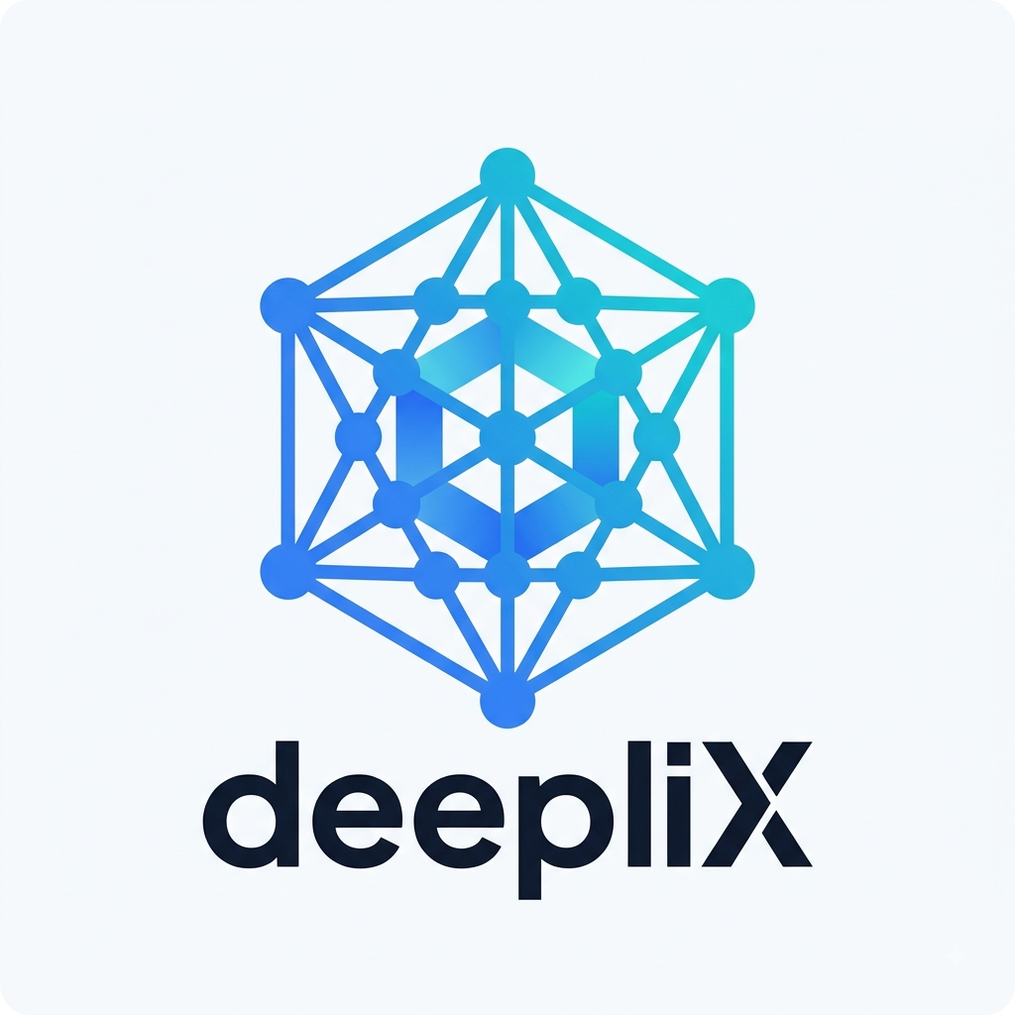
DEEPLIX
COMPANY PROFILE
Digital Infrastructure for Modern Businesses
2026

1. About deepliX
deepliX is an early-stage B2B technology company focused on the digital infrastructure behind modern business operations — data, systems integration, automation, business intelligence, and applied AI.
Many businesses run on a patchwork of CRMs, spreadsheets, accounting tools, and internal applications that were never designed to work together. deepliX exists to close that gap: connecting systems, engineering reliable data pipelines, automating repetitive workflows, and applying AI where it creates genuine business value — never as a buzzword.
deepliX is being built as a serious, early-stage technology company with a repeatable delivery process, not a freelance developer or a one-project vendor. Every engagement is designed with a long-term relationship in mind.

2. Our Vision
To be recognized as a trusted, long-term technology and digital infrastructure partner for the businesses we work with.
We want to be the team a client calls not for a single project, but for how their data and systems work as a whole — on an ongoing basis.

3. Our Mission
To help businesses replace fragmented systems and manual work with reliable data, automation, and intelligence — so decisions get faster, operations get cleaner, and technology stops being a source of friction.

4. The Business Problem
Most growing businesses accumulate technology faster than they build technology infrastructure. A typical company might run a CRM, an accounting platform, an ERP, several spreadsheets, an e-commerce store, and a handful of SaaS tools — each useful individually, but rarely connected to one another.
The result is a familiar set of symptoms:
- Fragmented data spread across disconnected systems
- Manual data entry and repetitive administrative work
- Spreadsheet dependency in place of real infrastructure
- Poor or slow reporting, and inconsistent numbers between teams
- Disconnected workflows that rely on someone remembering to copy information
- Difficulty monitoring operations or making fast, confident decisions
- Difficulty implementing AI effectively on top of messy or scattered data
A business can own a lot of software and still lack a coherent technology infrastructure. That is the problem deepliX solves.

5. What We Do
deepliX connects systems, improves data flows, automates repetitive processes, builds useful reporting and intelligence layers, and implements AI where it creates real business value — always in that order, because AI works best on top of good data and clean processes.

6. Core Capabilities
Data Engineering
Reliable pipelines, database design, and data infrastructure that make business data accessible, structured, and trustworthy — ETL/ELT, ingestion, transformation, warehouses, and data-quality processes.
System & Data Integration
Connecting CRM, ERP, e-commerce platforms, and internal applications to a central data layer, so information moves automatically instead of being copied by hand.
Business Automation
Automating repetitive workflows — data collection, reporting, notifications, and scheduled processes — to reduce manual work, errors, and operational friction.
Business Intelligence & Analytics
Dashboards, KPI reporting, and data models that turn raw data into information leaders can actually use to make decisions.
AI Systems
Internal AI assistants, retrieval-augmented generation, document processing, and intelligent search — implemented only where there is a genuine business case, built on top of solid data and processes.
Managed Data & Automation Services
Ongoing monitoring, maintenance, and support after go-live, so systems keep working — and keep improving — long after launch.

7. How We Work
Every engagement follows the same disciplined path, whether the first project is small or large:
1. Discover | Understand the business, current systems, data flows, and where friction actually happens.
2. Design | Design a solution scoped to the real problem — not the most impressive technology available.
3. Build | Implement the agreed solution with clear milestones and regular visibility for the client.
4. Deploy | Move the solution into production with proper testing, documentation, and handover.
5. Manage | Provide ongoing monitoring, maintenance, and support once the system is live.
6. Improve | Identify the next opportunity for automation, integration, reporting, or AI as the relationship matures.

8. Technology Approach
deepliX is deliberately technology-agnostic in how it talks to clients: we lead with the business outcome, not the tool stack. Underlying implementations are chosen for fit — practical, maintainable, and appropriate to the client's scale — rather than for novelty.
We favor solutions that a client's future internal team, or ours under a managed-services arrangement, can actually operate and extend — clear documentation, sensible architecture, and no unnecessary complexity.

9. Security & Reliability
deepliX treats client data and access credentials as sensitive by default. Engagements follow practical baseline principles:
- Least-privilege access to client systems and data
- Credentials and secrets managed through appropriate secrets-management tools — never stored in plain documents
- Data handled according to each client's own data protection requirements and applicable regulations
- Clear documentation of what was built, how it works, and how to maintain it
- Defined support and response expectations under any ongoing managed-services agreement

10. Engagement Models
Fixed Project | A clearly defined, scoped implementation delivered for a fixed price.
Milestone-Based Project | Larger implementations billed against agreed milestones.
Retainer / Managed Service | Ongoing monitoring, maintenance, and support after go-live.
Advisory / Consulting | Technology and data strategy engagements.

11. Who We Work With
deepliX works with businesses that have real operational complexity — multiple systems, meaningful data volumes, and manual workflows that are starting to cost real time and money. We are industry-agnostic by design, and are actively focused on sectors with strong data complexity and automation potential, including logistics, manufacturing, retail and e-commerce, professional services, and other data-intensive businesses.
Typical points of contact include founders and CEOs, COOs and heads of operations, CTOs and CIOs, and heads of data or IT — whoever owns the outcome the engagement is meant to improve.

12. Long-Term Partnership
deepliX is not structured around single transactions. A first engagement is usually focused — a data pipeline, an integration, a dashboard. From there, the relationship typically grows: reporting, automation, additional integrations, AI, and eventually fully managed technology infrastructure.
The goal is a client who can say: "deepliX understands how our technology and data infrastructure works, and helps us continuously improve it."

13. About the Founder
deepliX is led by founder Deepak Raj Valmani, who is responsible for the company's business direction, sales, strategy, and technical coordination in its early stage. [TO BE CONFIRMED — professional background, prior experience, and a short bio to expand this section before external distribution.]

14. Contact
Founder | Deepak Raj Valmani
Email | rajvalmani@gmail.com
Phone | +92 348 7932997
Address | Karachi, Sindh, Pakistan
Website | [TO BE CONFIRMED]

deepliX — Digital infrastructure for modern businesses.

